Settlement of International business disputes
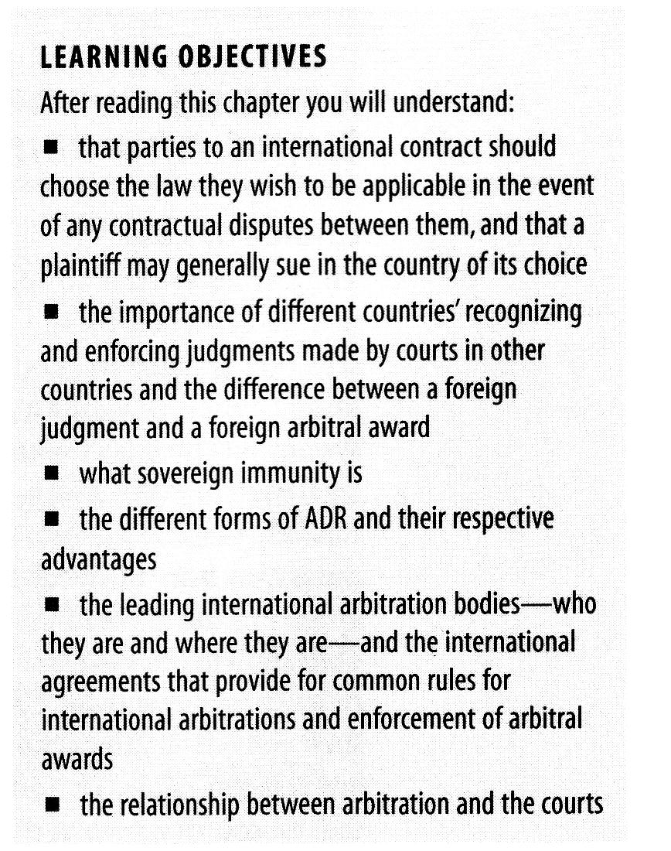

While no business person entering into a transaction, either domestic or international, likes to contemplate a dispute between the parties as the outcome of the deal, experience tells us that this will happen in a certain percentage of cases.

If a dispute arises in an international transaction, there are, in addition to the matters in dispute, three potential issues:

- Which country's law will apply to the dispute?
- Which country's court will hear the case?
- Will the courts of one country recognize and enforce a judgment obtained in another country?

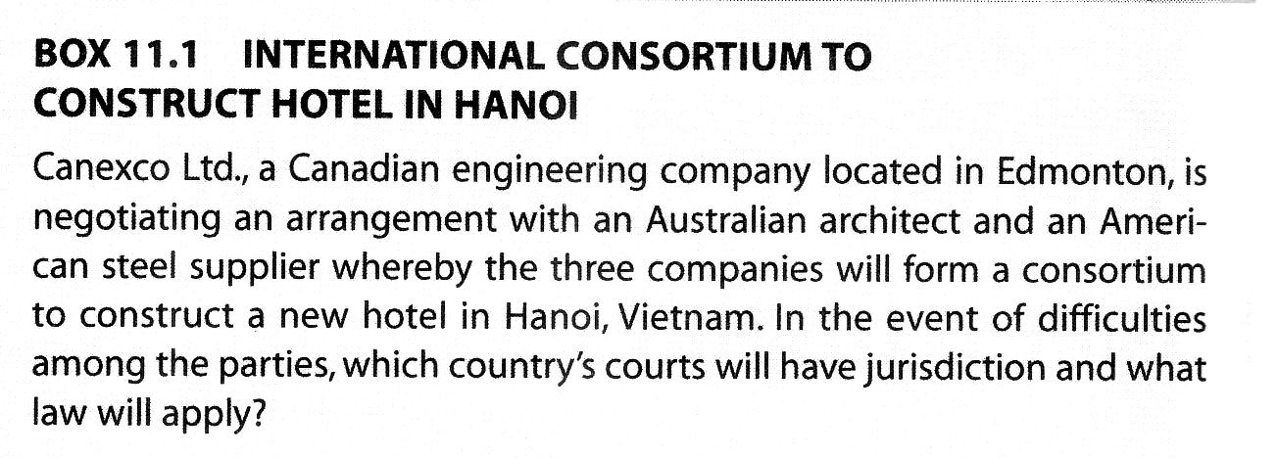
The parties to the contract have some control over the first two issues, and are less able to control the third.

1 )Actions in domestic courts: suing and being sued

1.1 Choice of law

The parties are free to specify in a choice of law clause that their contract will be governed by the law of a particular jurisdiction as long as their selection is made in good faith and is not for the purpose of avoiding the public policy of a country that has a connection with the contract.

The parties must also bear in mind that a choice of law clause governs the law that applies to the terms in the contract; it does not affect the parties' subsisting obligation to obey the laws of any jurisdiction in which they carry on business or perform any activity.

Canadian should note that they must always specify their provincial jurisdiction because a statement that the laws of Canada will apply is too vague.
1.2 the proper law of the contract

if the parties have not made a choice of law, the proper law of the contract must be determined.

A transaction may have several different aspects and it is possible that different law may be applicable to different aspects of the same transaction.

Do the laws of Alberta apply? What about the law of the state of Queensland, the domicile of the architect? The American steel supplier will argue the applicability of the uniform commercial code (UCC).

If the parties have not made an express selection of the law they wish to apply, a court will have to determine what is the proper law of the contract.

1.3 European convention on contractual law

The 1980 EC Convention of the law applicable to contractual Obligations regulates cases between parties in EU member states, and between member states and non-members states.

The convention states two basic principles:

- the right to choice of law
- where the parties have not chosen, the law of the contract will be the law having the closest connection with the contract. The principle of characteristic performance—the law of the domicile of the performing party.

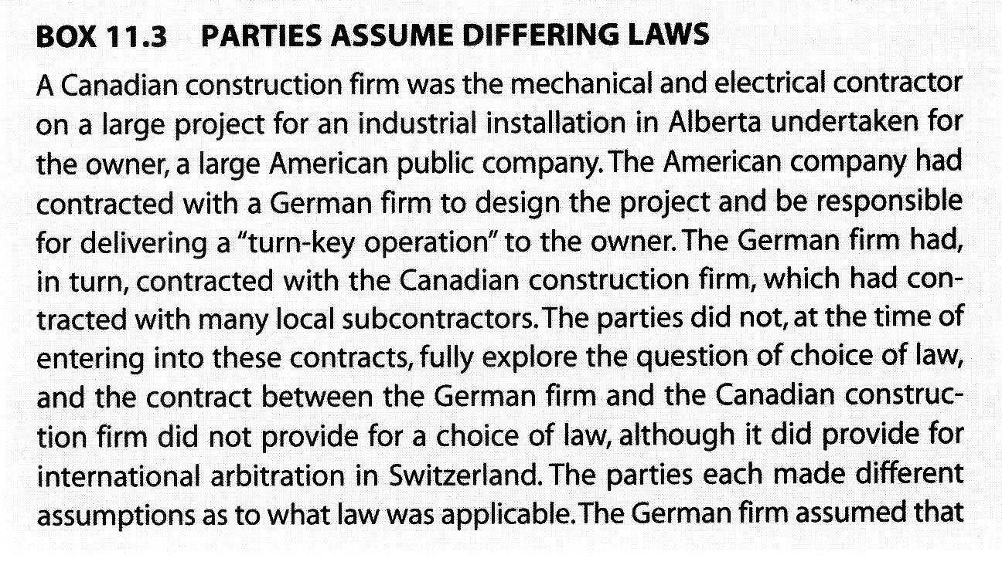
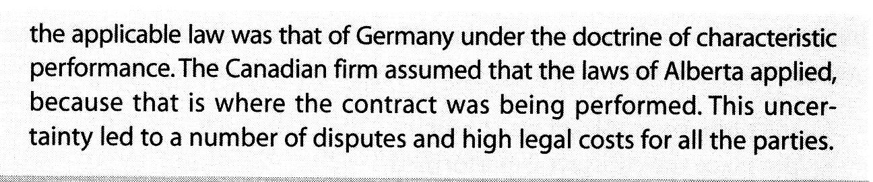
Forum con conveniens

Under the doctrine of forum non conveniens, a court that has jurisdiction over a defendant under national law declines to exercise it and stays the action because it is not the appropriate venue.

For example, a French defendant served in France in connection with an action brought in Ontario.
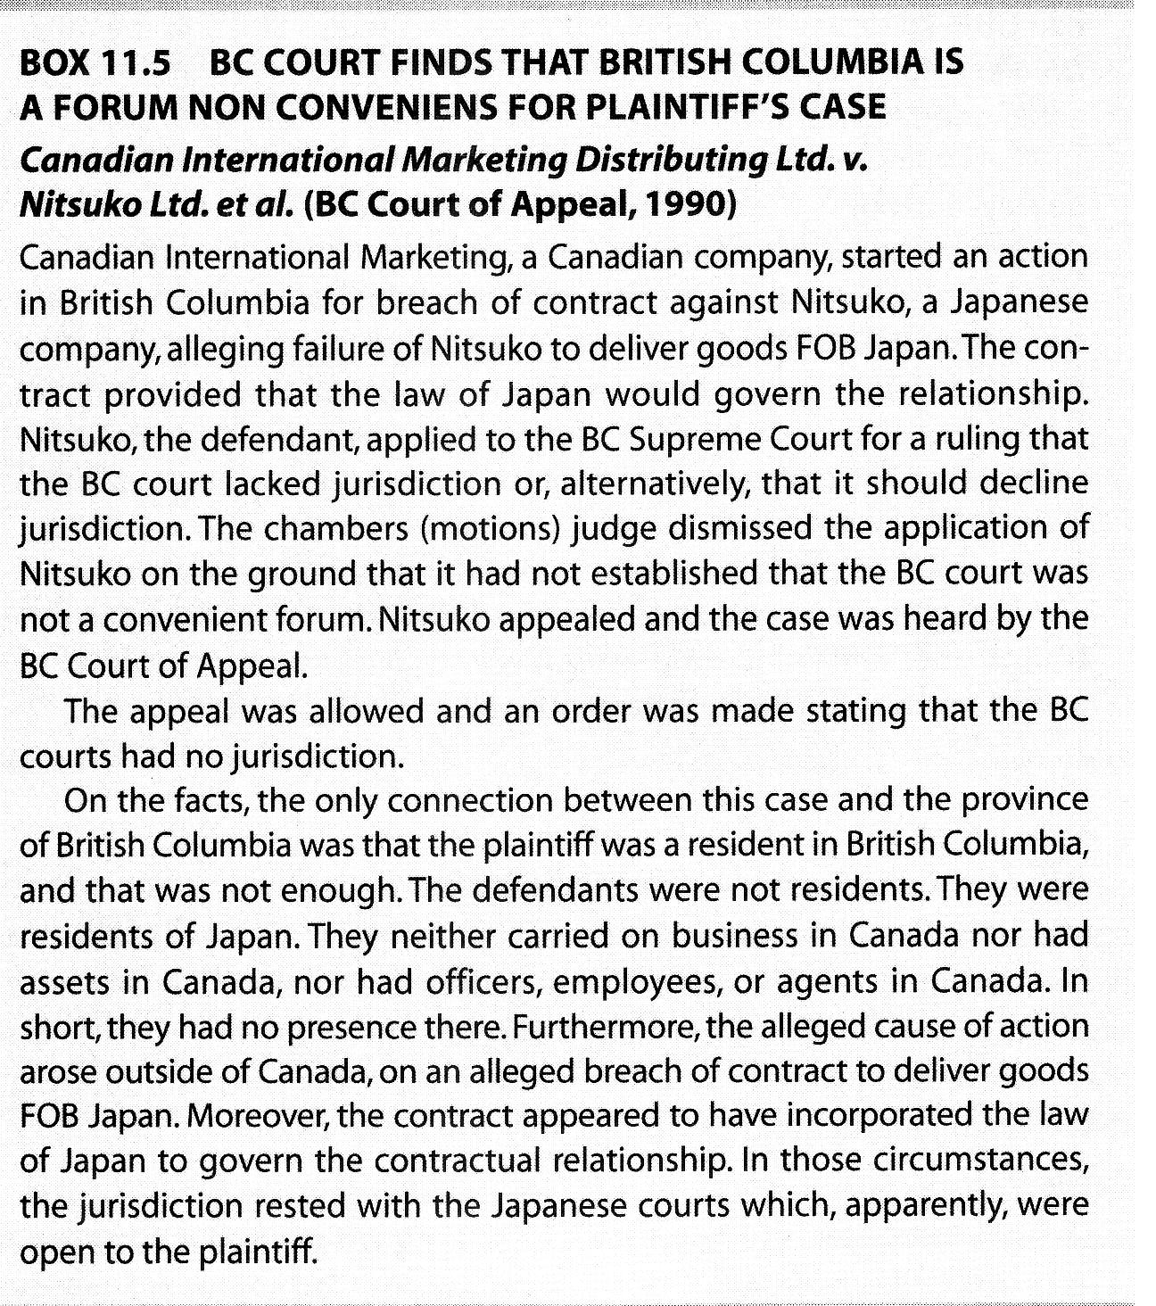
Another recent case in which an application for a stay of action was successfull is the Towne Meadow case.

This case illustrates two important limitations on a foreign court's jurisdiction:
- courts will not normally assert jurisdiction with respect to cases that involve real property in other countries;
- foreign judgements are enforced only where the awards are monetary in character.

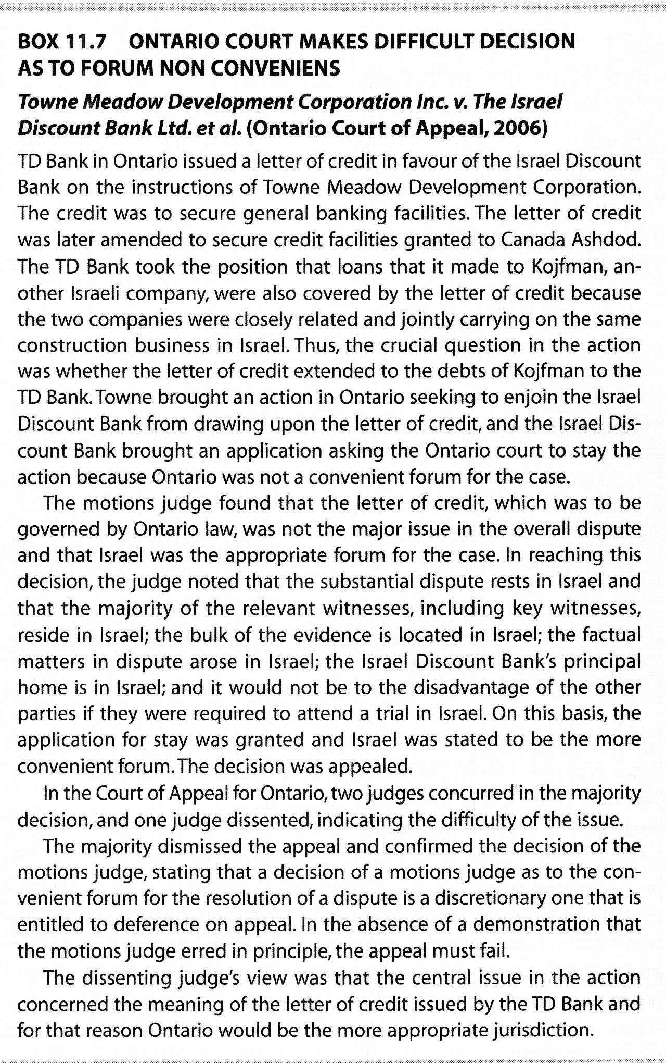
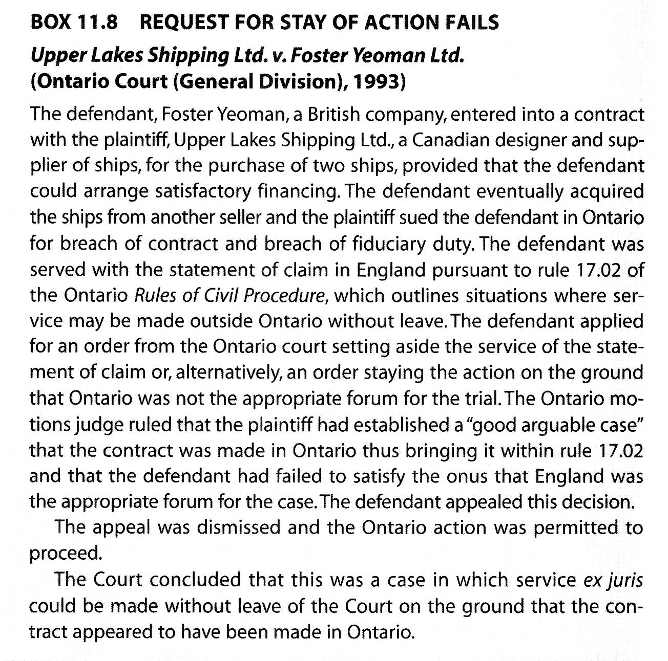
Enforcement of foreign Judgements
Although the plaintiff may feel vindicated by a judgement in its favour in an international contract dispute, the real reason for the lawsuit is the recovery of damages.
For this reason, the action should, whenever possible, be brought in a jurisdiction where the defendant has assets against which the judgement can be enforced.
If judgement has been obtained in one jurisdiction and the defendant's assets are in another; the plaintiff must obtain recognition of the judgement in the second jurisdiction and attempt to enforce the judgement there.

The principles of natural justice are two fundamental principles widely held to be legally necessary to a fair trial or valid decision in a legal system. These are:
- nemo iudex in causa sua: "nobody shall be a judge in his own cause", invalidating any judgment where there is a bias or conflict of interest or duty; and
- audi alteram partem: "hear the other side", giving at least a fair opportunity to present one's case (which may, for example, require access to counsel).
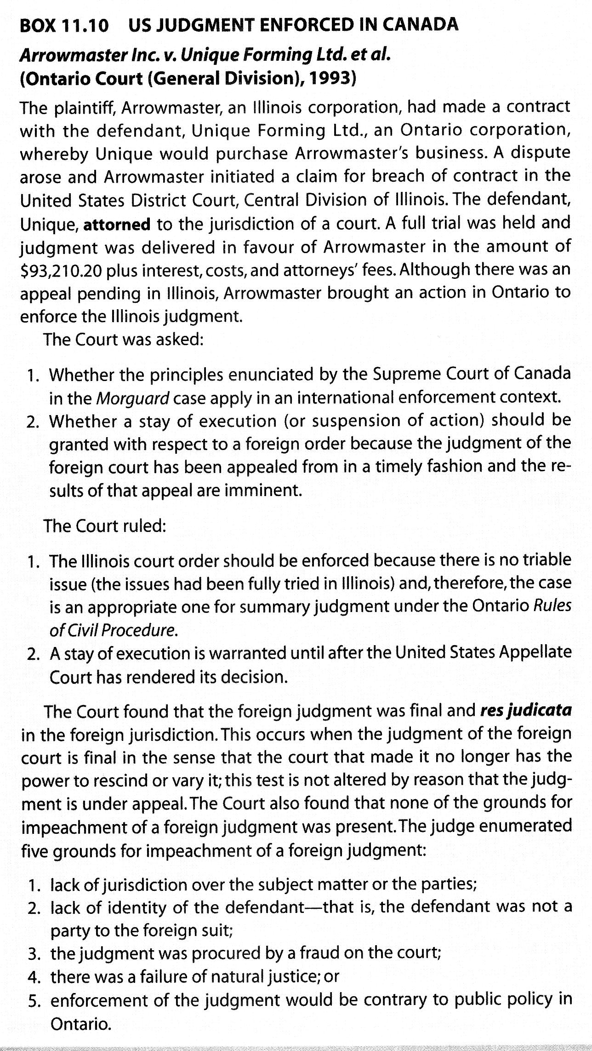
The Arrowmaster case indicates the five grounds available to a defendant seeking to persuade a court in Ontario (or other common law jurisdiction) not to recognize and enforce a judgement obtained outside the jurisdiction.

One of those grounds is that enforcement of the judgement would be contrary to the public policy of the enforcing jurisdiction.
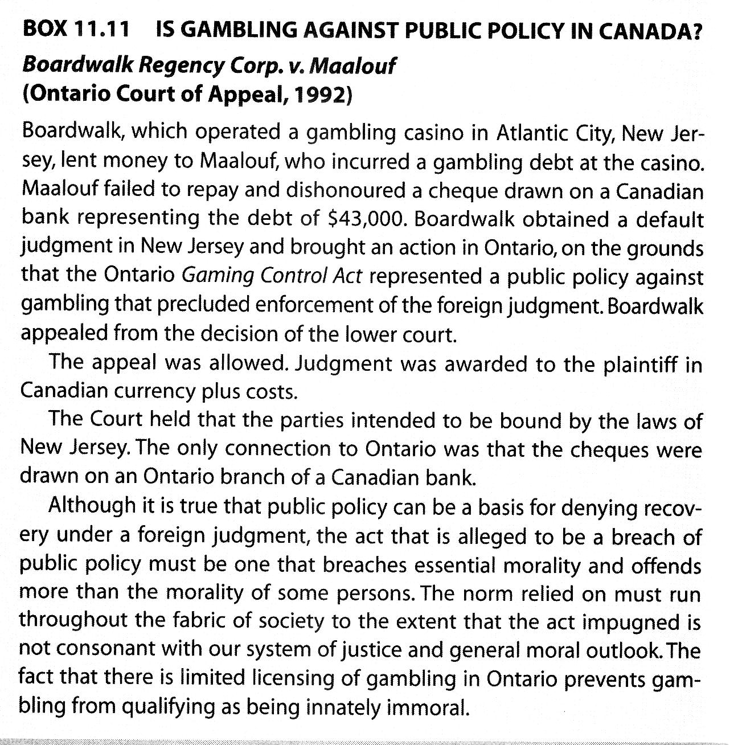

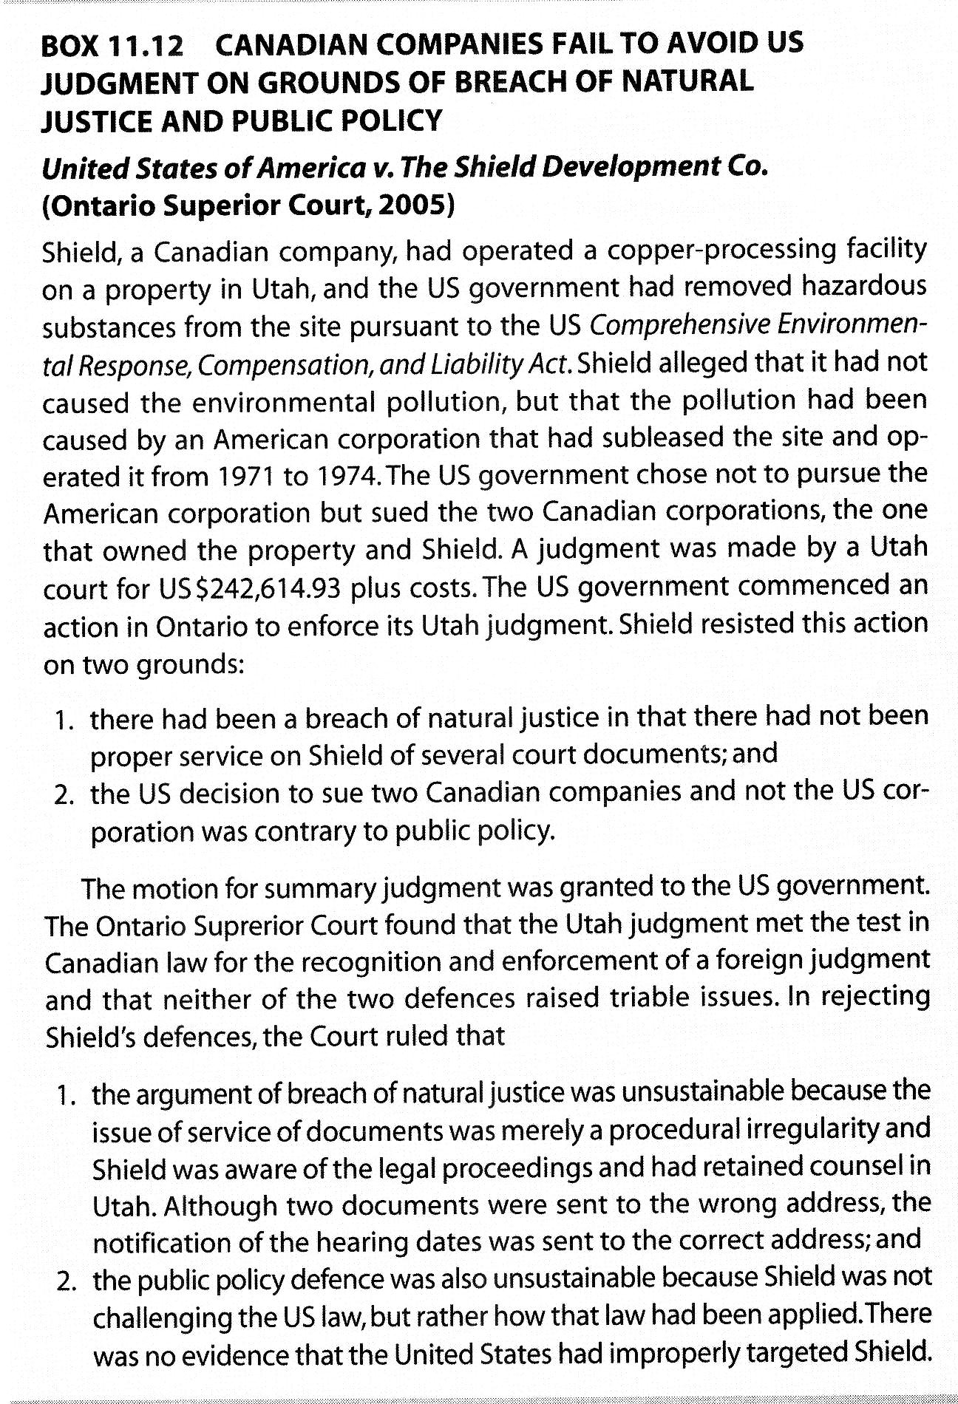
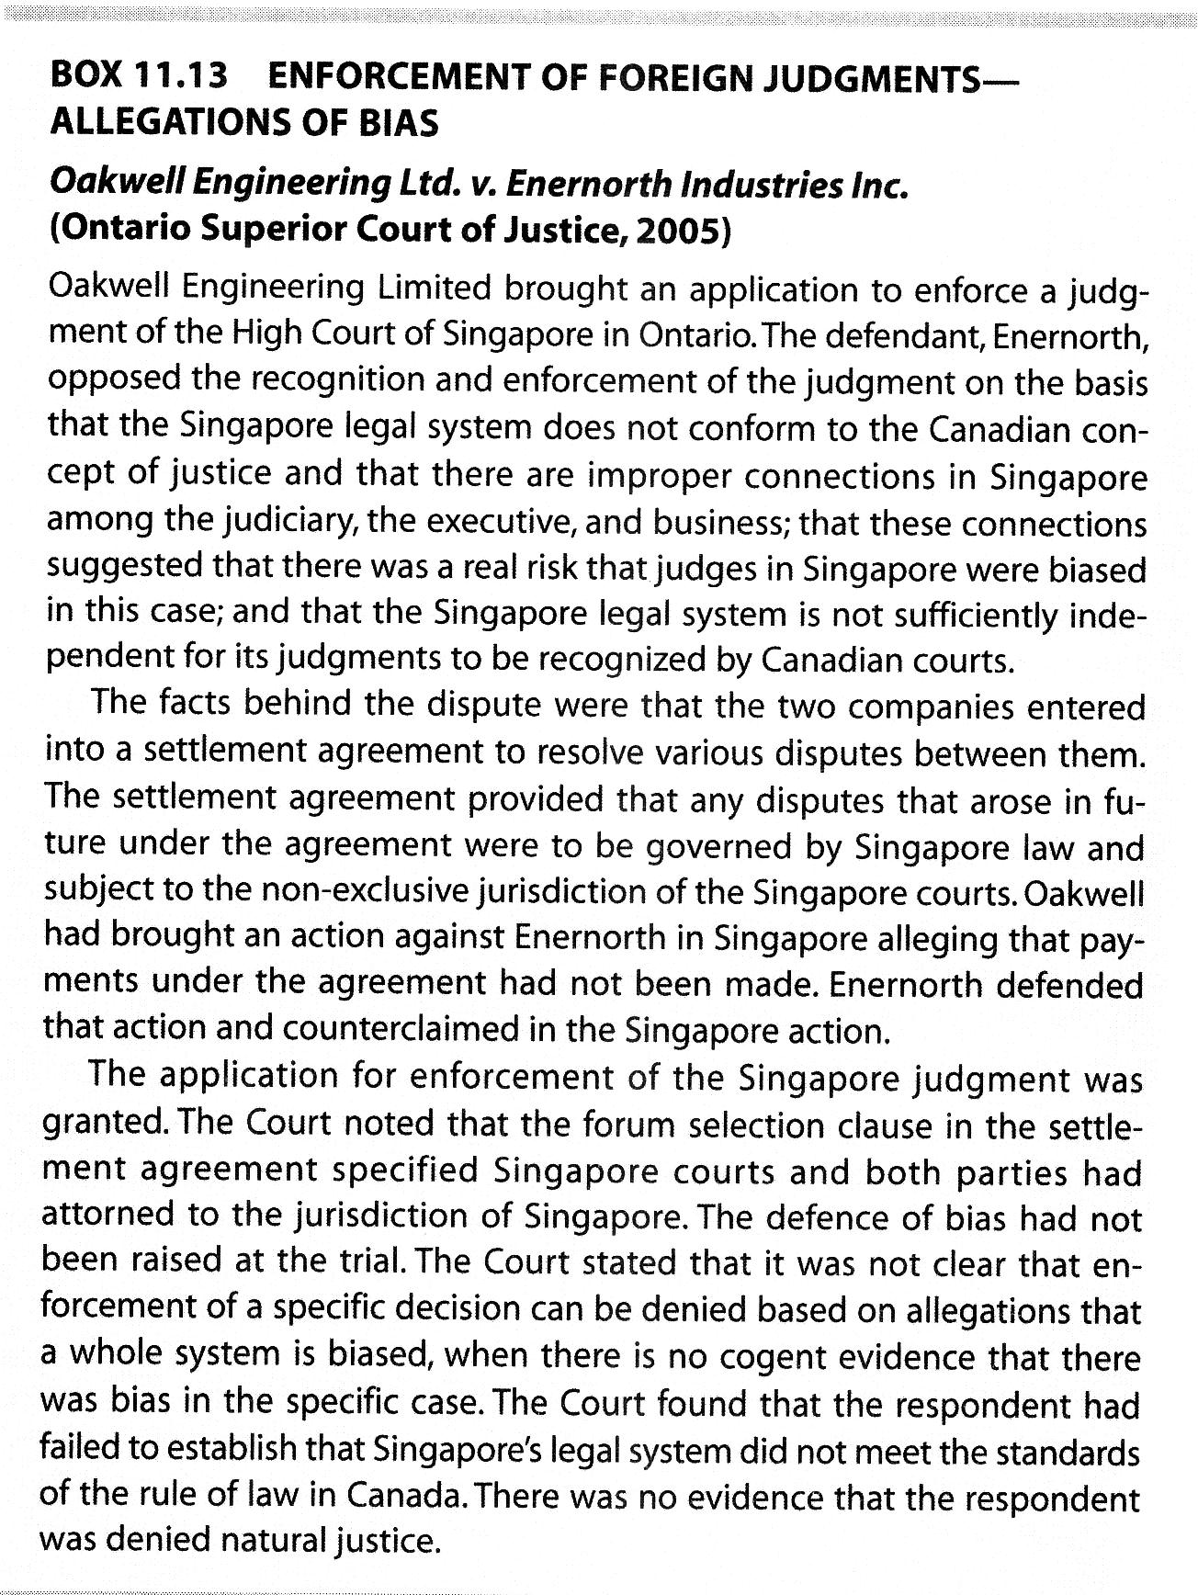
Alternative dispute resolution(ADR)

ADR provides the opportunity for the parties to determine what law will apply to their dispute, who will ''judge'' a dispute, and what forms of evidence will be permitted.

The two most common methods of ADR:
- Mediation and conciliation. Mediation and conciliation are voluntary dispute resolution processes that make use of the good offices of a neutral third party but there is no promise of an outcome that is binding on the parties.
- Arbitration. Arbitration is a more formalized voluntary process whereby a neutral party listens to the evidence and renders a decision that the parties have agreed in advance to honour.

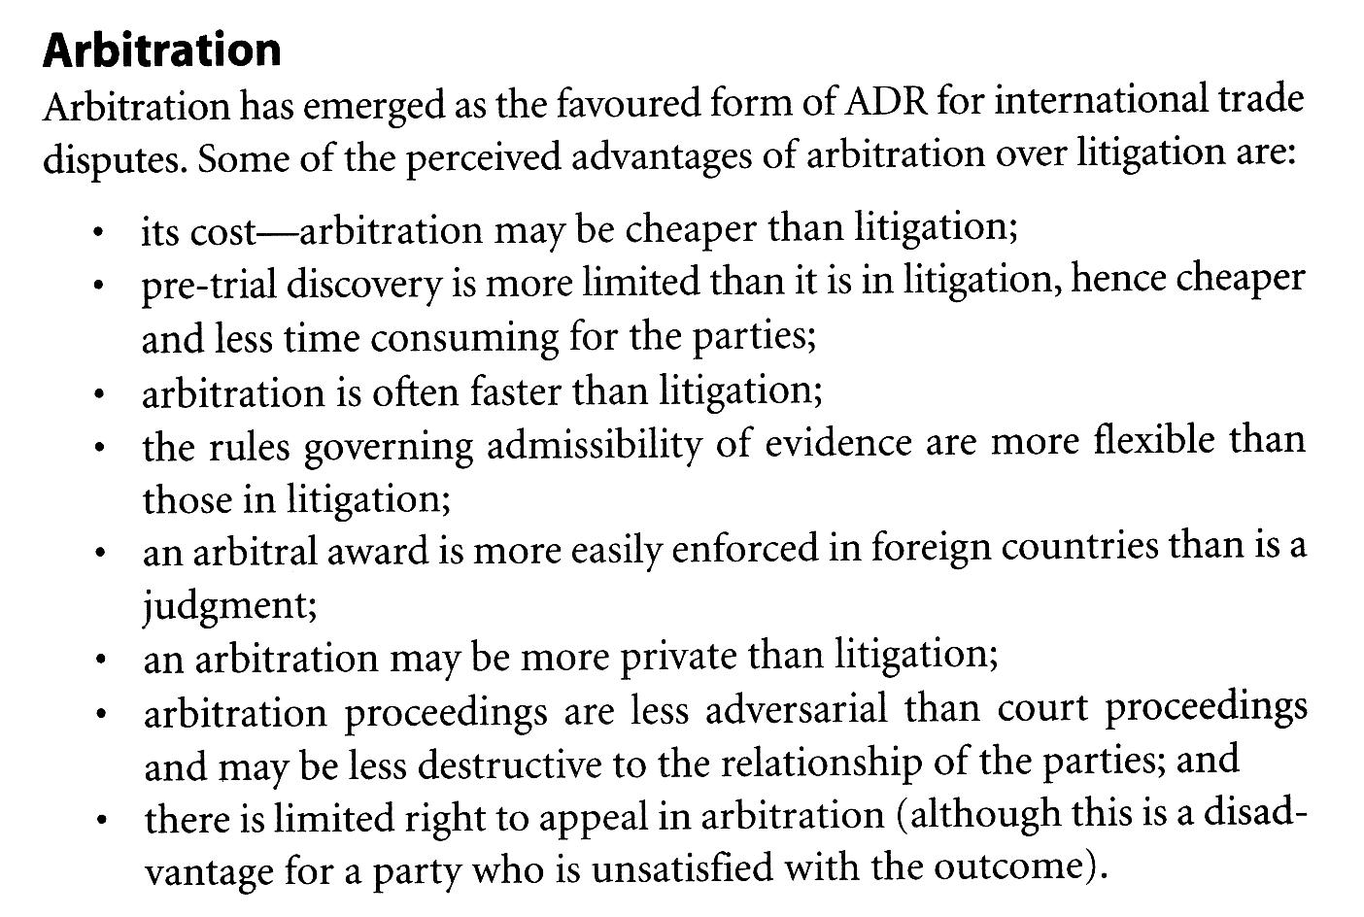
Enforcement of International Arbitration Decisions: the New York convention(1958)

More than 70 states have acceded to the convention. Canada will enforce an award made in any member state.

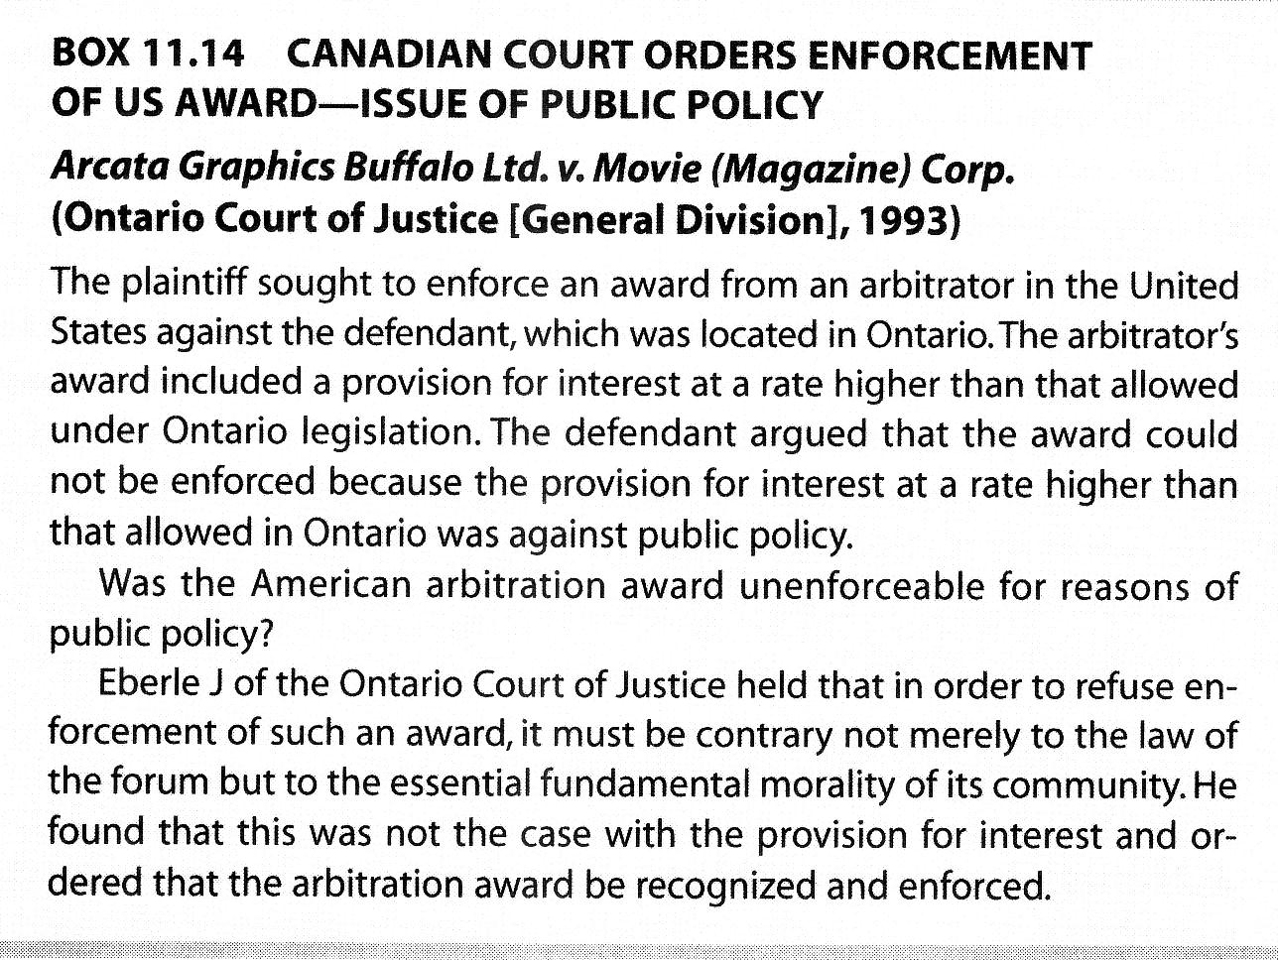
Review questions

- What three potential issues may arise in connection with an international business dispute other than the particular issue between the parties?
- Ar the parties to an international contract completely free to specify what law will apply to their contract?
- What factors will a court consider if it is necessary for it to make a decision as to the proper law of the contract?
- What is meant by characteristic performance?
- What three arguments are available to a defendant who wishes to object to the jurisdiction of a court?
- Outline some of the advantage of arbitration as a method of dispute settlement.

