The North American Free Trade Agreement (NAFTA)
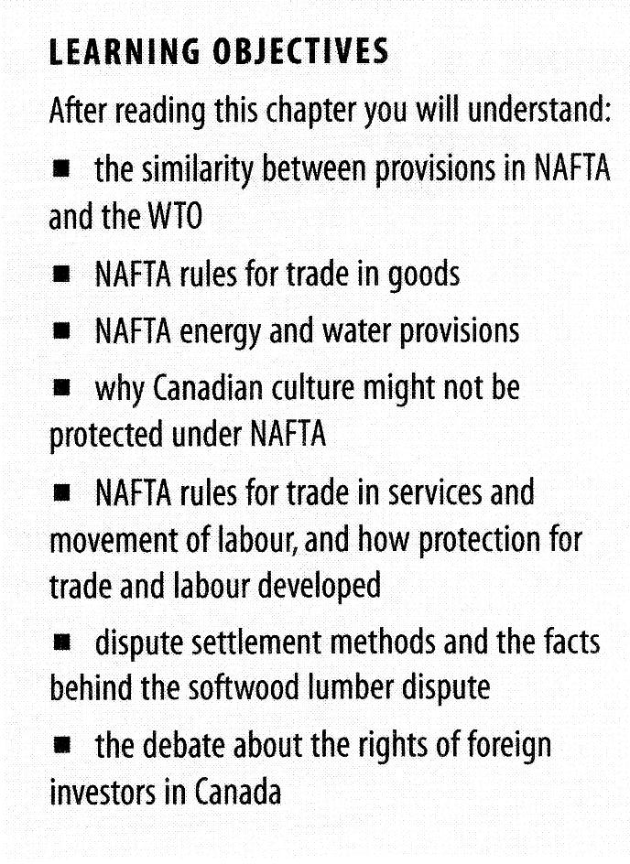
The Canada-US Free Trade Agreement (CFTA, January 1989) and later on the North American
Free Trade Agreement (NAFTA, January 1994), are treaties whose purpose was to create a free trade area characterized by national treatment, most-favoured-nation (MFN) treatment, and trasparency.

More specifically, the agreement was intended to

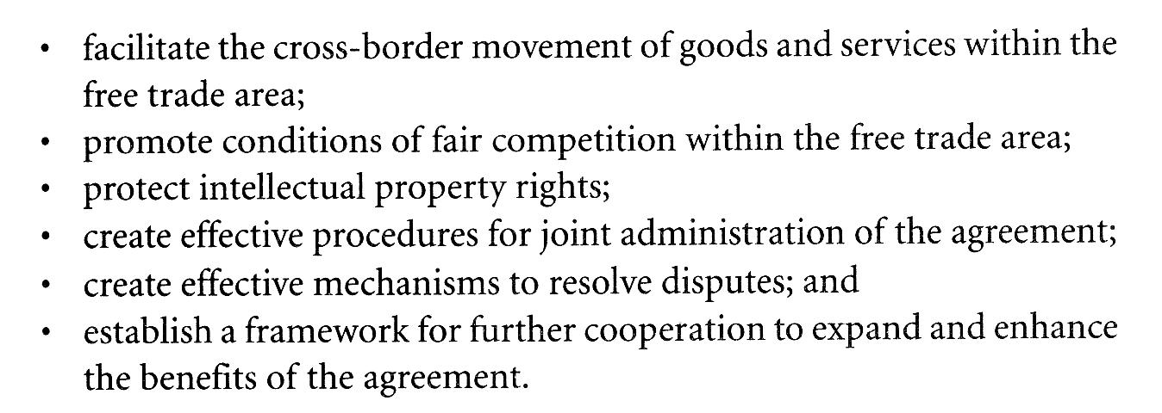
Rules relating to trade in goods

Each NAFTA country retains its own external tariffs that are applied to goods from non-member countries, but levies a lower or no tariff on the goods originating from the other NAFTA members.

Some tariffs remain in place for certain products from Canada's supply-managed sectors(eggs, dairy, and poultry products). In the United States, tariffs remain in place for certain products such as sugar, dairy, peanuts, and cotton.

(Read article on supply management)

Rules of origin
How do goods qualify as originating?
We consider a good to be an originating good, if it meets one of the five requirements set out in the NAFTA rules of origin.
These five requirements are as follows. We consider a good to be originating if:
● the good is wholly obtained or produced in a NAFTA country (including those goods that are entirely grown, fished, or mined in a member country – it does not include goods purchased in a NAFTA country that were imported from a non-NAFTA country);
● the good is made up entirely of components and materials that qualify in their own right as goods that originate in a NAFTA country;
● the good meets the requirements of a specific rule of origin for that product, as listed in NAFTA Annex 401;
● the good qualifies under NAFTA article 401(d), which only applies to a few cases; or
● the good is automatic data processing equipment or parts qualifying under the provisions of Annex 308.1.
Of these five requirements, the most common is the third, which applies to a good that includes any non-originating materials in its production.
What are non-originating materials?
The non-originating materials used to produce the good are those materials or components that would not qualify as originating under the NAFTA rules of origin.
Non-originating materials are:
☑ materials or components you import from a non-NAFTA country; or
☑ materials produced in a NAFTA country but, because of the high level of offshore input used to produce them, do not meet the rule of origin.
Note
You have to treat any material of unknown or unconfirmed origin as a non-originating material.
How do the specific rules of origin work?
NAFTA provides a specific rule of origin for every type of good that incorporates non-originating materials. In many cases, two different rules may apply to a good, and the good may qualify under either rule.
Generally, a good qualifies as originating in one of the NAFTA countries if its last place of manufacture was within the NAFTA territory, and if the manufacturing process resulted in a significant change in all of the components or materials not of Canadian, American, or Mexican origin. To test whether a significant change has occurred, we use a tariff classification change test.

When a product is transformed from all materials and components used into the finished good, there is a resulting change from the tariff classifications of the materials and components to that of the finished good.
Technical Barriers to Trade and Technical standards

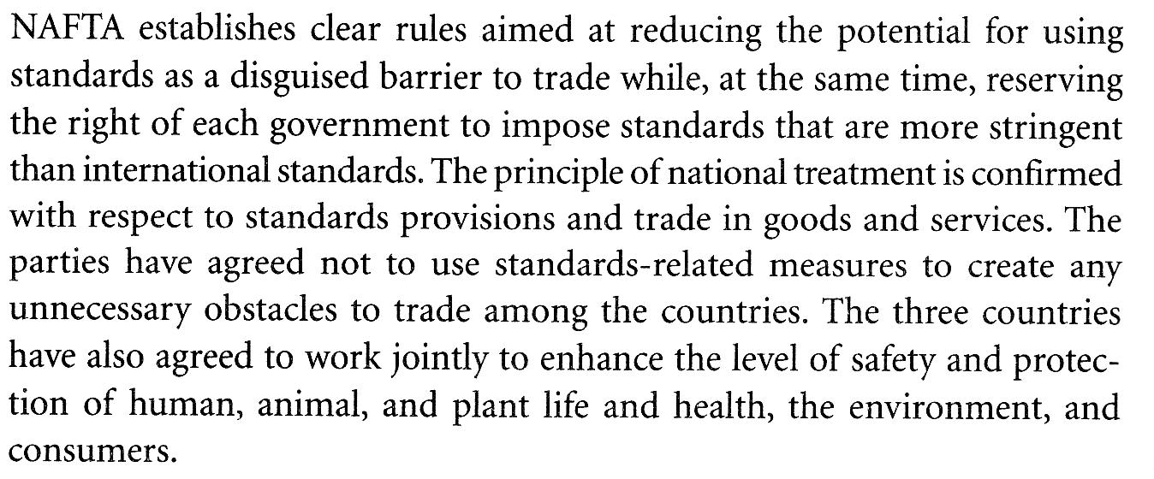
Sanitary and Phytosanitary Measures

Article 2 - Basic Rights and Obligations

- Members have the right to take sanitary and phytosanitary measures necessary for the protection of human, animal or plant life or health, provided that such measures are not inconsistent with the provisions of this Agreement.
- Members shall ensure that any sanitary or phytosanitary measure is applied only to the extent necessary to protect human, animal or plant life or health, is based on scientific principles and is not maintained without sufficient scientific evidence, except as provided for in paragraph 7 of Article 5.
- Members shall ensure that their sanitary and phytosanitary measures do not arbitrarily or unjustifiably discriminate between Members where identical or similar conditions prevail, including between their own territory and that of other Members. Sanitary and phytosanitary measures shall not be applied in a manner which would constitute a disguised restriction on international trade.
- Sanitary or phytosanitary measures which conform to the relevant provisions of this Agreement shall be presumed to be in accordance with the obligations of the Members under the provisions of GATT 1994 which relate to the use of sanitary or phytosanitary measures, in particular the provisions of Article XX(b).

Selected areas on interest or controversy

Anti-dumping (AD) and countervailing duty provisions(CVD)

Each country would retain its own AD and CVD laws, but a system of binational panels would oversee the competent investigating authorities in each country and determine whether they were applying their own law fairly to the situation.

Energy

Energy provision apply to crude oil, natural gas, refined products, basic petrochemicals, coal, electricity, and nuclear energy.

Canada is the US' largest foreign supplier of oil, natural gas, and electricity.

Canada wanted unimpeded access to the US market, and the American wanted to limit Canada's ability to jeopardize access to these energy sources at reasonable prices.

Agriculture

the NAFTA decision on Canadian butter, dairy, poultry, and egg tariffs.

In 1994 the WTO prohibited the practice of imposing quotas on agricultural imports for the purpose of
protecting domestic markets. This new rule required such quotas to be converted to tariffs, which would be more transparent and would eventually be lowered through successive WTO neogtiating rounds.

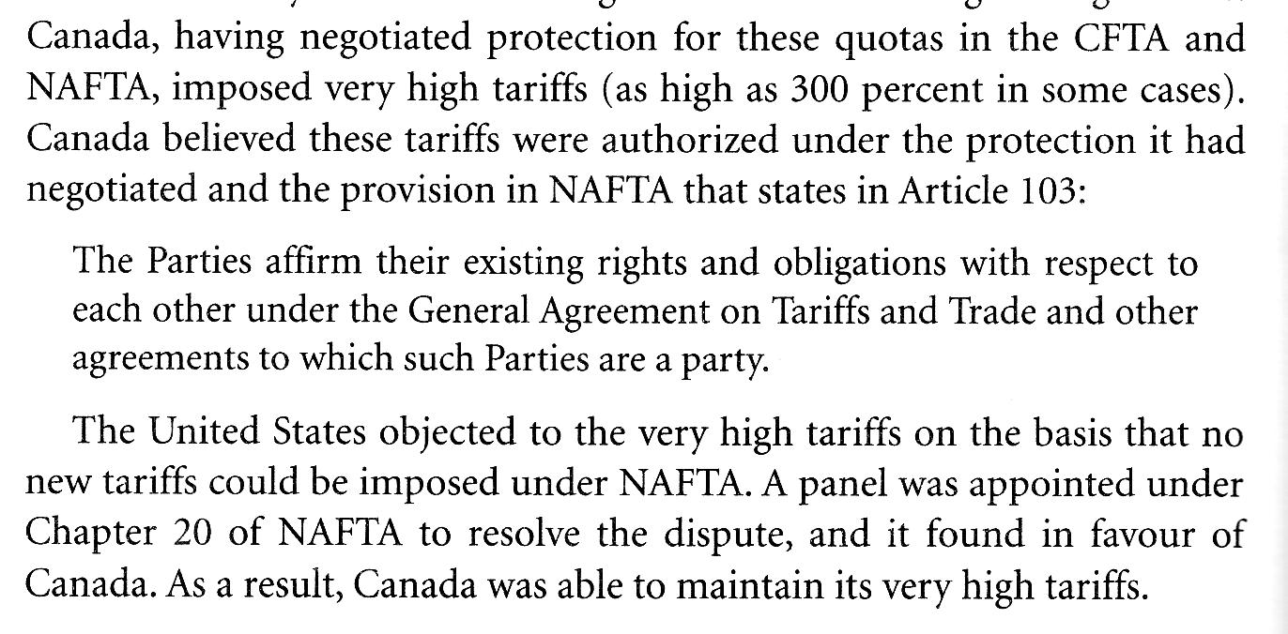
The Canadian wheat board(CWB)

The CWB is a state trading enterprise. State trading enterprises are permissible under WTO rules as long as their practices are non-discriminatory and their sales or purchases are made in accordance with commercial practices.

The operations of the CWB are based on three principles:

- single-desk selling
- price pooling
- and a government guarantee of the initial payment to producers

Cultural industries

- printed publications
- film and video
- music recording
- music publishing
- broadcasting

Cultural industries are exempted from NAFTA.

Government Procurement
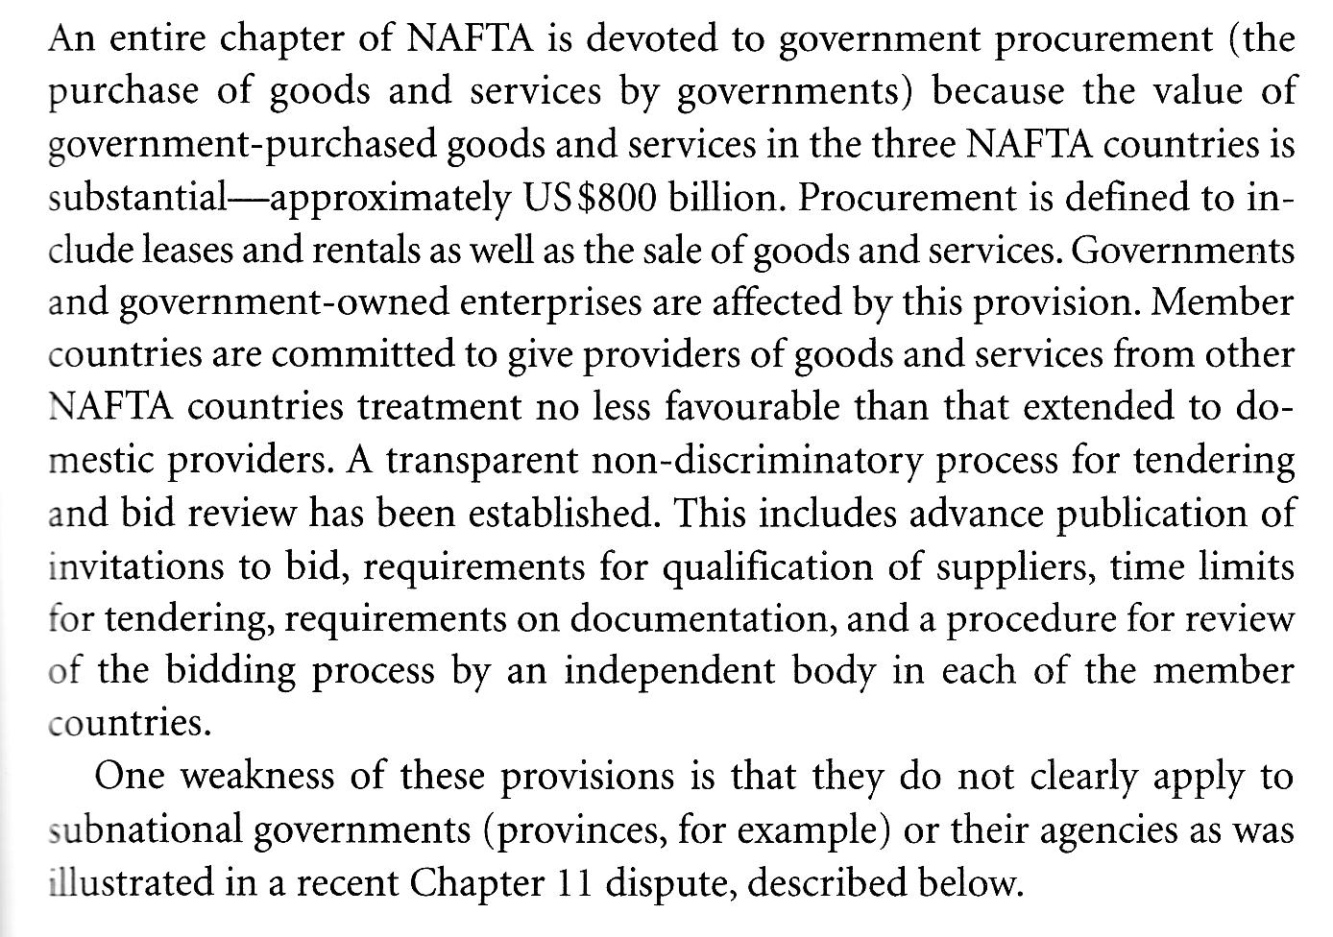
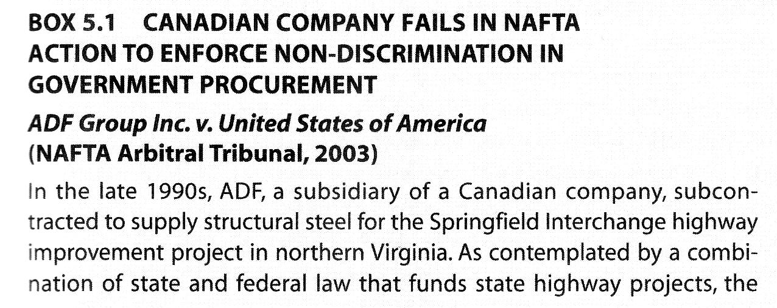
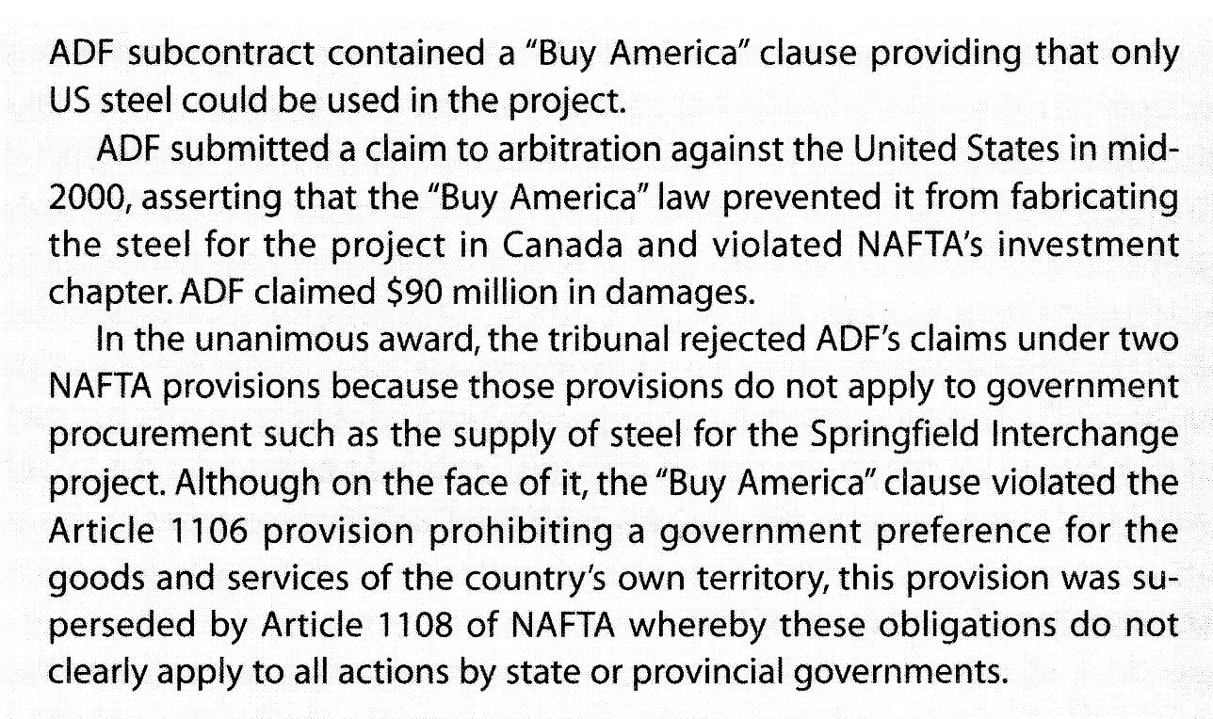
Dispute Settlement under Nafta

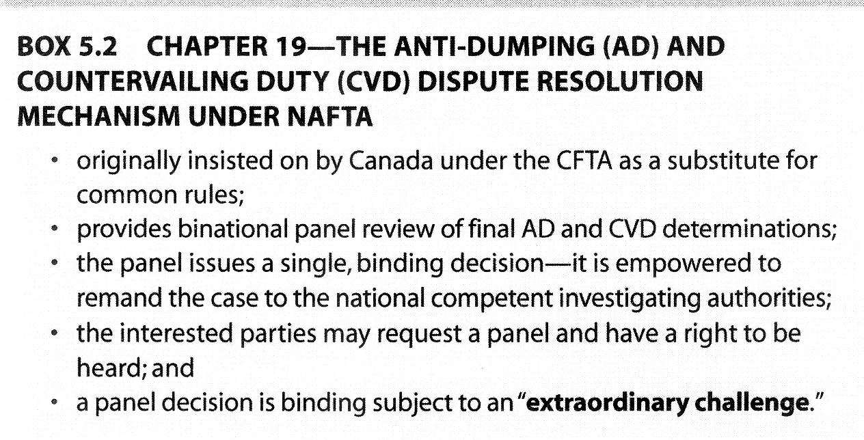
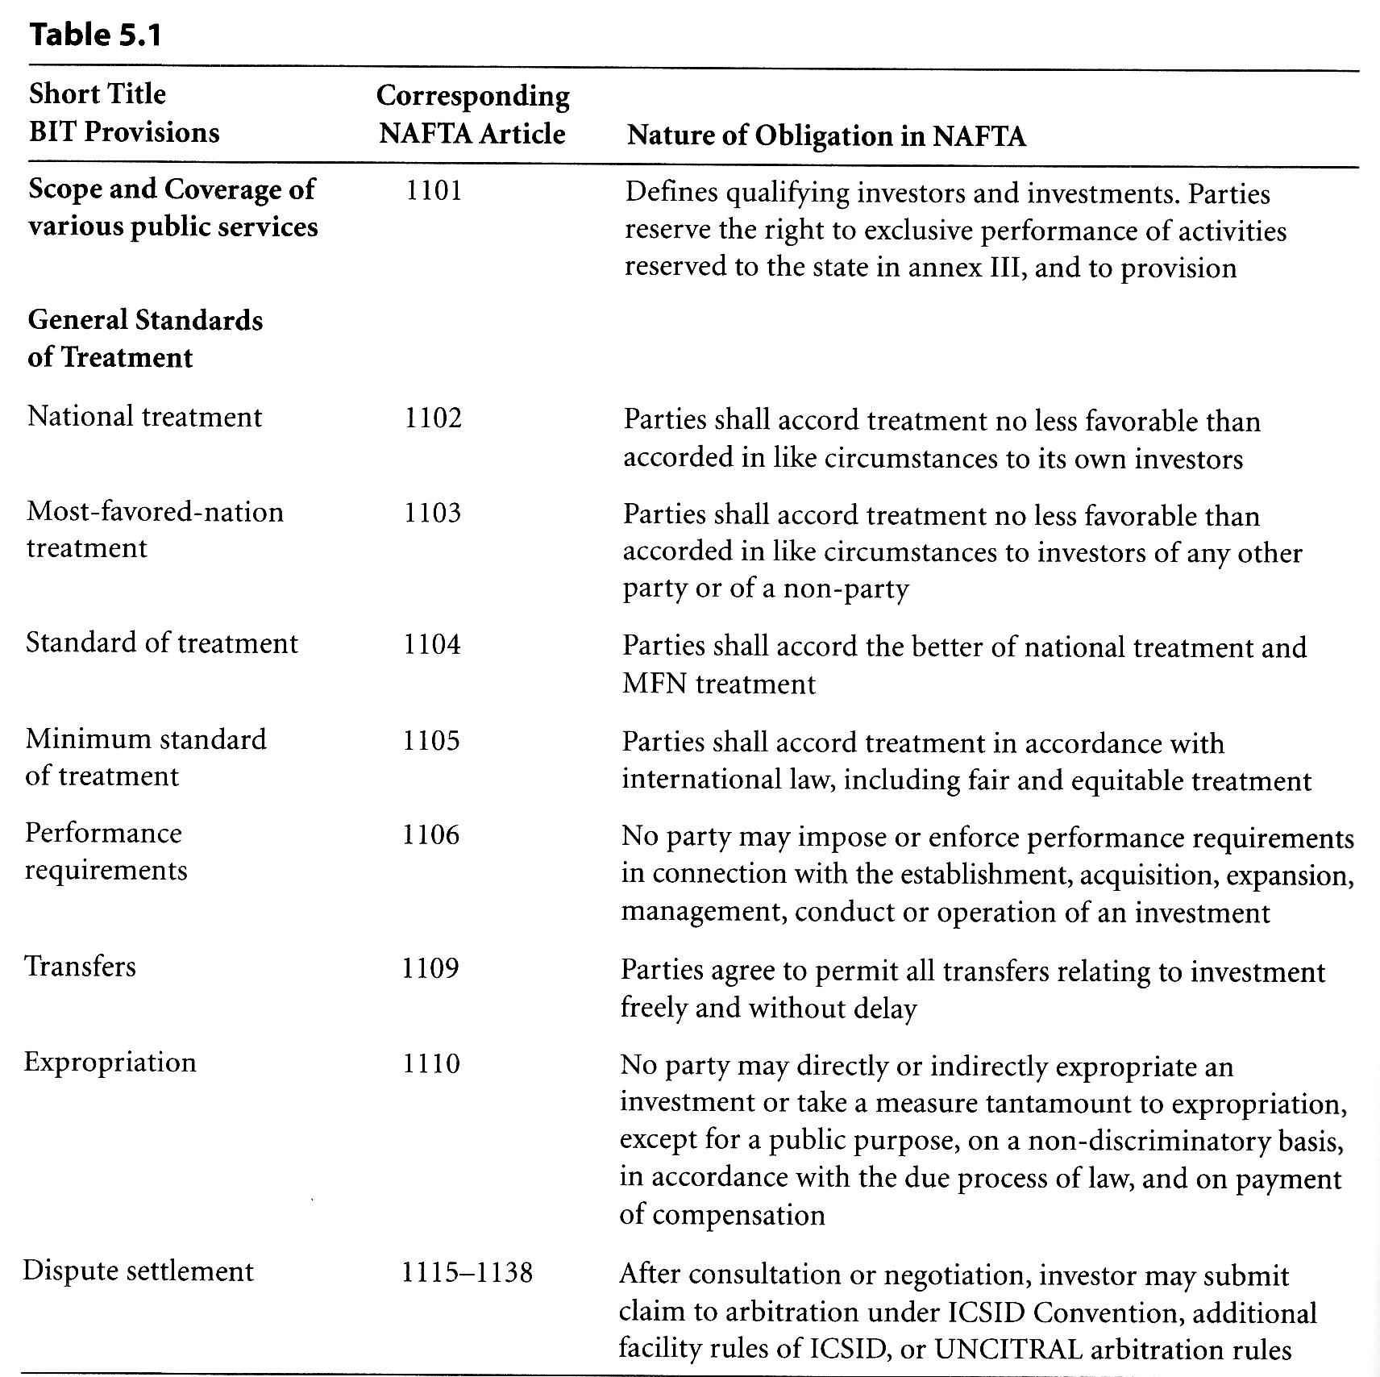
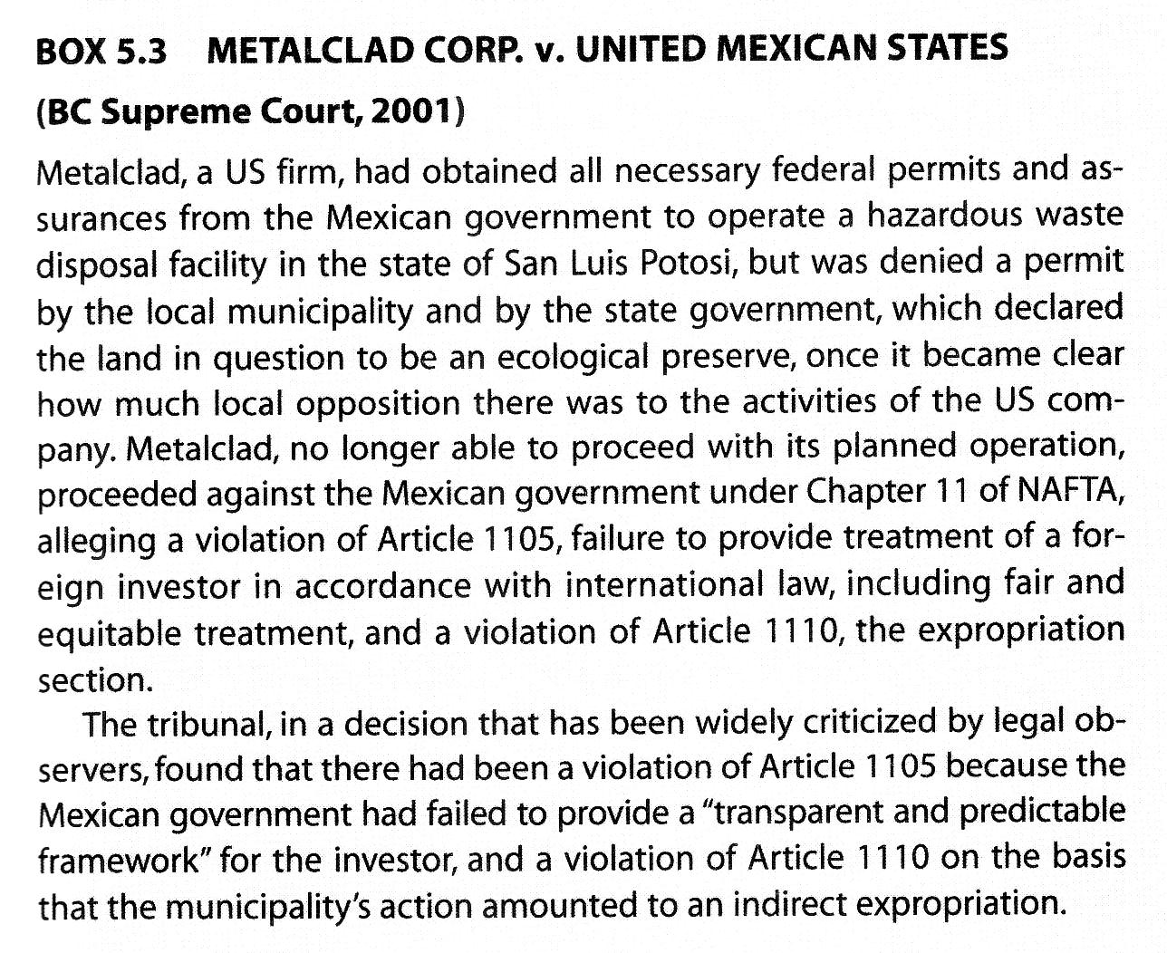
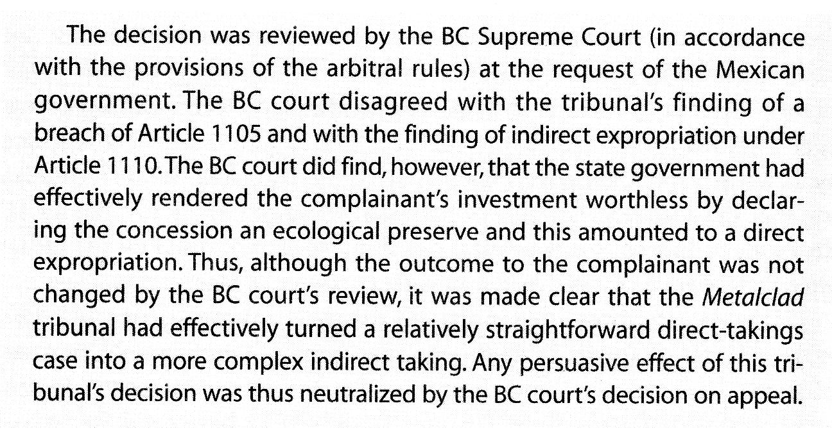
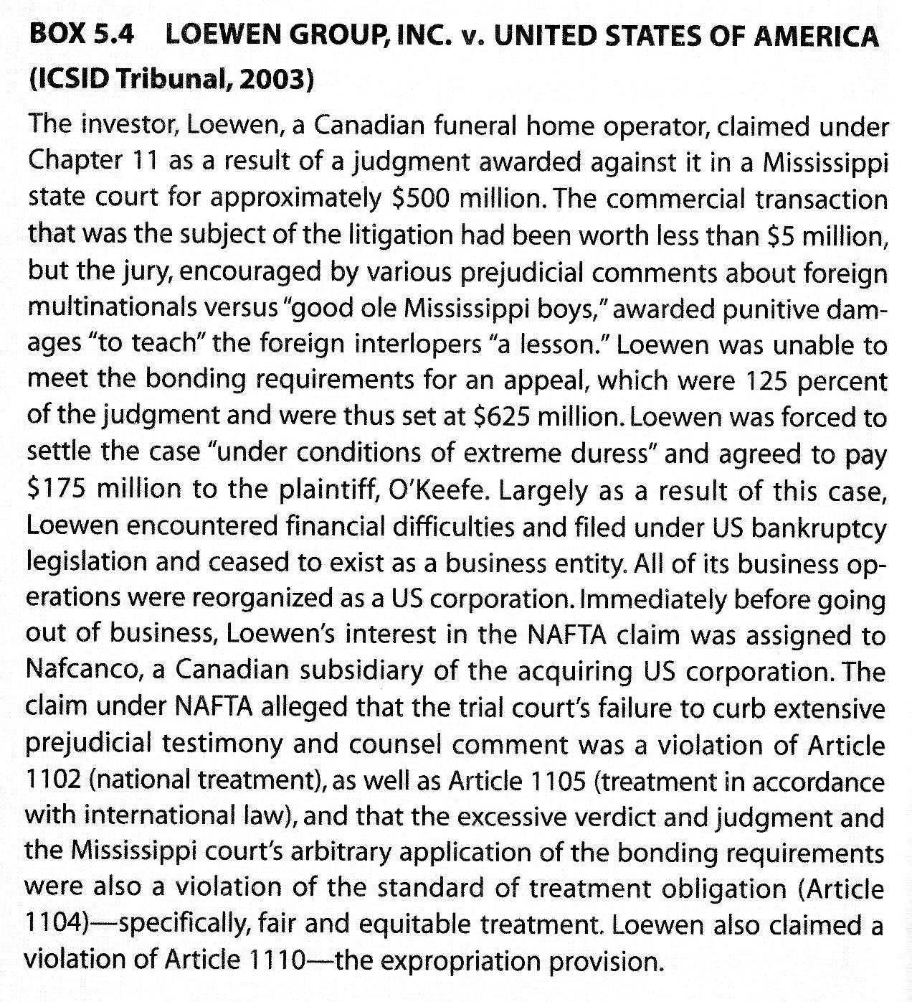
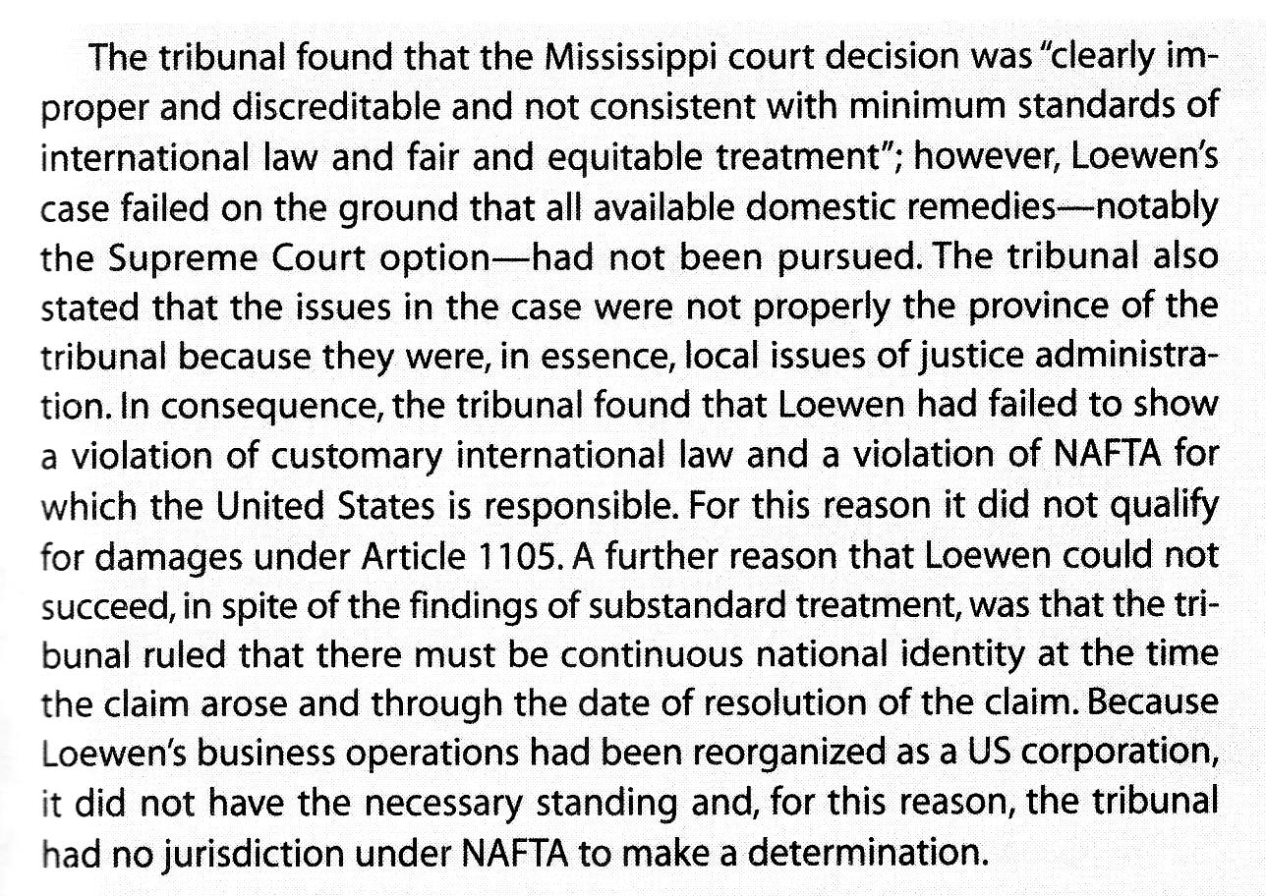
Rewiew questions

What is the significance of rules of origin and what is area treatment? Is it necessary for goods to be wholly obtained or produced in North America to qualify for area treatment.

