The European Union and other regional trade Arrangements

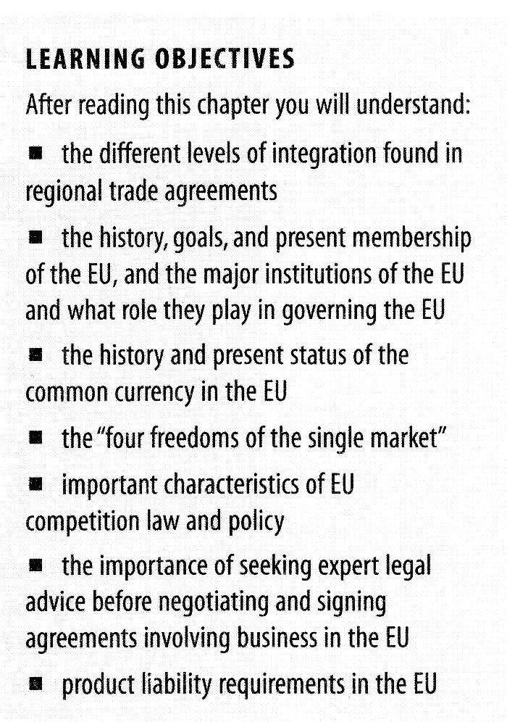
Different levels of integration have emerged and can be described in stages, beginning with the least integrated form of favourable treatment and progressing through five stages to the most integrated form of cooperation.

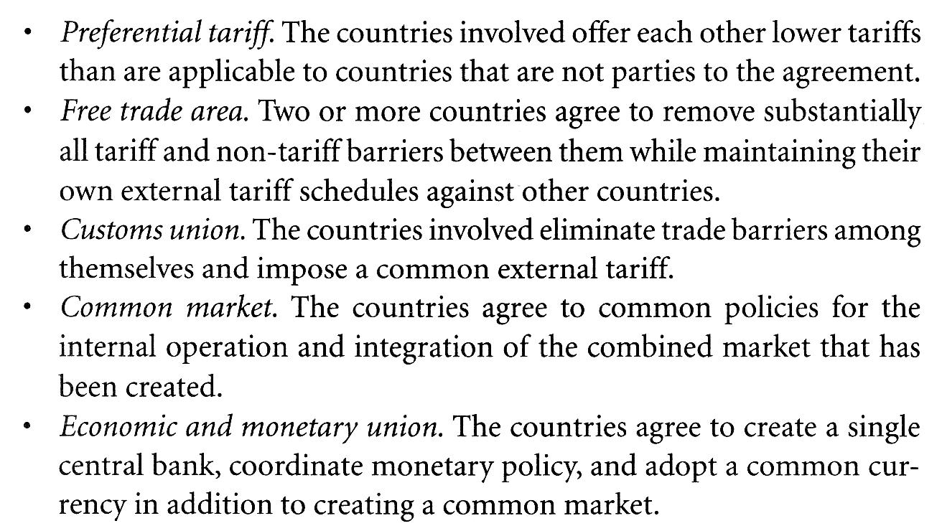

The historical development of the European union.

European Coal and Steel Community, 1952 (France, Belgium, West Germany, Italy, Luxembourg, and the Netherlands)

The European Atomic community, 1957

The European Economic community(EEC), The Treaty of Rome, 1957: create a common market in which all countries agreed to gradually eliminate all trade barriers among themselves and form a common tariff on all goods entering the EEC.

European Community(EC), Single European act, 1986: single market as an area without internal borders to goods, services, capital, and people.
The four freedoms of the single market

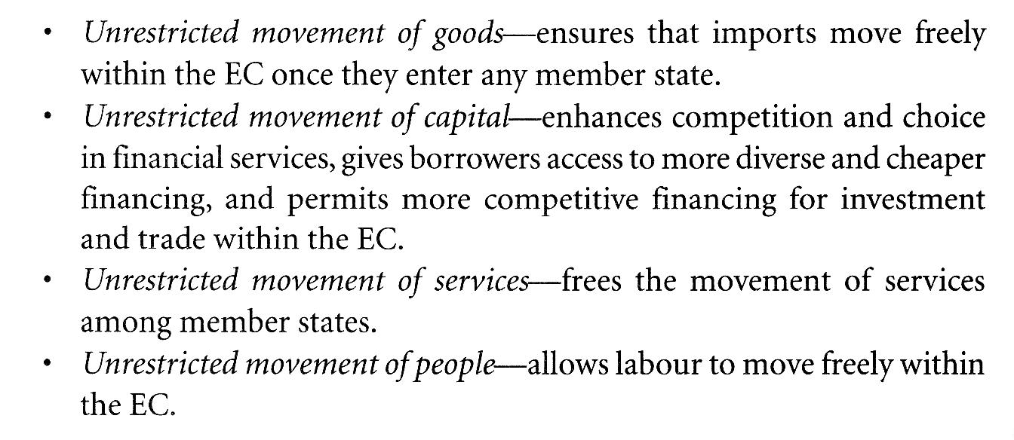
European Union, Treaty on European Union, Maastricht 1993: greater integration of European monetary, foreign, and social policy.

Treaty of Amsterdam, 1997, provide clarification on civil rights, personal mobility and citizenship, common foreign policy, and security, and to set some pre-conditions for further enlargement of the EU community.

The common currency, 1999 , Euro 12 members state, the original six plus Austria, Portugal, Finland, and Greece.

The Treaty of Nice, 2003, redefine, clarify, and extend the legislative, administrative, executive, and judicial powers of the EU.
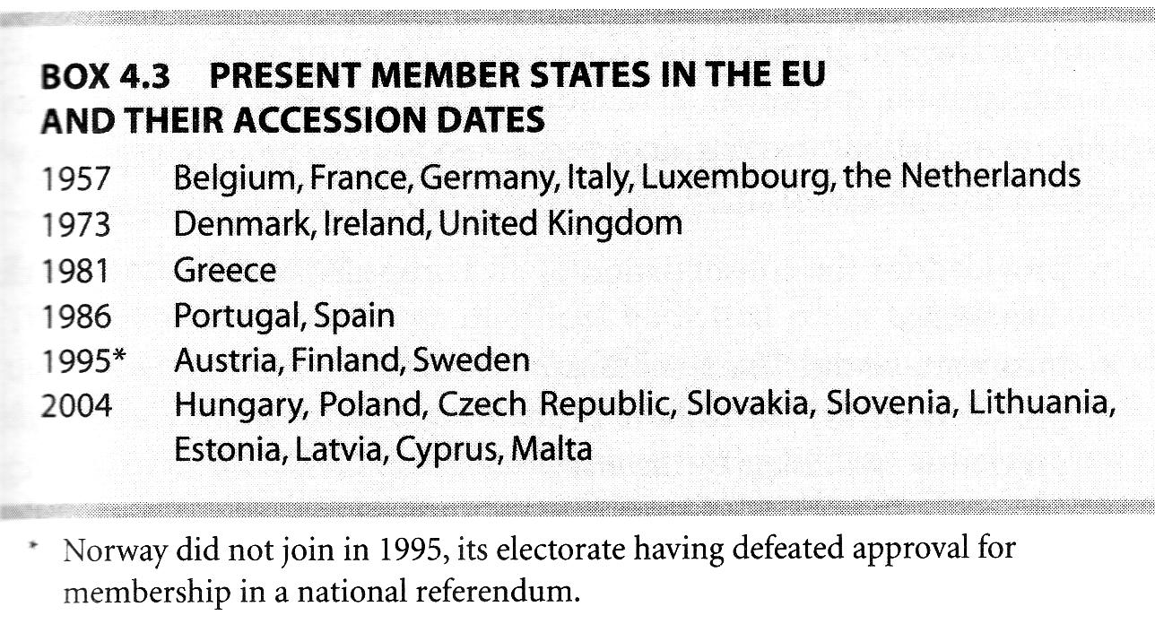

The institutions of the EU

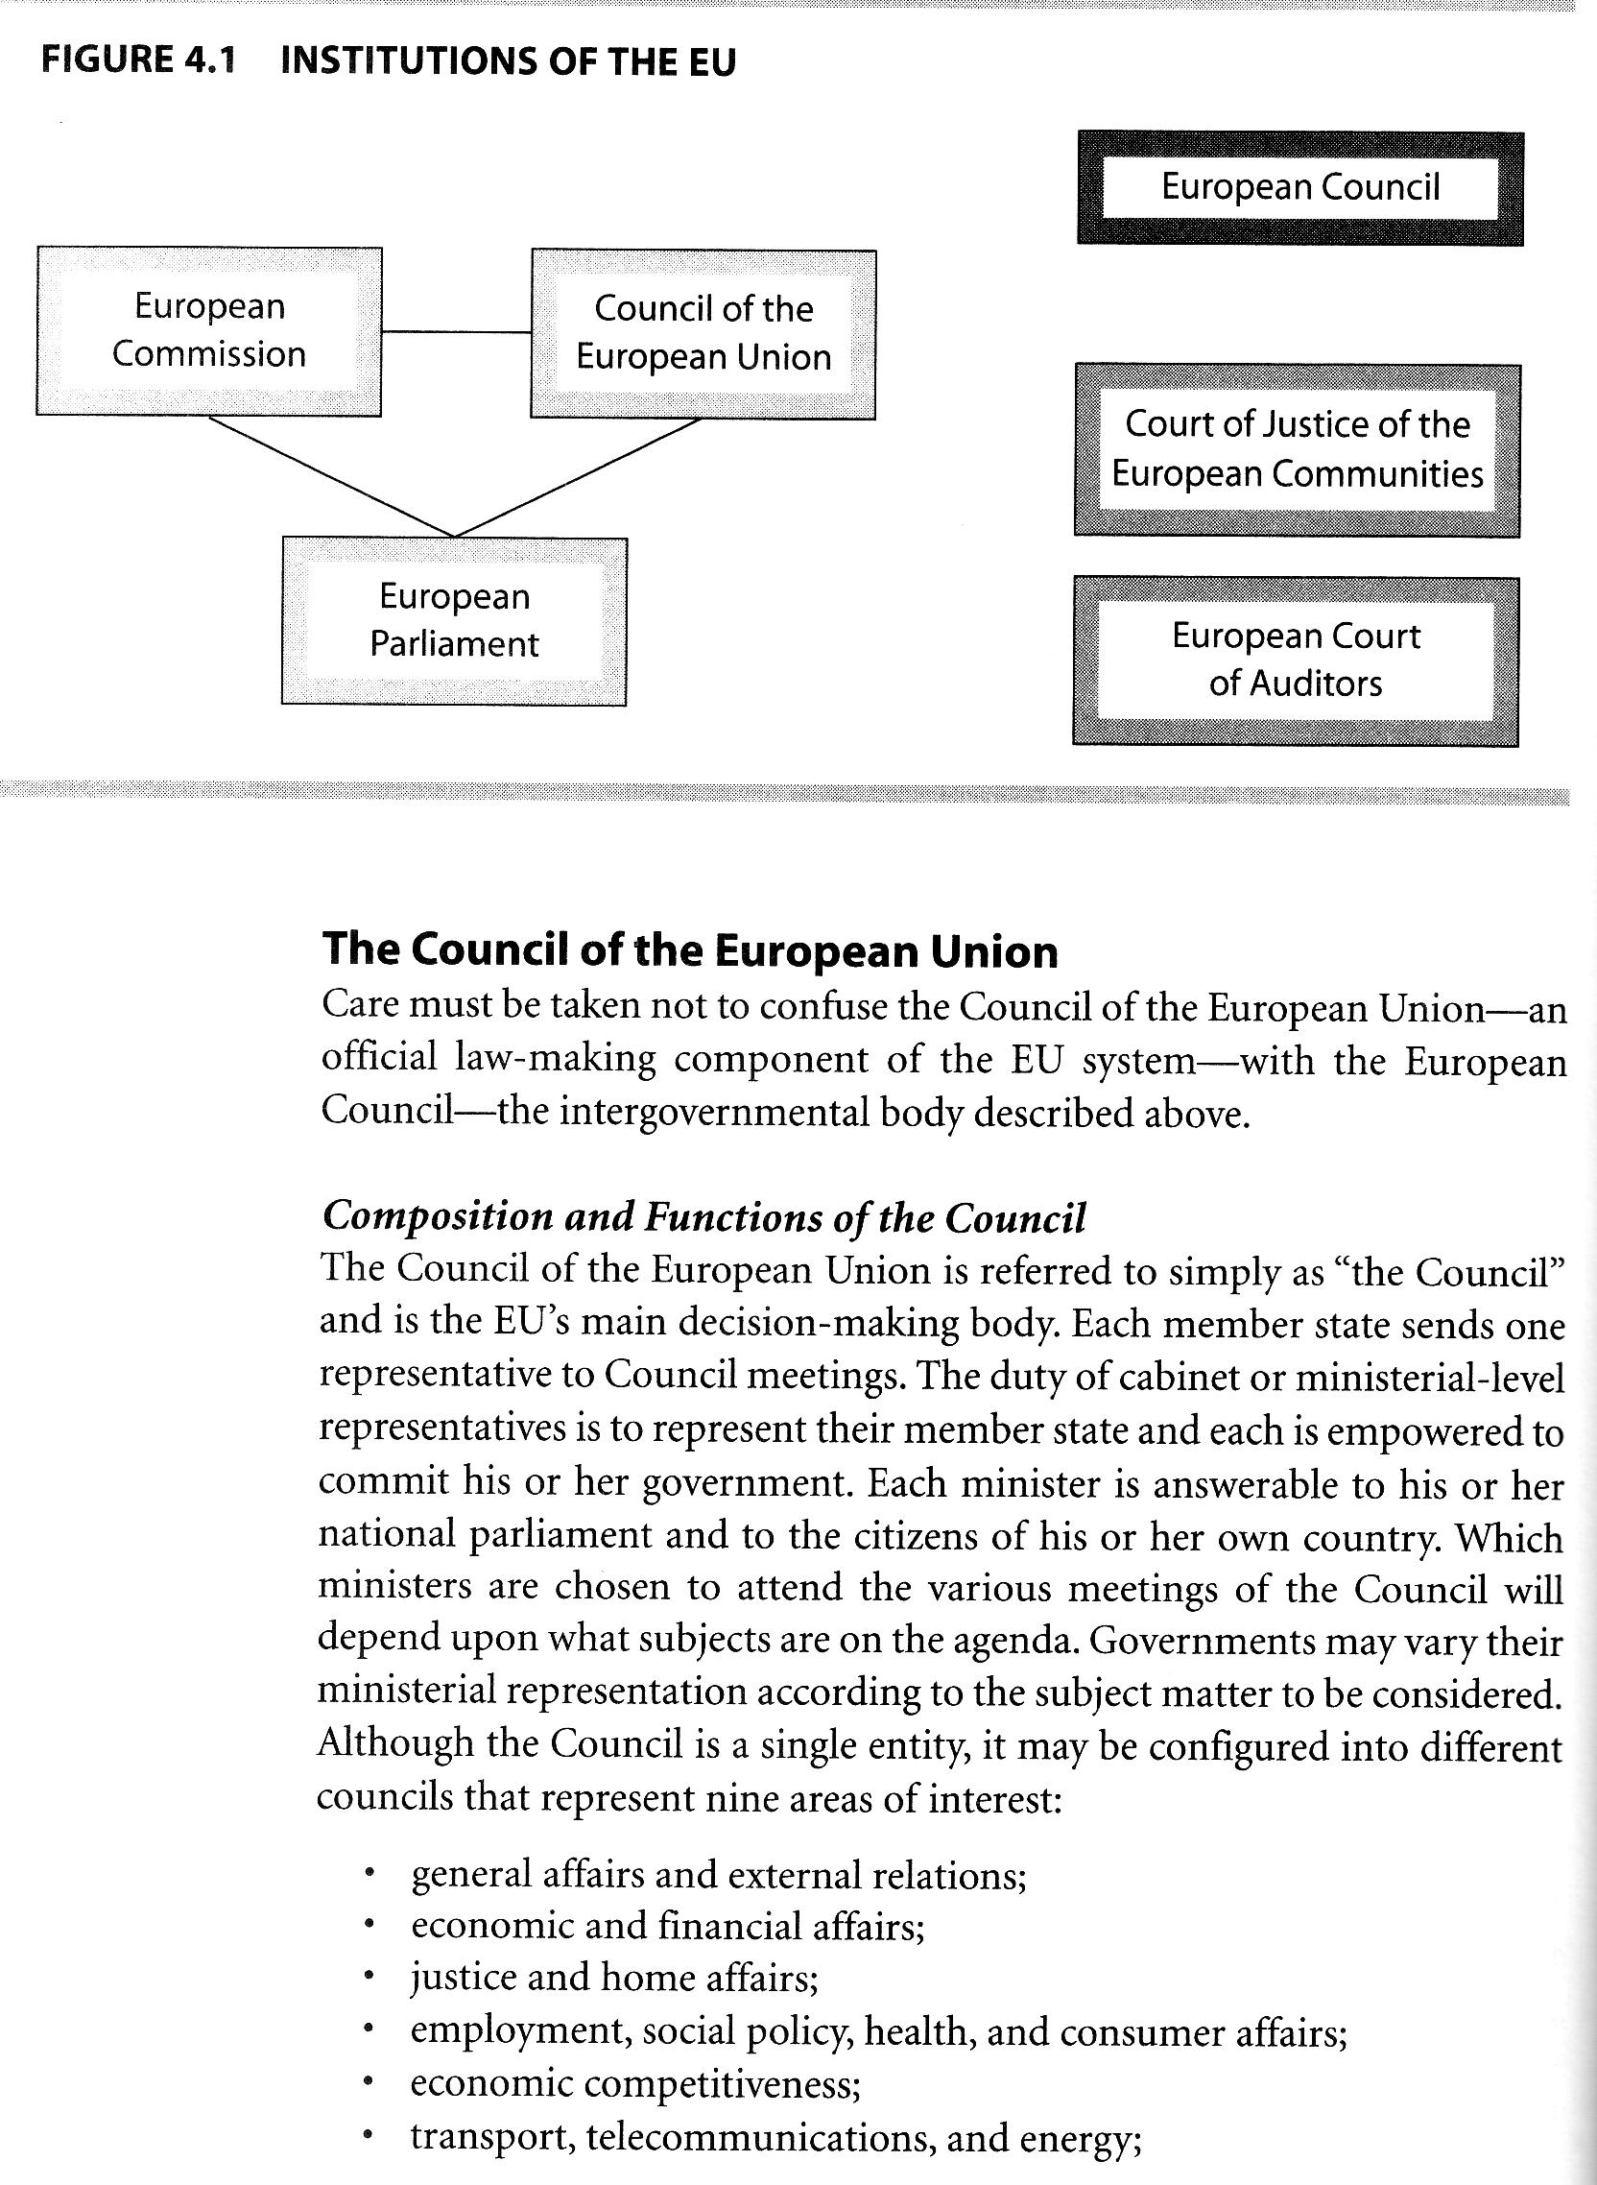
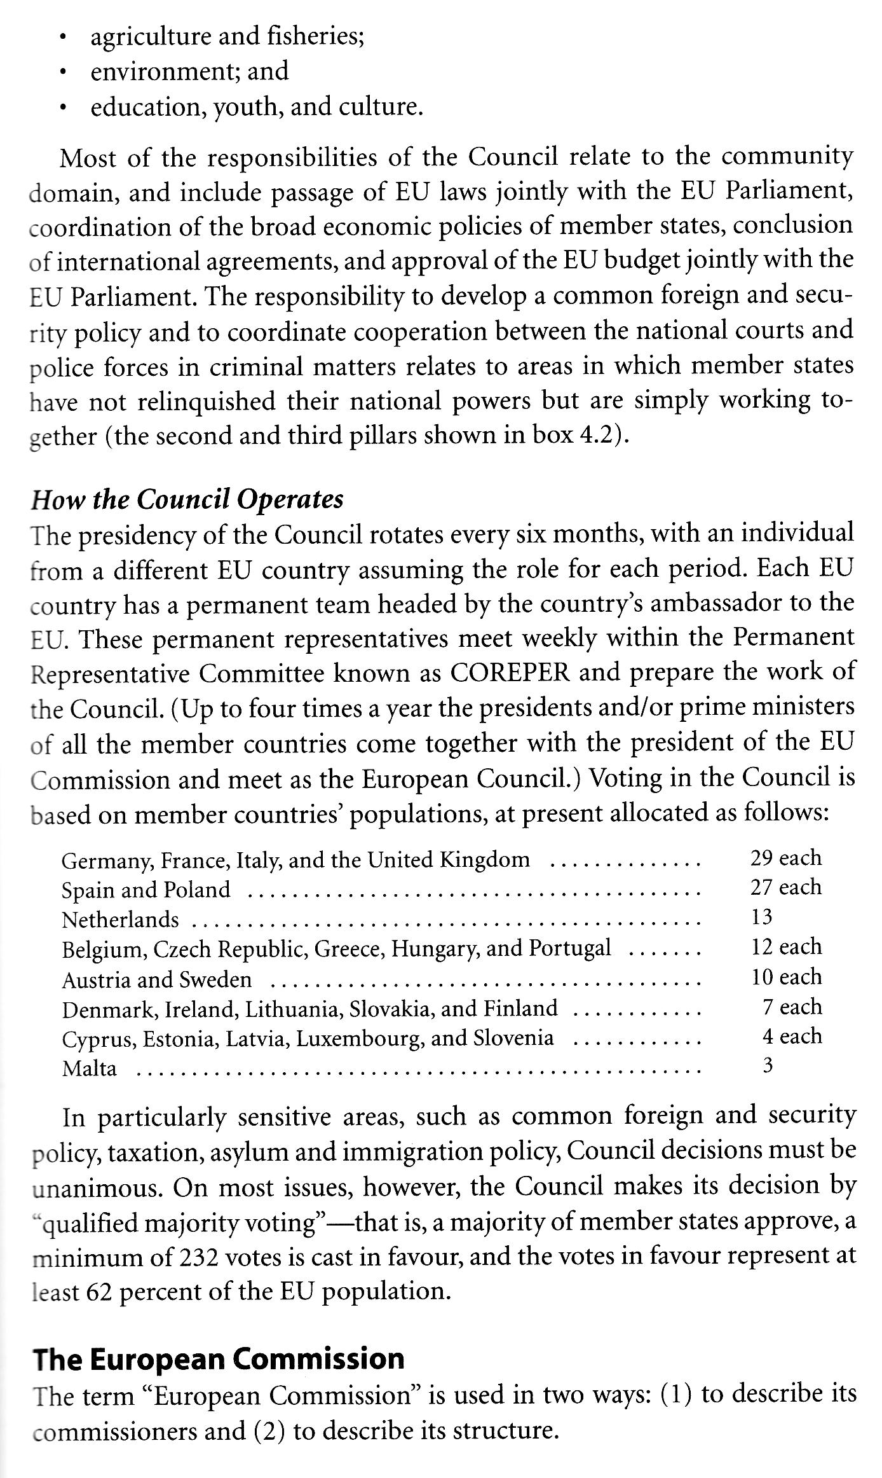
Commissioners are appointed by their home countries—at present, one per country. The commission has two functions: first, to draft proposals for new European laws; and second, to function as the EU's executive arm.

How does the EU make decisions?

Generally, the European Commission proposes new legislation, and it is the Council and Parliament that pass the proposal. The three main procedures are co-decision, consultation, and assent.

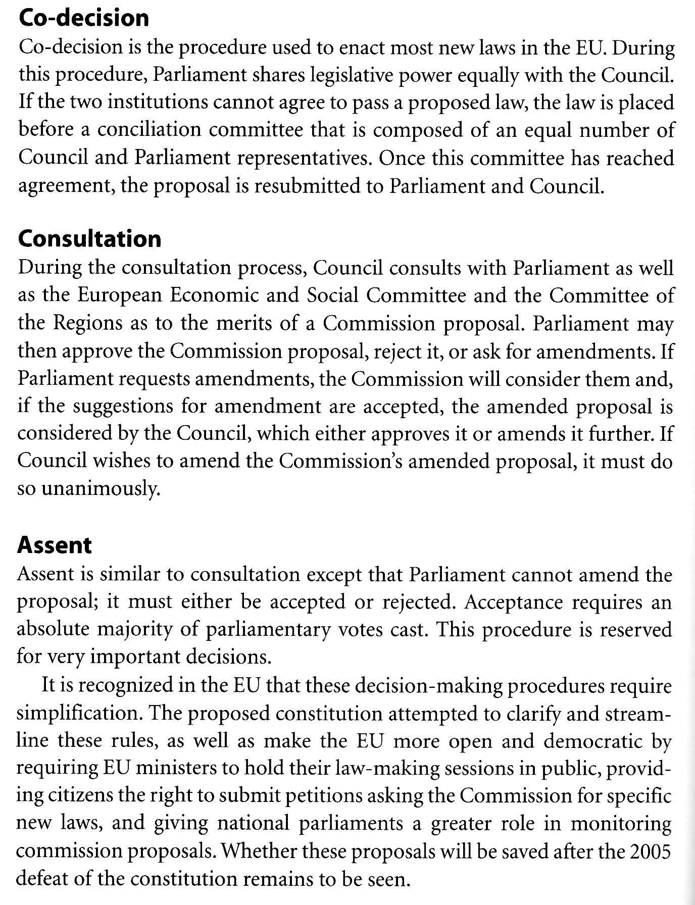
Harmonization of law in the EU.

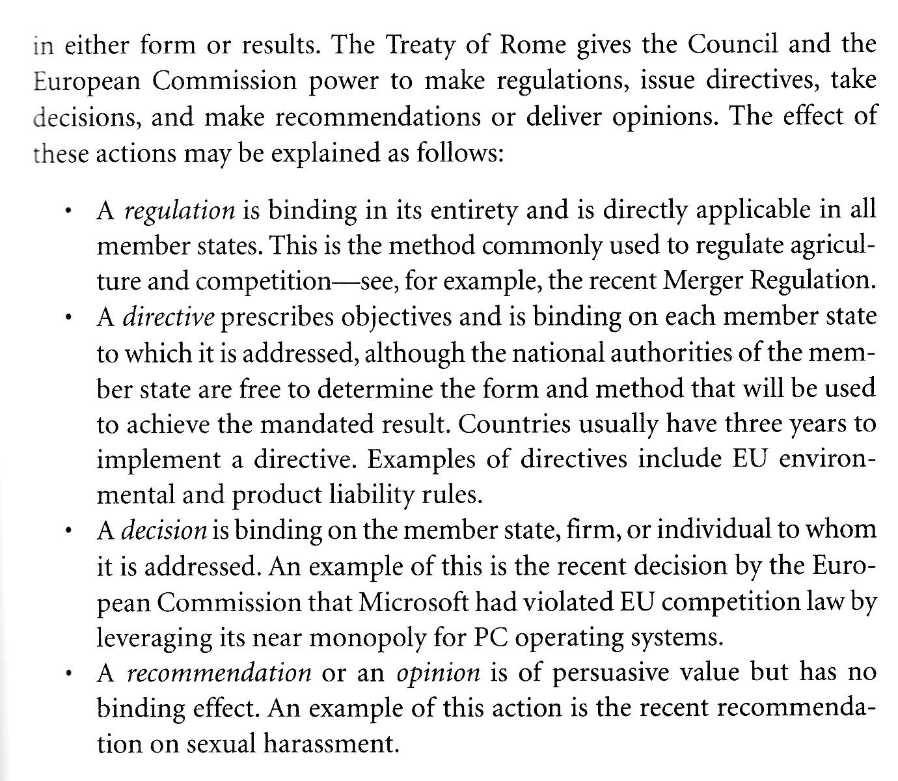
European Legal Provisions Relevant to Canadian Business

Competition Law

It involves such sensitive areas as national regulatory goals, market power, and political strategy.

These basic provisions are found in Article 85 and 86 of the Treaty of Rome and cover anti-competitive agreements between firms, abuse of dominant position, and company mergers.

Article 85 –concerted market behaviour

This provision prohibits concerted market practices which affect trade between Member States and which have as their object or effect the prevention, restriction or distortion of competition within the common market. Price fixing, limitations on production, market sharing, discrimination among parties, and tie-ins.

Article 85
1. The following shall be prohibited as incompatible with the common market: all agreements between undertakings, decisions by associations of undertakings and concerted practices which may affect trade between Member States and which have as their object or effect the prevention, restriction or distortion of competition within the common market, and in particular those which:
- directly or indirectly fix purchase or selling prices or any other trading conditions;
- limit or control production, markets, technical development, or investment;
- share markets or sources of supply;
- apply dissimilar conditions to equivalent transactions with other trading parties, thereby placing them at a competitive disadvantage;
- make the conclusion of contracts subject to acceptance by the other parties of supplementary obligations which, by their nature or according to commercial usage, have no connection with the subject of such contracts.

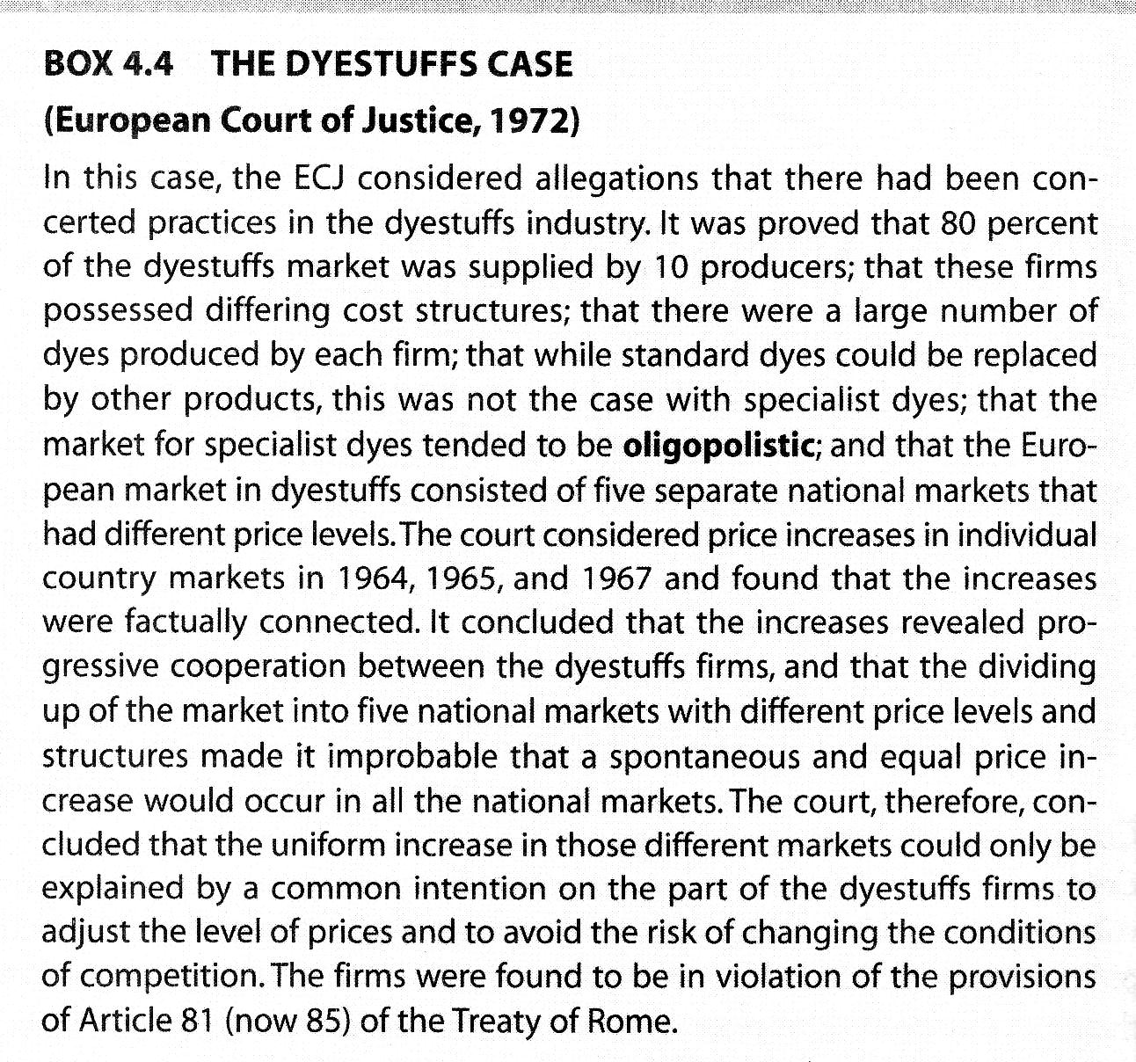
Preservation of the single European
One of the major goals of Article 85 is to preserve the single European market and to prevent its fragmentation into single country markets.

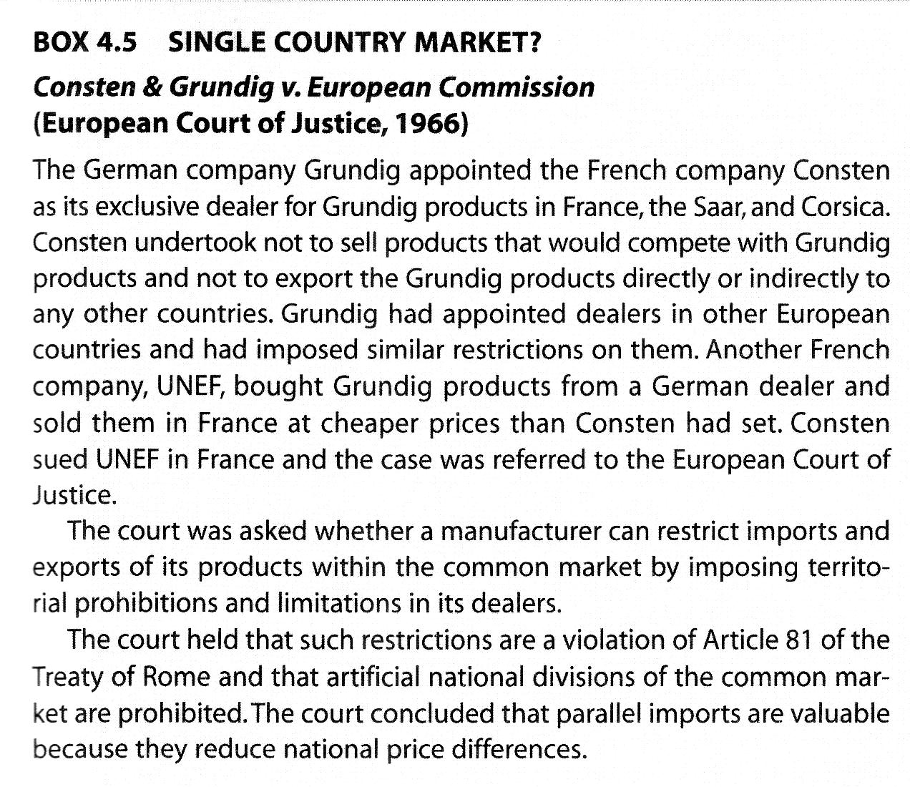
Extraterritorial Application of EU competition law
The EU asserts a right to enforce its competition policy beyond its own borders.
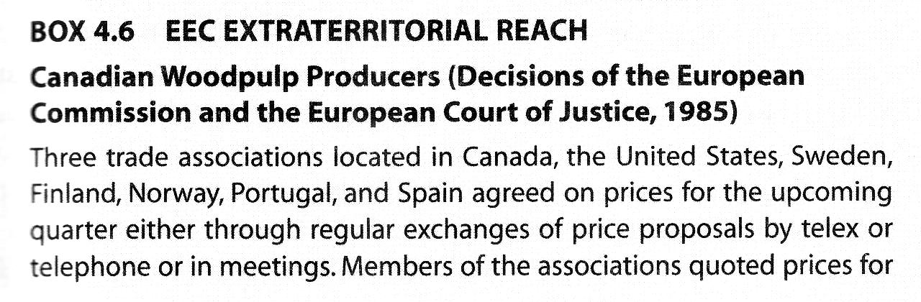
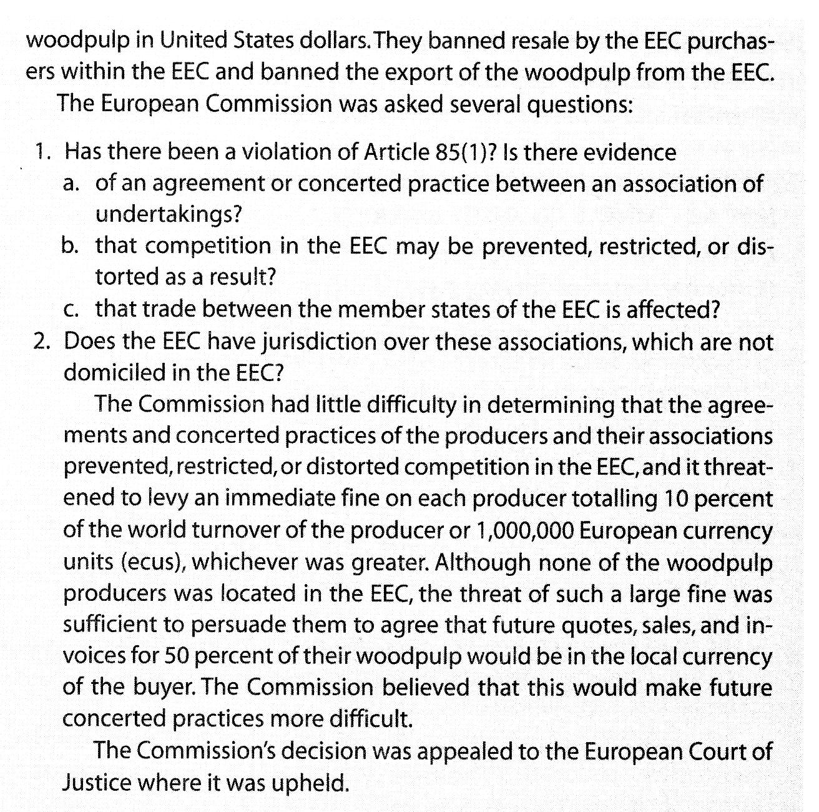
Control of Market Power. Article 86
Article 86 addresses the behaviour of a single, dominant firm that abuses its market power. The provision does not prohibit market power or monopoly in itself; it prohibits the abuse of market power.
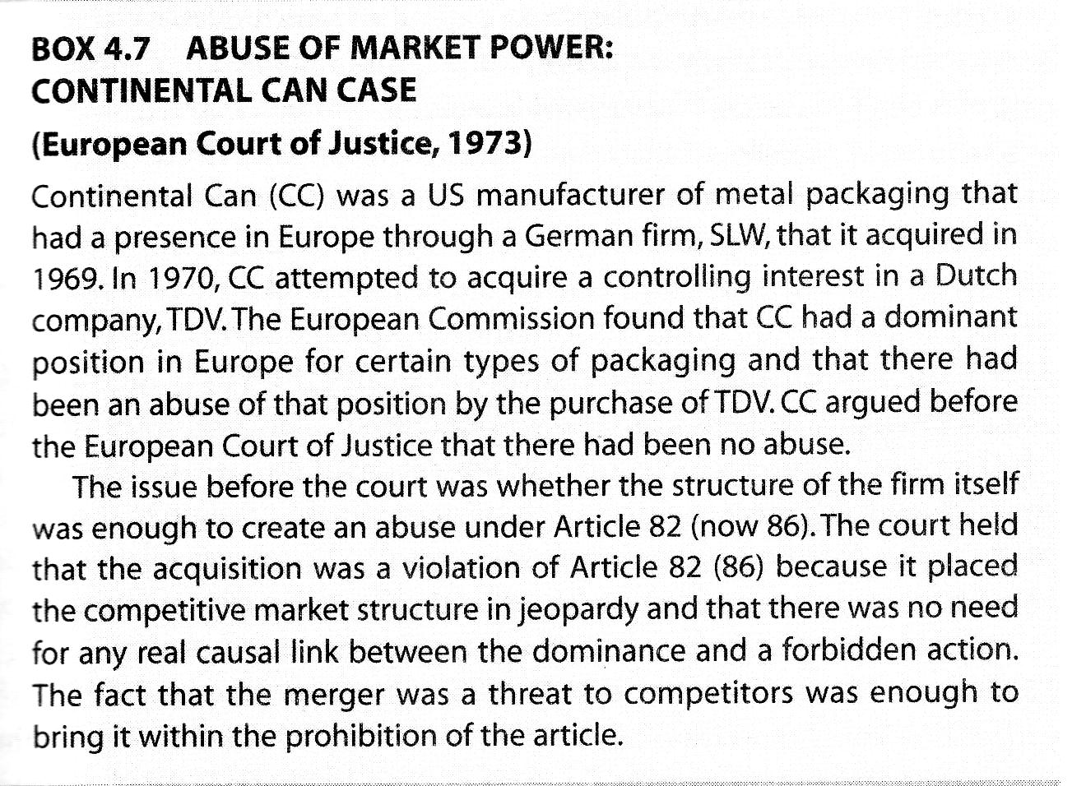
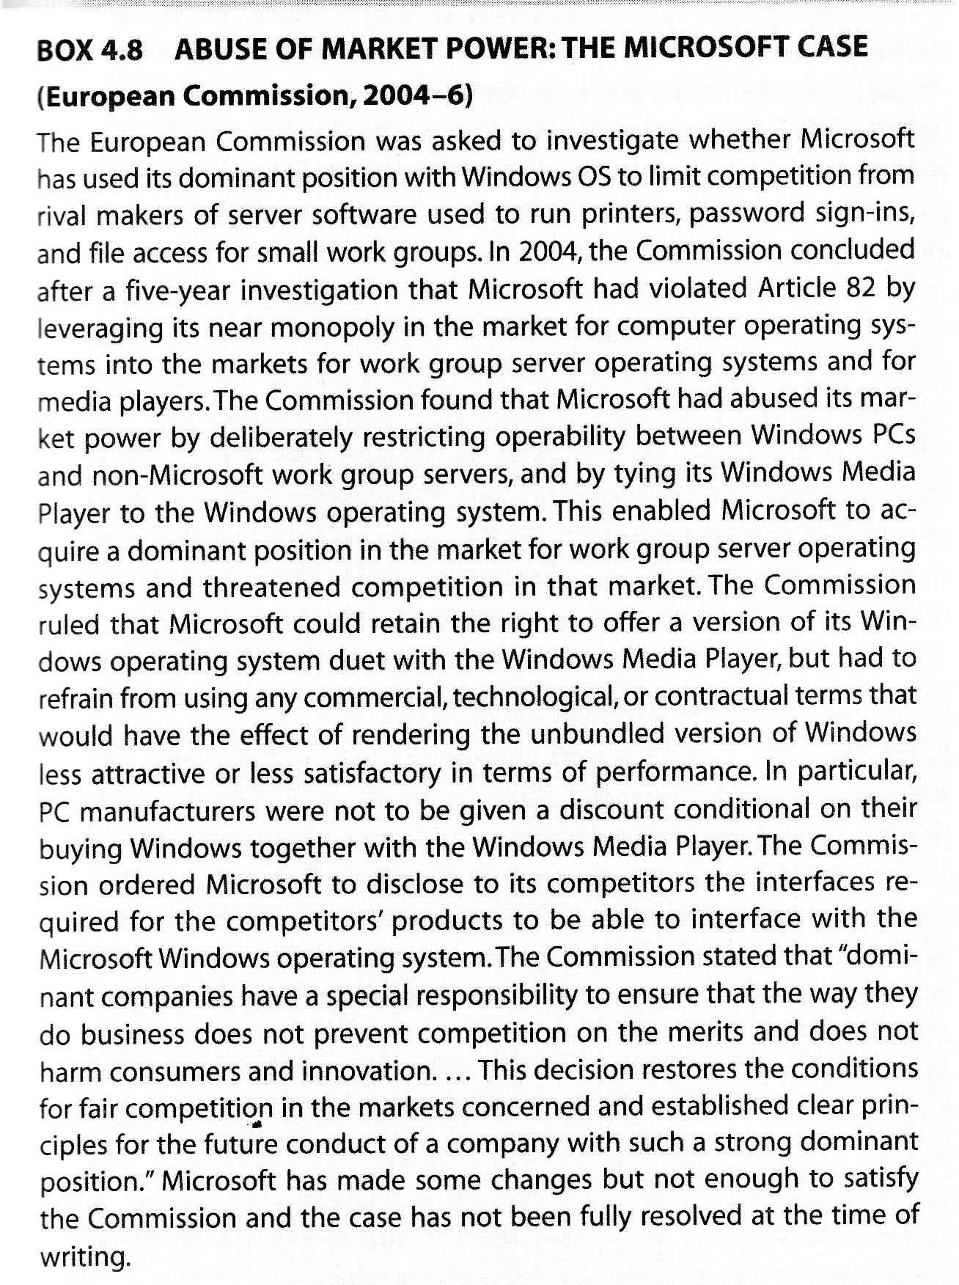
Review questions
- What is the difference between a free trade area and a customs union? Why do both appear to derogate from MFN principle?Why are they tolerated and approved by the WTO?
- Name the major institutions of the EU, and briefly describe their composition and function?
- What are the three main prohibitions provided by EU competition law and where is the law relating to these found?
- What is the significance of the Grundig case and what does it remind us about EU competition law?

Cases
1)
What are the legal consequences of payments made under a rule of national law which is invalid as it is against European law?
3.d.1 San Giorgio (1983)
The first leading case in this area is Amministrazione delle Finanze dello Stato v. SpA San Giorgio.(109) San Giorgio was required to pay health inspection charges which were levied contrary to Community law when it imported dairy products from other Member States. It then reclaimed the charges paid. The Court, referring also to earlier case law, ruled that when, contrary to the EC Treaty, charges having an equivalent effect to customs duties are levied or internal taxes are discriminatorily applied, repayment of these charges or taxes is a direct consequence of this prohibition. Although repayment will have to take place in accordance with the conditions as to both substance and form as laid down in the laws of the Member States, the conditions may not be less favourable than those relating to repayment of domestic charges and they must not make repayment virtually impossible either. Even if reimbursement of all or a substantial number of unduly paid taxes would not be allowed in a particular Member State, still the citizen is entitled to repayment of charges and taxes not levied in conformity with Community law. As such, this is a clear expression of the right of European citizens to judicial protection when their rights, given to them by the European treaties, have been violated. In the words of the Court, this is a 'consequence of, and an adjunct to, the rights conferred on individuals by the Community provisions prohibiting charges having an effect equivalent to customs duties or, as the case may be, the discriminatory application of internal taxes'.(110) But this is the public law side of the coin. The private law side is that the Member State which levied the charge or imposed the tax, received money without legal ground. In other words, the Member State would be unjustifiedly enriched. Also for this reason, the citizen is given the right to repayment. This private law side of the decision becomes even clearer when one reads the other considerations of the Court in this case. The Court states that repayment of charges or taxes does not violate citizens' rights if repayment were to lead to unjustified enrichment of the citizen. This could happen in situations where the charge or tax has been incorporated in the price and is passed on to other persons (e.g. consumers), as long as this is what actually happened. The burden of proof as laid down in the laws of the Member States may, however, not have the effect of 'making it virtually impossible or extremely difficult'(111) to reclaim the charges. As a consequence, the burden of proof in regard to the passing of the charges and duties to other persons must not fall on the citizen reclaiming money and the evidence which the citizen must put forward may not be limited to, e.g., documentary evidence.
The end result of this line of reasoning is that taxpayers can reclaim money paid, that the burden of proof is on the state which imposed the duties, charges or taxes, but if the state can prove that the duties were passed on to other persons, the citizen loses his claim - otherwise this citizen would be unjustifiedly enriched. The idea behind this reasoning is that in such a situation others might be able to reclaim the duties, but also that in case others cannot reclaim either, on balance it is fairer that the state keeps the proceeds of such duties than a citizen.

2)
1.2 V.GB26
49. In a judgement of 14 May 1997, the Court of First Instance considered a set of agreements
between five Dutch wholesalers and VBA, a co-operative. Under the terms of these so-called Cultra
agreements, the wholesalers undertook to purchase flowers exclusively from VBA’s members, for
subsequent resale to retailers. Assessing whether the agreements complied with Article 85.1 of the Treaty
of Rome, the Court held that the obligation of exclusivity concerned only five wholesalers and was not
binding on Dutch retailers and that hence the theory of cumulative effect did not apply. Consequently, it
concluded that the exclusivity obligation did not contribute significantly to any compartmentalisation of
the Dutch market.

3)

a) Case of Walrave v UCI (ECJ, 12.12.74, case no. C-36/74)
Free movement of workers within the common market; discrimination based on
nationality within the common market; application of these principles to the practice of
sport in certain circumstances; applicability of such principles to sports association
regulations
The Facts:
Two Dutch nationals, Mr Walrave and Mr Koch, who regularly participated as
pacemakers in medium-distance cycle races known as "Stayers", regarded a provision of
the International Cycling Union (UCI) regulations, according to which a pacemaker
should be of the same nationality as his rider, to be discriminatory.
In this particular sport, each cyclist follows his pacemaker, who rides a motorbike.
Walrave and Koch brought an action against the UCI and the Dutch and Spanish cycling
federations. The federations appealed to the Utrecht District Court (Netherlands). In a
ruling of 15 May 1974, the Court in turn referred the case to the European Court of
Justice (ECJ) under Article 177 of the EEC Treaty, submitting a number of preliminary
questions concerning the interpretation of Articles 7.1, 48 and 59.1 of the EEC Treaty
and Council Regulation No.1612/68 of 15 October 1968 on freedom of movement for
workers within the Community.
Questions for a preliminary ruling:
The basic question concerned whether the aforementioned texts should be interpreted as
being incompatible with the UCI regulation relating to medium-distance world cycling
championships behind motorcycles, according to which "the pacemaker must be of the
same nationality as his rider".
The Law:
1. The ECJ began by examining whether Community law could apply to sport. It
explained that the practice of sport was only subject to Community law insofar as it
constituted an economic activity. To this effect, it gave the following reasons:
- having regard to the objectives of the Community, the practice of sport was only
subject to Community law insofar as it constituted an economic activity within the
meaning of Article 2 of the Treaty;
Elr, Recueil JP 01.02 6
- the prohibition of discrimination based on nationality, set out in Articles 7, 48 and 59
of the EEC Treaty, did not affect the composition of sports teams, in particular
national teams, the formation of which was a question of purely sporting interest and
as such had nothing to do with economic activity.
2. The ECJ then explained that Community law, in this case the prohibition of
discrimination based on nationality, applied not only to public authorities, but also to the
rules of private sports associations. This principle applied to Articles 48 (workers) and 59
(services) of the Treaty:
- prohibition of discrimination based on nationality not only applied to the action of
public authorities, but extended likewise to rules of any other nature aimed at
regulating in a collective manner gainful employment and the provision of services.
3. The ECJ also explained that the rule on non-discrimination applied to all legal
relationships which could be located within the territory of the community.

A tie-in is an authorized product based on a media property a company is releasing, such as a movie or video/DVD, computer game, video game, television program/television series, board game, web site, role-playing game or literary property. Tie-ins are used primarily to generate additional income from that property and promote its visibility.

