Valuation of inventories

The sale of inventory at a price greater than total cost is the primary source of income for manufacturing and retail businesses.

Inventories are asset items held for sale in the ordinary course of business or goods that will be used or consumed in the production of goods to be sold.

A merchandising business ordinarily purchases its merchandise in a form ready for sale. It reports the cost assigned to unsold units at the end of the period as merchandise inventory. Only one inventory account, Merchandise Inventory, appears in the financial statement.

Determining inventory quantities

Perpetual inventory system: purchases and sales of goods are recorded directly in the inventory account as they occur. No purchases account is used because the purchases are debited directly to inventory.

Periodic inventory system: purchases account is used to record acquisitions. The balance in the inventory account is unchanged during the period. At the end of the accounting period, a closing entry is made which debits the inventory account for the ending inventory amount and credits the inventory account for the beginning inventory amount.

Cost of goods is determined by using the following equation:
beginning inventory + net purchases – ending inventory.
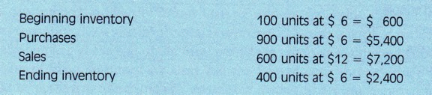
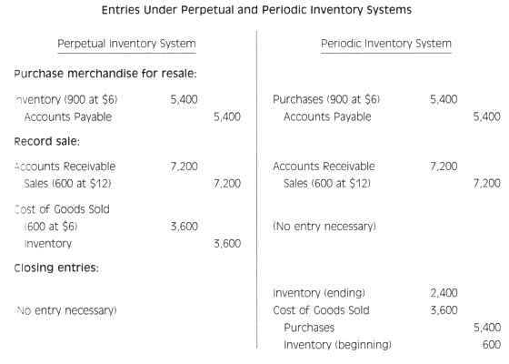

Basic issues in inventory valuation

The valuation of inventories can be a complex process that requires determination of

- the physical goods or items to be included in inventory
- the cost to be included in inventory
- the cost flow assumption to be adopted

Cost flow assumptions: a framework for analysis

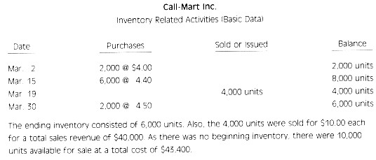
The problem is which cost or costs should be assigned to the 6,000 units of ending inventory and the 4,000 units sold. The solution depends on what one wishes to accomplish. There are several acceptable alternative cost flow methods.

These methods are based on different assumptions and accomplish different objectives. A suggested approach to selecting a method is as follows:

- identify possible objectives to be accomplished
- know the different acceptable methods, their assumptions, and how they work
- evaluate the advantages and disadvantages of the different methods for achieving the objectives
- choose the method appropriate to the situation and the objectives to be accomplished.

Objective of inventory valuation

The following general objectives are often associated with making a decision as to which inventory cost flow method to choose;

- to match expenses (cost of goods sold) realistically against revenue.
- to report inventory on the balance sheet at a realistic amount.
- to minimize income taxes.

Cost flow methods of inventory valuation

The cost flow matches the physical flow of goods.
First-in, First-out (FIFO)

The FIFO method assigns costs to goods sold in the order in which costs were incurred, that is, the cost of the first good purchased is assumed to be the cost of the first sold.

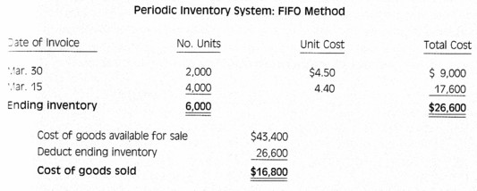

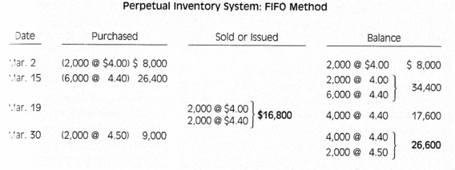

When FIFO is used, the ending inventory and cost of goods for a period would be the same whether a periodic or perpetual system is employed.
An objective of FIFO is to approximate the physical flow of goods. The FIFO method very nearly represents specific identification.

At the same time it does not permit manipulation of income because the enterprise is not free to pick a certain cost to be charged as an expense.

Another advantage is that the ending inventory amount is close to its current costs.

The ending inventory amount will be composed of the cost of the most recent purchases.

The basic disadvantage of this method is that current costs are likely not matched against current revenues on the income statement. The oldest costs are charged against current revenues on the income statement, which can lead to distortions in gross profit and net income.
Last-in, First-out (LIFO)

The LIFO method assigns costs on the assumption that the cost of the most recent purchase is the first cost to be charge to cost of goods sold.

Using the data for Call-Mart, the assumption would be made that the 4,000 units withdrawn consisted of the 2,000 units purchased on March 30 and 2,000 of the 6,000 units purchased on March 15. Therefore, the cost of the ending inventory of 6,000 units would be assumed to come from the cost of any beginning inventory and then the earliest purchases in the period.

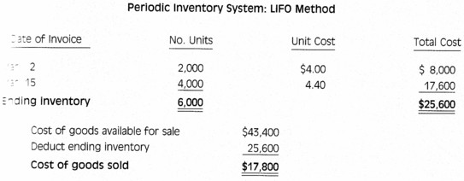
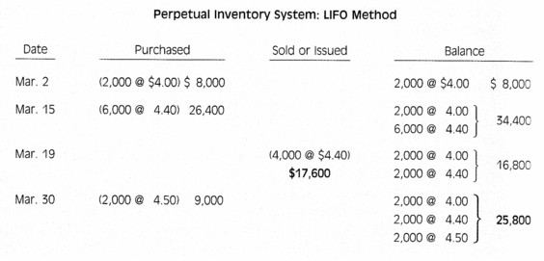

Major advantages of LIFO

Matching. In LIFO, the more recent costs are marched against current revenues to provide what may be viewed as a more realistic measure of current earnings.

Inventory profits occur when the inventory costs matched against sales are less than the replacement cost of the inventory. The cost of goods sold therefore is perceived to be understated and profit is overstated.

By using LIFO more recent costs are matched against revenues and inventory profits are thereby reduced.

Major disadvantages of LIFO

Reduced earnings: lower profits reported under the LIFO method, relative to other methods.

Inventory understated: the inventory valuation on the balance sheet is normally outdated because the oldest costs remain in inventory.

Physical flow: LIFO does not approximate the physical flow of the items.

Not acceptable for TAX purposes.
Which method to select?

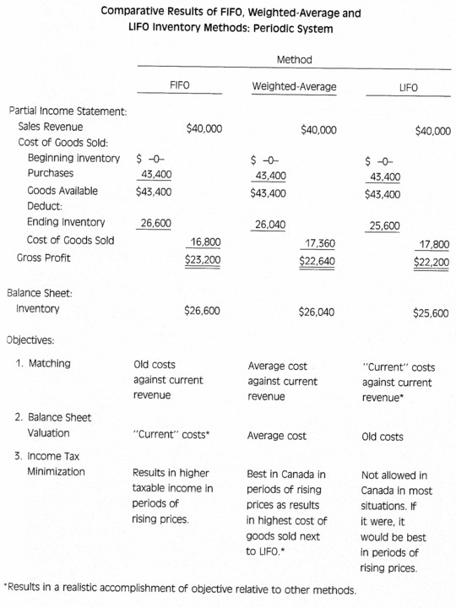
Examples
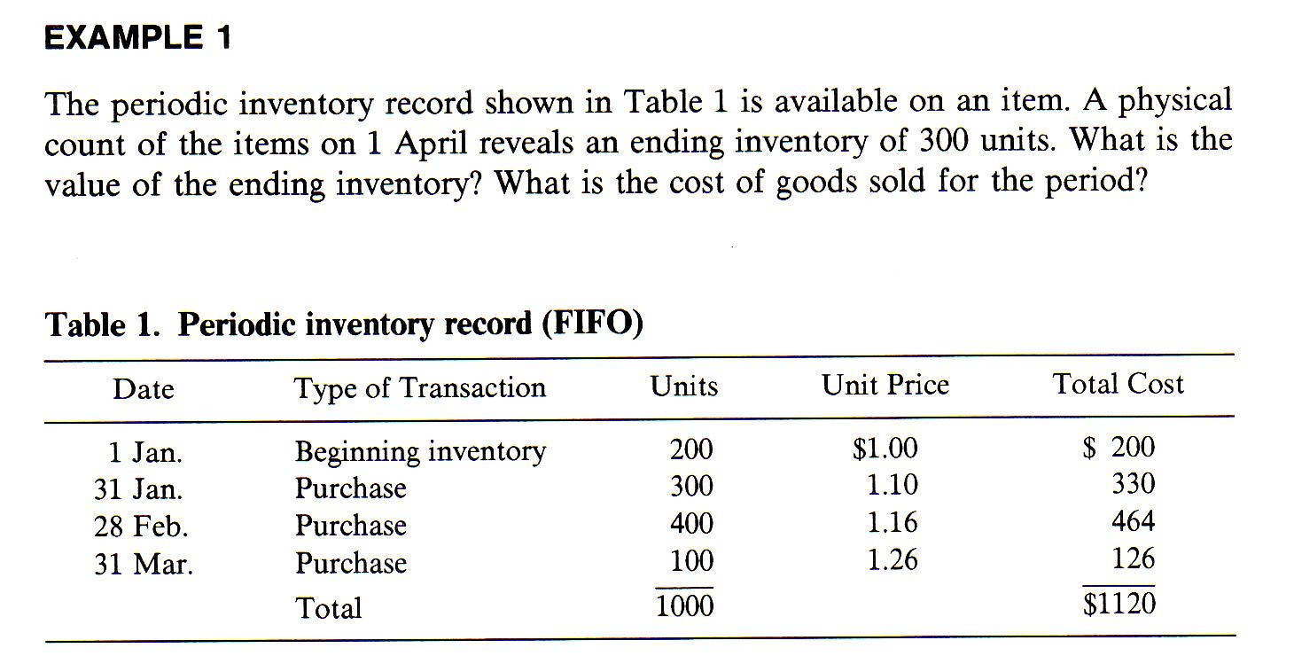

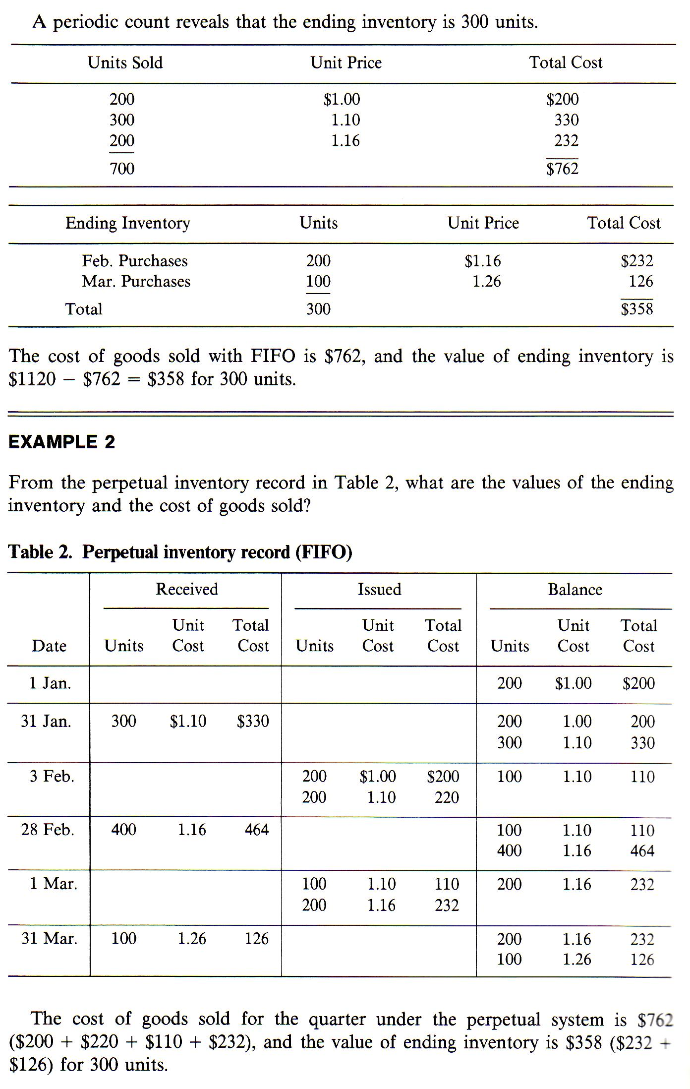
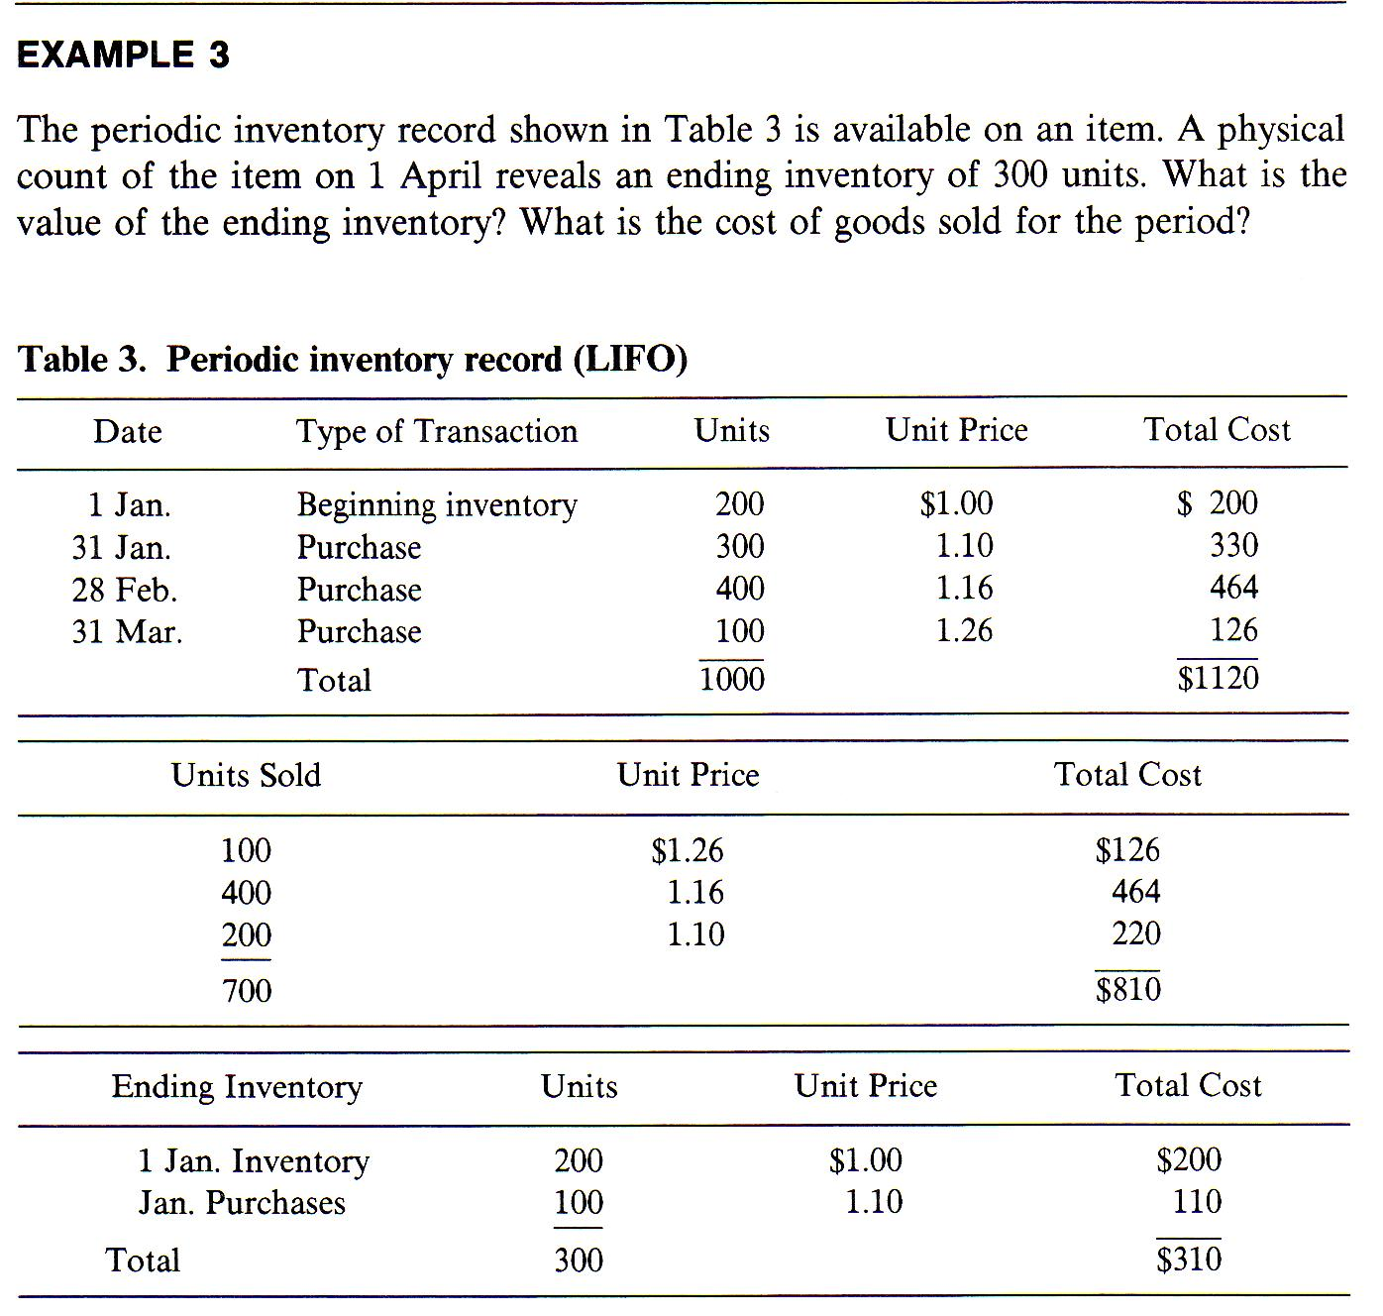
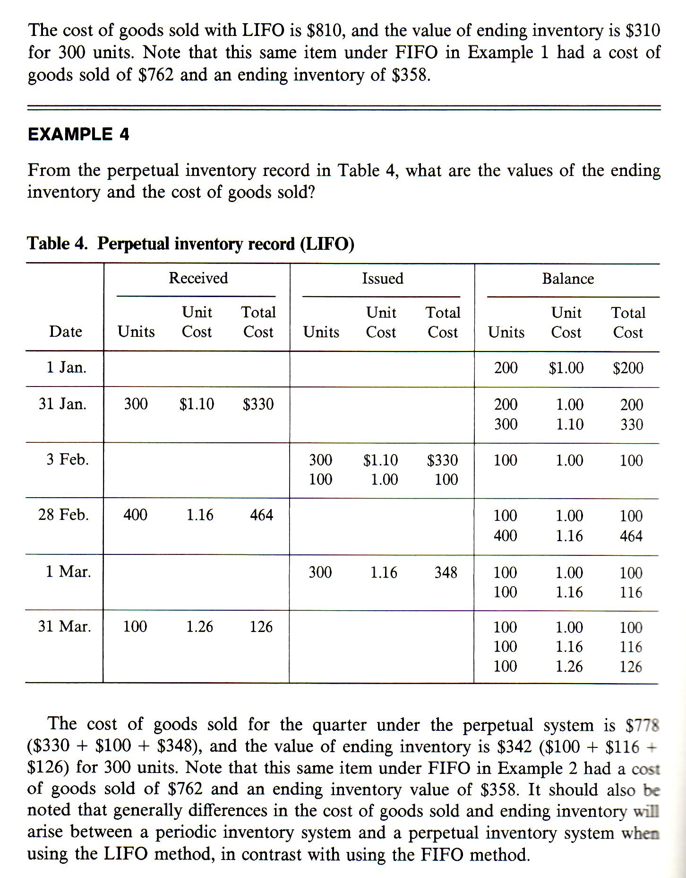
Example average
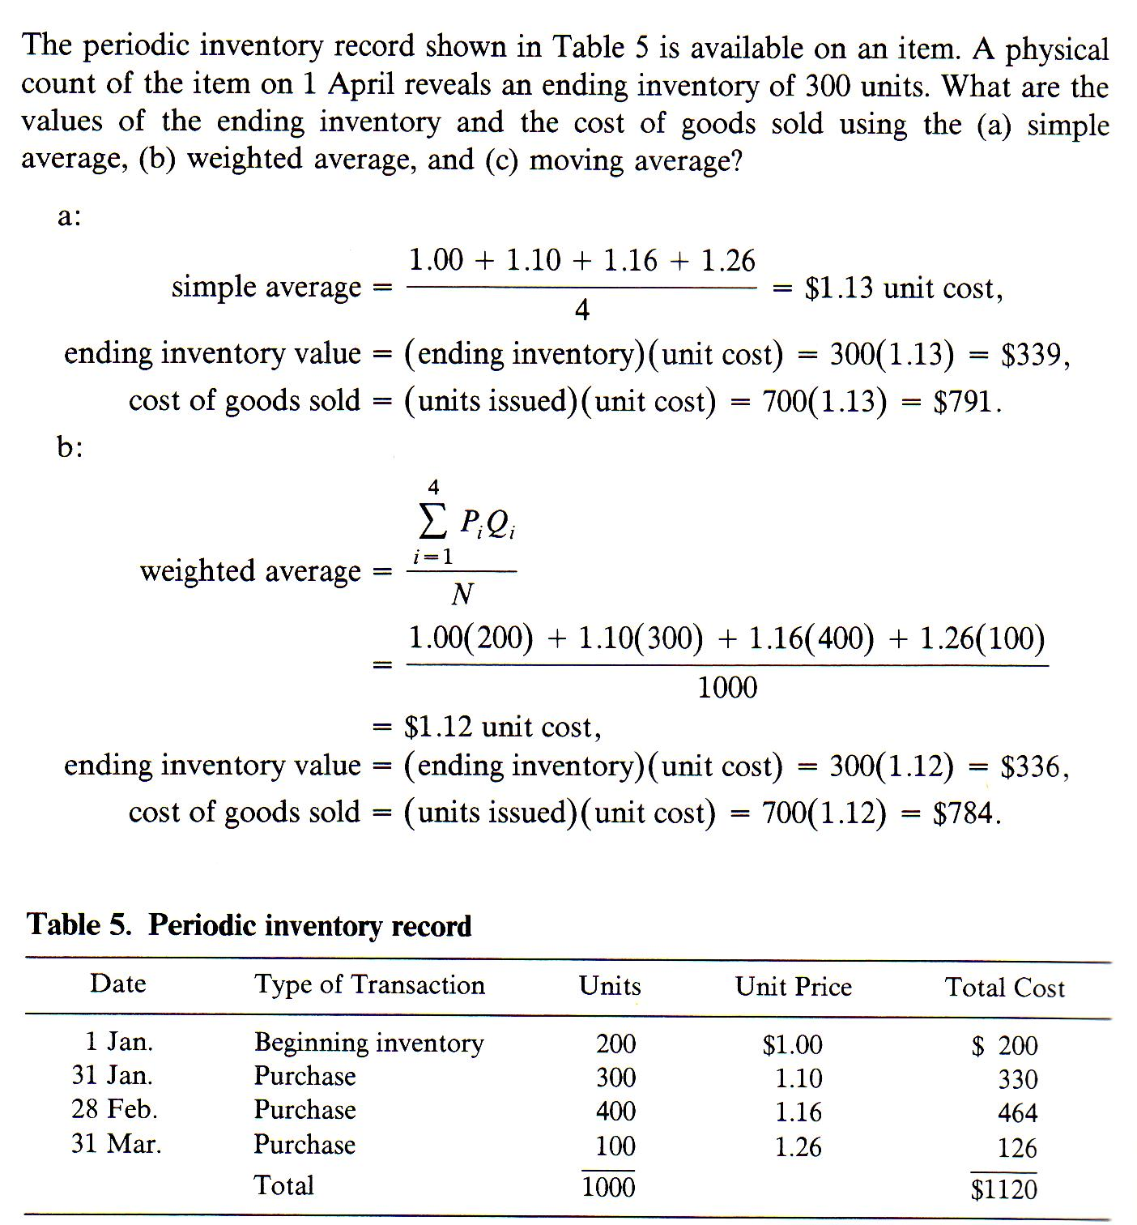
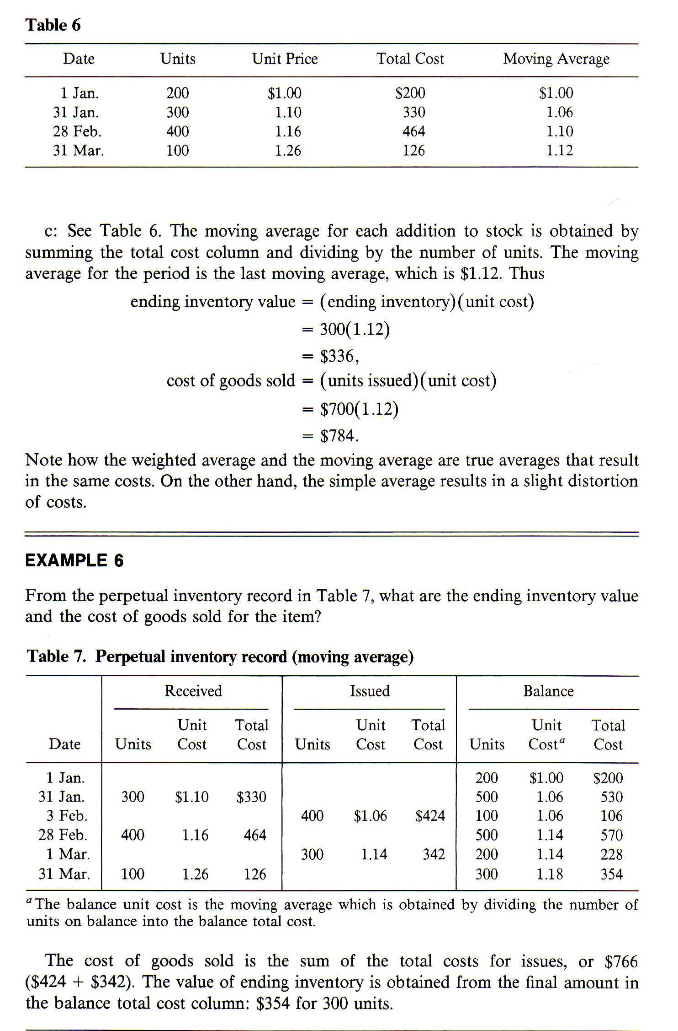
Case
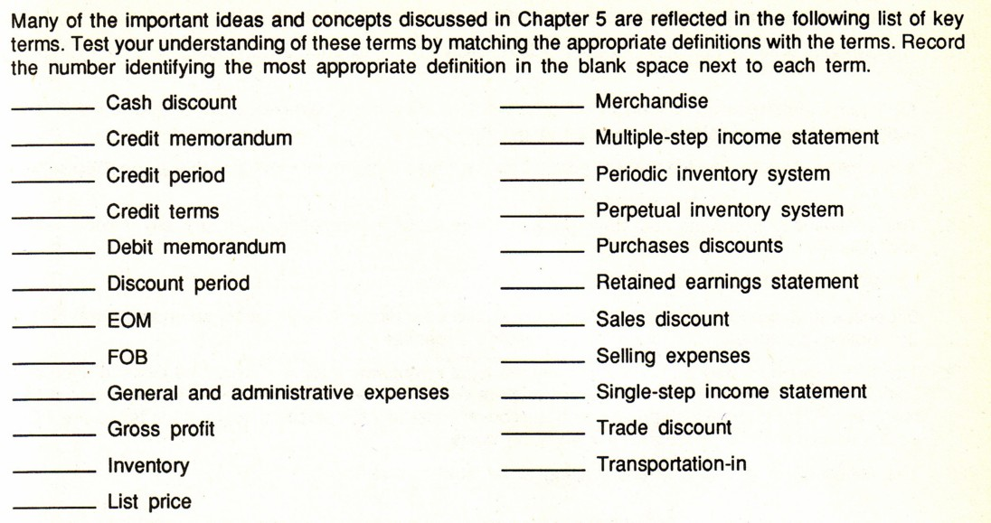

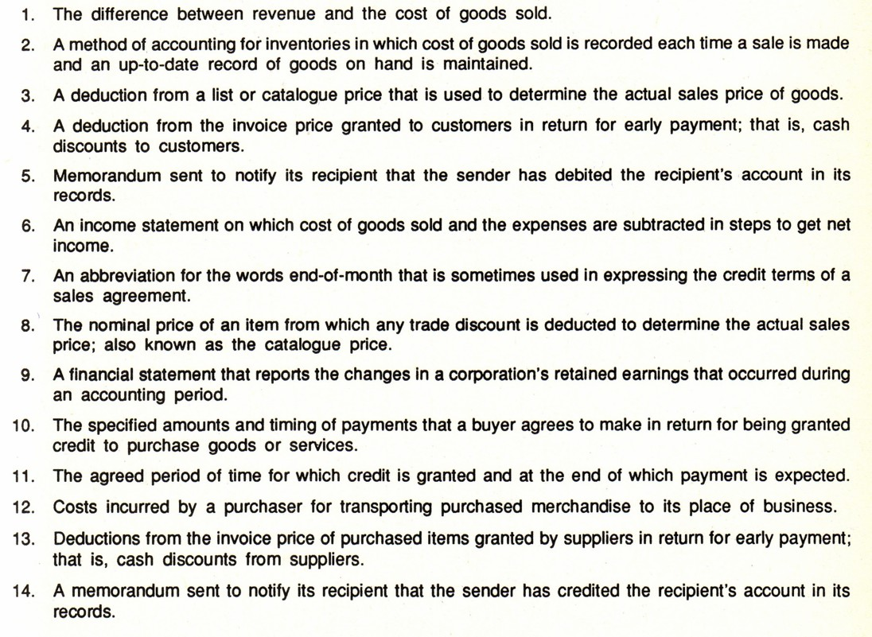
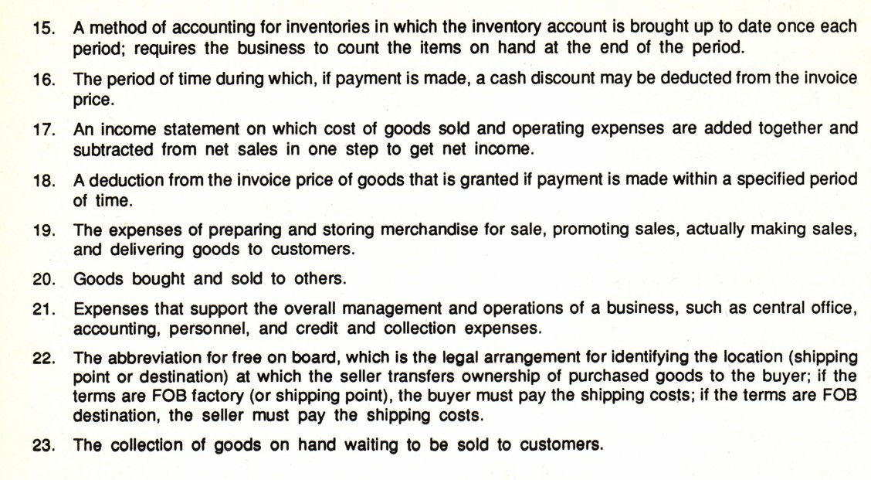
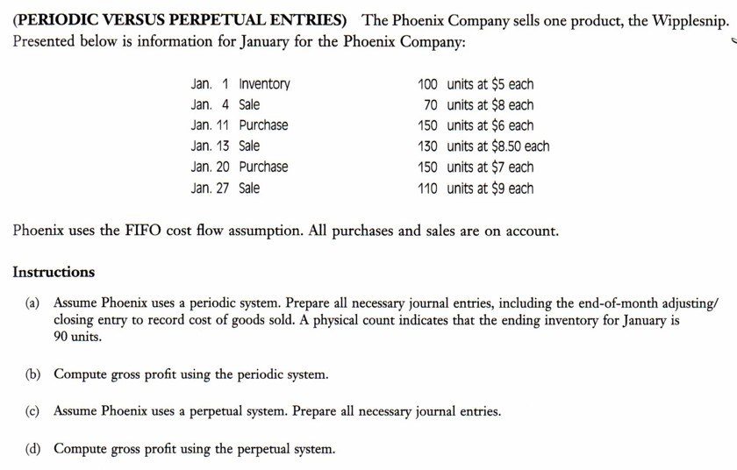
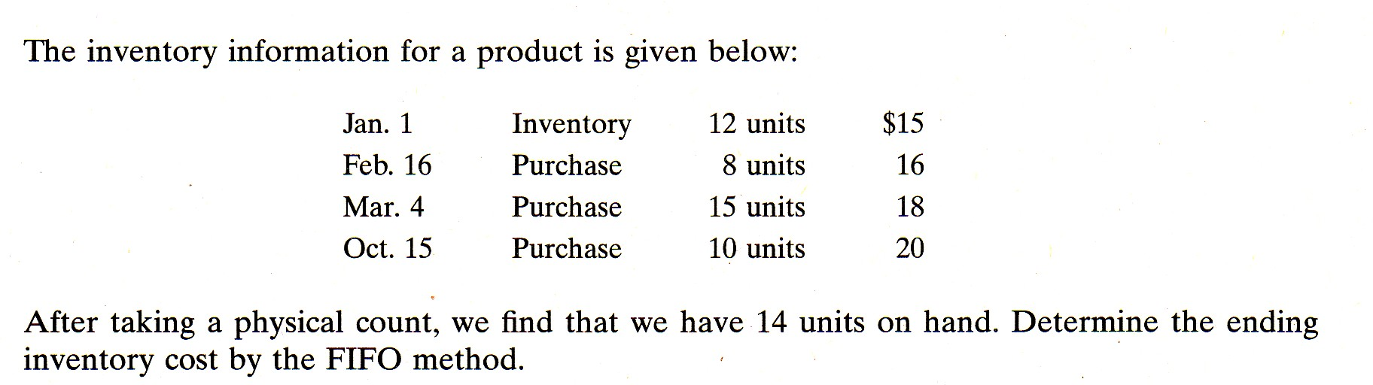

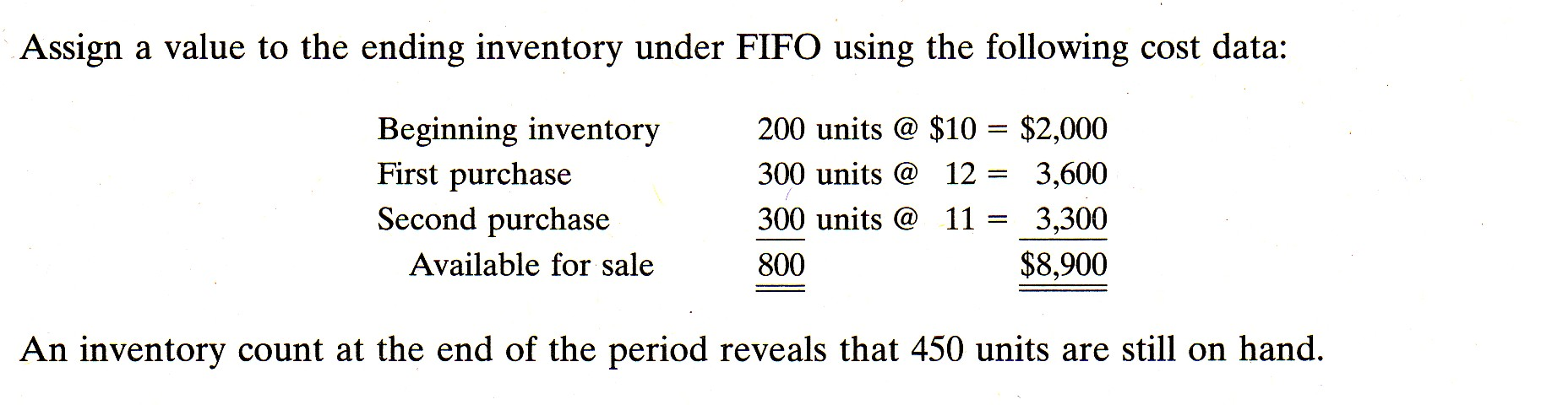
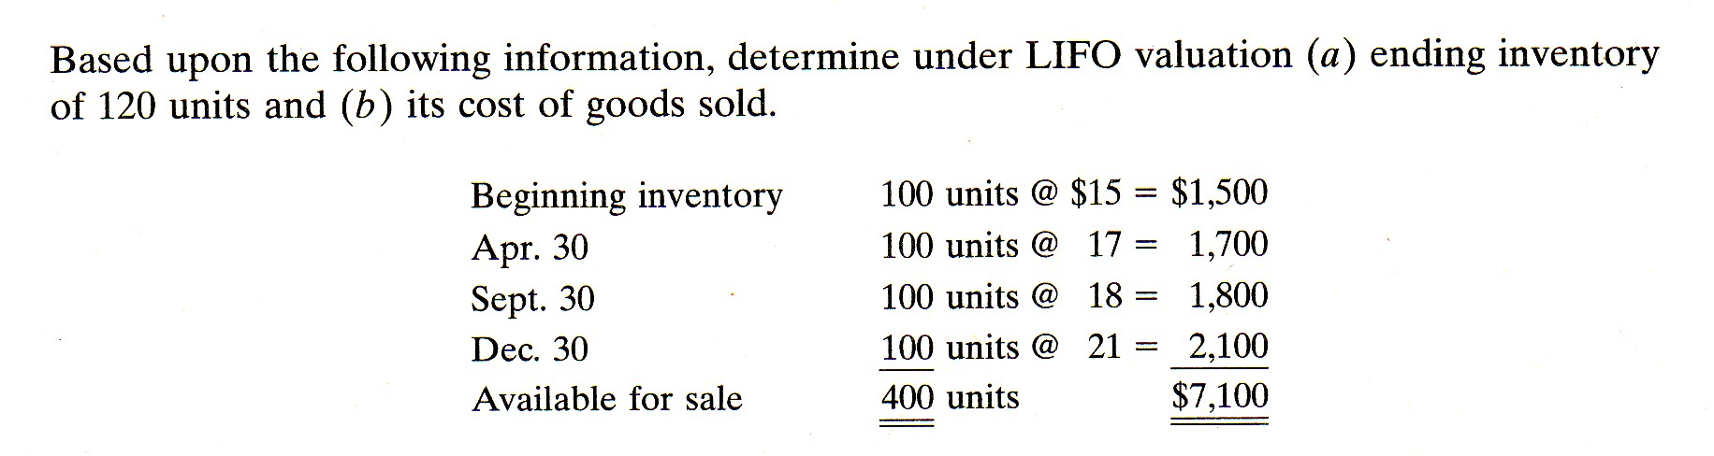

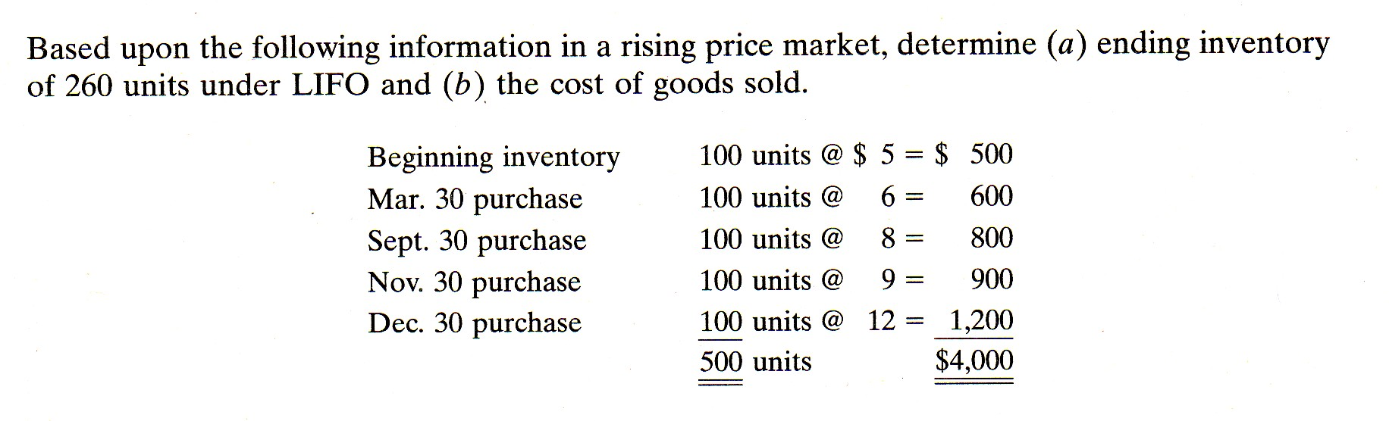

Extra Problems
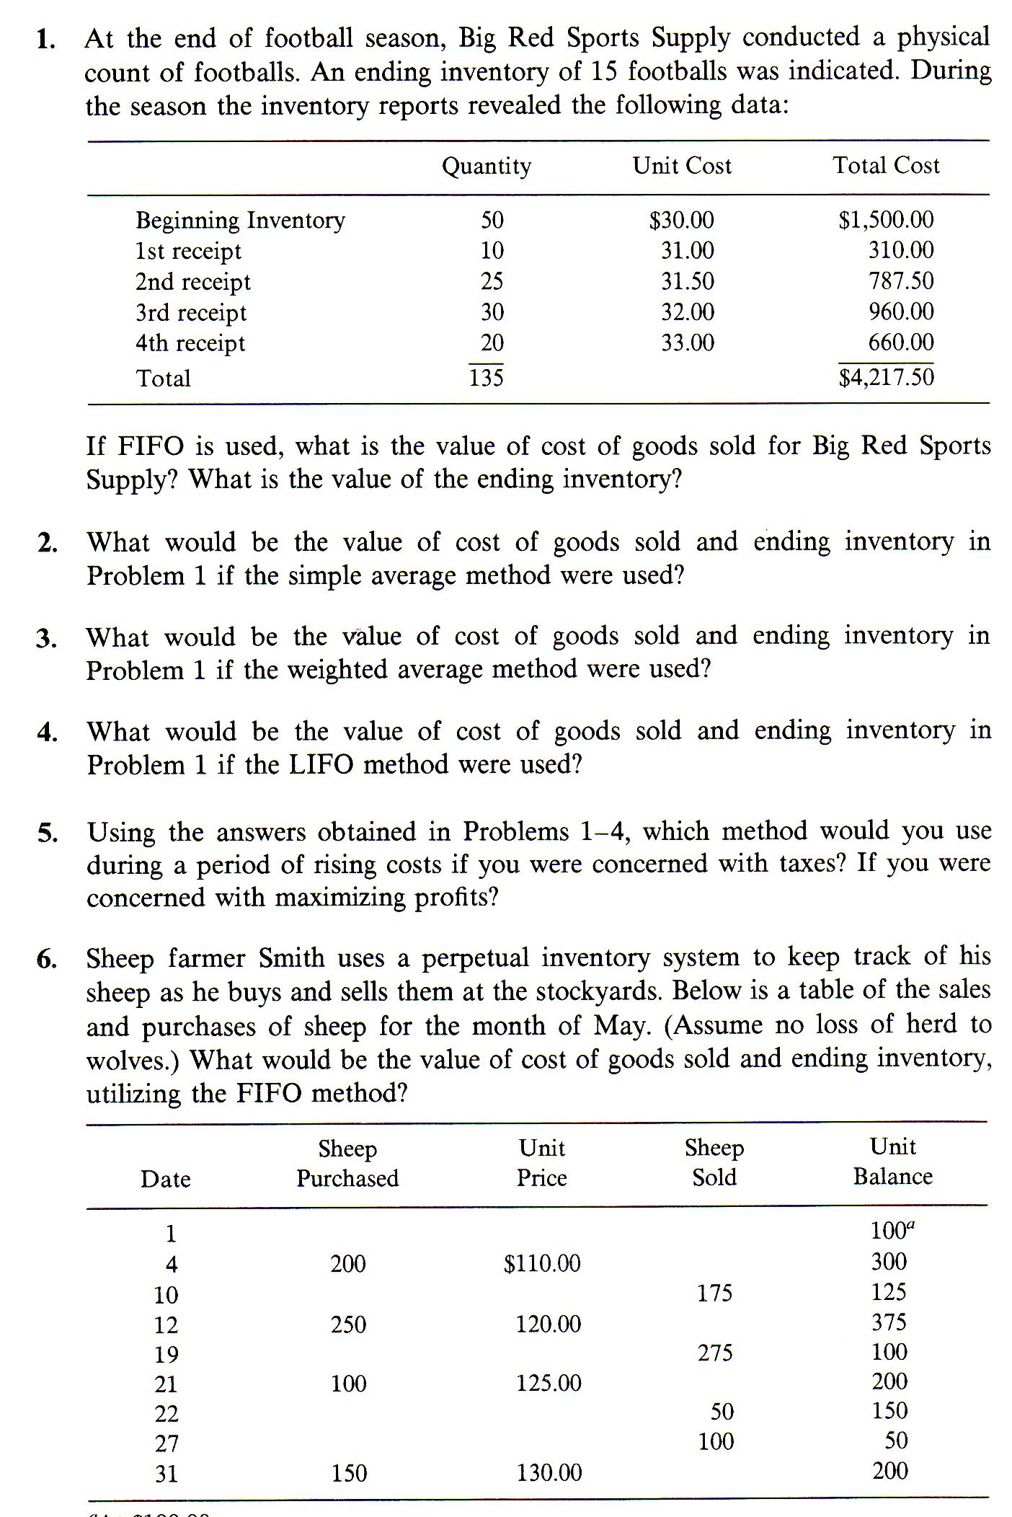
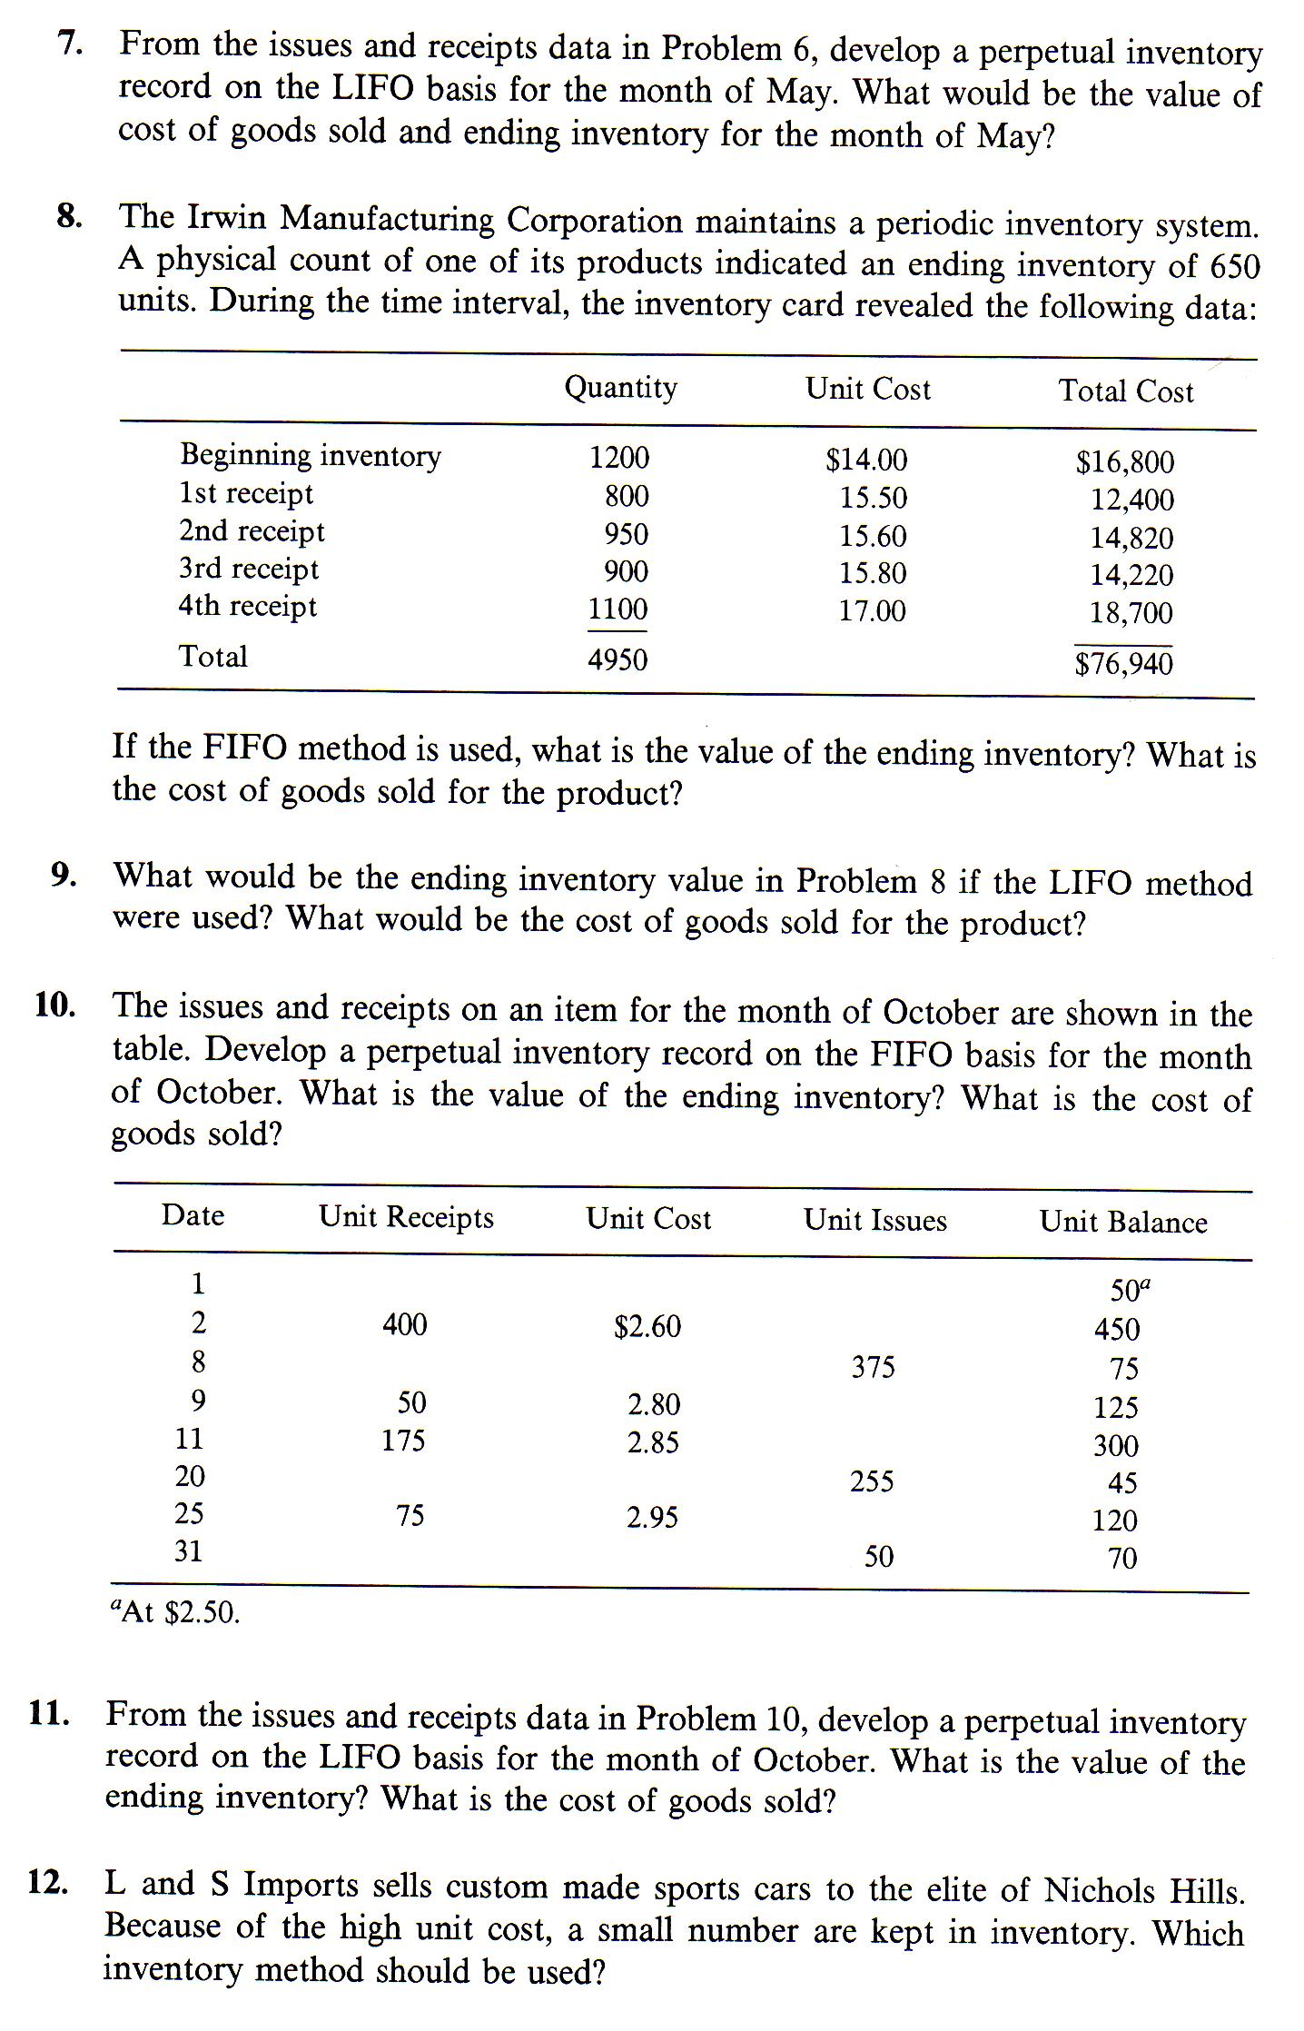
Cases
