International organizations and International Law

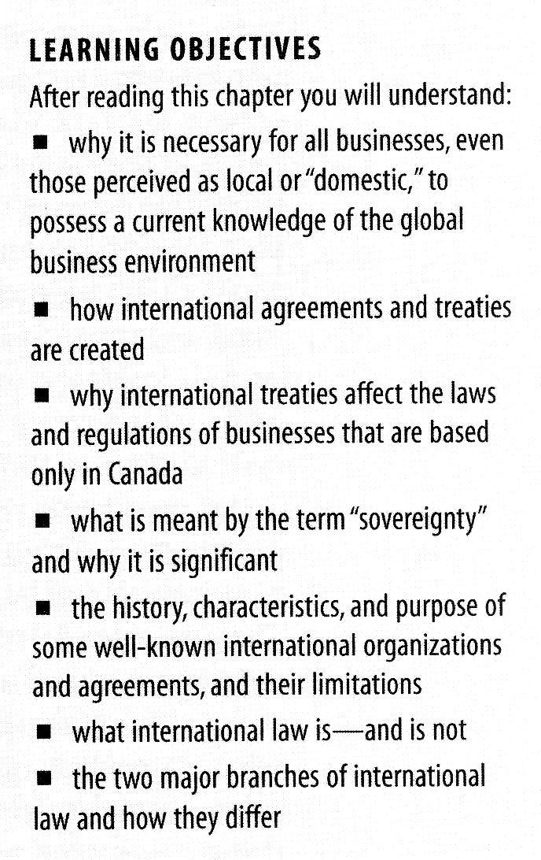
How international agreements are made

In domestic business, there exists the concept of contract between individuals or businesses. The principle of privity of contract—those who are parties to the contract can enforce the rights and obligations it contains.

Nations do not enter into contracts with each other: they negotiate treaties or conventions, or multilateral or bilateral agreements.

A treaty is a binding agreement between two or more states.

A convention is a binding agreement among states sponsored by an international organization.

The process of treaty creation

The first step is negotiation of the terms of the treaty by representatives of national governments.

This negotiation will result in a draft text signed by representatives of the national governments.

The signature of a treaty, unlike the signature of a domestic contract, does not result in a legally binding obligation.

It is a preliminary and general endorsement of the treaty provisions and indicates that the signatory country intends to undertake a careful examination of the treaty before it confirms its position.

At a minimum, signing a treaty indicates that a country commits not to undermine the principles of the treaty.

At a maximum, it indicates that it is government policy to commit fully to the treaty as it is currently written.

Ratification must be done by parliament.

What is the effect of a treaty on the rights and obligations of the citizens of a signatory country?

It depends on whether a treaty is self-executing or non-self-executing.

A self-executing treaty becomes part of the signatory's domestic law without further implementing legislation, and provides substantive rights and obligations within that country.

A non-self-executing treaty imposes requirements upon the government of the signatory country but does not impose any requirements or privileges on the citizens or provinces of that country.
The significance of non-self-executing treaties and conventions for the individual business is that they oblige national governments to change domestic laws to conform to the obligations.

i.e. Canada ratified the Kyoto Protocol in December 2002, but has not yet passed implementing legislation.

NAFTA has been both ratified and enabling legislation passed.

The concept of sovereignty

In order to understand the powers as well as the limitations of any global organization or agreement, it is necessary to be familiar with the concept of sovereignty.

Sovereignty is is the supreme and independent power and authority claimed by a nation state over its own territory.

Treaty commitments represent a limitation on the sovereignty or freedom of action for the signatory government.

A dominant issue that will continue to preoccupy national policy makers is the extent to which sovereignty should be relinquished in order to gain the advantages of participation in a larger community.

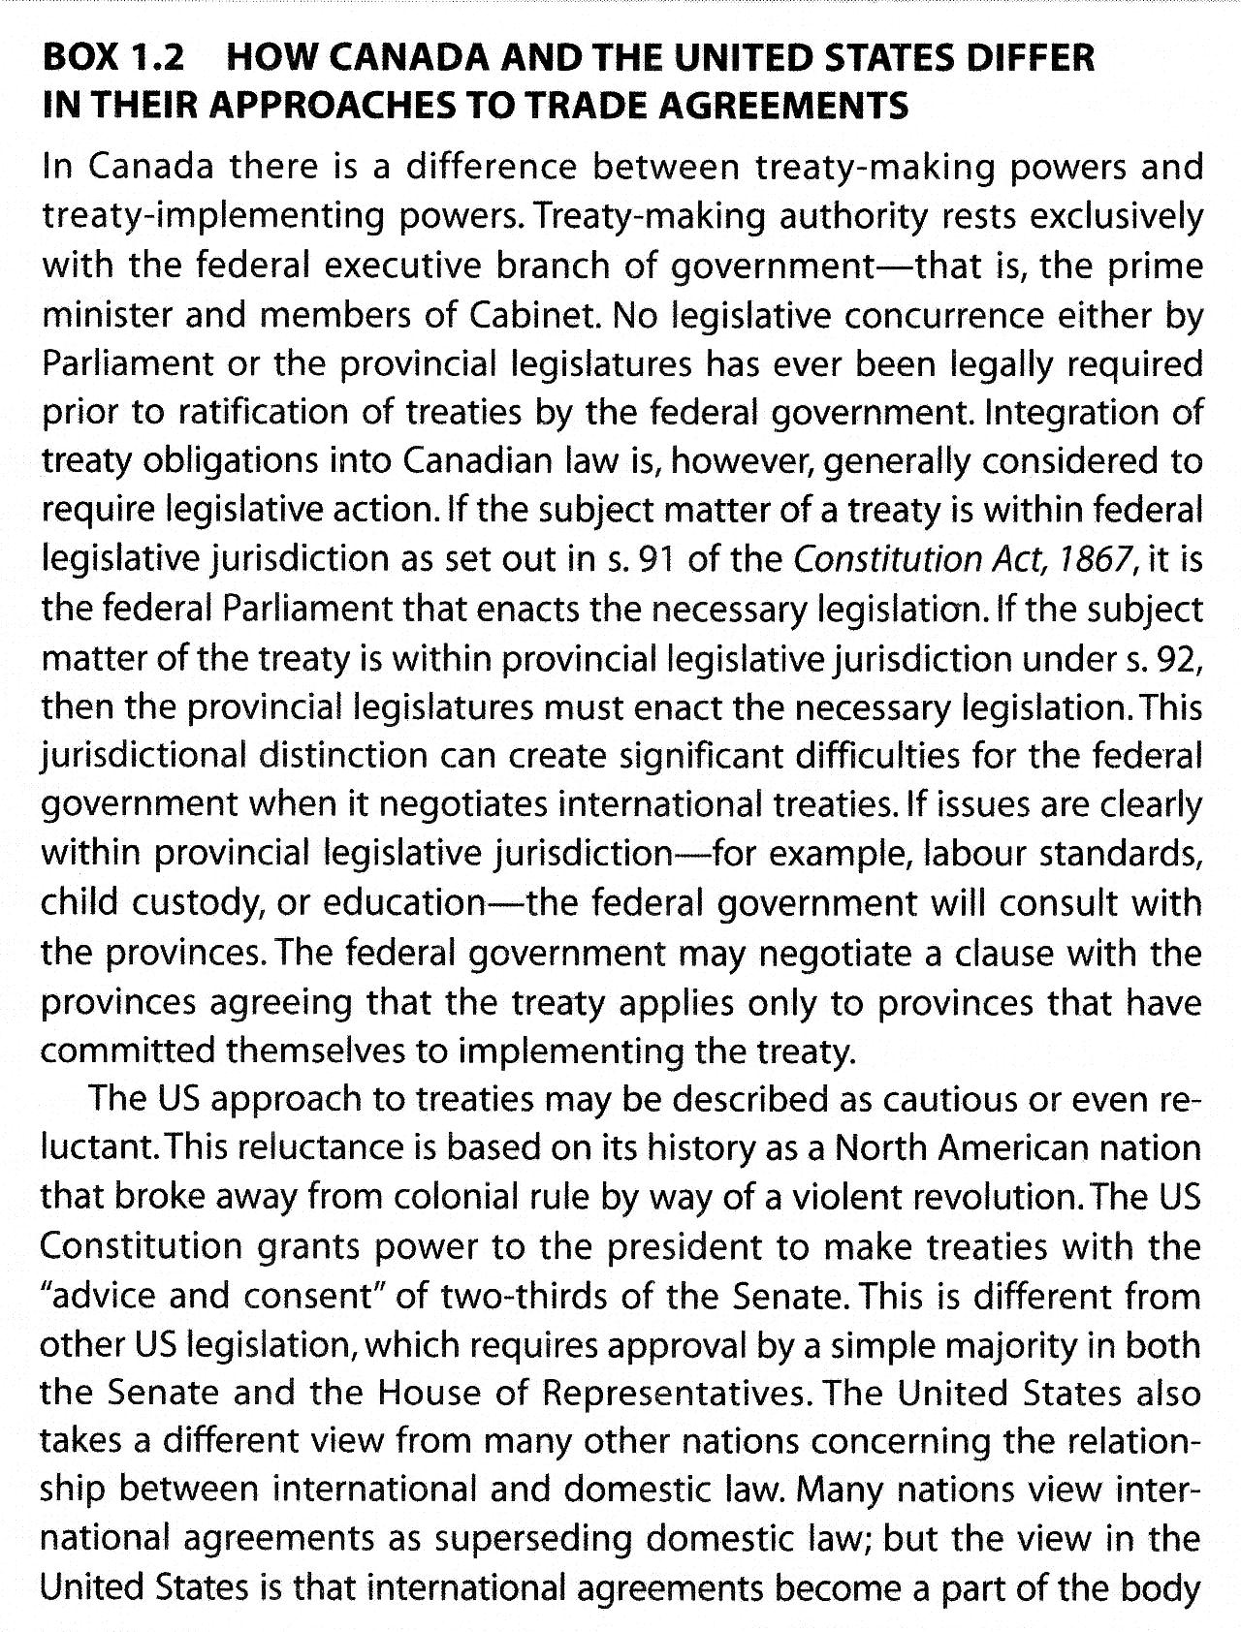
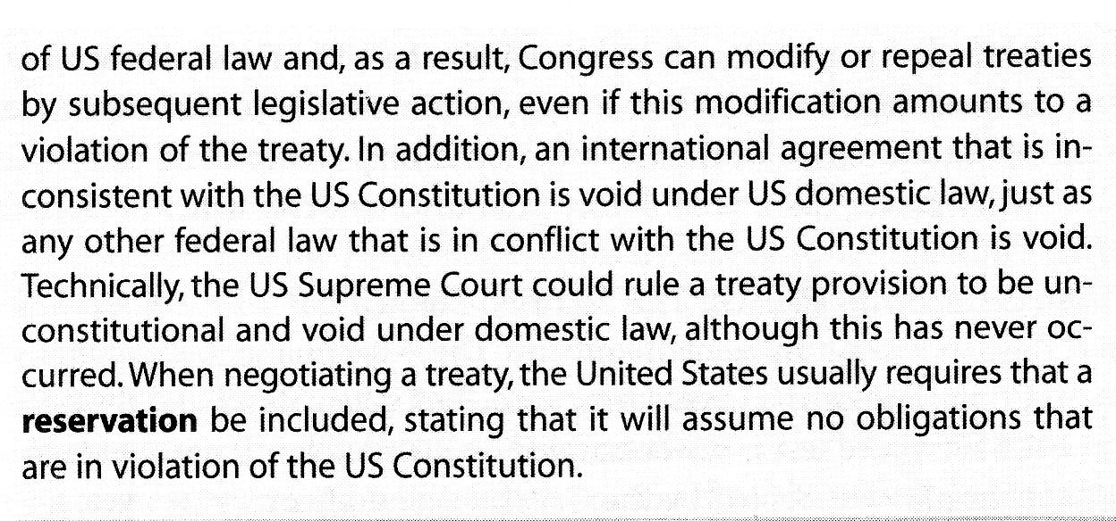
Significant international organizations and agreements

The United Nations

Its mandate is

- to maintain international peace and security;
- to develop friendly relations among nations;
- to cooperate to solve problems of an economic, social, cultural, or humanitarian nature; and
- to promote and encourage human rights and fundamental freedoms.

The UN is organized the following way:

- The General Assembly. Each member state or country sends a delegate to the UN General Assembly and each state has one equal vote, regardless of its size, population, or political influence. It may recommend action but the power to enforce the Charter rests with the Security Council.
- The Security Council. The council has 15 members—5 of which are permanent members. China, France, the United Kingdom, the United states and Russia. The 10 non-permanent members are elected by the General Assembly every two years. The five permanent members have a veto power. Just one of these countries can block any action proposed by the Security Council.
- The Secretary General. He is the UN's chief administrative officer and is responsible for running the Secretariat.

Organizations affiliated with the United Nations

United Nations Conference on Trade and Development (UNCTAD)

United Nations Commission on International Trade Law (UNCITRAL)

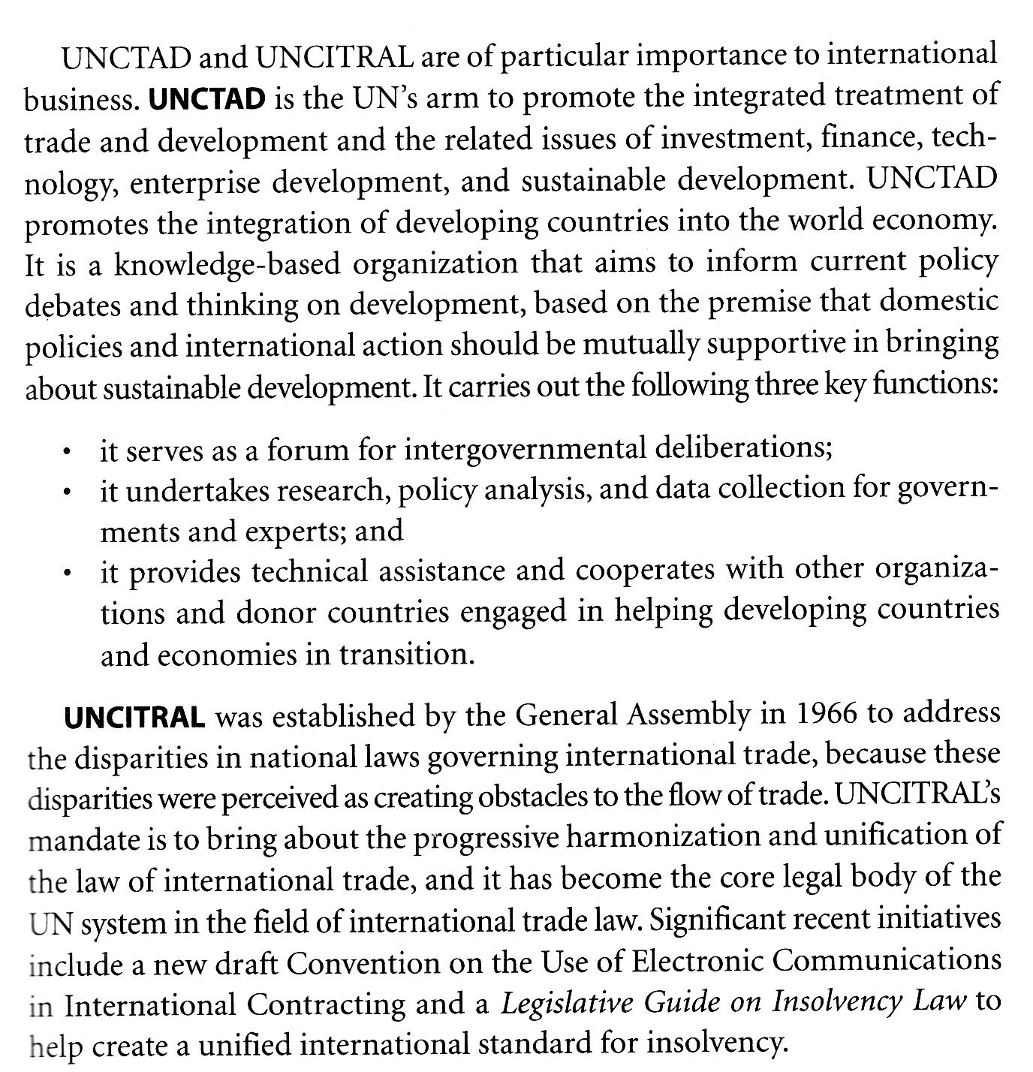

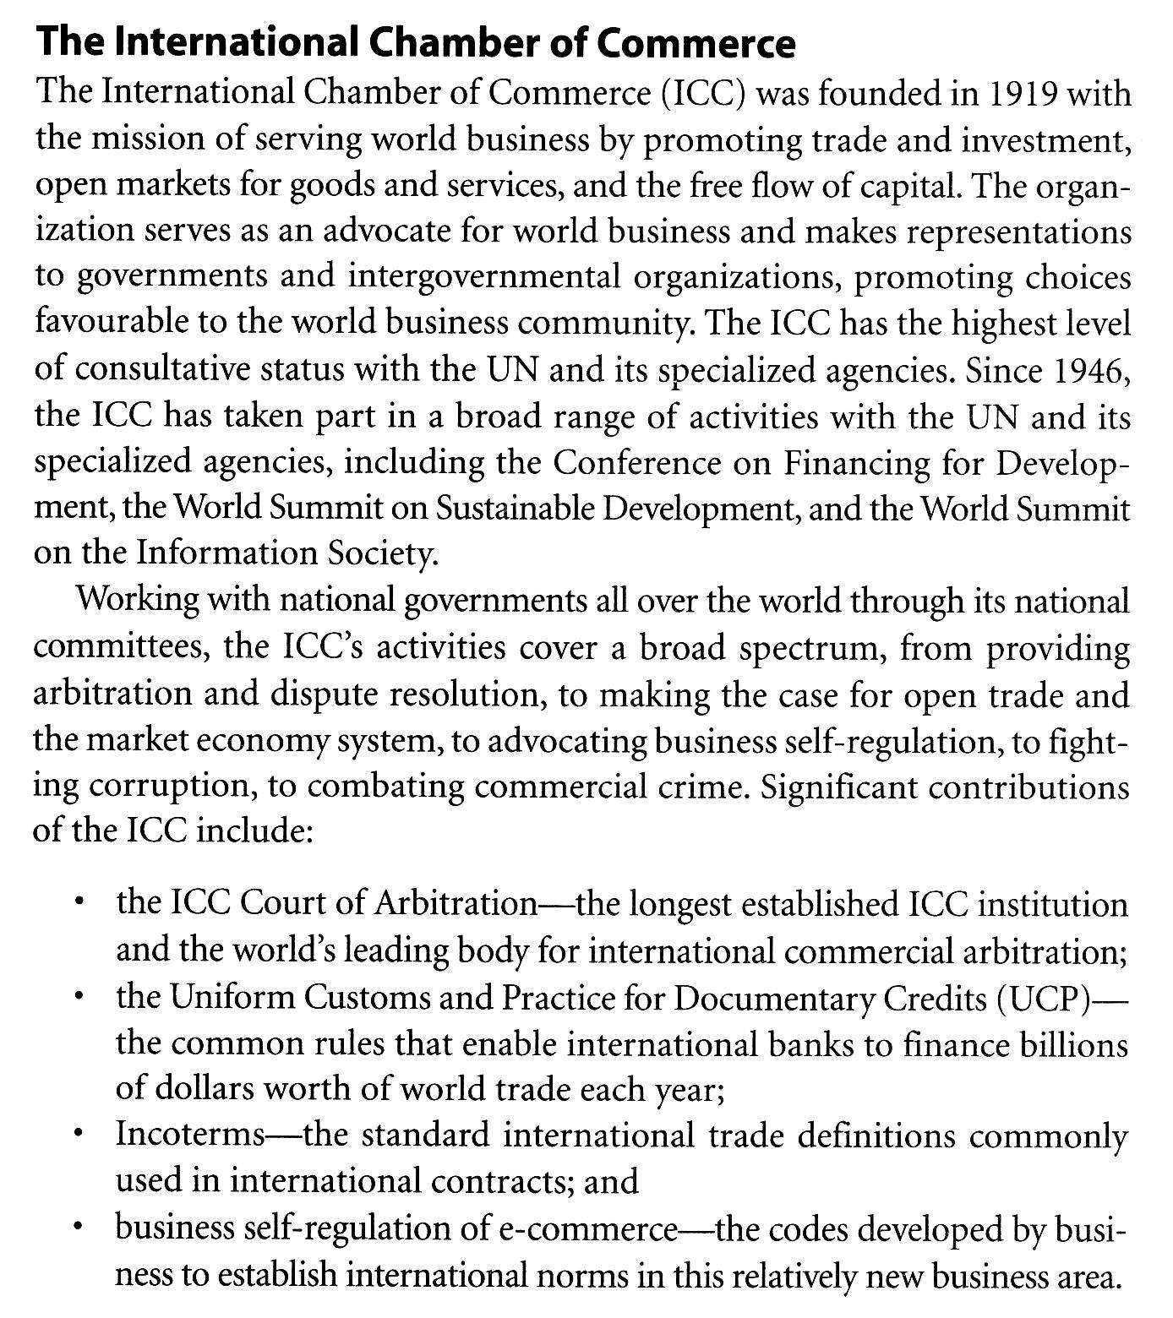
International Law

Public international law

It involves the relationship among states and is reflected in treaties, conventions, and the charter of international organizations. It is generally confined to rules and principles of general application that deal with the conduct of states and of international organizations and with their relations among themselves.

Private International Law

It is also described as conflict of laws—the question of whose country's laws will govern a transaction. Treaties, such as the convention on the International Sale of Goods(CISG), that govern relationships between private parties in different countries are being used more often as a means of predetermining applicable laws and eliminating conflict of law questions because these can be expensive and time consuming for the parties.

Reviews Questions

- What is the difference between a treaty and a convention?
- What if the significance of a country signing a treaty or convention?
- What is the significance of a country ratifying a treaty or convention?
- What is the difference between a self-executing and non-self-executing treaty?
- What is meant by sovereignty and what is the significance of this concept in the context of treaties and other international agreements?
- Describe the different requirements in Canada and the United States with respect to ratification of a treaty. How does this reflect the differing attitudes o f the two countries toward international obligations?
- Describe the work of UNCTAD and UNCITRAL
- Is the International Chamber of commerce an intergovernmental organization? Why was it founded and what are some of its achievements?
- What is the difference between public international law and private international law?
- Why is private international law sometimes described as the conflict of laws?

