Negotiation IV
Invent options for mutual gains

All too often negotiators''leave money on the table''--they fail to reach agreement when they might have, or the agreement they do reach could have been better for each side.

Skill at inventing options is one of the most useful assets a negotiator can have.

Expand the pie before dividing it.

Diagnosis

As valuable as it is to have options, people involved in a negotiation rarely sense a need for them.

In most negotiations there are four major obstacles that inhibit the inventing of an abundance of options:
- premature judgment;
- searching for the single answer;
- the assumption of a fixed pie;
- thinking that solving their problem is their problem.

1) Premature judgment

Inventing options does not come naturally. Not inventing is the normal state of affairs. Even when you are outside a stressful negotiation.

Nothing is so harmful to inventing as a critical sense waiting to pounce on the drawbacks of any new idea. Judgment hinders imagination.
See the following situation:

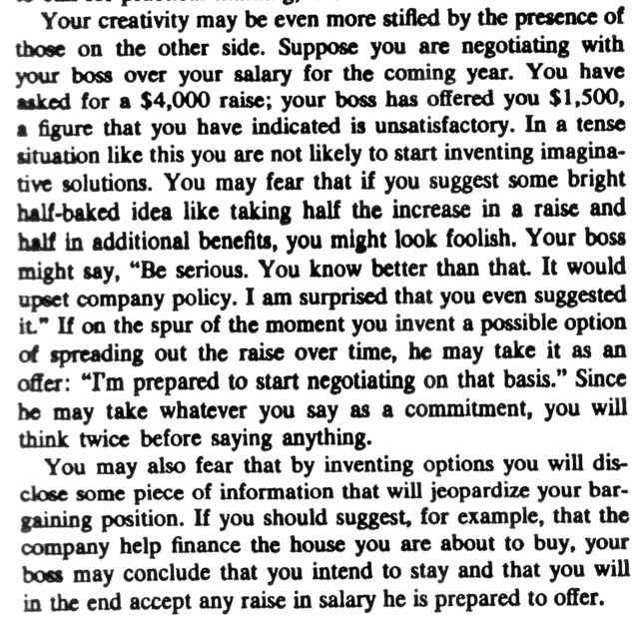
2) Searching for the single answer

In most people's minds, inventing simply is not part of the negotiation process. People see their job as narrowing the gap between positions, not broadening the options available.

They tend to think,''we're having a hard enough time agreeing as it is. The last thing we need is a bunch of different ideas.''

Since the end product of negotiation is a single decision, they fear that free-floating discussion will only delay and confuse the process.

If the first impediment to creative thinking is premature criticism, the second is premature closure.

By looking from outset the outset for the single best answer, you are likely to short-circuit a wiser decision-making process in chich you select from a large number of possible answers.

3) The assumtion of a fixed pie.

A third explanation for why there may be so few good options on the table is that each side sees the situation as essentially either/or either I get what is in dispute or you do.

A negotiation often appears to be a fixed-sum game; $100 more for you on the price of a car means $100 less for me. Why bother to invent if all the options are obvious and I can satisfy you only at my own expense?

4) Thinking that solving their problem is their problem.

A final obstacle to inventing realistic options lies in each side's concern with only its own immediate interests.
There also frequently exists a psychological reluctance to accord any legitimacy to the views of the other side; it seems disloyal to think up ways to satisfy them.

Shortsighted self-concern thus leads a negotiator to develop only partisan positions, partisan arguments, and one-side solutions.

Prescription

To invent creative options, then you will need:
- to separate the act of inventing options from the act of judging them;
- to broaden the options on the table rather than look for a single answer;
- to search for mutual gains;
- to invent ways of making their decision easy.

1) Separate inventing from deciding

Since judgment hinders imagination,
- separate the creative act from the critical one;
- separate the process of thinking up possible decisions from the process of selecting among them.

Invent first, decide later.

A brainstorming session is designed to produce as many ideas as possible to solve the problem at hand. They key ground rule is to postpone all criticism and evaluation of ideas.

Before brainstorming:

a) define your purpose. Think of what you would like to walk out of the meeting with.
b) choose a few participants. The group should normally be large enough to provide a stimulating interchange, yet small enough to encourage both individual participation and free-wheeling inventing—usually between five and eight people.
c) design an informal atmosphere. What does it take for you and others to relax?
d) Choose a facilitor. Someone at the meeting needs to facilitate—to keep the meeting on track, to make sure everyone gets a chance to speak, to enforce any ground rules, and to stimulate discussion by asking questions.

During brainstorming:

a) Seat the participants side by side facing the problem.

The physical reinforces the psychological.

Physically sitting side by side can reinforce the mental attitude of tackling a common problem together.

People facing each other tend to respond personally and engage in dialogue or argument; people sitting by side in a semicircle of chairs facing a blackboard tend to respond to the problem depicted there.

b) Clarify the ground rules, including the no-criticism rule.

Joint inventing produces new ideas because each of us invents only within the limits set by our working assumptions.

If ideas are shot down unless they appeal to all participants, the implicit goal becomes to advance an idea that no one will shoot down.

If, on the other hand, wild ideas are encouraged, even those that in fact lie well outside the realm of the possible, the group may generate from these ideas other options that are possible and that no one would have previously have considered.

c) Brainstorm

Once the purpose of the meeting is clear, let your imaginations go.

Try to come up with a long list of ideas, approaching the question from every coonceivable angle.

d) record the ideas in full view.

Recording ideas either on a blackboard, or on large sheets of paper gives the group a tangible sense of collective achievement;

it reinforces the no-criticism rule;

it reduces the tendency to repeat;

and it helps stimulate other ideas.

After brainstorming;

a) star the most promising ideas.

You are still not at the stage of deciding; you are merely nominating ideas worth developing further.

Mark those ideas that members of the group think are best.

b) Invent improvements for promising ideas.

Take one promising idea and invent ways to make it better and more realistic, as well as ways to carry it out.

c) Set up a time to evaluate ideas and decide.

Before you break up, draw up a selective and improved list of ideas from the session and set up a time for deciding which of these ideas to advance in your negotiation and how.

Consider brainstorming with the other side.

Brainstorming with people from the other side can also prove extremely valuable.

Joint brainstroming sessions have the great advantages of producing ideas which take into account the interests of all those involved, of creating a climate of joint problem-solving, and of educating each side about the concerns of the other.

To protect yourself when brainstorming with the other side, distinguish the brainstorming session explicitly from a negotiating session where people state official views and speak on the record.

People are so accustomed to meeting for the purpose of reaching agreement that any other purpose needs to be clearly stated.

Let's look at an example:
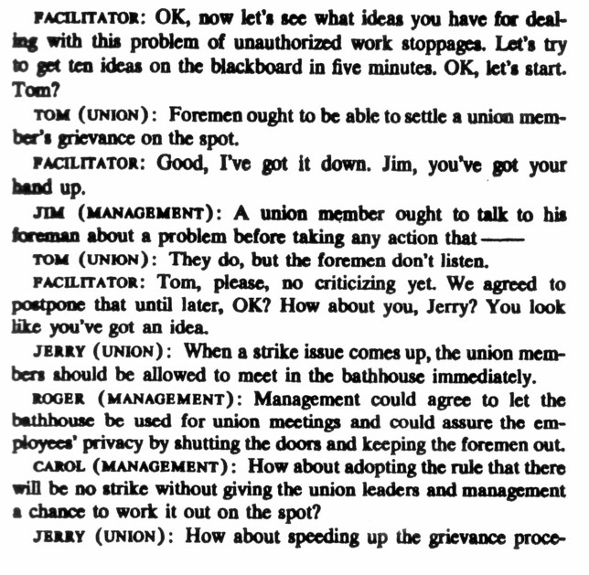
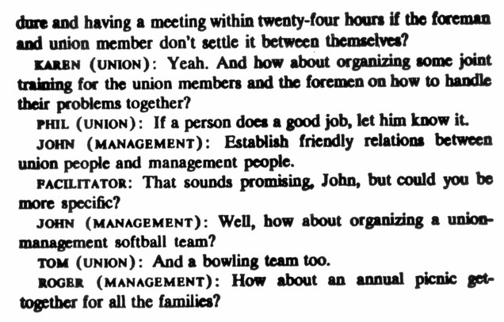
But whether you brainstorm together or not, separating the act of developing options from the act of deciding on them is extremely useful in any negotiation. Discussing options differs radically from taking positions.

Multiply options by shuttling between the specific and the general: the circle chart.

The task of inventing options involves four types of thinking.
- Thinking about a particular problem.
- Thinking as a descriptive analysis—diagnose an existing situation in general terms.
- Thinking about what ought to be done.
- Thinking about some specific and feasible suggestions for action.
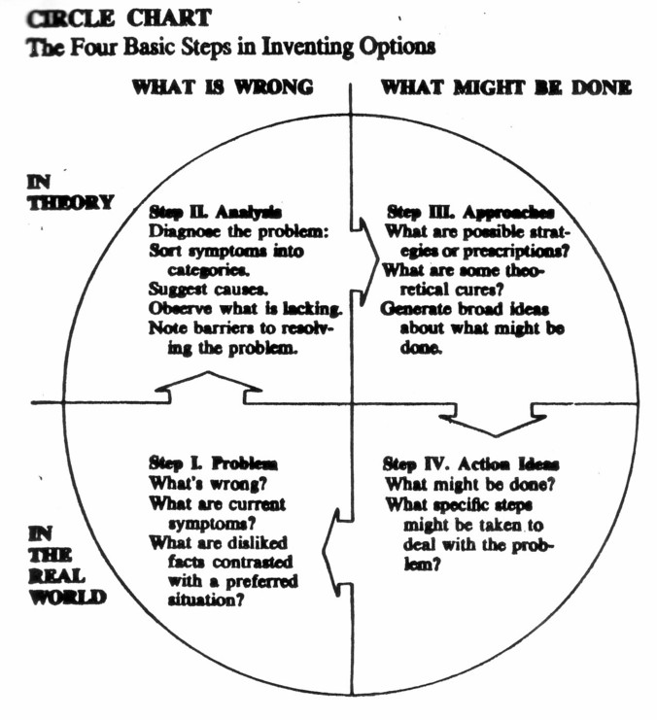
Look for mutual gains

There almost always exists the possibility of joint gains.

Example
Townsend Oil | City of pageville
 | The city wants to raise taxes from $ 1 million to $2 millions
Thinks the $1 million is quite sufficient
Where do shared interests come into play? Let's have a closer look.
Townsend is considering a major refurbishment and expansion of the plant.  Concerned about later increase in taxes.  Have been encouraging a platics plant to locate itself nearby to use townsend products.  Worry that the new platics will have second thoughts if the city increases its taxes. | Needs money to pay for city services, a new civic center, relieve the ordinary taxpayers.  But the city cannot obtain it needs now and in the future from Townsend oil.  The city would like to encourage industrial expansion and attract new businesses.
Both agree on the goals of fostering industrial expansion and encouraging new industries.
How to achieve those goals?
A taxe holiday of seven years for new industries.
A joint publicity campaign with the Chamber of Commerce to attract new companies.
A reduction in taxes for existing industries that choose to expand.

As a negotiator, you will almost always want to look for solutions that will leave the other side satisfied as well.

Three points about shared interests.

1) Shared interests lie latent in every negotiation.

Do we have a shared interest in preserving our relationship?
What opportunities lie ahead for cooperation and mutual benefit?
What costs would we bear if negotiations broke off?
Are there common principles, like a fair price, that we both can respect?

2) Shared are opportunities, not godsends.

To be used, you need to make something out of them.

It helps to make a shared interest explicit and to formulate it as a shared goal.

I.e. Townsend Oil and the city could set a joint goal of bringing five new industries within three years. The tax holiday would then not be a concession to Townsend but an action in pursuit of your shared goal.

3) Stressing your shared interests can make the negotiation smoother and more amicable.

