Negotiation III
Focus on interests, not position

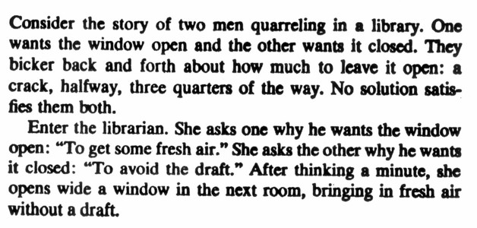
For a wise solution reconcile interests, not positions

This story is typical of many negotiations. Since the parties' problem appears to be a conflict of positions, and since their goal is to agree on position, they naturally tend to think and talk about positions—and in the process often reach an impasse.

Instead the librarian looked to their underlying interests of fresh air and no draft.

This difference between positions and interests is crucial.

Interests define the problem

The basic problem in a negotiation lies in conflicting positions, but in the conflict between each side's needs, desires, concerns, and fears.

The parties may say:

''he wants $50 000 for the house. I won't pay a penny more than $47 400.''
But on a more basic level the problem is:
''he needs at least $50 000 to settle with his ex-wife. I told my family that I wouldn't pay more than $47 500 for a house.''

Reconciling interests rather than positions works:

For every interest there usually exist several possible positions that could satisfy it.

When you do look behind opposed positions for the motivating interests, you can often find an alternative position which meets not only your interests but theirs as well.

Behind opposed positions lie shared and compatible interests, as well as conflicting ones.

Let's go back at the tenant example:

Look at the interests a tenant shares with a prospective landlord:

- Both want stability. The landlord wants a stable tenant: the tenant wants a permanent address.

- Both would like to see the apartment well maintained. The tenant is going to live there; the landlord wants to increase the value of the apartment as well as the reputation of hte building.

- Both are interested in a good relationship with each other. The landlord wants a tenant who pays the rent regularly; the tenant wants a responsive landlord who will carry out the necessary repairs.

They may have interest that do not conflict but simply differ.

- The tenant may not want to deal with fresh paint, to which he is allergic. The landlord will not want to pay the costs of repainting all the other apartments.

- The landlord would like the security of a downpayment of the first month's rent, and he may want it by tomorrow. The tenant, knowing that this is a good apartment, may be indifferent on the question of paying tomorrow or later.

Shared interests and differing but complementary interests can both serve as building blocks for a wise agreement.

How do you identify interests?

In negotiation figuring out their interests will be at least as important as figuring out yours.

Ask why?

Put your self in their shoes. Examine each position they take, and ask yourself why.

For instance you can ask the landlord why he takes a particular position. If you do, make clear that you are asking not for justification of his position, but for understanding of the needs, hopes, fears, or desires that it serves.

If you are trying to change their minds, the starting points is to figure out where their minds are now.

Realize that each side has multiple interests.

Thinking of negotiation as a two-person, two-sided affair can be illuminating, but it should not blind you to the usual presence of other persons, other sides, and other influences.

In one baseball salary negotiation the general manager kept insisting that $200 000 was simply too much for a particular player, although other teams were paying at least that much to similarly talented players.

In fact the manager felt his position was unjustifiable, but he had strict instructions from the club's owners to hold firm without explaining why, because they were in financial difficulties that they did not want the public to hear about.

To understand that negotiator's interests means to understand the variety of somewhat differing interests that he needs to take into account.

Make a list

To sort out the various interests of each side, it helps to write them down as they occur to you.

Talking about interests

The purpose of negotiating is to serve your interests.

The chance of that happening increases when you communicate them.
The other side may not know what your interests are, and you may not know theirs.

One or both of you may be focusing on past grievances instead of on future concerns.
Or you may not even be listening to each other.

How do you discuss interests constructively without getting locked into rigid positions?

If you want the other side to take your interests into account, explain to them what those interests are.

Make your interest come alive

It is your job to have the other side understand exactly how important and legitimate your interests are.

One guideline is be specific. Concrete details not only make your description credible, they add impact.

As long as you do not seem to imply that the other side's interests are unimportant or illegitimate, you can afford to take a strong stance in setting forth the seriousness of your concerns.

Acknowledge their interests as part of the problem.

People listen better if they feel that you have understood them.

If you want the other side to appreciate your interests, begin by demonstrating that you appreciate theirs.

In addition to demonstrating that you have understood their interests, it helps to acknowledge taht their interests are part of the overall problem you are trying to solve.

Put the problem before your answer

If you want someone to listen and understand your reasoning, give your interests and reasoning first and your conclusion or proposals later.

Look forward, not back

Caught up in a quarrel, whether between husband or wife, between company and union, or between two businesses, people are more likely to respond to what the other side has said or done than to act in pursuit of their own long-term interests.

One looks backward for a cause and treats our behaviour as determined by prior events. The other looks forward for a purpose and treats our behaviour as subject to change.

Be concrete but flexible

In a negotiation you want to know where you are going and yet be open to fresh ideas.

To avoid having to make a difficult decision on what to settle for, people will often go into a negotiation with no other plan that to sit down with the other side and see what they offer or demand.

Having thought about your interests, you should go into a meeting not only with one or more specific options that would meet your legitimate interests but also with an open mind.
Be hard on the problem, soft on the people

I may mot be wise to commit yourself to your position, but it is wise to commit yourself to your interests. This is the place in a negotiation to spend your aggressive energies.

Often the wisest solutions, those that produce the maximum gain for you at the minimum cost to the other side, are produced only by strongly advocating yout interests.

Two negotiators, each pushing hard for their interests, will often stimulate each other's creativity in thinking up mutually advantageous solutions.

Attack the problem without blaming the people. Go even further and be personally supportive:Listen to them with respect, show them courtesy, express your appreciation for their time and effort, emphasize your concern with meeting their basic needs, and so on.

Show them that you are attacking the problem, not them.

Successful negotiation requires being both firm and open.

