Negotiation I
Although negotiation takes place every day, it is not easy to do well. Standard strategies for negotiation often leave people dissatisfied, worn out, or alienated—and often all three.

People find themselves in a dilemma. They see two ways to negotiate: soft and hard.
- The soft negotiator wants to avoid personal conflict and so makes concessions readily in order to reach an agreement. He wants an amicable resolution; yet he often ends up exploited and feeling bitter.
- The hard negotiator sees any situation as a context of wills in which the side that takes the most extreme positions and holds out longer fares better. He wants to win; yet he often ends up producing an equally hard response which exhausts him and his ressources and harms his relationship with the other side.

There is a third way to negotiate, a way neither hard nor soft, but rather both hard and soft.

The method of principled negotiation developed at the Harvard Negotiation Project is to decide issues on their merits rather than through a haggling process focused on what each side says it will and won't do.

It suggests that you look for mutual gains wherever possible, and that where your interest conflict, you should insist that the result be based on some fair standards indepedent of the will of either side.

The method of principled negotiation is hard on the merits, soft on the people. It employs no ricks and no posturing. Principled negotiation shows you how to obtain what you are entitled to and still be decent. It enables you to be fair while protecting you against those who would take advantage of your fairness.

Don't bargain over positions
Positional bargaining
Each side takes a position, argues for it, and makes concessions to reach a compromise. The classic example of this negotiation minuet is the haggling that takes place between a customer and the proprietor of a secondhand store:

customer | shopkeeper
How much do you want for this brass dish? | That is a beatiful antique, isn't it? I guess I could let it go for $75.
Oh come on, it's dented. I'll give you $15. | Really! I might consider a serious offer, but $15 certainly isn't serious.
Well, I could go to $20, but I would never pay anything like $75. Quote me a realistic price. | You drive a hard bargain, young lady. $60 cash, right now.
$25 | It cost me a great deal more that that. Make me a serious offer.
$37.50 That's the highest I will go. | Have you noticed the engraving on that dish? Next year pieces like that will be worth twice what you pay today.

Three criteria to judge any mehtod of negociation:

- It should produce a wise agreement if agreement is possible.
- It should be efficient.
- It should improve not damage the relationship between parties.

The most common form of negotiation as was illustrated by the customer and shopkeeper is a sequence of position.

Taking positions serves some useful purposes in a negotiation.

- It tells the other side what you want.
- It provides an anchor in an uncertain and pressured situation.
- It can produce the terms of an acceptable agreement.

However, positional bargainning fails to meet the basic criteria of producing a wise agreement, efficiently and amicably.
Arguing over positions produces unwise agreements.

- When negotiators bargain over positions, they tend to lock themselves into those positions.
- The more you clarify your position and defend it against attack, the more committed you become to it.
- The more you try to convince the other side of the impossibility of changing your opening position, the more difficult it becomes to do so.
- Your ego becomes identified with your position.

Example:

In the 1960s the US and USSR were negotiating a comprehensive ban on nuclear testing. A critical question arose: How many on site-inspections per year should the Soviet Union and the Inuted States be permitted to make within the other's territory to investigate suspicious seismic events?

The soviets agreed to three, the US wanted at least 10. The talks broke down over positions despite the fact that no one understood whether an inspection would involve one person looking around for one day, or hundred prying indiscriminately for a month.

As more attention is paid to positions, less attention is devoted to meeting the underlying concerns of the parties. Any agreement reached may reflect a mechanical splitting of the difference between final positions rather than a solution carefully crafted to meet the legitimate interests of the parties.

Arguing over positions is inefficient

Bargainning over positions creates incentives that stall settlement.

You try to improve the chance that any settlement reached is favourable to you by starting with an extreme position, by stubbornly holding to it, by deceiving the other party as to your true views, and by making small concessions only as necessary to keep the negotiation going.

Arguing over positions endangers an ongoing relationship

Positional bargaining becomes a contest of will. Each negotiator asserts what he will and won't do. The task of jointly devising an acceptable solution tends to become a battle. Each side tries through sheer will power to force the other to change its position.

Being nice is no answer

The two most common form of bargaining are soft and hard.

Soft:
Many people recognize the high costs of hard positional bargaining, particularly on the parties and their relationship. They hope to avoid them by following a more gentle style of negotiation. Here the standard moves are to make offers and concessions, to trust the other side, to be friendly, and to yield as necessary to avoid confrontation.

Hard:
The hard bargainer insists on concessions and makes threats. The game is biased in favour of hard player.

Pursuing a soft and friendly form of positional bargaining makes you vulnerable to someone who plays a hard game of positional bargaining.

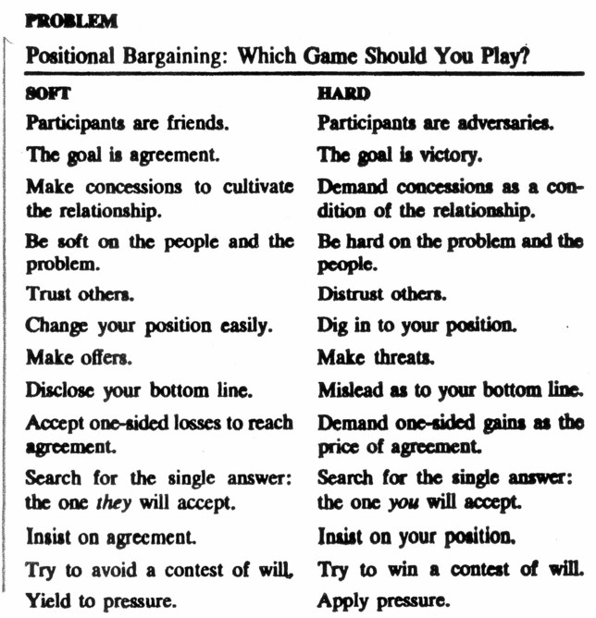
There is an alternative

the game of negotiation takes place at two levels.

- Negotiation addresses the substance
- negotiation focuses on the procedure for dealing with the substance.

The first level may concern the salary, the terms of a lease, or a price to be paid.

The second level concerns how one will negotiate the substantive question: soft or hard positional bargaining, or something else.

The second level is a game about a game. Each move one makes in not only a move that deals with rent, salary, or whatever; it also helps structure the rules of the game.

The second level by and large escapes notice because it seems to occur without conscious decision. Only with dealing with someone from another country, particularly someone with a markedly different cultural background, are you likely to see the necessity of establishing some accepted process for the substantive negotiations.

Conscious or not every moves serves to establish procedural rules.

So, the answer to the question of whether to use soft positional bargaining or hard is neither. One must change the game.

At the Harvard negotiation project they have developed an laternative to positional bargaining: a method of negotiation explicitly designed to produce wise outcomes efficientloy and amicably.

Principled negotiation or negotiation on the merits.

This method boils down to four basic points. Each point deals with a basic element of negotiation, and suggests what one should do about it.

- People: Separate the people from the problem.
- Interests: Focus on interests not on position.
- Options: Generate a variety of possibilities before deciding what to do.
- Criteria: Insist that the result be based on some objective standard.

People:
We are human beings not computer.We are creatures of strong of emotions who often have radically different perceptions and have difficulty communicating clearly. Before working on the substantive problem, the ''people problem'' should be disentangled from it and dealt with separately. The participants should come to see themselves as working side by side, attacking the problem, not each other.

Interests:
There is a drawback in focusing on people's stated positions when the object of the negotiation is to satisfy their underlying interests. A negotiating position often obscures what you really want. Compromising between positions is not likely to produce an agreement which will effectively take care of the human needs that led people to adopt those positions.

Options:

It is difficult to design optimal solutions while under pressure. Trying to decide in the presence of an adversary narrows your vision. Having a lot at stake inhibits creativity.

You can offset these constraints by setting aside a designated time within which to think up a wide range of possible sotutions that advance shared interests and creatively reconcile differing interests.

Criteria:
The agreement must reflect some fair standard independent of the naked will of either side. This does not mean insisting that the terms be based on the standard you select, but only that some fair standard such as market value, expert opinion, custom, or law determine the outcome.

By discussing such criteria rather than what the parties are willing or unwilling to do, neither party need give in to the other; both can defer to a fair solution.

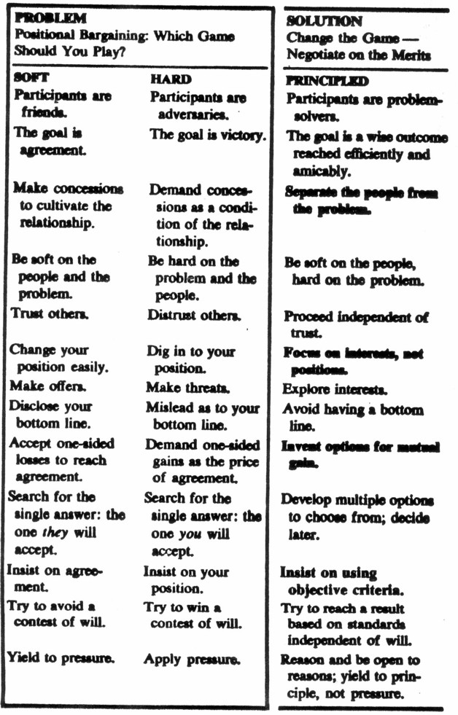
The four propositions of principled negotiation are relevant from the time youn begin to think about negotiating until the either an agreement if reached or you decide to break off the effort.

That period can be divided into three stages:
Analysis | - Try to diagnose the situation—gather information, organize it, think about it.  - Consider the people problems of partisan perceptions, hostile emotions, and unclear communication  - Identify your interests and those of the other side.  - Note options already on the table  - Identify criteria already suggested as a basis for agreement
planning | - Deal with the same elements a second time, both generating ideas and deciding what to do.  - How to handle people problems  - Of your interests which are most important.  - What are some realistic objectives  - Generate additional options and criteria
discussion | - Acknowledge and address differences in perception, feelings of frustration and anger, and difficulties in communication.  - Understand the interest of the other  - Jointly generate options that are mutually advantageous  - Seek agreement on objective standards

