Money

Objectives;

Describe money and describe its functions

Describe the monetary system

Describe the functions of the Bank of Canada
Money performs three vital functions:

Medium of exchange
Unit of account
Store of value

Medium of exchange is an object that is generally accepted in return for goods and services.

A unit of account is an agreed-upon measure for stating the prices of goods and services.

Any commodity or token that can be held and exchanged later for goods and services is called a store of value.
Official measures of money
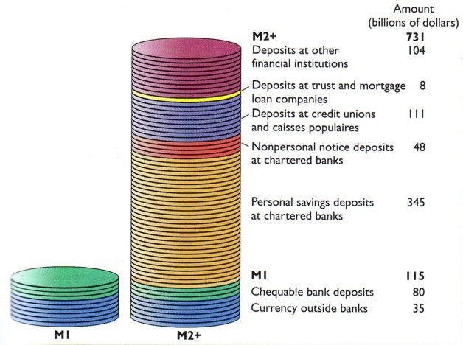

The bank of Canada is Canada’s central bank.

A central bank is a public authority that provides banking services to banks and regulates financial finstitutions and markets.

A central bank does not provide banking services to business and individual citizens.

The Bank’s of Canada’s ultimate monetary policy objective is to keep inflation arete inside a target range of between 1 percent and 3 percent a year.

By keeping the inflation rate steady and low, the Bank seeks to maintain full employment, moderate the business cycle, and contribute towards achieving faster and sustained economic growth.

Money creation and control

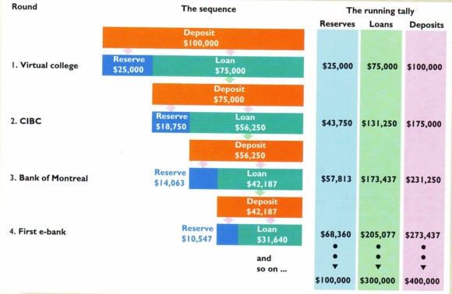
the deposit multiplier is the number by which an increase in bank reserves is multiplied to find the resulting increase in bank deposits.

Change in deposits = deposit multiplier x change in reserves

In the previous example that we’ve just worked through, the deposit multiplier is 4. The $100,000 increase in reservis brought a $400 000 increase in deposits.

Deposit multiplier = 1
Desired reserve ratio

Deposit multiplier = 1 / 0.25 = 4
Money, interest and inflation

The demand for money is the total amount of money that the public wishes to hold for all purposes.

Three important services that are provided by money give rise to three motives for holding money: the transactions, precautionary and speculative motive.

The transactions motive
Most transactions require money. Money passes from households to firms to pay for the goods and services produced by firms; money passes from firms to households to pay for the factor services supplied by households to firms.

The larger the value of national income, the more transactions ar emade and thus the larger will be the value of transactions balances.

The precautionary motive
The precautionary arises because housholds and firms are uncertain about the timing of payments and receipts.

The speculative motive

Money can laso be held to provide a hedge against the uncertainty innherent in fluctuating prices of other financial assets.

The speculative motive implies that the demand for money varies negatively with the interest rate.

The following shows the demand for money as a function of interest rates, income, and the price level.

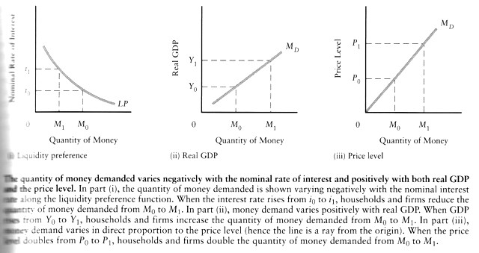
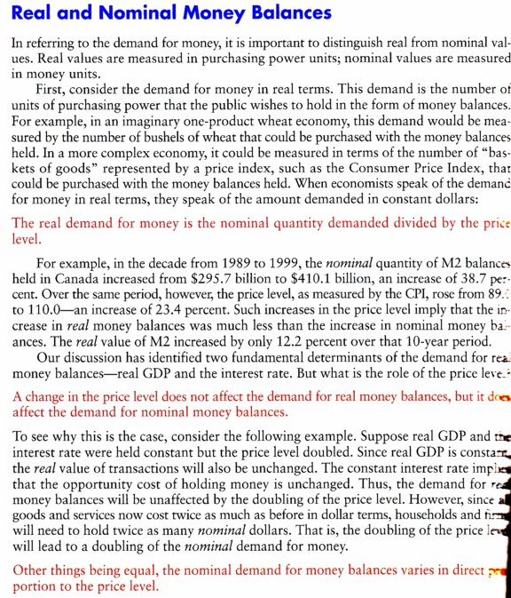

Real money supply M₀ = M/P (m is nominal quantity of money and P is the price level)

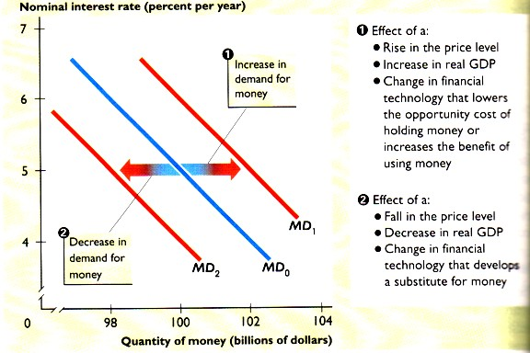

Monetary equilibrium occurs when the quantity of money demanded equals the quantity of money supplied.

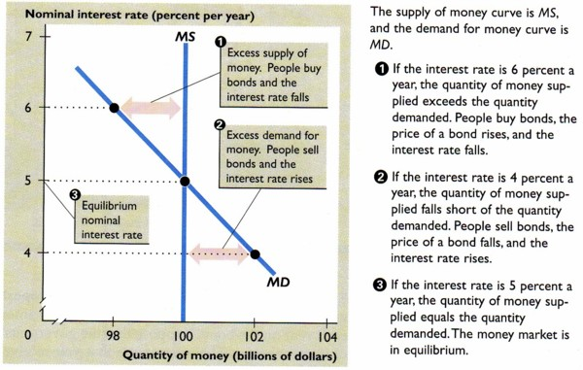

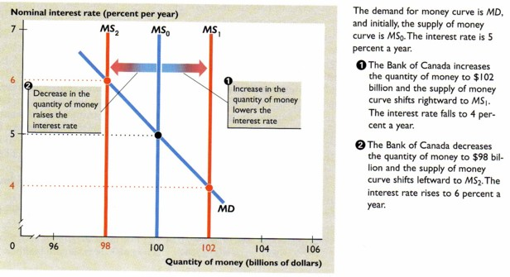

the transmission mechanism: a mechanism by which changes in the demand for and supply of money affect aggregate demand.

It operates in three stages: the first is le link between monetary equilibrium and the interest rate, the second is the link between the interest rate and investment expenditure, and the third is the link between investment expenditure and agregate demand.

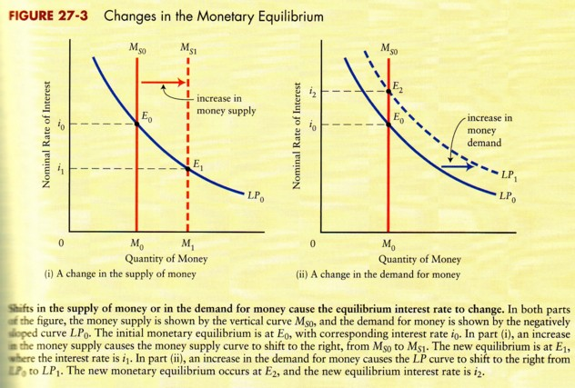
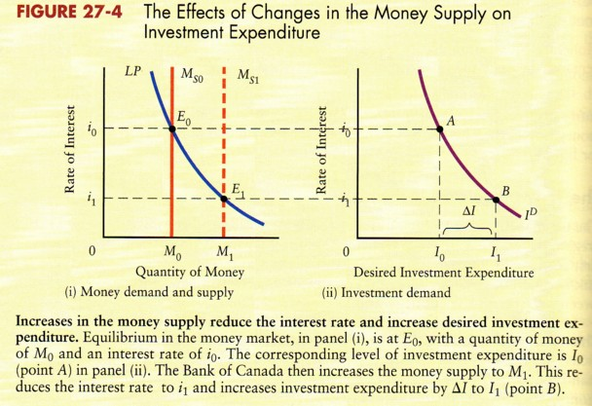 | 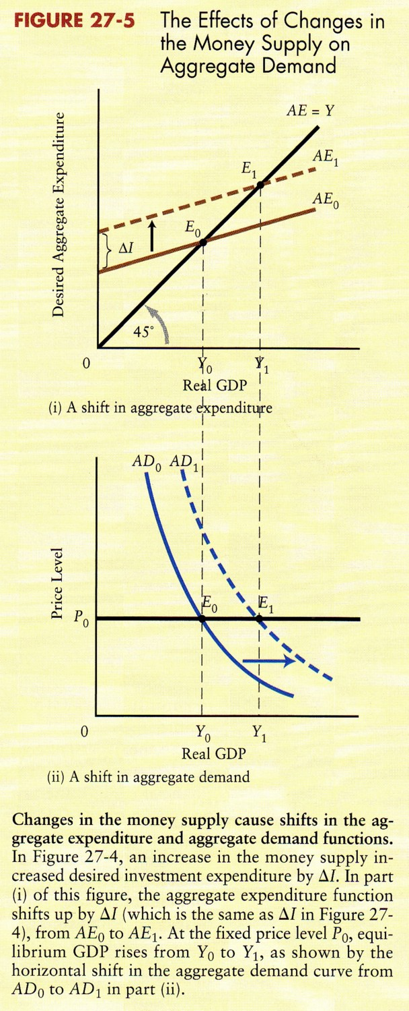

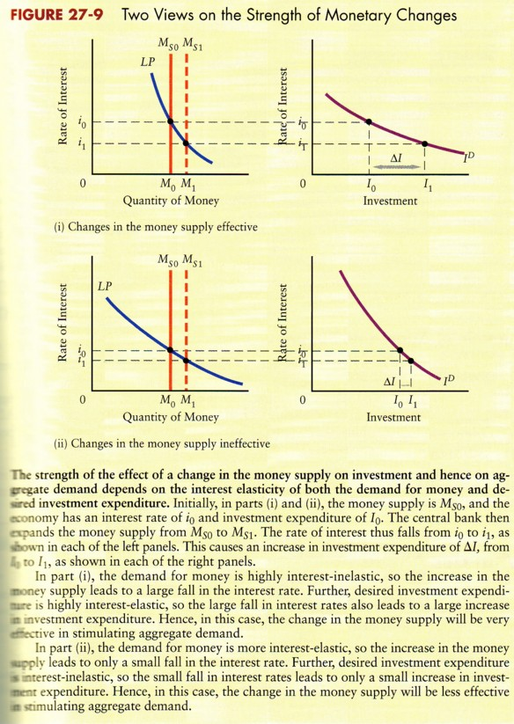
Exercises
