The strategy of
International business

- Explain the concept of strategy

- Understanding how firm can profit by expanding globally

- Understand how pressures for cost reductions and pressures for local responsiveness influence strategic choice

- Be familiar with different strategies by competing globally and their pros and cons

- Explain the pros and cons of using strategic alliances to support global strategies

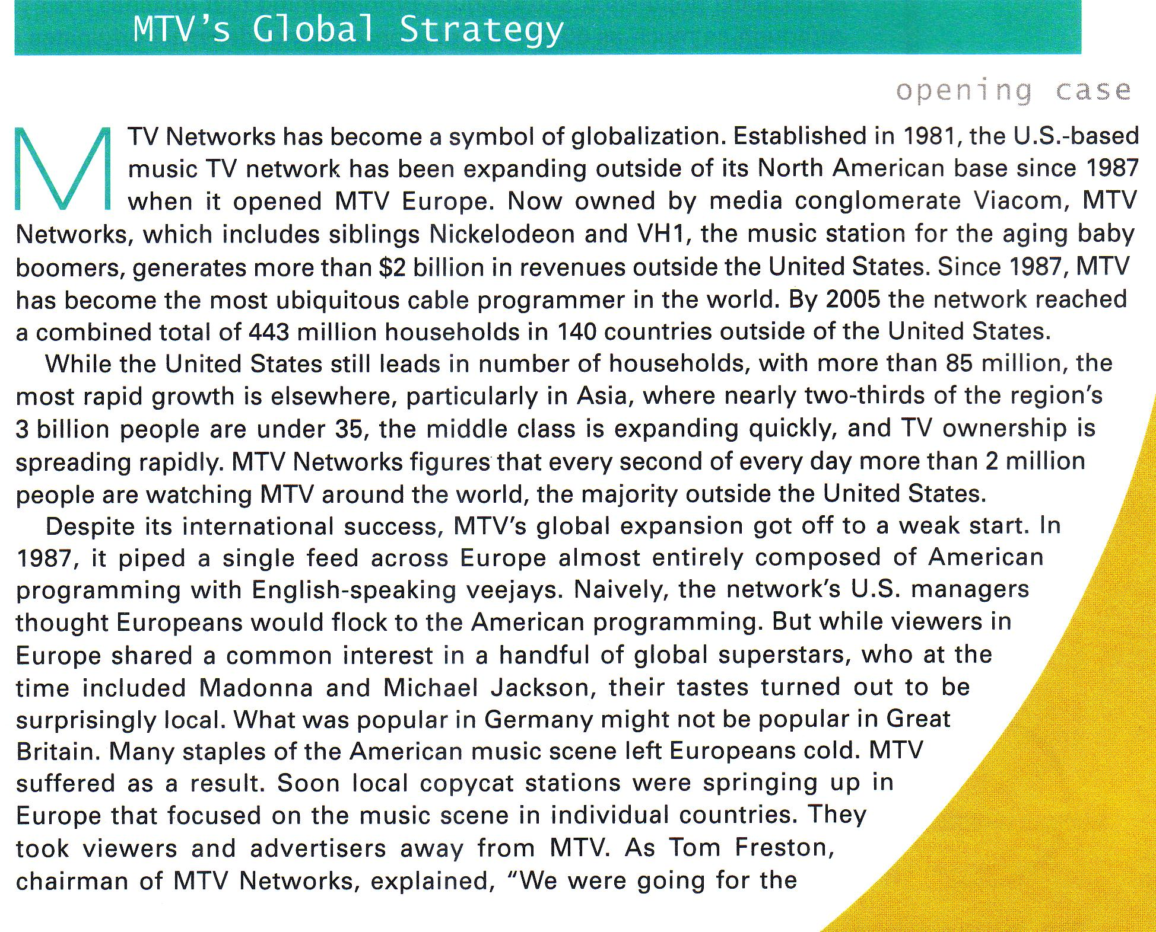
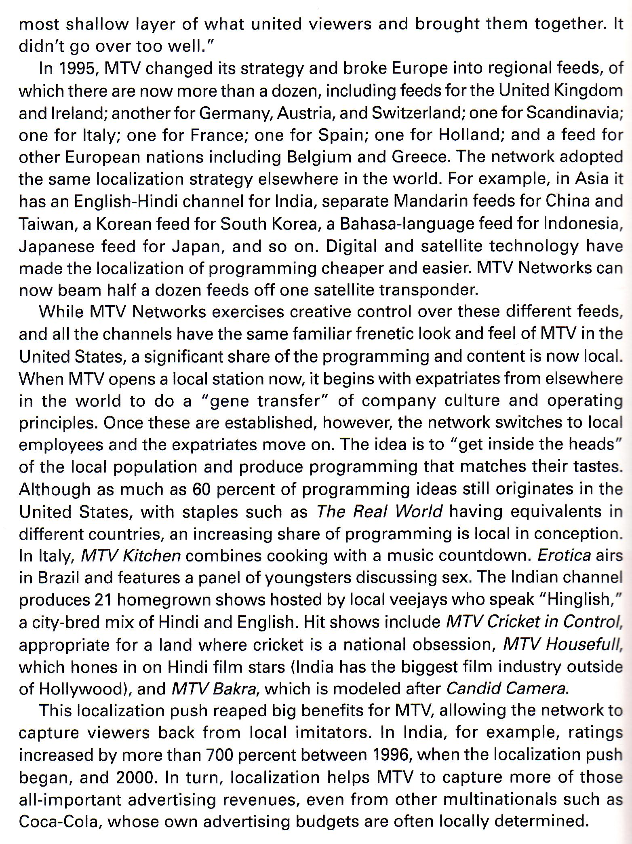
MTV moved into other countries because it saw huge growth opportunities there, and it thought it could create value by transferring its business model and American-style music programming to foreign markets.

MTV initially treated foreign markets much like the US, right down to airing the same music videos worldwide, but it soon found that this was not the correct approach.

National differences in customer tastes and preferences required MTV to change its approach to programming.

It moved away from one-size-fits-all strategy of global standardization and became more local in its orientation, adapting its programming to different markets, with different music videos and programmes being aired in different markets.

MTV's foreign affiliates still have the same look, feel, and overall programming philosophy of the US parent.

Striking the right balance between global standardization and local responsiveness let MTV reap big dividends, enabling the network to gain viewers and advertisers ant the expense of competitors.
Strategy and the firm

A firm's strategy can be defined as the actions that managers take to attain the goals of the firm.

The preeminent goal is to maximize the value of the firm for its owners, its shareholders (subject to the very important constraint that this is done in a legal, ethical, and socially responsible manner).

To maximize the value of a firm, managers must pursue strategies that increase the profitability of the enterprise and its rate of profit growth.

Profitability is the rate of return that the firm makes in its invested capital, which is calculated by dividing the net profits of the firm by the total invested capital.

Profit growth is measured by the percentage increase in net profits over time.

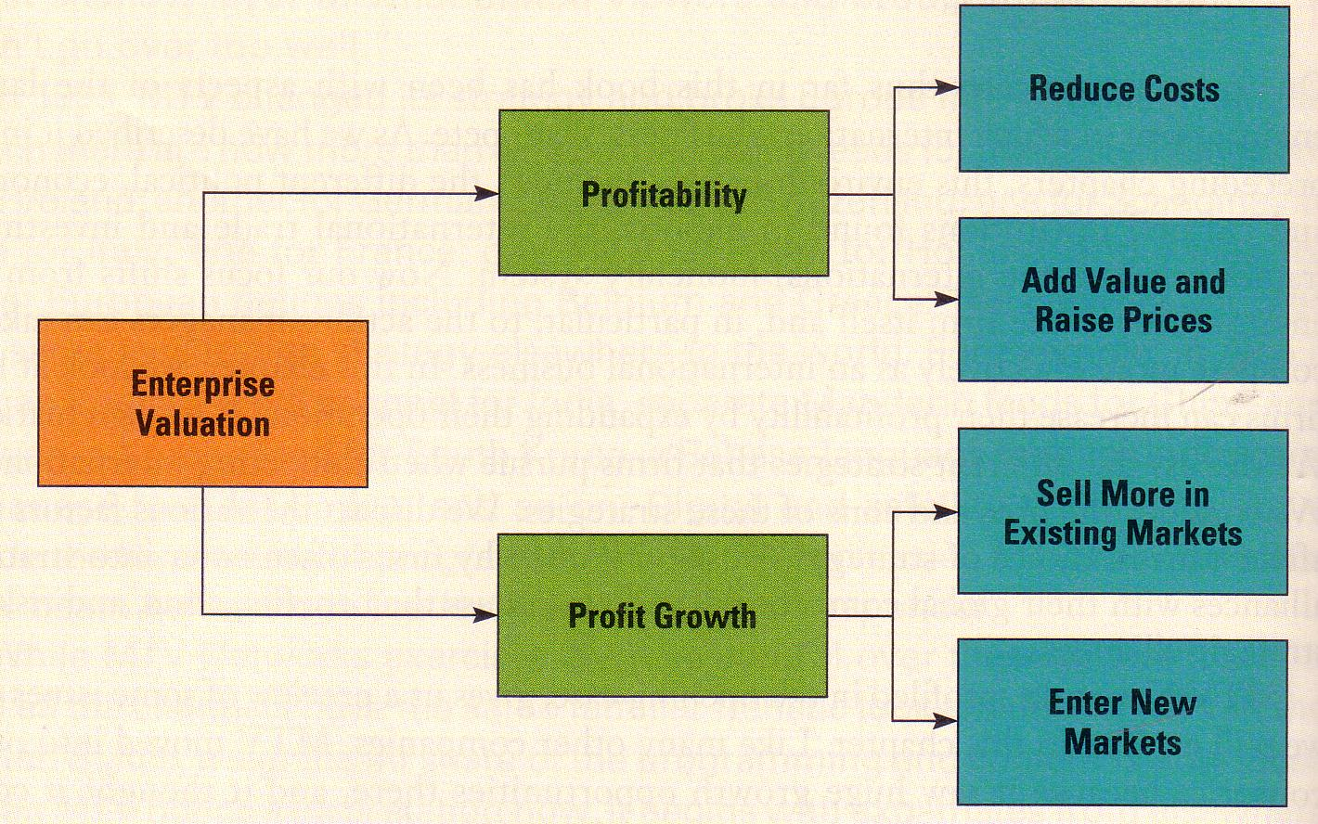
Value Creation

The way to increase the profitability of a firm is to create more value.

The amount of value a firm creates is measured by the difference between its costs of production and the value that consumers perceive in its products.

In general, the more value customers place on a firm's products, the higher the price the firm can charge for those products.

The price a firm charges for a good or service is typically less that the value placed on that good by the customer.

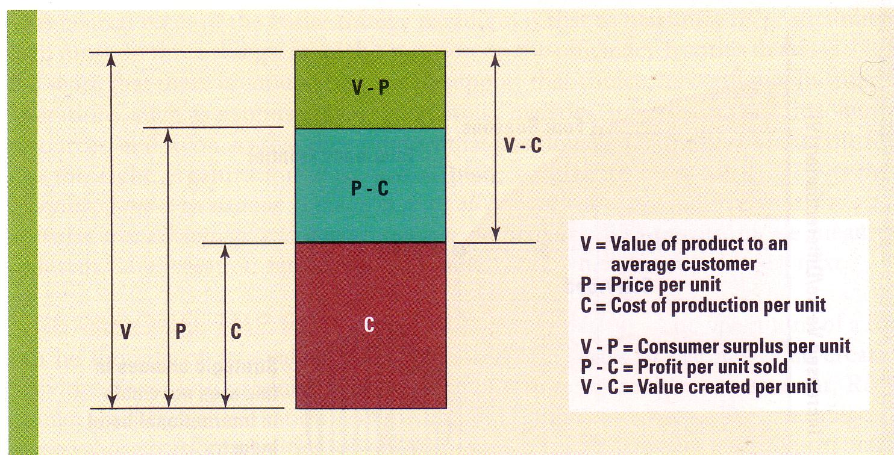
Michael Porter has argued that low cost and differentiation are two basic strategies for creating value and attaining a competitive advantage in an industry.

Superior profitability goes to those firms that can create superior value, and the way to create superior value is to drive down the cost structure of the business or differentiate the product in some way so that
consumers value it more and are prepared to pay a premium price.

Strategic positioning

Porter notes that it is important for a firm to be explicit about its choice of strategic emphasis with regard to value creation (differentiation) and low cost, and to configure its internal operations to support that strategic emphasis.

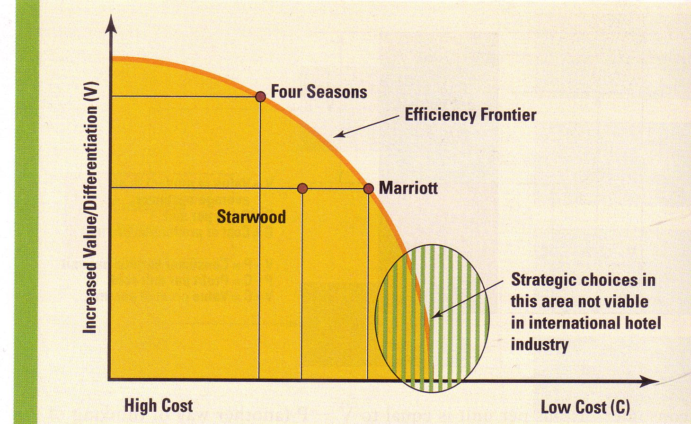
The efficiency frontier shows all of the different positions that a firm can adopt with regard to adding value to the product (V) and low cost (C), assuming that its internal operations are configured efficiently to support a particular position.

Three hotel firms with global presence that cater to international travellers are plotted. Four Seasons, Marriott International, and Starwood (Sheraton and Westin chains).

Four Seasons positions itself as a luxury chain and emphasizes the value of its product oferings, which drives up its costs of operations.

Marriott and Starwood are positioned more in the middle of the market. Both emphasize sufficient value to attract international business travellers, but they are not luxury chains.

Porter emphasizes that it is very important for management to decide where the company wants to be positioned with regard to value (V) and cost (C), to configure operations accordingly, and to manage them efficiently to make sure the firm is operating on the efficiency frontier.

To maximize its profitability a firm must do three things:

a) pick a position on the efficiency frontier that is viable in the sense taht there is enough demand to support that choice;

b) configure its internal operations, such as manufacturing, marketing, logistics, informations systems, human resources, and so on, so that they support that position;

c) make sure that the firm has the right organization structure in place to execute its strategy.

Operations: the firm as a value chain

The operations of a firm can be thought of as a value chain composed of a series distinct value-creation activities, including production, marketing and sales, materials management, R & D, human resources, information systems, and the firm infrastructure.
We can categorize these value-creation activities as primary activities and support activities.

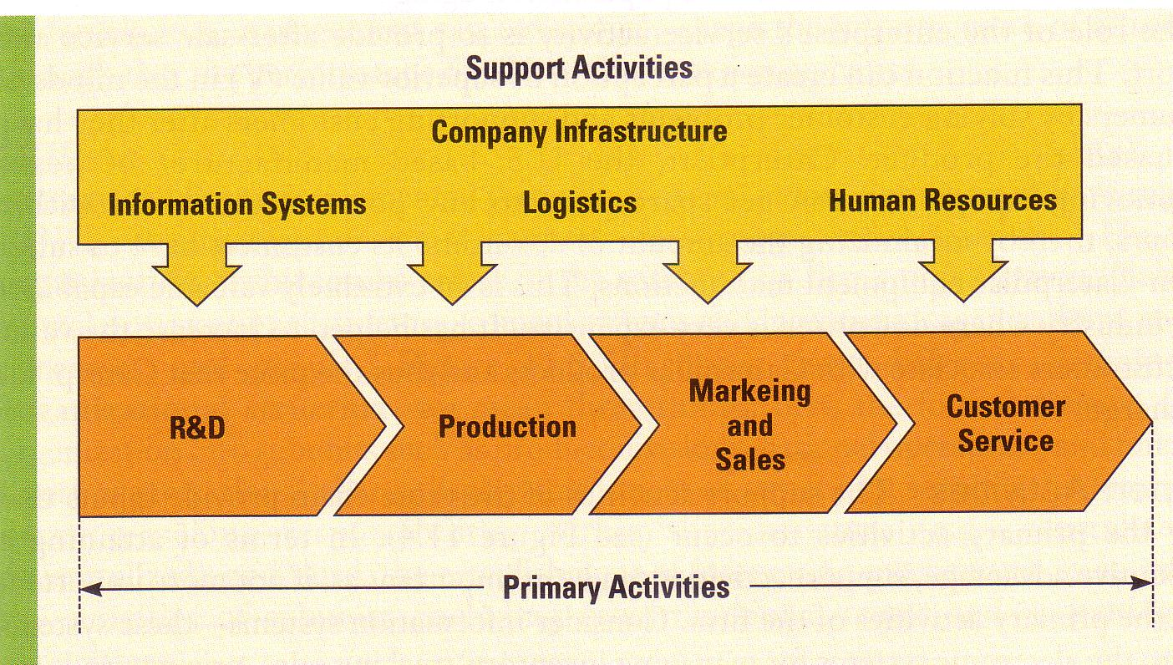
Primary activities

primary activities have to do with the design, creation, and delivery of the product: its marketing; and its support and after-sale service.

Primary activities are divided into four functions: research and development, production, marketing and sales, and customer service.

The production activity creates value by performing its activities efficiently so lower costs result, or by performing them in a such a way that higher-quality product is produced.

Marketing and sales functions can create value through brand positioning and advertising; or by discovering consumer needs and communicating them back to the R& D function of the company, which can then design products that better match those needs.

Support activities

support activities provide inputs that allow the primary activities to occur.

Information systems, when coupled with the communications features of the internet, can alter the efficiency and effectiveness with which a firm manages its other value-creation activities.

The logistics function controls the transmission of physical materials through the value chain, from procurement through production into distribution.

The human resources function can help create value;

- it ensures that the company has the right mix of people to perform its value-creation activities effectively;
- it ensures that people are adequately trained, motivated, and compensated to perform their value-creation tasks;

The company infrastructure includes the organizational structure, control systems, and culture of the firm.

Organisation: the implementation of strategy

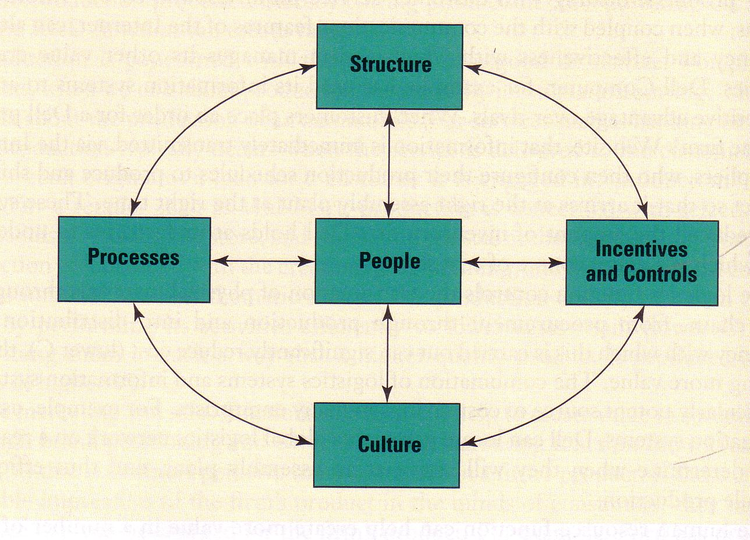
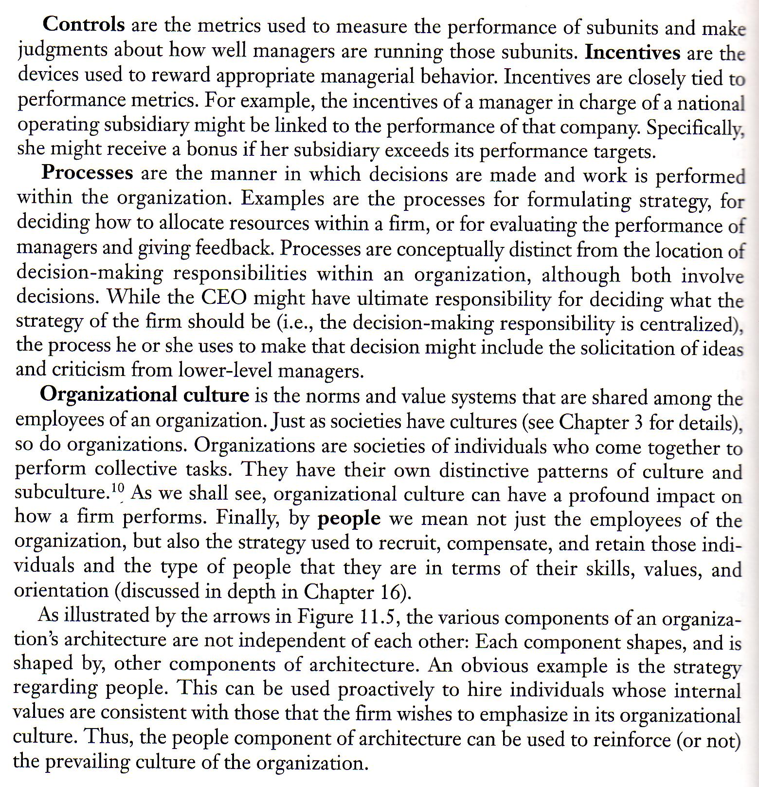

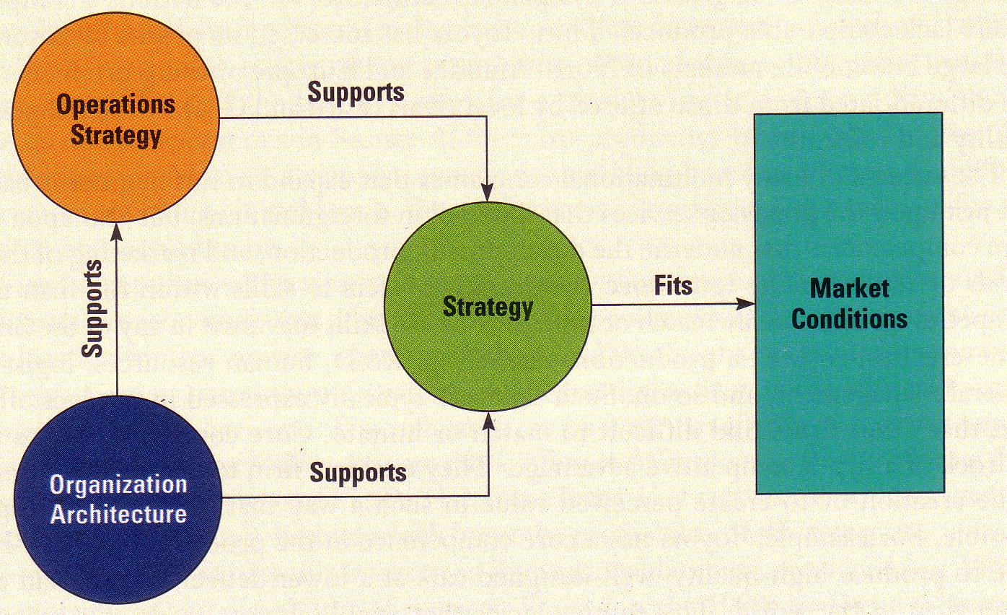
Market conditions, strategy, operations and organization must all be consistent with each other,or fit each other, for superior performance to be attained.

