The Case for government intervention

Political arguments for intervention

- Protecting jobs and industries from unfair foreign competition

I.e. Tariffs placed in imports of foreign steel by the US in 2002 to -protect the US steel industry.

Consequences: raised steel prices for the automobile companies, making them less competitive in the global marketplace.

- National security

Countries that certain industries are important for national security. Defense-related industries such aerospace, advanced electronics, semiconductors.

- Retaliation

Some argue that governments should use the threat to intervene in trade policy as a bargaining tool to help open foreign markets and force trading partners to play by the rules of the game.

If it works, such a politically motivated rationale for government intervention may liberalize trade and bring with it resulting economic gains.

It is a risky strategy; a country that is being pressured may not back down and instead may respond to the imposition of punitive tariffs by raising trade barriers of its own.

- Protecting consumers

Many governments have long had regulations to protect consumers from unsafe products.

The indirect effect of such regulations often is to limit or ban the importation of such products.

In the following country focus we see how the European Union banned the sale and importation of hormone-treated beef. The ban was motivated by a desire to protect European consumers from the possible health consequences of eating meat from animals treated with growth hormones.

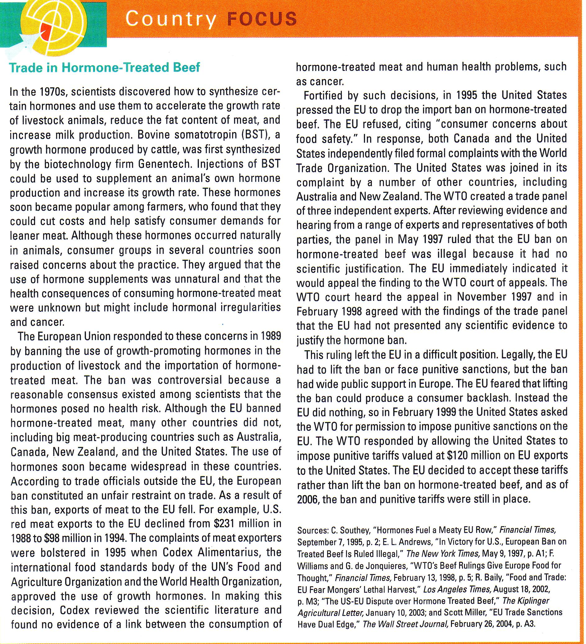

- Furthering foreign policy objectives

Governments sometimes use trade policy to support their foreign policy objectives.

A government may grant preferential trade terms to a country with which it wants to build strong relations.

Trade policy has also been used to pressure or punish rogue states that do not abide by international law of norms.

- Protecting human rights

Protecting and promoting human rights in other countries is an important element of foreign policy for many democracies.

Governments use trade policy to try to improve the human rights policies of trading partners.

Some argue that trade policy should be used as a political weapon to force a country to change its internal policies toward human rights.

Others contend that limiting trade to change such countries would make matters worse, not better. They argue that the best way to change its internal human rights stance of a country is to engage it through international trade.

Growing bilateral trade raises the income levels of both countries, and as a state becomes richer, its people begin to demand, and generally receive, better treatment with regard to their human rights.

Economic arguments for intervention

- The infant industry argument

many developing countries have a potential comparative advantage in manufacturing, but new manufacturing industries cannot initially compete with established industries in developed countries.

Governments should temporarily support new industries(with tariffs, import quotas, and subsidies) until have grown strong enough to meet international competition.

Many economists remain critical of this argument for two main reasons.

a) Protection of manufacturing from competition does no good unless the protection helps make the industry efficient.

b) Firms are unable to make efficient long-term investments by borrowing money from domestic or international capital market, hence government are required to subsidize long-term investments.

Given the development of global capital market this assumption looks no longer valid.

- Strategic trade policy

The new trade policy argues that in industries in which the existence of substantial economies of scale implies that the world market will profitability support only a few firms, countries may predominate in the export of certain products simply because they had firms that were able to capture first-mover advantages. (i.e. Boeing)

a) A government can raise national income if it can somehow ensure that the firms that gain first-mover advantages in an industry are domestic rather than foreign enterprises. (Japan's dominance of LCDs)

b) It might pay to intervene in an industry by helping domestic firms to overcome the barriers to entry created by foreign firms that have already reaped first-mover advantages. (i.e. Airbus)

