Global production, outsourcing,logistics

Production refers to the activities involved in creating a product.

Logistics is the activity that controls the transmission of physical materials, from procurement through production and into distribution.

Where to produce

other things being equal, a firm should locate its various manufacturing activities where the economic, political, and cultural conditions, including relative factor costs, are conducive to the performance of those activities.

Also important in some industries is the presence of global concentrations of activities at certain locations. Externalities include the presence of an appropriately skilled labour pool and supporting industries.

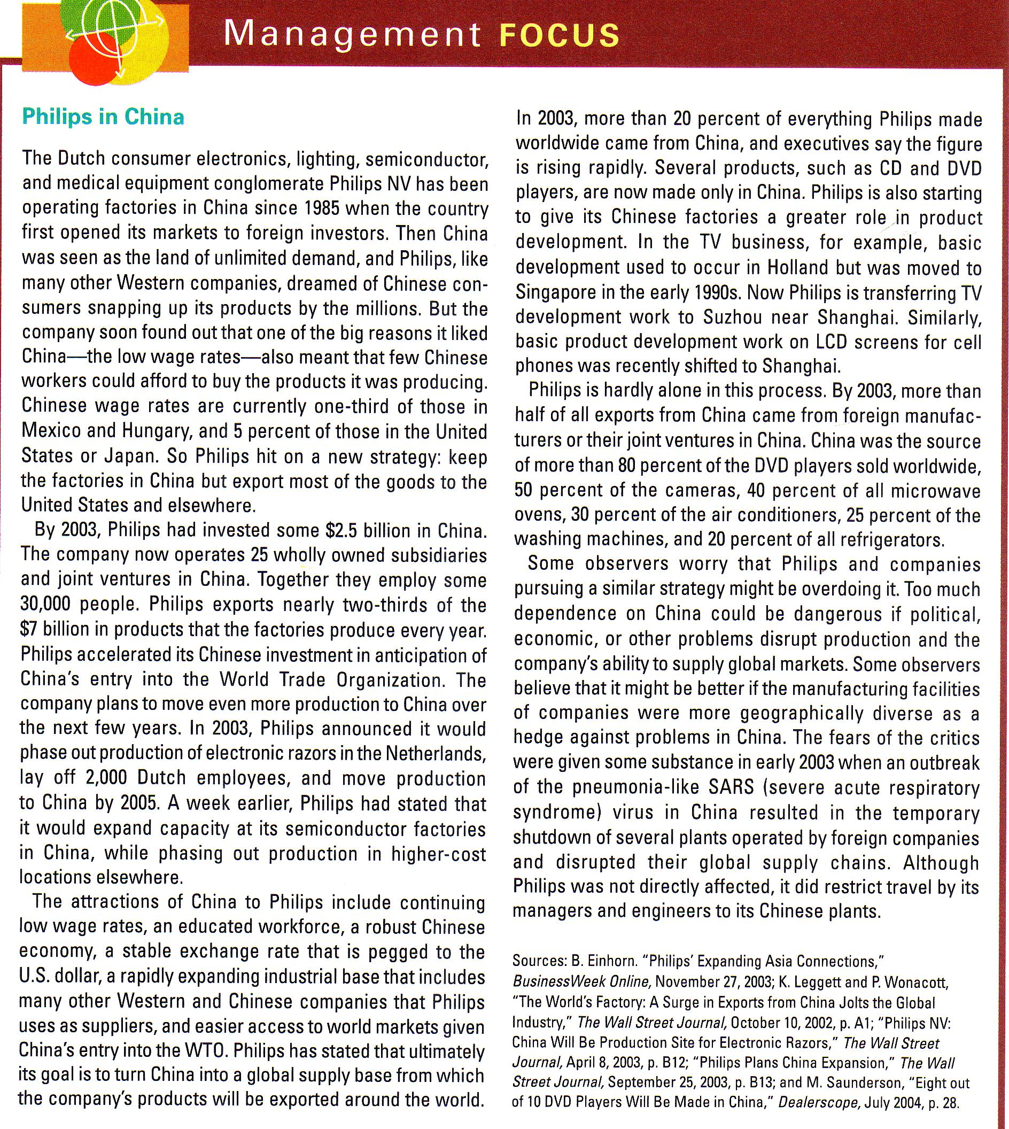

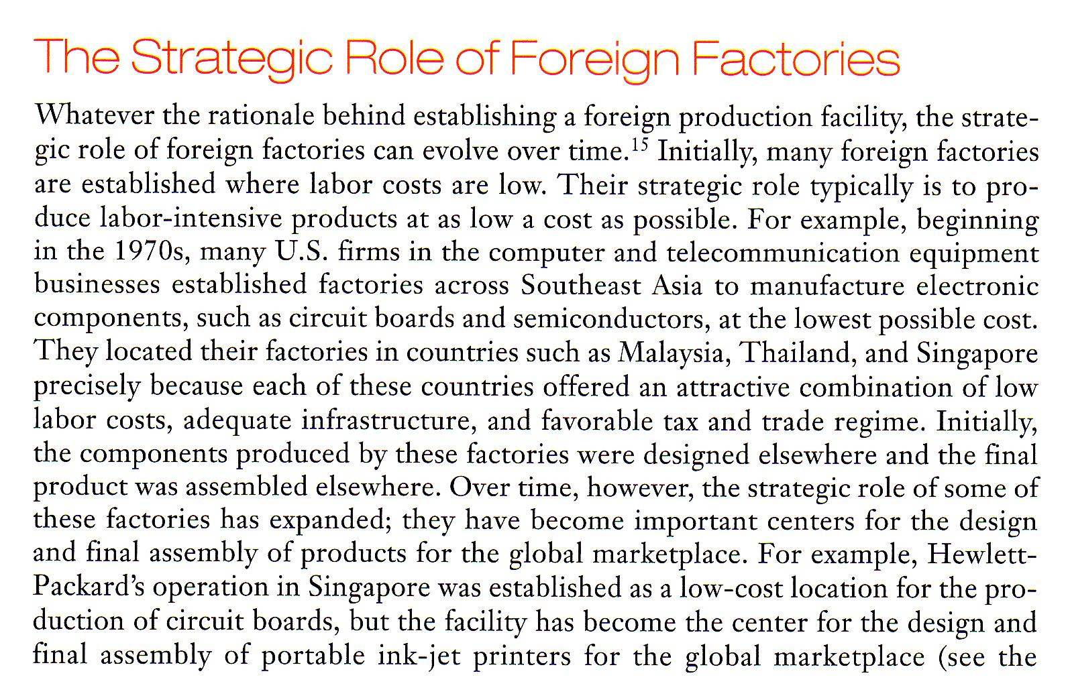

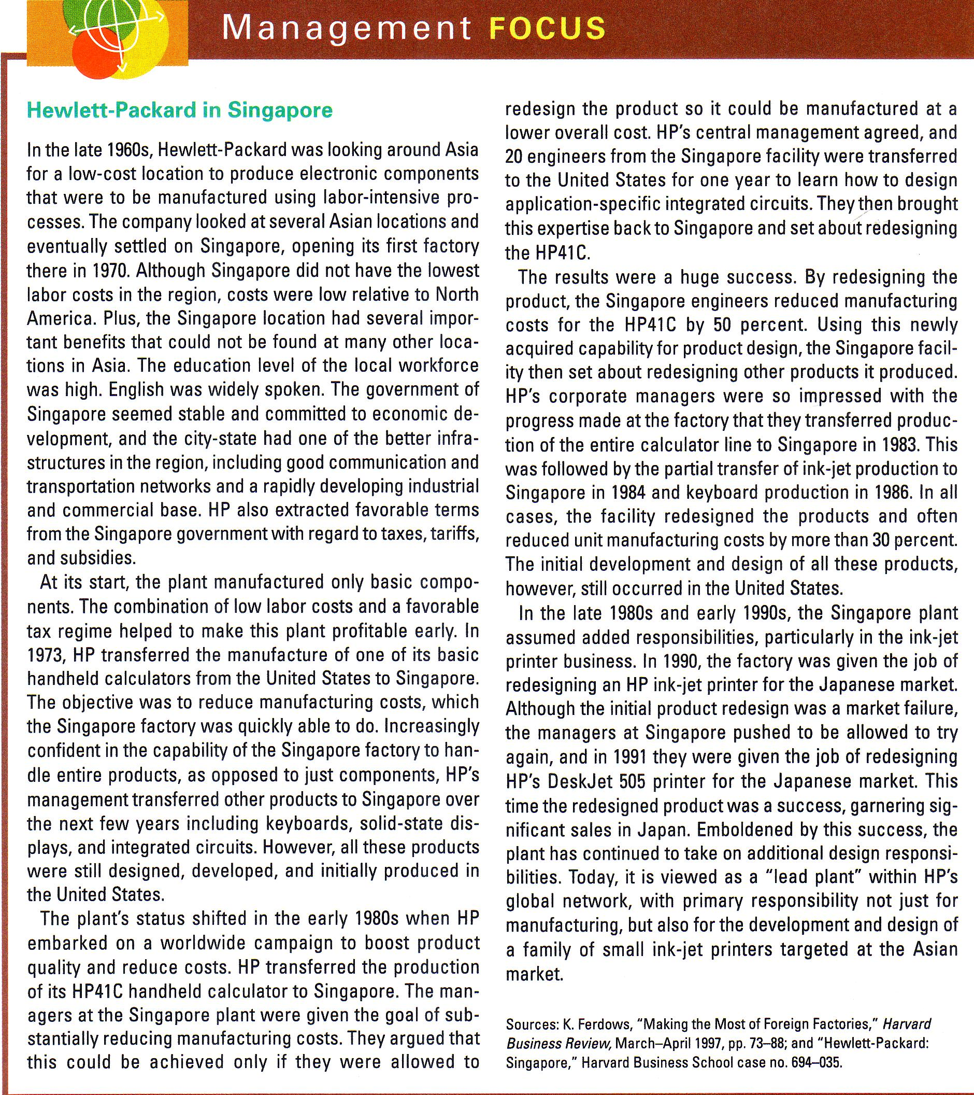
Outsourcing the pros and cons


