Demand and supply

Objectives :

Distinguish between quantity demanded and demand and explain what determines demand.

Distinguish between quantity supplied and supply and explain what determines supply.

Explain how demand and supply determine price and quantity in a market and explain the effects of changes in demand and supply.

Explain how price ceilings, price floors, and sticky prices cause shortages, surpluses, and unemployment.
The law of demand

Other things remaining the same, if the price of a good rises, the quantity demanded of that good decreases; if the price of a good falls, the quantity demanded of that good increases.

Why does the quantity demanded increase if the price falls?

The answer is that faced with a limited budget,people always have an incentive to find the best deals they can.

Demand schedule and demand curve

Demand is the relationship between the quantity demanded and the price of a good when all other influences on buying plans remain the same.

The quantity demanded is one quantity at one price.

A demand schedule is a list of the quantities demanded at each different price.

A demand curve is a graph of the relationship between the quantity demanded of a good and its price.

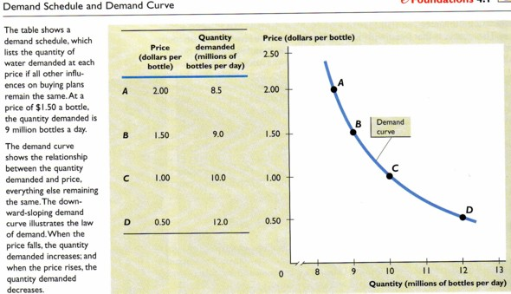
Changes in demand

The demand curve shows how the quantity demanded changes when the price changes but all other influences on buying plans remain de same.

When the price change the result is a change in the quantity demanded.

When any influence on buying plans other than the price of the good changes, there is a change in demand.

- Prices of related goods

A change in the price of one good can bring a change in the demand for a related good.

A substitute for a good is another good that can be consumed in its place. (butter:margarine, taxi: subway)

The demand for a good increases if the price of one substitutes rises; the demand for a good decreases if the price of its substitutes falls.

A complement of a good is another good that is consumed with it. (hamburger: fries)

The demand for a good decreases if the price of one its complements rises; and the demand for a good increases if the price of one of its complements falls.

- Income

A good is a normal good if a rise in income brings an increase in demand and a fallin income brings a decrease in demand.

A good is inferior good if a rise in income brings a decrease in demand and a fall in income brings an increase in demand.

- Expectations

Expected future income and prices influence demand.

- Number of buyers

The greater the numbers of buyers in a market, the larger is demand.

- Preferences.

When preferences change, the demand for one item decreases and the demand for another increases.

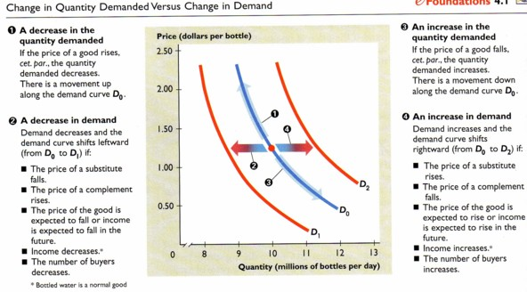
Practice problem
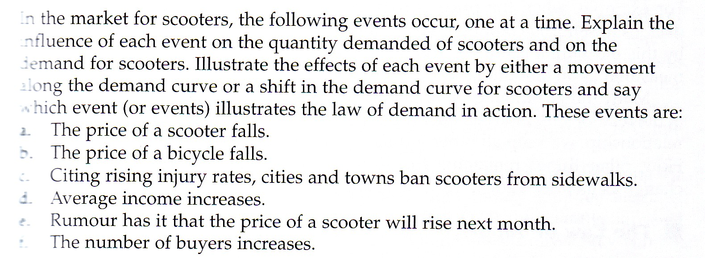

Supply

Quantity supplied
The amount of any good, service, or resource that people are willing and able to sell during a specified period at a specified price.

The law of supply
Other things remaining the same, if the price of a good rises, the quantity supplied of that good increases; and if the price of a good falls, the quantity supplied of that good decreases.

Supply schedule and supply curve
Supply is the relationship between the quantity supplied and the price of a good.

The quantity supplied is one quantity at one price.

A supply schedule lists the quantities supplied at each different price.

A supply curve is a graph of the relationship between the quantity supplied of a good and its price.

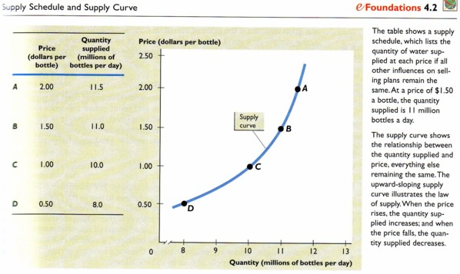
Changes in supply

When the price changes the results is a change in the quantity supplied.

When any influence on selling plans other than the price of the god changes, there is change in supply.

The main influences on selling plans that change supply are:

- Prices of related goods

A substitute in production for a good is another good that can be produced in its place. The supply of a good decreases if the price of one of its substitutes in production rises; and the supply of a good increases if the price of one of its substitutes in production falls.

A complement in production of a good is another good that is produced along with it. Leather is a complement in production of beef. The supply of a good increases if the price of one of its complements in production rises; and the supply of a good decreases if the price of one of its complements in production falls.

- Prices of resources and other inputs

Supply changes when the price of a resource or other input used to produce the good changes. The reason is that resource and input prices influence the cost of production. The more it costs to produce a good, the smaller is the quantity supplied of that good.

- Expectations

Expectations about future prices influence supply.

If you think input prices are going to go up you might want to produce more now.

If you think selling prices are going to go up, you might want to wait to sell a good. (reduce the supply now increase the supply later)

- Number of sellers

The greater the number of sellers in a market, the larger is supply.

- Productivity

Productivity is output per unit of input. An increase in productivity lowers costs and increases supply.

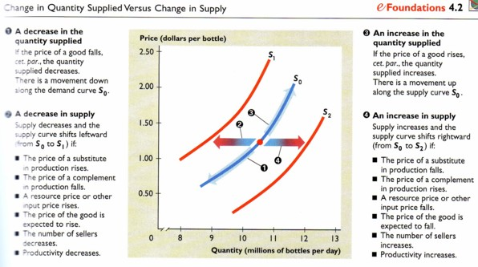
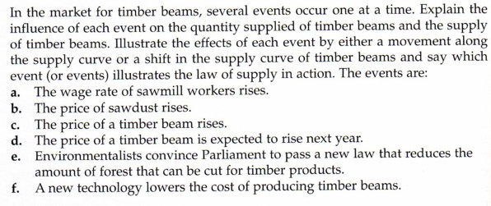
Market equilibrium

Market equilibrium occurs when the quantity demanded equals the quantity supplied.

The equilibrium price is the price at which the quantity demanded equals the quantity supplied.

The equilibrium quantity is the quantity that is bought and sold at equilibrium price.

Equilibrium price and quantity
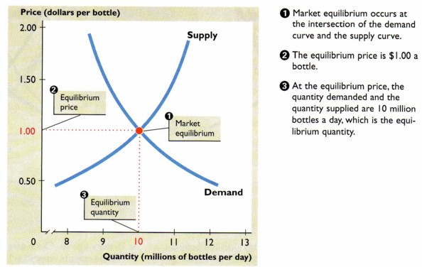
Price: a market’s automatic regulator

When there is a shortage, the price rises; and when there is a surplus, the price falls.

Price is the regulator that pulls the market towards its equilibrium.

If the price is above the equilibrium price, there is a surplus or excess supply—the quantity supplied exceeds the quantity demanded—and the price falls.

If the price is below the equilibrium price, there is a shortage or excess demand—the quantity demanded exceeds the quantity supplied—and the price rises.

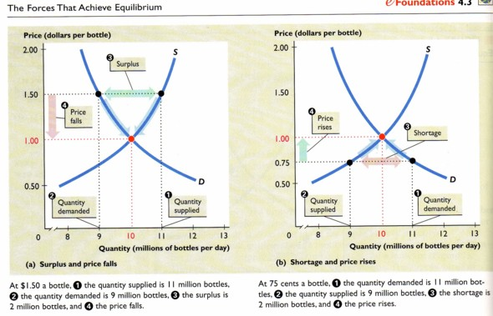
Effects of changes in Demand

Markets are constantly hit by events that change demand and supply and bring changes in price and quantity.

Some events change only demand, some change only supply, and some change both demand and supply.

When demand changes, there is no change in supply. But there is a change in the quantity supplied—a movement along the curve.

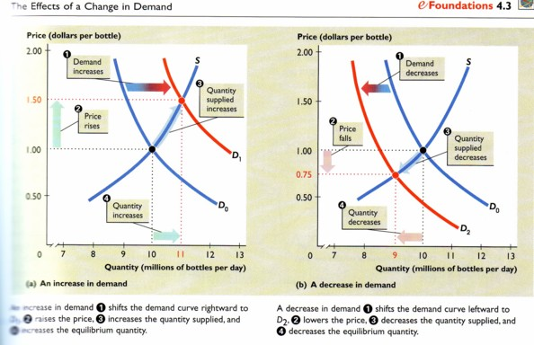
Effects of changes in supply
When supply changes, there is no change in demand. But there is a change in the quantity demanded—a movement along the demand curve.
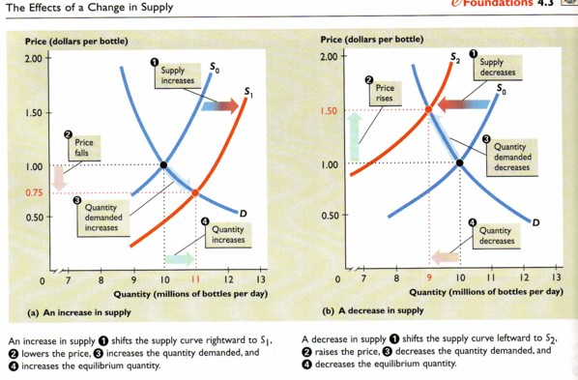
Changes in both demand and supply

Often, in real markets, events occur that change both demand and supply.

Increase in demand and increase in supply.

When demand and supply increase together, the equilibrium quantity increases. But an increase in demand raises the price, and an increase in supply lowers the price. (Change in equilibrium price is ambiguous)

Decrease in demand and decrease in supply.

A decrease in demand decreases the quantity, and a decrease in supply decreases the quantity.But a decrease in demand lowers the price, and a decrease in supply raises the price. (Change in equilibrium price is ambiguous.)

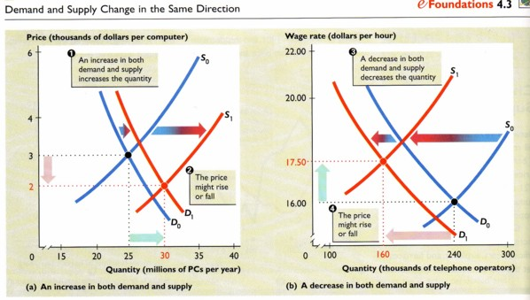
Increase in demand and decrease in supply

When demand increases, the price rises. When supply decreases, the price rises.

So when demand increases at the same time as supply decreases, the equilibrium price rises.

But an increase in demand increases the quantity, and a decrease in supply decreases the quantity. (the new equilibrium quantity is ambiguous.)

Decrease in demand and increase in supply

When demand decreases, the price falls. When supply increases, the price falls.

So when demand decreases at the same time as supply increases, the equilibrium price falls.

But a decrease in demand decreases the quantity, and an increase in supply increases the quantity. (the new equilibrium is ambiguous.)
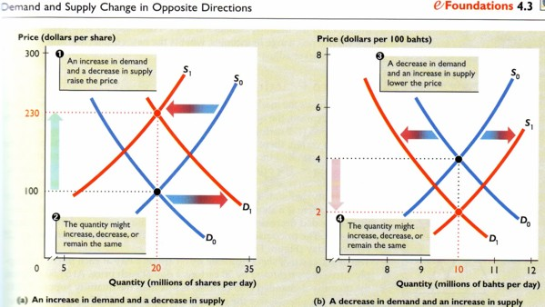
Parctice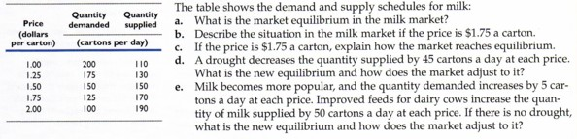
Price rigidities

Price ceiling
A price ceiling is the highest price at which it is legal to trade a particular good, service, or factor of production.

An example is rent ceiling on houses and apartments—a law that makes it illegal for landlords to charge a rent that exceeds a set limit.

Price floor
A price is the lowest price at which it is legal to trade a particular good, service, or factor of production.

An example is the minimum wage lwa, which is a government regulation that makes hiring for less than a specified wage illegal.
A rental apartment market | A rent ceiling creates a shortage of apartments
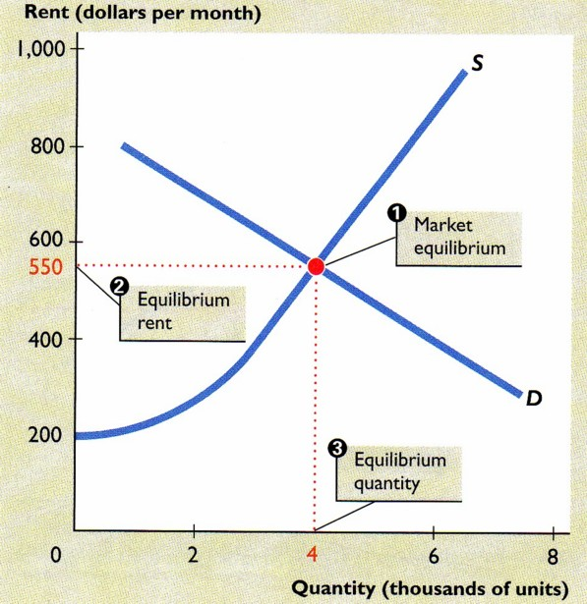 | 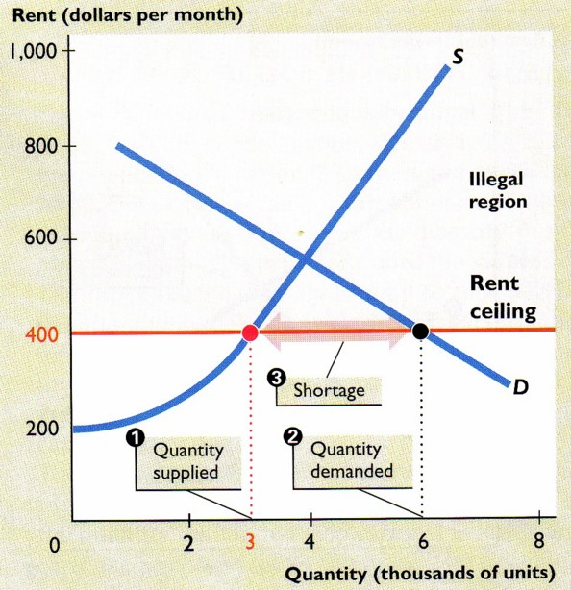
1)market equilibrium is determined by the demand for apartmetns and the supply of apartments for rent.  2) The equilibrium rent is $550 a month.  3) At the equilibrium rent, the equilibrium quantity of apartments rented is 4 000. | - The quantity of apartments supplied decreases.  - The quantity of apartments demanded increases to 6000  - A housing shortage of 3000 apartments arises.
A market for fast-food servers | A minimum wage creates unemployment
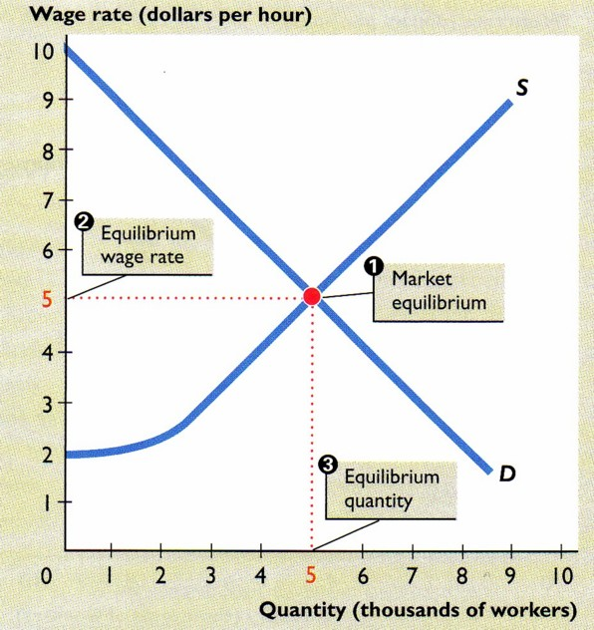 | 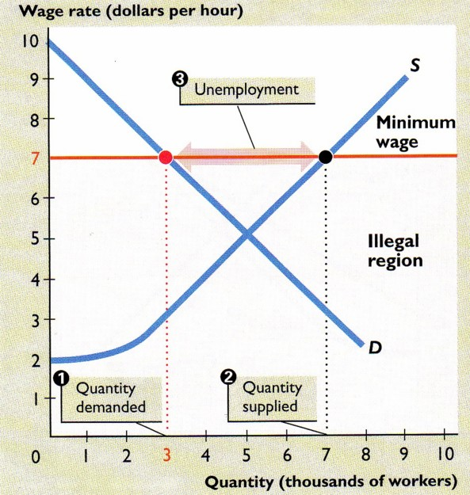
- market equilibrium is determined by the demand for and the supply of fast-food servers.  - The equilibrium wage rate is $5 an hour.  - At the equilibrium wage rate, the equilibrium quantity of fast-ffod servers is 5,000. | - The quantity of labour demanded decreases to 3, 000  - The quantity of labour supplied increases to 7,000  - 4,000 people are unemployed.
Practice
