Business ownership

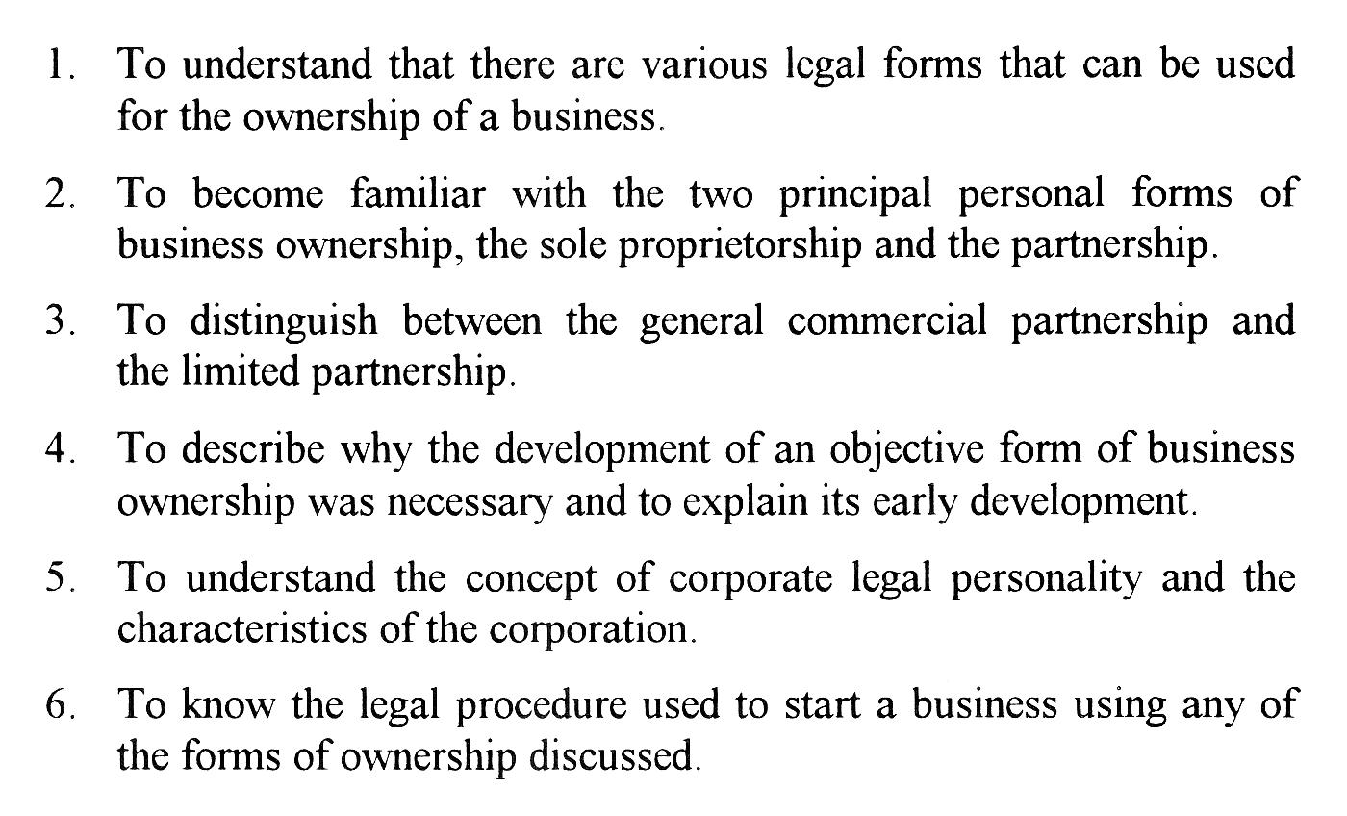
The operation of a business involves the transacting of a series of acts of commerce by a merchant, generally with the object of earning a profit.

By contrast, an individual who enters into a single isolated transaction which is not part of a continuing series would not be a merchant, and the transaction would merely be a private undertaking, for it would not be part of an organized economic activity.

People considering a business have to decide which of the various forms best suits their objectives. In selecting a particular form of business ownership, the factors that must be evaluated include the nature of the transactions to be carried out, the funds required (and available) to begin the business, the type of work to be done, and the number of people to be involved.

The forms of business ownership most frequently used in Canada include:

- sole proprietorship
- partnership
- corporation

The sole proprietorship

1 )Description

The most common form for business start-ups.

It encompasses any and all enterprise undertaken by one single individual, who remains the sole owner and retains full authority to manage the administration of the enterprise.

Entrepreneurs, select this form of business ownership when they have very limited capital or choose to maintain only a part-time participation in the enterprise, and do not wish to take on partners or invest capital for incorporation.

It is the most common form because it is the least complex form.

A person can begin the operation of an enterprise using his or her own personal name( not a business name), in Québec without any formalities whatever.

There may, however, be requirements for a business to obtain a licence from the municipal authorities.

1.1) Characteristics

1.1.1Start-up (registration)

Any person who carries on business registers this fact with the Québec government authorities.

A special form provided for this purpose is filed along with the required fees. An annual update is also required and a fee paid each year.

The only exception to this requirement is the person who is using only his or her own personal name as the name of the business.

In this case, the person is not required to register but may do so voluntarily.

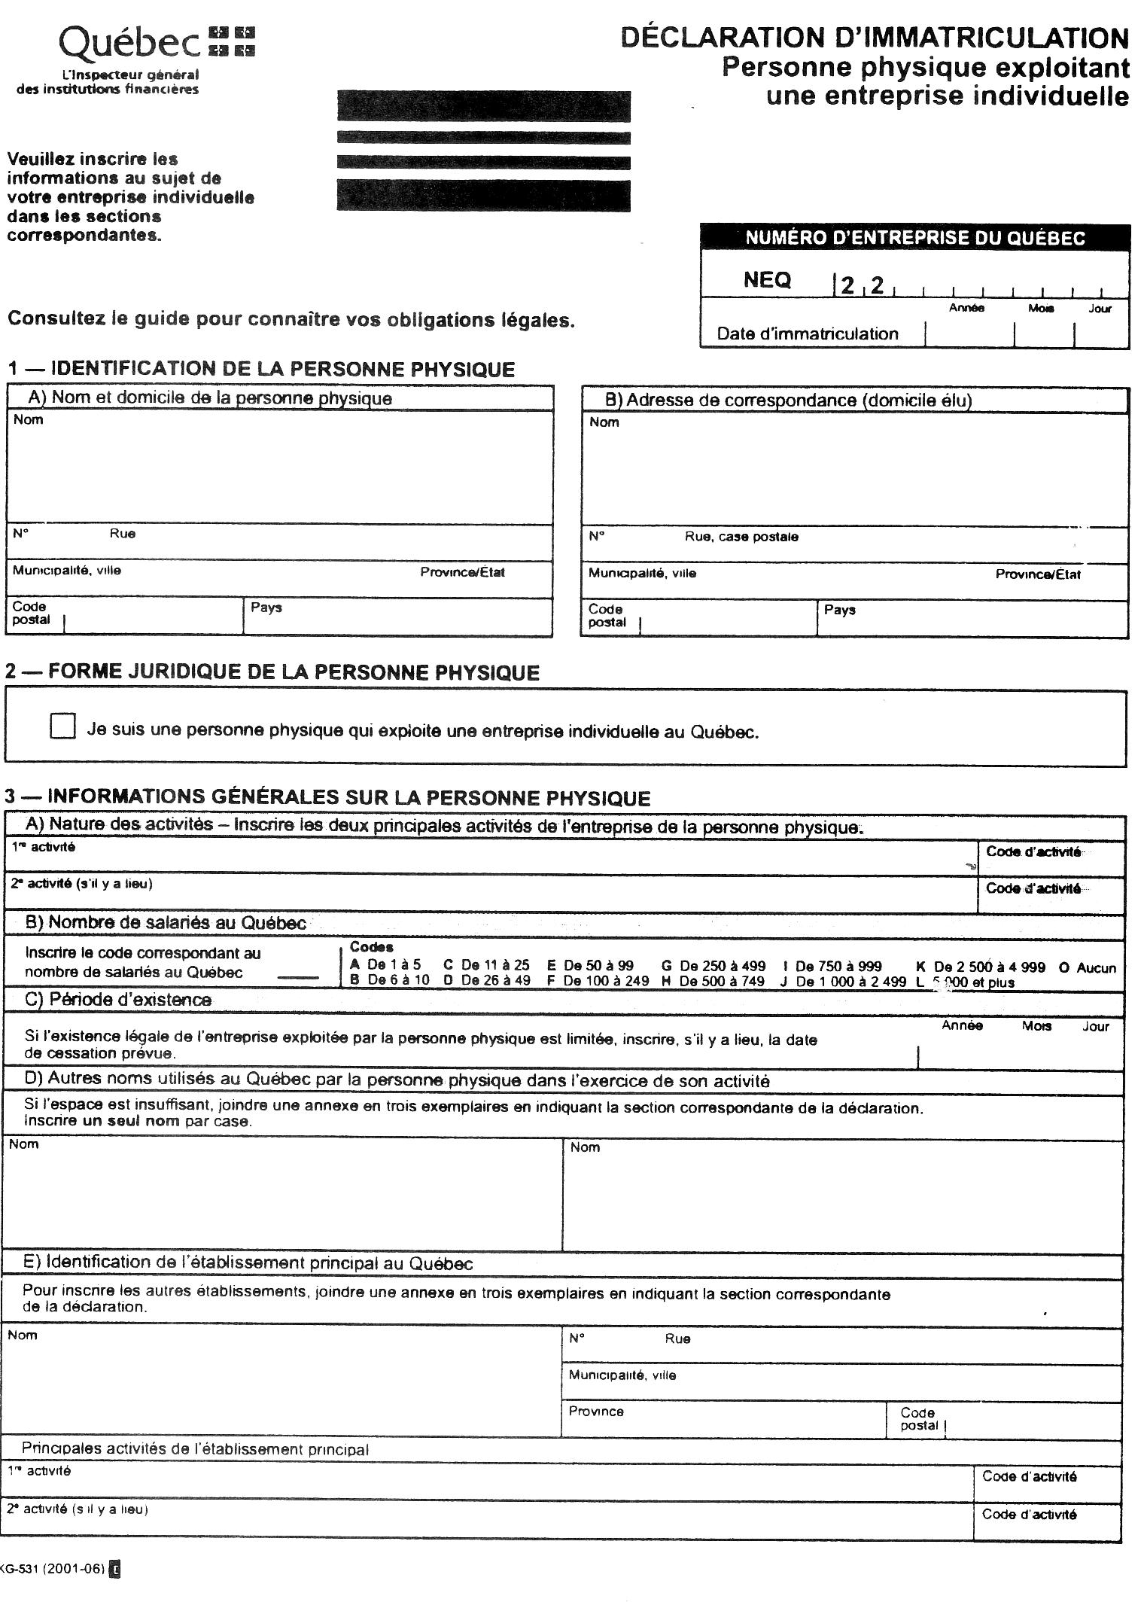
A business owner who wishes to use some other name to operate the business is therefore required by law to register a declaration at the court house.

Once registered, Declaration of Sole Proprietorship are kept in a specific office which is open to the public.

Other business people can use these declarations to find out who is behind any firm name, so that creditors may make a more informed decision about extending credit to a business they have not previously dealt with.

1.1.2 Ownership

- the owner

A sole proprietor is one individual who maintains complete, one hundred per cent, financial control and interest over the enterprise.

If an agreement should be made with another person to share the ownership, the legal form changes to partnership and exposes both to different rules and regulations.

This includes any sharing of ownership regardless of the percentage owned by each person.

- Transfer of ownership

Transfer of ownership is not possible.

Because the enterprise and the sole proprietor are considered to be one in the eyes of the law, ownership cannot be passed on to another person.

For instance, if a sole proprietor dies and an heir wishes to continue the activity, they must either inherit the assets or buy them from the estate and then register a new business ownership in their name.

1.1.3 Liability for debts

The sole proprietorship is a personal form of business ownership.

This means unlimited and personal liability for the debts of the business.

Any debts related to the operation of the business are considered to be the personal debts of the business owner.

All the property owned by the sole proprietor may be seized and sold, if need arises, in order to pay the debts of the business.

If a business becomes bankrupt, so does an owner whose personal assets are not sufficient to pay off the business debts.

The business and the owner are, in law, the same.

The debt incurred for the business, by the owner, remains even upon his or her death. All debts must be paid out of the owner's estate before a division can take place amongst surviving heirs.

1.1.4 Management

the sole proprietor is the one and only person who manages the business.

He or she makes all the decisions about every aspect of the business operation and does not have to consult anyone or obtain permission or agreement for any of the business activities.

1.1.5 profits

he or she is the owner of any profits earned.

These profits are considered as personal income of the business owner and are taxed accordingly.

1.1.6 termination

A sole proprietorship is terminated when the business owner dies or wishes to cease doing business.

The person remains responsible for any debts undertaken while carrying on the business.

A declaration should be registered stating that the person is no longer using the business name.

  - Advantages and disadvantages

Advantages | disadvantages
Simple registration—easily done by owner | Owner is personally liable for all debts—unlimited extent
Inexpensive to start—costs under $50 to register | Difficult to obtain outside financing
All profits belong to the owner | Depends only on skills of owner
All decision made by the owner | Lack of continuity
flexibility | No legal distinction between and business
Simple to dissolve | May be difficult to sell ''good will'' if reputation depends very heavily on the personality of the owner
Enjoyment and challenge of personal involvement | All profits are considered to be earned by the sole proprietor personally and are taxed at full personal income tax rates.
Operations and results can be kept secret

- the partnership

2.1 Description

When two or more people agree to operate a business together, this agreement forms a contract between them known as the Contract of Partnership.

Under the terms of this contract, which may be verbal or written, each of the partners agrees to contribute something to their common venture, and in return they share the profits (and also the losses) resulting from their efforts.

Essentially, a partnership is similar to several sole proprietors running one business together. They each have the advantages and responsibilities of a sole proprietor.

2.2 Characteristics(The general partnership)

2.2.1 start-up (registration)

All partnership are required to register a partnership declaration.

This document will identify the partners, the location and type of business they intend to operate.

This declaration becomes a public document and can be consulted by anyone interested in knowing who are the owners of a particular partnership business.
2.2.2 Ownership

- the owners

Ownership of the assets is determined by the partners themselves and may be included in the partnership Agreement.

The division of ownership does not have to be equal amongst all existing partners.

It is common for some partners to have a larger share of ownership over the other partners for whatever reason.

- Transfer of ownership

transfer is possible, but within limits.

The partners may agree on how to deal with each partner's share depending on the circumstances, such as death of one of the partners or if a partner wishes to cease his or her involvement in the enterprise.

(iii) liability for debts

The partners are the business and they each have unlimited, personal liability for the debts of their enterprise.

In a general partnership, if the business is unable to pay its debts from the assets used for the business, the partners will be called upon to pay these from their own personal assets.

Partners are solidarily liable for the partnership debts. Any one or more of the partners may be required to pay all or part of all or part of any debt owed by the business.

2.2.3 management

the partners will agree between themselves as to how the business is to be managed.

- How much time each partner will devote to the business

- what responsibilities each partner will have, e.g. Sales, production, financial management, etc.

- What happens if one of the partners becomes too ill to work in the business.

2.2.4 profits

The partners may agree between themselves as to whether they will be equal partners (each receiving the same share of the profits) or unequal partners with some other arrangement regarding the sharing of profits.

There is only one arrangement not permitted by the Civil Code and that is one which excludes a person from any share of the profits.

Such an arrangement is null. A partner must have some share in the profits, no matter how small.

The partner's share of the profits is considered as personal earnings an dis taxed as such.

2.2.5 termination

The partnership is a relatively fragile form of business ownership.

It can be terminated by the agreement of the partners, by bankruptcy of the business, or upon the accomplishment of its objective.

Some partnerships may be ended by the death or bankruptcy of one of the partners.

  - Characteristics (The limited partnership)

A special form of partnership is permitted for situations where some partners want to invest in the business, however they are prepared to leave the management to the other partners.

The limited partnership differs from the general partnership in the liability for debts and in the right to participate in the management of the business.

In a limited partnership, the general partners are solidarily liable for the debts to an unlimited, personal extent(just as in a general partnership.)

Special partners are liable for the debts only to the extent of a stipulated amount they have contributed to the partnership, and is stated in the partnership declaration.

If the amount is not stated, they are solidarily liable for all debts, along with the general partners.

The special partners are not permitted to take part in the day-to-day operation and running of the business. They must not take an active role in the regular management activities.

Advantages | Disadvantages
Simple registration—easily done by the partners themselves | Partners are personally liable for all debts and the liability is solidary (one partner may be require to pay all debts if the other partner(s) cannot or will not)
Inexpensive to start—costs under $ 50 to register | Lack of continuity
Profits shared only between the partners | Difficult to transfer ownership
Partners able to assist each other | Difficult to recover one's investment
Quite flexible | Requires a written agreement if partners do not share equally or if some partners are to be excluded from carrying out some of the functions of the business.
Simple to dissolve | Partner's share of profits taxed at full personal income tax rates
Limited partnership allows for some limitation of liability

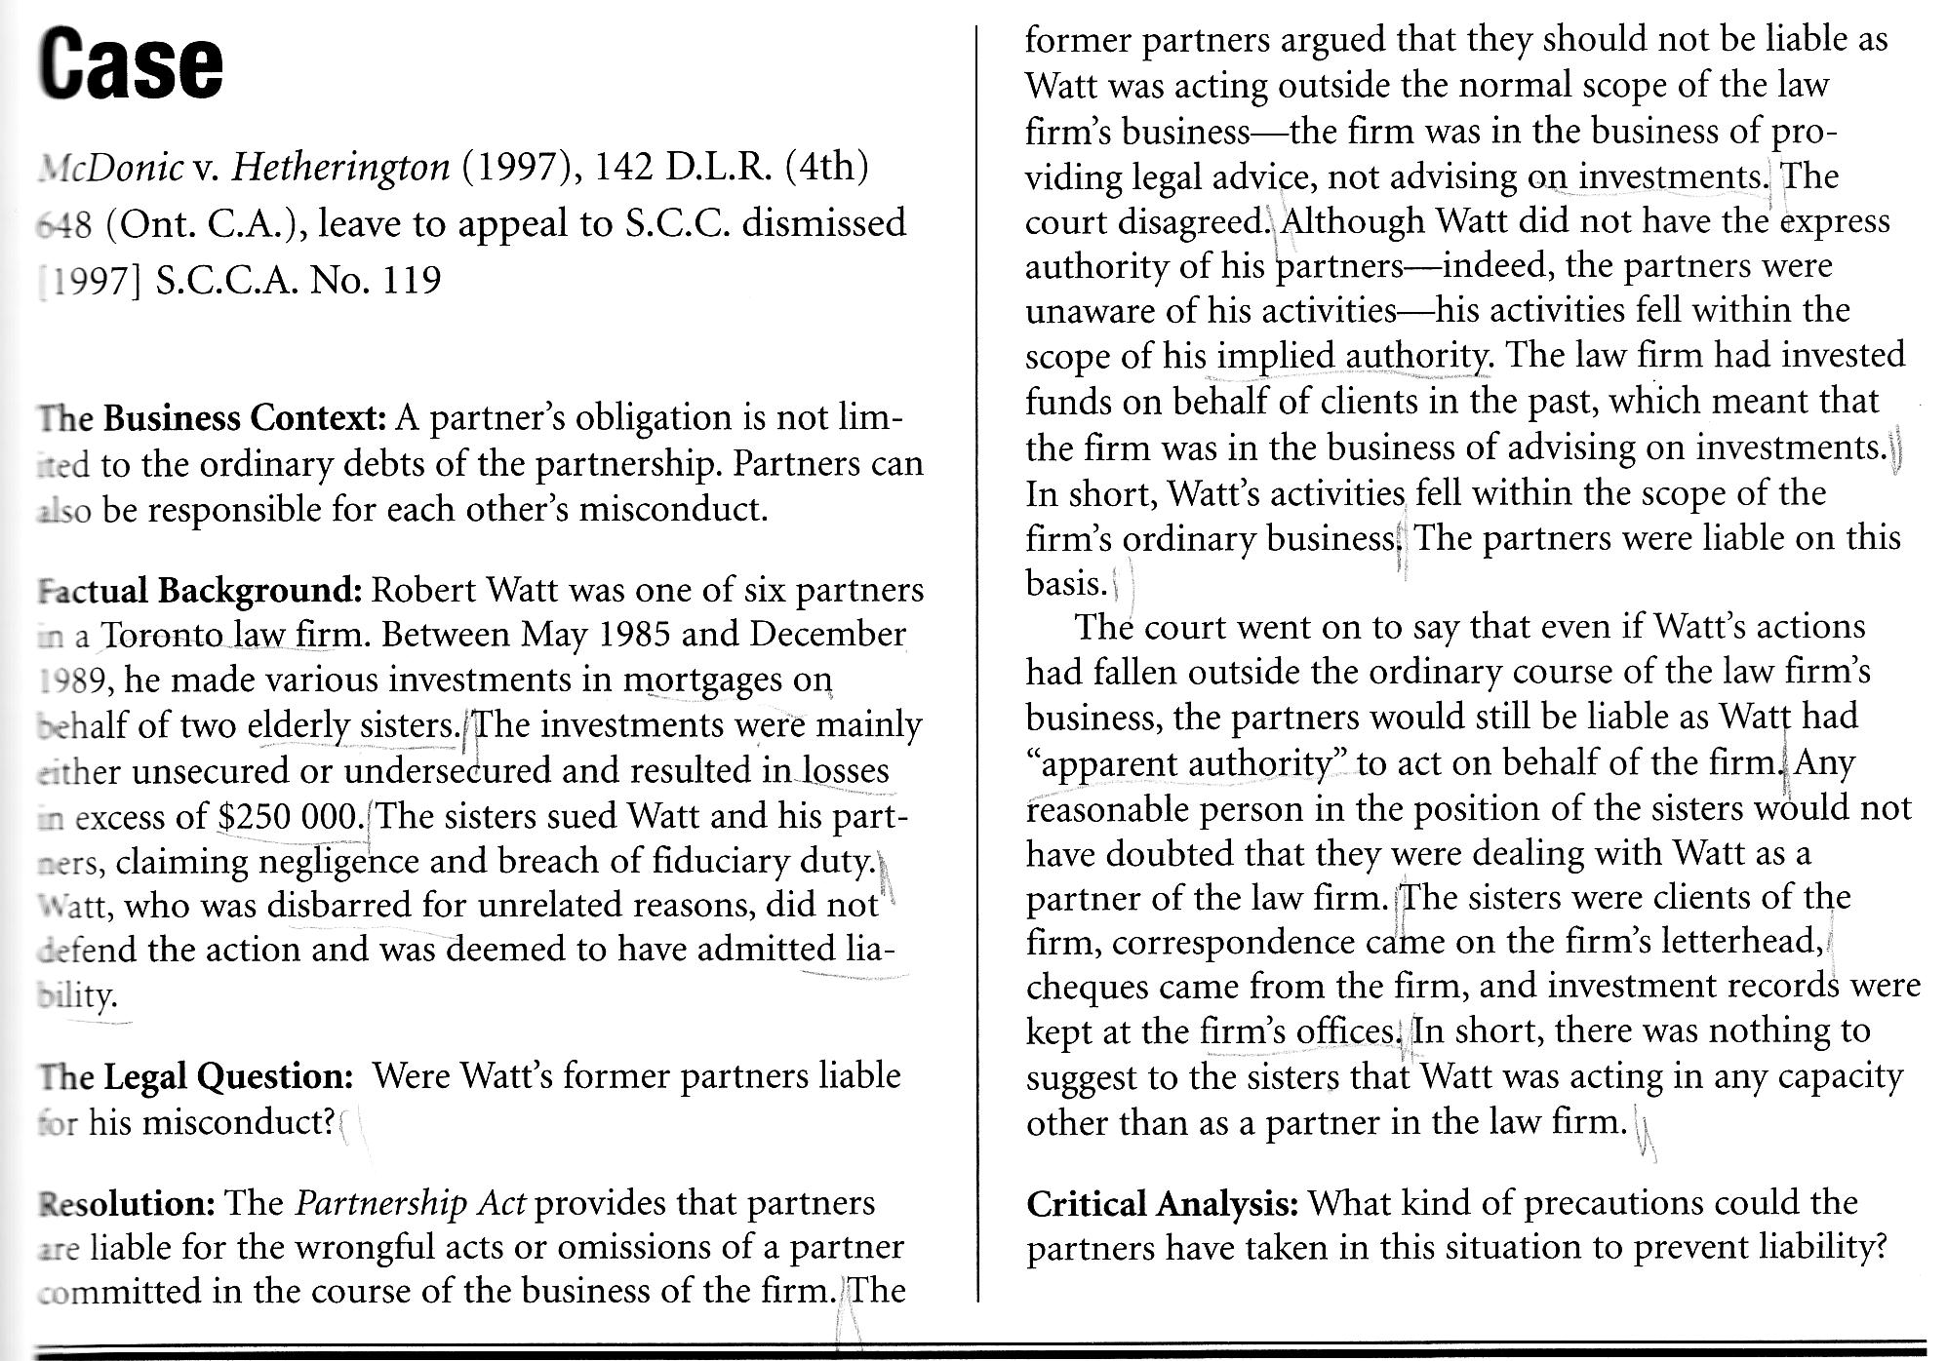
4 ) the corporation

4.1 background

In sole proprietorship and partnership, there is no legal distinction between the owners and the business—they are one and the same.

In most cases, these enterprises are relatively small.

The owners do not object to the personal liability because, as long as the business is small, their exposure to debt may not be great enough to wipe them out.

If the business owes $10 000 or $20 000, then even if conditions force them to close the business, they will likely be able to find the resources to pay off the debts without having to totally surrender their personal assets.

If the debt is $10 million, not many people would be prepared to take the same risk.

Before allowing a business to grow too large, the owners will look for some way to limit their liability for debts.

4.2 Characteristics

4.2.1 A separate legal person—an artificial or moral person.

The corporation form of business is created by the government as a separate legal person.

Obviously a corporation does not have a tangible existence in the same sense as a human being.

However, apart from those activities that are clearly impossible(e.g. Marriage, adoption, etc.) a corporation may engage in any activities or undertakings that are not prohibited by the law or by the application for incorporation.

A corporation may own assets, have debts, enter contracts, hire people, issue cheques, sell property, share its profits with its owners, become insolvent or bankrupt, sue in the courts, and be sued.

A corporation may even form or buy another corporation in whole or in part with other corporation.

The important point to note about a corporation's separate legal personality is that the owners, the people who set up the corporation, are not in any way liable for the corporation's debts.

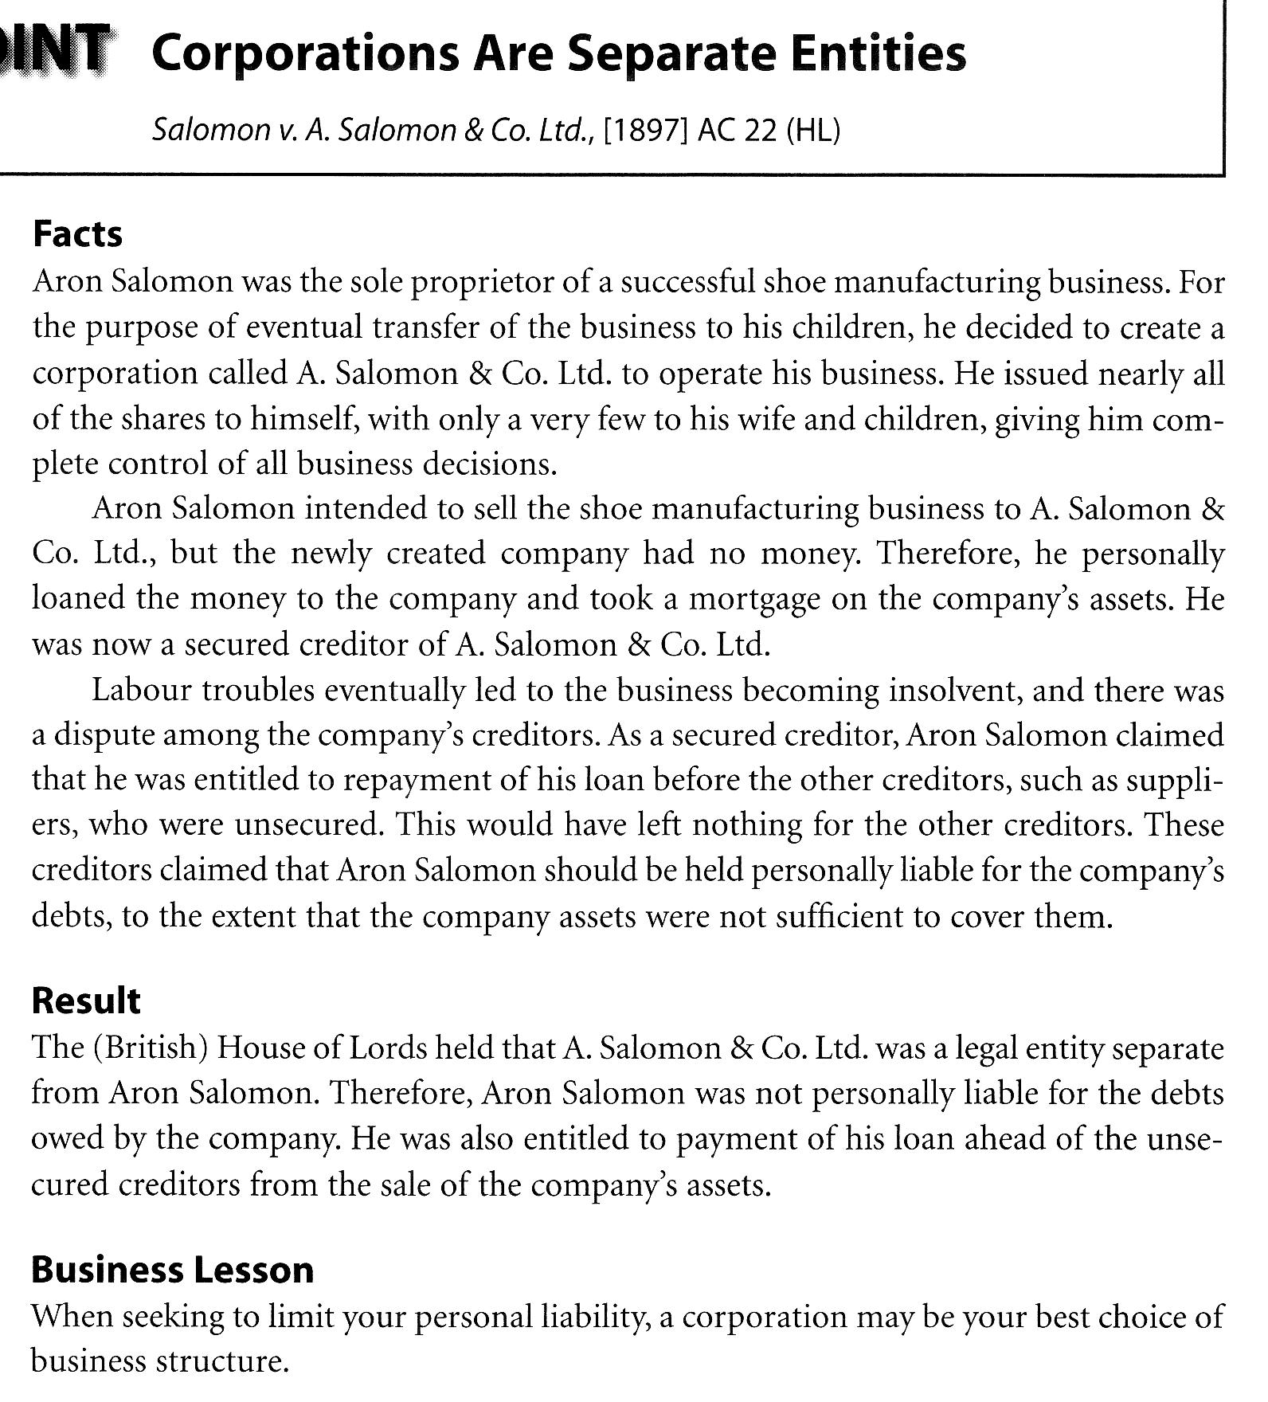
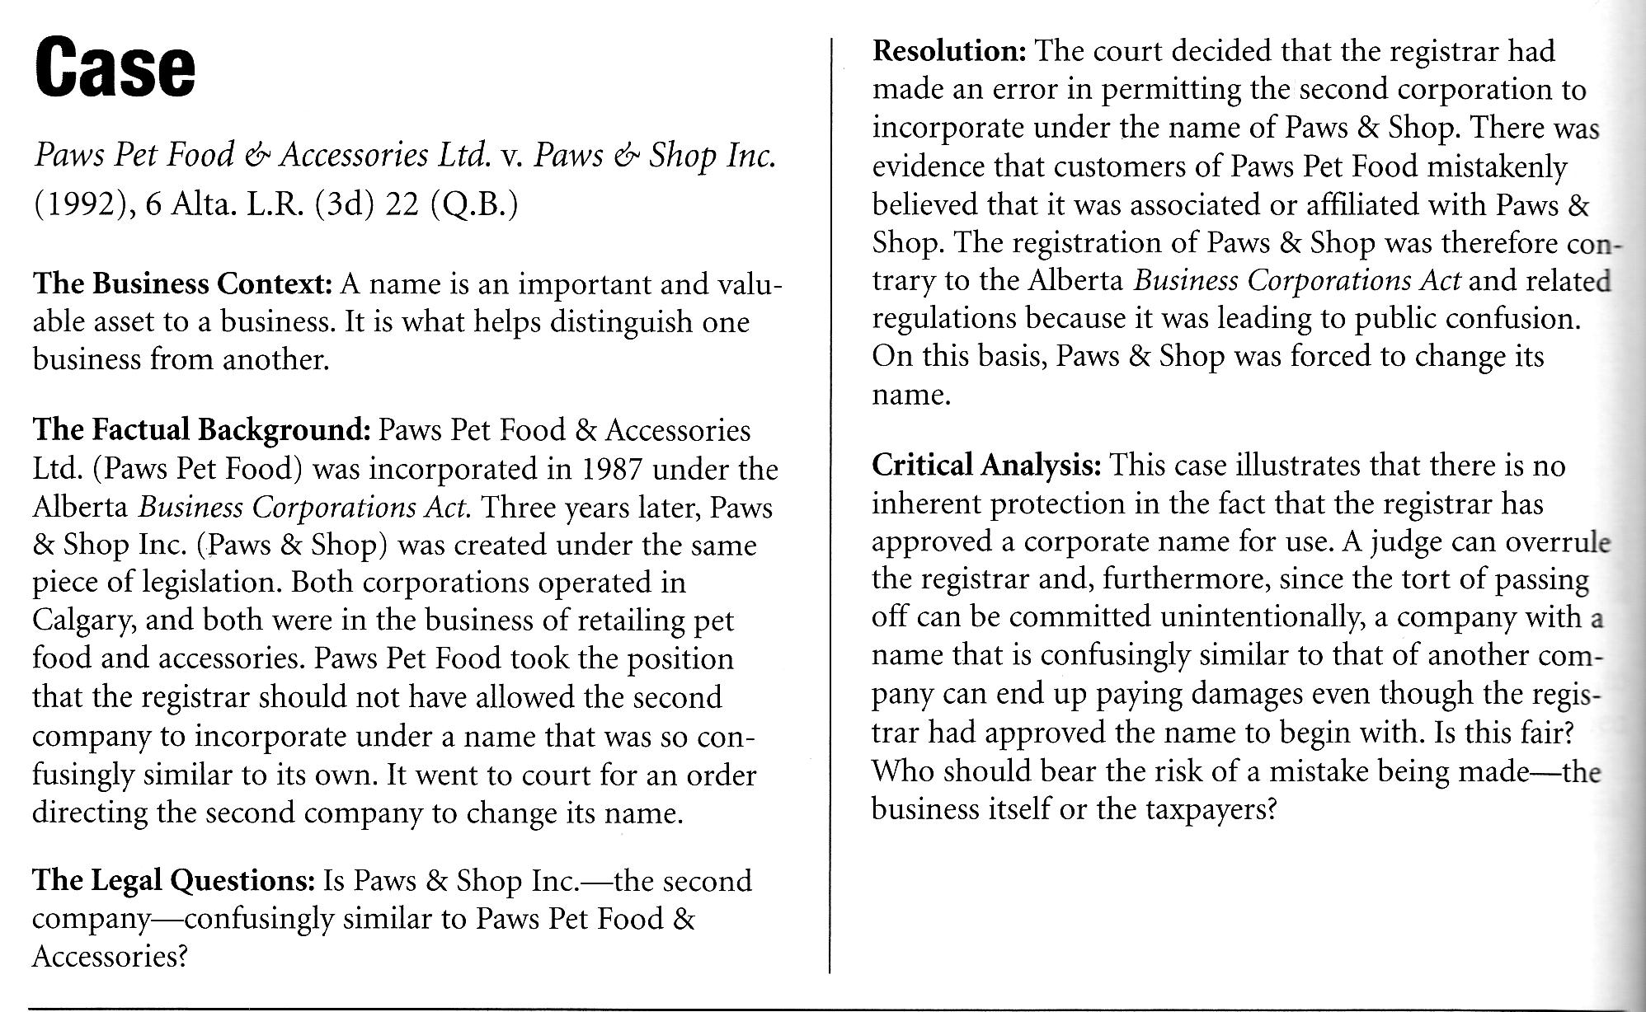
4.2.2 Definition

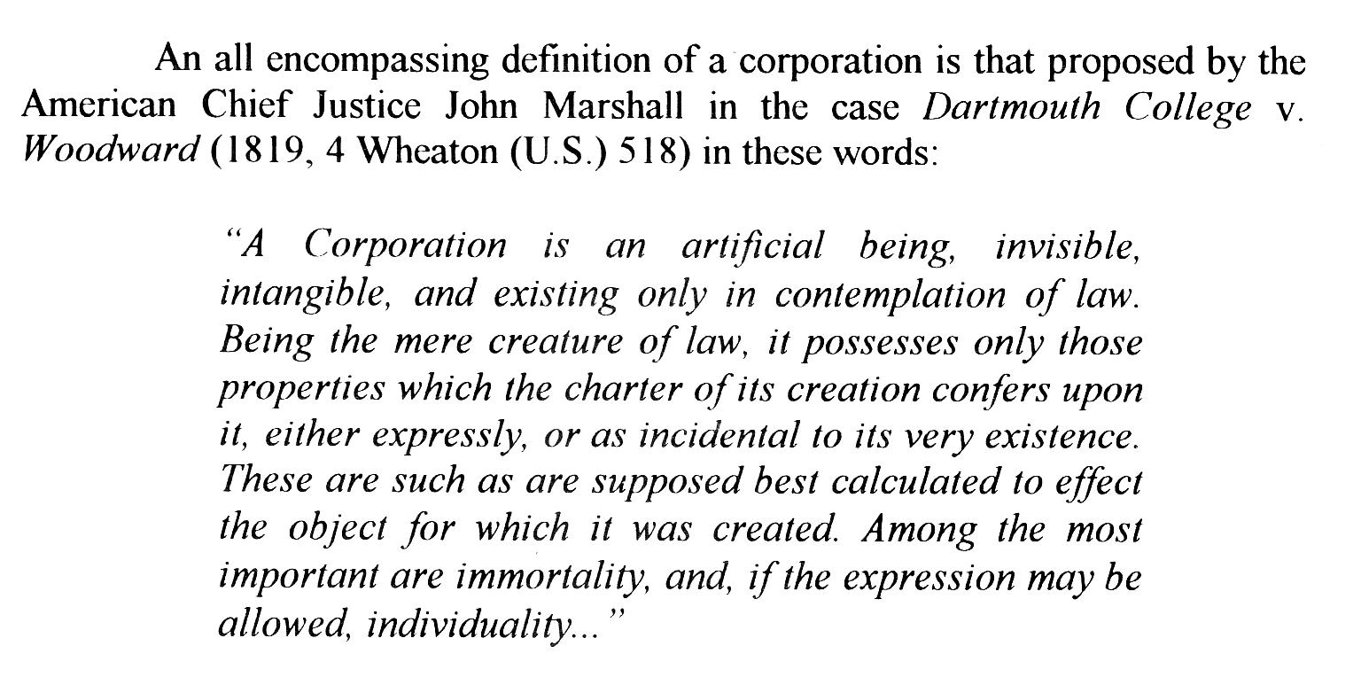
4.2.3 Owner participation

There are three ways to participate financially in the corporation

- The owners, as separate persons in law, can now be employees of the business. The corporation can hire some, or all, of them and pay them a salary for the work they do.
- The ownership of the corporation is divided into small units.
  - These units are called shares. Each of the owners invest money to buy some of these shares.
  - The money they invest belongs to the corporation, and it is used to carry on the business.
  - Other shares can be sold later to new investors.
  - The profits earned by the corporation can be divided amongst those who hold shares(shareholders).
  - This profit divided amongst shareholder is called a dividend.
- If the corporation is successful, it may keep its profits in the bank, and this may increase the value of its shares. Some shareholders may sell their shares at a higher price than they paid for them. The difference is called a capital gain.

4.2.4 Created by legislation

A corporation does not simply come into existence because its incorporators wishes.

In order for its legal personality to become reality, an application must prepared and be approved by the government authorities.

It is this approval that actually creates the corporation, and brings it to life under the terms of the law.

4.2.5 Limitation of liability

A person who invest money in the shares of a corporation is protected against the loss of any further funds.

In the event that the company should incur debts that it cannot pay, or even bankrupt, no shareholder can be called upon to bear any portion of these debts beyond the amount paid for the shares.

This limitation of liability encourages individuals to invest their money in business corporations, secure in the knowledge that their maximum possible loss is the amount they have already paid as their investment in the shares.

Limitation of liability applies to the shareholders, not to the corporation. The corporation remains fully liable for all its debts, without limit.

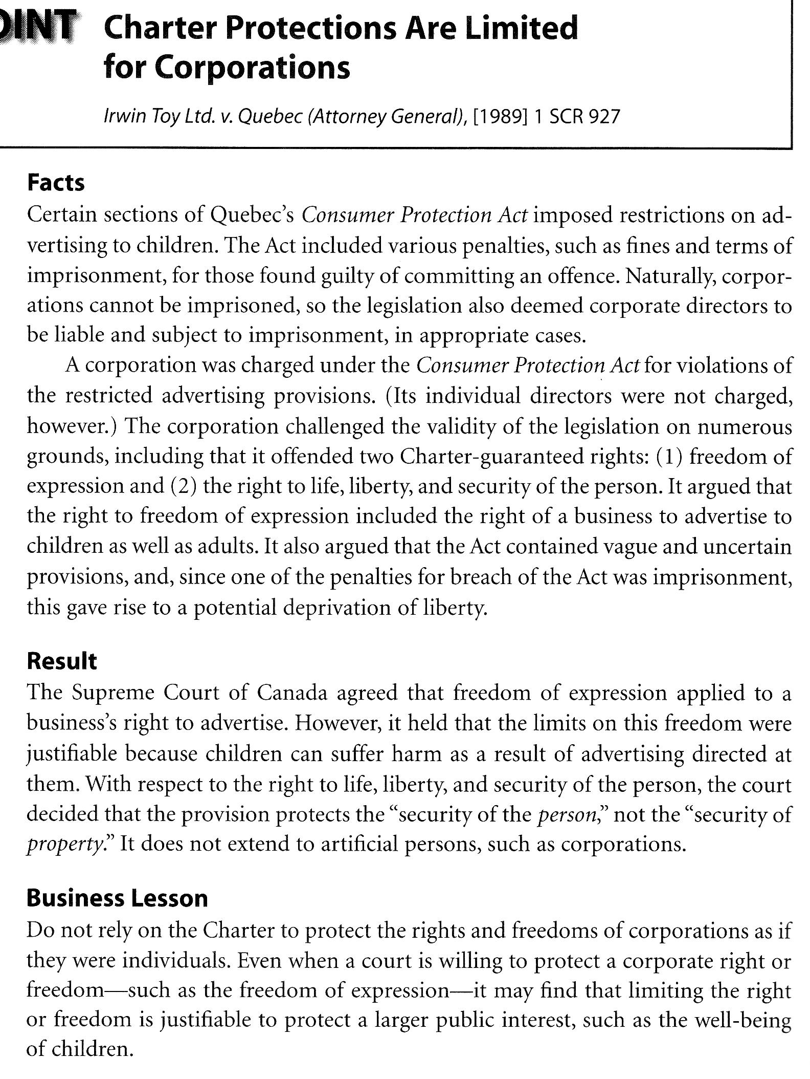

4.2.6 Immortality

the life of a company is perpetual.

It continues its existence notwithstanding the death of some or even all of the shareholders.

The ownership of the shares of a deceased shareholder passes to the heirs without effect on the corporation.

The company will exist forever, unless the shareholders decide to end its existence by surrendering its charter.

Its existence may also be terminated by bankruptcy or by order of a court for violation of a provision of law.

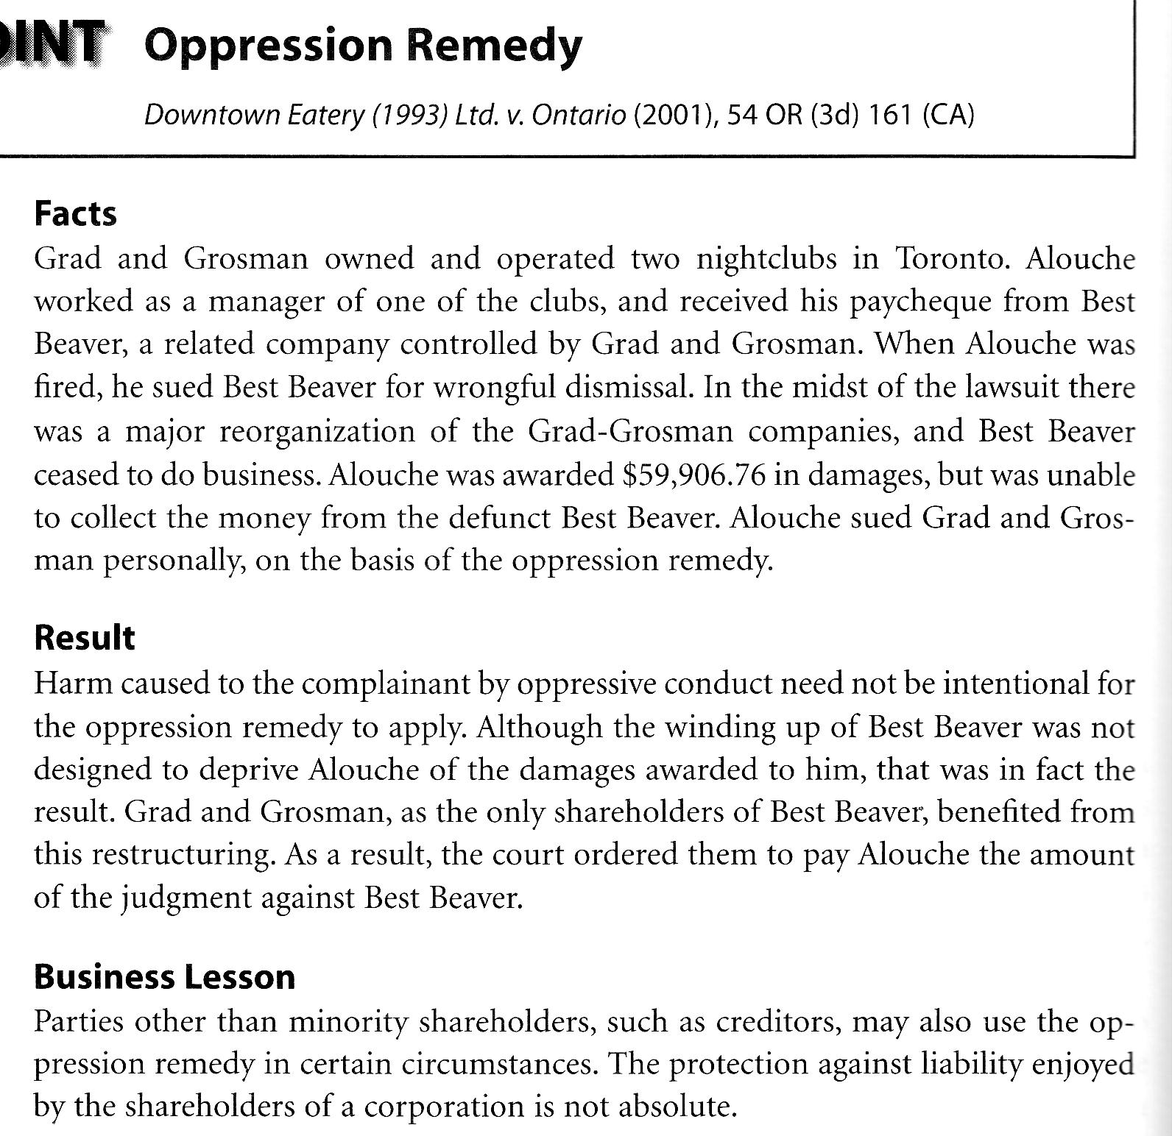
4.3 Procedure for incorporation

4.3.1 federal or provincial incorporation?

In Canada, there are eleven laws under which the corporation may be formed.

The federal law is the Canada Business Corporations Act (CBCA)

The Québec law is the Québec Companies Act (QCA)

the decision to incorporate under one rather than the other is guided by the objects of the business; that is, the geographical scope of the proposed business.

If a business carries on its activities in more than one province, the objects would be considered as being federal, hence CBCA.

If a business remains local, the provincial law would be preferred.

A provincially chartered company may carry on business in other provinces; however if it wishes to open a branch in another province, it will be required to obtain and pay for a licence from each province.

A company created under the CBCA has the capacity to carry on business in all parts of Canada.

4.3.1.1 Federal incorporation

A request for federal incorporation requires the completion and filing of a document called Articles of Incorporation.

This document identifies the details of the structure of the proposed corporation as well as the persons who are are the original incorporators.

Any person or persons who are
- over 18 years of age
- of sound mind
- not a bankrupt

Http://strategis.gc.ca/corporations

4.3.1.2 Québec incorporation

The Québec Companies Act permits the incorporation of a company by the filing of Articles of Incorporation.

Under this law, incorporation is not a privilege, to be granted at the pleasure of the government, but rather, it is a right which is available to every person who follows the required procedures.

Any person over the age of 18, not under protective supervision or bankrupt.

4.3.2 By-laws

Every corporation is required to prepare a set of internal rules, called by-laws.

These rules state how the company may borrow money, issue bonds, elect directors and officers, and hold meetings of shareholders.

The by-laws are approved by the shareholders. They then form the basis in which the company will carry on its business activities.

4.3.3 Principal place of business

A corporation must maintain, under the CBCA, a registered office within Canada.

Under the QCA, the business must maintain a head office within Québec.

4.3.4 name of the corporation

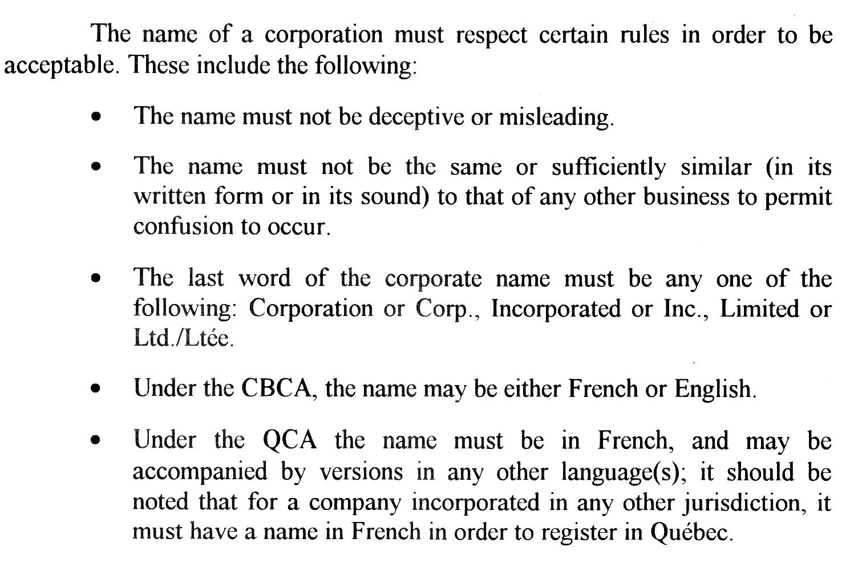
4.4 Financial structure
4.4.1 Ownership

Ownership in a corporation results from the purchase of shares.

They are sold by the company to investors in order to raise funds for working capital and special projects, such as expansion, acquisitions and replacement of equipment.

4.4.1.1 Common shares

The ownership of a corporation rests in the hands of the common shareholders.

All matters presented for the approval of shareholders are voted on by the holders of the common shares on the basis of one share—one vote.

Most issues require only a simple majority of votes to be approved.

Certain matters, such as amalgamation, amendment of the articles of incorporation or dissolution of the corporation require, by law, the approval of at least two-thirds (2/3) of the common share holders.

The common shareholders of the company share in the profits when a dividend is declared by the boards of directors.

There is no obligations to declare a dividend.

The common shareholder further participate when the company is liquidated. ( In proportion to the number of shares they own.)

Common shares are referred to as ''no-par value. No-par value indicates that no price has been set as the value of the share.

The Federal law requires all companies to have only no-par value shares.

4.4.1.2 Preferred shares

Preferred shares offer ownership in the corporation but in a limited form.

When new funds are needed common shareholders nay not wish to reduce their voting control in the firm that would result from issuing more common shares.

Special rights and priorities as well as restrictions that do not apply to common shares.
- Guaranteed a certain dividend
- paid before any dividends is paid to common shares
- always carry a stated value or par value
- right to have their investment repaid before any payment to common shareholders at the time of liquidation.
- redeemable(repay the money they have invested)
- do not carry the right to vote

4.4.1.3 transfer of ownership

A simpler matter than under any other business form.

Th ownership is not a personal matter as in sole proprietorship rather it is objective.

The shareholder does not own machinery or buildings or trucks.

The shareholder owns only units or shares, and these can be quite easily transferred to one or more persons.

The evidence of ownership in a corporation is the share certificate, which can simply be transferred from one owner to the next.

This transfer does not in any way affect the legal existence of the company, since it exists, in law, as a separate entity.

4.4.2 Raising capital

4.4.2.1 selling shares

Corporations are created with an unlimited number of common, or Class A shares.

Existing shareholders may raise additional capital by selling shares from the corporation.

The company may also raise new funds through the issue of preferred shares or class B shares.

However, here Class A shareholders will have to wait to receive dividends until after preferred shareholders.

4.4.2.2 debt obligations

the company may, like any other person, obtain funds by borrowing from financial institutions or private lenders, or by sale of bonds or debentures.

When a corporation wishes to borrow large sums of money to be repaid at a set rate of interest over a long period of time, the lenders will generally insist upon having a better security than ordinary creditors.

A debenture is a guarantee to repay, giving the creditor a preferred right to collect his or her debt. Note that the preferred right is based only on the general credit of the corporation.

A bond provides greater security to the creditor because it usually provides for specific security such as a pledge or mortgage on all part of the company's assets.

4.5 Structure and management of the corporation

4.5.1 Shareholders' general meetings

the owners of the common shares in a corporation are the ones who own the corporation. They have the authority to make all the decisions for the corporation.

In order to manage and direct the business affairs of the firm, the shareholders delegate their authority to operate the company to a group elected by them. This group is known as the board of directors.

4.5.2 Board of directors

in a small company, with only a few shareholders, the Board of directors may be composed of all the owners of the company.

In a large firm with thousand of shareholders, perhaps only ten or twenty people would be elected to hold office on the Board.

4.5.3 responsibility of directors

A director is responsible under both federal and provincial law:

- to disclose any conflict of interest which he may have;
- for up to six months wages to employees of the corporation;
- for payment of any dividend which would render the corporation insolvent or impair the capital of the corporation;
- for the difference, if they have given shares for a consideration other than money, and this consideration has a value less than the fair market value of the shares;
- for any loans made to shareholders, directors, officers or employees, except to assist an employee in the purchase of a home for his family.

4.5.4 operation of the corporation

A distinction must be drawn between policy-making and the implementation of that policy.

The board of directors establishes what the policy of the company will be—e.g. Build a new plant, merge with another company.

The officers of the corporation (Chief Executive Officer, VP,) carry out that policy.

Advantages | Disadvantages
Created as a separate legal entity | More complex form and financial structure
Limitation on the liability of the owners for the debts of the business—no personal liability | Expensive to start
Easier to attract professional managers | Must observe government reporting requirements
Easier to obtain outside financial support | Double taxation
Long life—does not depend on the life of the owner
Lower tax rates

Review questions

1) Elizabeth bought a lamp in one store, a sweater in another store, and three books in a bookstore. Do these activities show that she is carrying on an enterprise within the meaning of the Civil Code?

2) Explain the following characteristics of the sole proprietorship
- liability for debts
- management
- ownership of profits

3) Explain how a limited partnership differs from a general partnership

4) It is said that with the corporate form ob business ownership there is limitation of liability. To whom does this apply? Is this an advantage for all parties.

5) What criteria must be met by someone who wants to incorporate as a business?

6) Explain the difference between Class A and Class B shares

