Revenues, revenue variances, and
customer profitability analysis
Part I

- distinguish between tracing and revenue allocation

- describe two methods of allocating the revenues of a bundled package to the individual products in that package

- describe the insight from dividing the sales volume variance into the sales mix and sales quantity variances

- show how customer profitability reports can be prepared to highlight differences across customers in their profitability.

Companies that prosper make revenue planning and revenue analysis centre stage in how managers allocate their energies.

Three revenue-related topics.

Part one: revenue analysis. Discusses tracing and revenue allocation issues when assigning revenues to products, services, customers, or departments.

Part two: revenue and sales mix analysis. Discusses revenue and sales mix analysis for companies with multiple products or for companies with single products sold in different countries.

Part three: customer profitability analysis. Covers issues in collecting and analyzing customer revenues and customer costs.

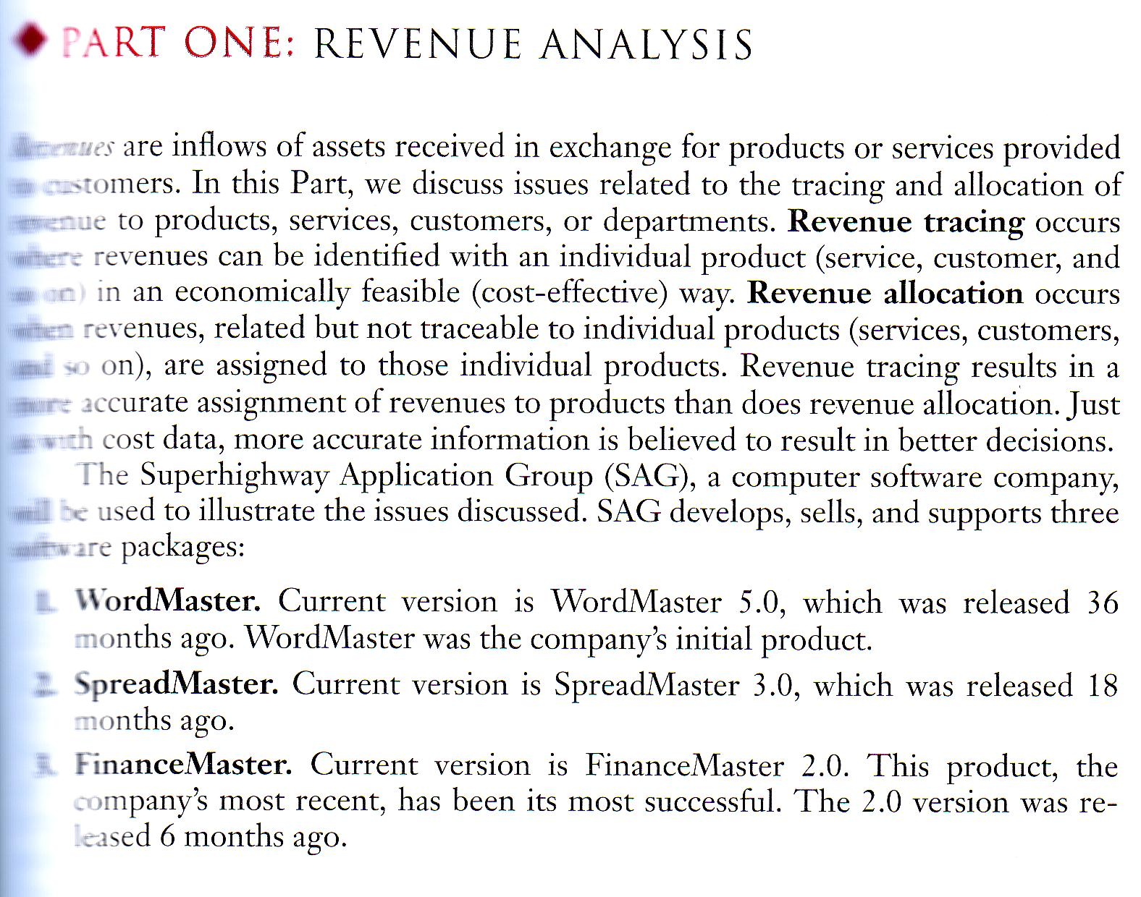
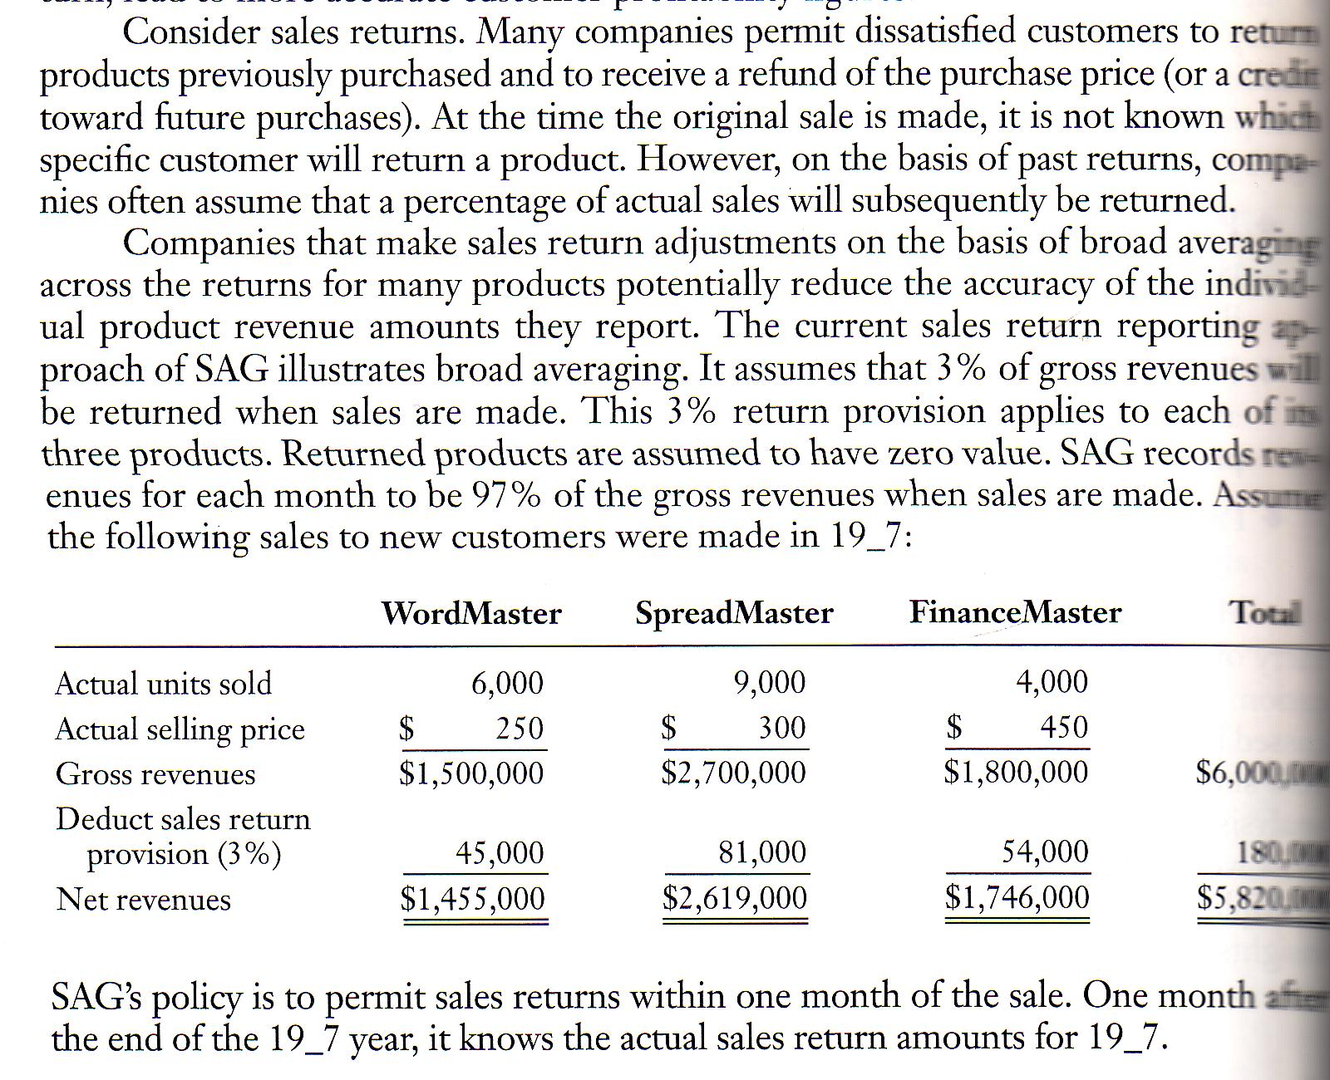
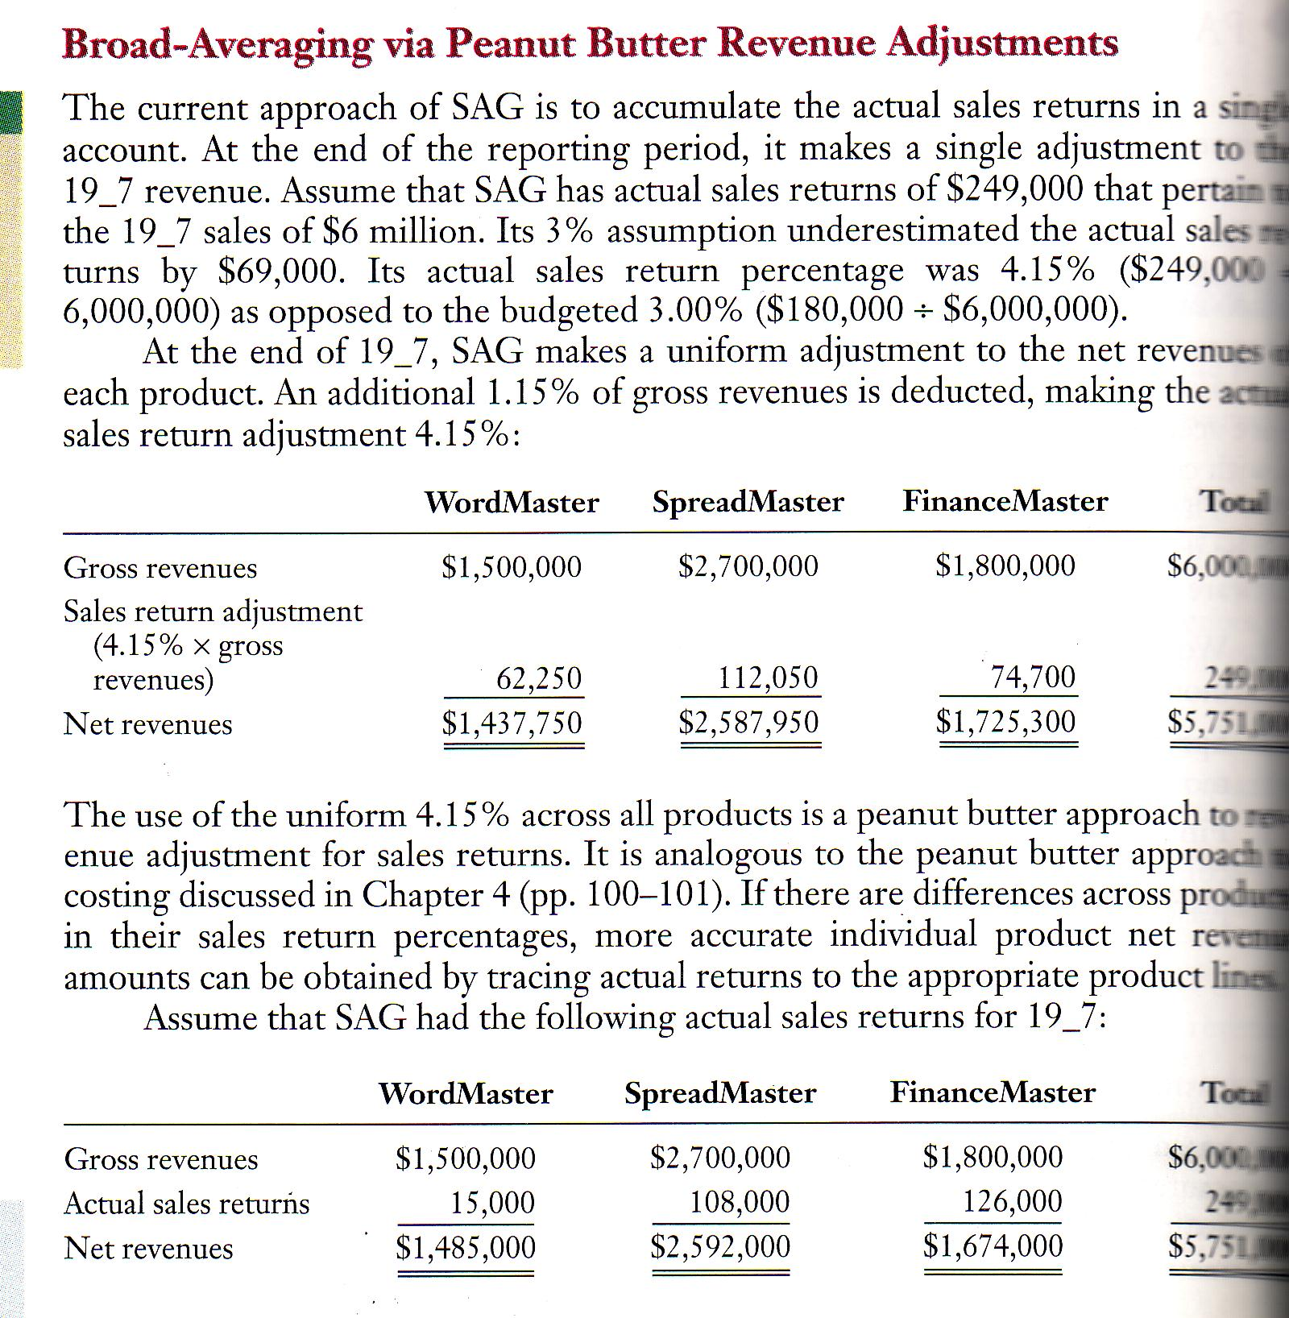
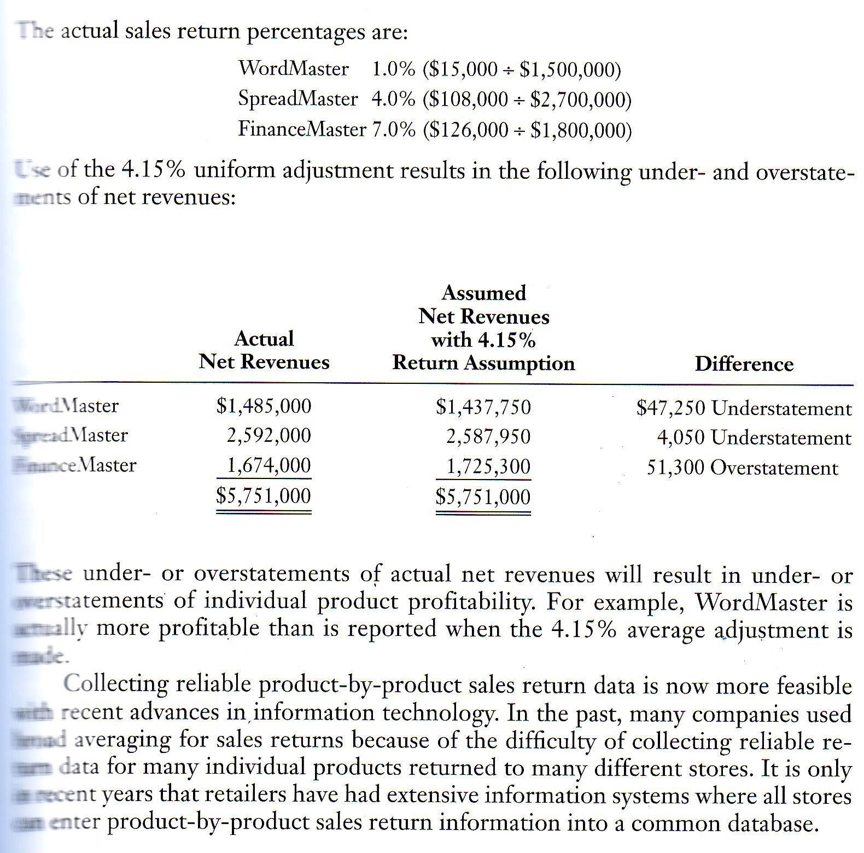
Revenue allocation

A bundles product is a package of two or more products or services, sold for a single price, where the individual components of the bundle may also be sold as separate items, each their own stand-alone prices.

