Pricing, Quotations, and
Terms
Proper pricing, complete and accurate quotations, choosing the terms of the sale, and selecting
the payment method are four critical elements in selling a product or service overseas. Of the
four, pricing can be the most problematic, even for an experienced exporter.

Pricing Considerations

The price considerations listed below will help an exporter determine the best price for the
product overseas.
- At what price should the firm sell its product in the foreign market?
- What type of market positioning (customer perception) does the company want to convey from its pricing structure?
- Does the export price reflect the product's quality?
- Is the price competitive?
- Should the firm pursue market penetration or market-skimming pricing objectives abroad?
- What type of discount (trade, cash, quantity) and allowances (advertising, trade-off) should the firm offer its foreign customers?
- Should prices differ by market segment?
- What should the firm do about product line pricing?
- What pricing options are available if the firm's costs increase or decrease? Is the demand in the foreign market elastic or inelastic?
- Are the prices going to be viewed by the foreign government as reasonable or exploitative?
- Do the foreign country's antidumping laws pose a problem?

As in the domestic market, the price at which a product or service is sold directly determines a
firm's revenues. It is essential that a firm's market research include an evaluation of all of the
variables that may affect the price range for the product or service. If a firm's price is too high,
the product or service will not sell. If the price is too low, export activities may not be sufficiently
profitable or may actually create a net loss.

The traditional components of determining proper pricing are costs, market demand, and
competition. Each of these must be compared with the firm's objective in entering the foreign
market. An analysis of each component from an export perspective may result in export prices
that are different from domestic prices.

It is also very important that the exporter take into account additional costs that are typically
borne by the importer. They include tariffs, customs fees, currency fluctuation transaction costs
and value-added taxes (VATs). These additional costs can add substantially to the final price
paid by the importer, sometimes resulting in a total of more than double the U.S. domestic price.

Foreign Market Objectives

An important aspect of a company's pricing analysis is determining market objectives. For
example, is the company attempting to penetrate a new market, looking for long-term market
growth, or looking for an outlet for surplus production or outmoded products? Many firms view
the foreign market as a secondary market and consequently have lower expectations regarding
market share and sales volume. This naturally affects pricing decisions.

Marketing and pricing objectives may be general or tailored to particular foreign markets. For
example, marketing objectives for sales to a developing nation where per capita income may be
one tenth of that in the United States are necessarily different from the objectives for Europe or
Japan.

Costs

The computation of the actual cost of producing a product and bringing it to market is the core
element in determining if exporting is financially viable. Many new exporters calculate their export
price by the cost-plus method. In the cost-plus method of calculation, the exporter starts with the
domestic manufacturing cost and adds administration, research and development, overhead,
freight forwarding, distributor margins, customs charges, and profit.

The effect of this pricing approach may be that the export price escalates into an uncompetitive
range. Table 4 gives a sample calculation. It clearly shows that if an export product has the
same ex-factory price as the domestic product, its final consumer price is considerably higher
once exporting costs are included.

Marginal cost pricing is a more competitive method of pricing a product for market entry. This
method considers the direct, out-of-pocket expenses of producing and selling products for
export as a floor beneath which prices cannot be set without incurring a loss. For example,
additional costs may occur due to product modification for the export market that
accommodates different sizes, electrical systems, or labels. On the other hand, costs may
decrease if the export products are stripped-down versions or made without increasing the fixed
costs of domestic production.

Other costs should be assessed for domestic and export products according to how much
benefit each product receives from such expenditures. Additional costs often associated with
export sales include:

After the actual cost of the export product has been calculated, the exporter should formulate an
approximate consumer price for the foreign market.
Table 4
Sample Cost-Plus Calculation of Product Cost
 | Domestic sales | Export sales
Factory price | $7.50 | $7.50
Domestic freight  subtotal | .70  8.20 | .70  8.20
Export documentation |  | 0.51
subtotal |  | 8.71
Ocean freight and insurance  subtotal |  | 1.20  9.91
Import duty (12%landed cost)  subtotal |  | 1.19
Wholesaler markup  subtotal | 1.23  9.43
importer/distributor markup  subtotal |  | 2.44  13.53
Retail markup(50%) | 4.72 | 6.77
Final consumer price | 14.15 | 20.31

Market Demand

For most consumer goods, per capita income is a good gauge of a market's ability to pay.
Some products may create such a strong demand such as popular goods like Levis, that even
low per capita income will not affect their selling price. Simplifying the product to reduce its
selling price may be an answer for the exporter to most lower per capita income markets. The
firm must also keep in mind that currency fluctuations may alter the affordability of its goods.

Thus, pricing should try to accommodate wild changes in the U.S. and/or foreign currency. The
firm should anticipate the type of potential customers. If the firm's primary customers in a
developing country are expatriates or belong to the upper class, a higher price might be feasible
even if the average per capita income is low.

Competition

In the domestic market, few companies are free to set prices without carefully evaluating their
competitors' pricing policies. This situation is true in exporting, and is further complicated by the
need to evaluate the competition's prices in each potential export market.

If there are many competitors within the foreign market, the exporter may have little choice but
to match the market price or even underprice the product or service in order to establish a
market share. On the other hand, if the product or service is new to a particular foreign market,
it may actually be possible to set a higher price than in the domestic market.

Pricing Summary
In summary, here are the key points to remember when determining your product's price:

- Determine the objective in the foreign market.
- Compute the actual cost of the export product.
- Compute the final consumer price.
- Evaluate market demand and competition.
- Consider modifying the product to reduce the export price.
- Include "nonmarket" costs, such as tariffs and customs fees.
- Exclude cost elements that provide no benefit to the export function, such as domestic
- advertising.

Terms of Sale

In any sales agreement, it is important that there is a common understanding of the delivery
terms since confusion over their meaning can result in a lost sale or a loss on a sale. The terms
in international business transactions often sound similar to those used in domestic business, but
they frequently have very different meanings. For this reason, the exporter must know the terms
before preparing a quotation or a pro forma invoice.

The following are a few of the more frequently used terms in international trade:
- CIF (cost, insurance, freight) to a named overseas port where the seller quotes a price for the goods (including insurance), all transportation, and miscellaneous charges to the point of debarkation from the vessel. (Used only for ocean shipments.)
- CFR (cost and freight) to a named overseas port where the seller quotes a price for the goods that includes the cost of transportation to the named point of debarkation. The buyer covers the cost of insurance. (Used only for ocean shipments.)
- CPT (carriage paid to) and CIP (carriage and insurance paid to) a named place of destination. These terms are used in place of CFR and CIF, respectively, for all modes of transportation, including intermodal.
- EXW (ex works) at a named point of origin (e.g., ex factory, ex mill, ex warehouse)where the price quoted applies only at the point of origin. The seller agrees to place the goods at the buyer's disposal at the specified place within the fixed time period. All other charges are put on the buyer's account.
- FAS (free alongside ship) at a named port of export where the seller quotes a price for the goods that includes the charge for delivery of the goods alongside a vessel at the port. The seller handles the cost of wharfage, while the buyer is accountable for the costs of loading, ocean transportation, and insurance.
- FCA (free carrier) at a named place. This term replaces the former "FOB named inland port" to designate the seller's responsibility for handing over the goods to a named carrier at the named shipping point. It may also be used for multimodal transport, container stations, or any mode of transport, including air.
- FOB (free on board) at a named port of export where the seller quotes the buyer a price that covers all costs up to and including the loading of goods aboard a vessel.

- Charter Terms:
- Free In is a pricing term that indicates that the charterer of a vessel is responsible for the cost of loading goods onto the vessel.
- Free In and Out is a pricing term that indicates that the charterer of the vessel is responsible for the cost of loading and unloading goods from the vessel.
- Free Out is a pricing term that indicates that the quoted prices include the cost of unloading goods from the vessel.
- It is important to understand and use sales terms correctly. A simple misunderstanding may prevent exporters from meeting contractual obligations or make them responsible for shipping costs they sought to avoid.

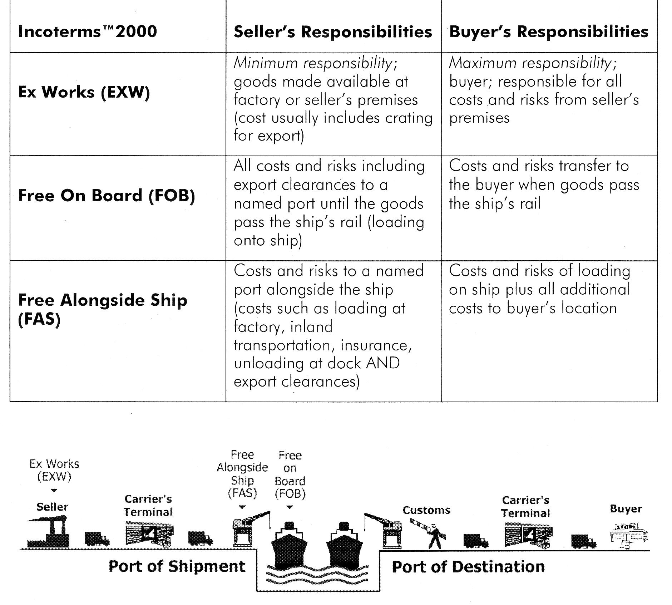
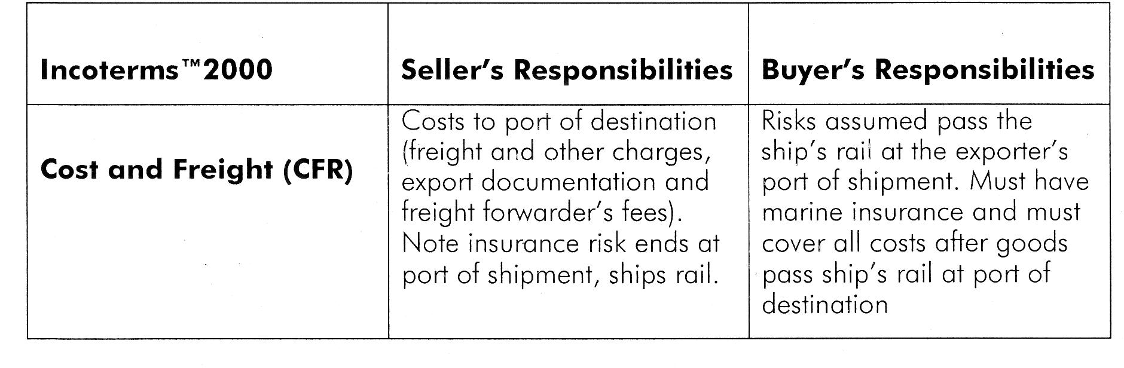
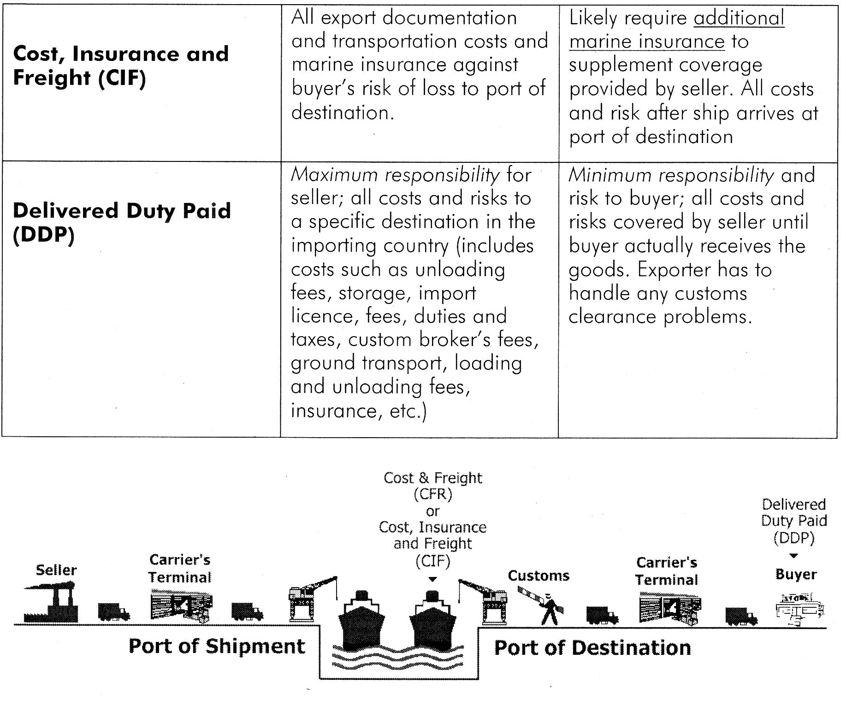
When quoting a price, the exporter should make it meaningful to the prospective buyer. For
example, a price for industrial machinery quoted "EXW Saginaw, Michigan, not export packed" is
meaningless to most prospective foreign buyers. These buyers would find it difficult to determine
the total cost and might hesitate to place an order.

The exporter should quote CIF or CIP whenever possible, as it shows the foreign buyer the cost
of getting the product to or near the desired country.

If assistance is needed in figuring CIF or CIP prices, an international freight forwarder can help.
The exporter should furnish the freight forwarder with a description of the product to be exported
and its weight and cubic measurement when packed. The freight forwarder can compute the CIF
price usually at no charge.

If at all possible, the exporter should quote the price in U.S. dollars. This will eliminate the risk of
exchange rate fluctuations and problems with currency conversion.

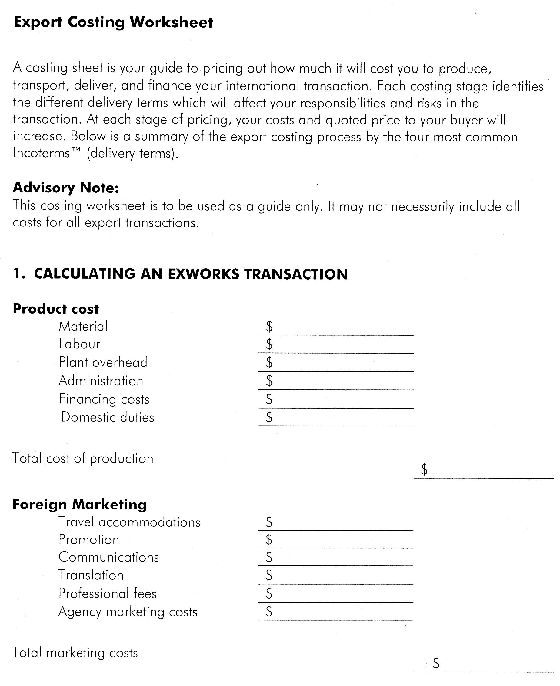
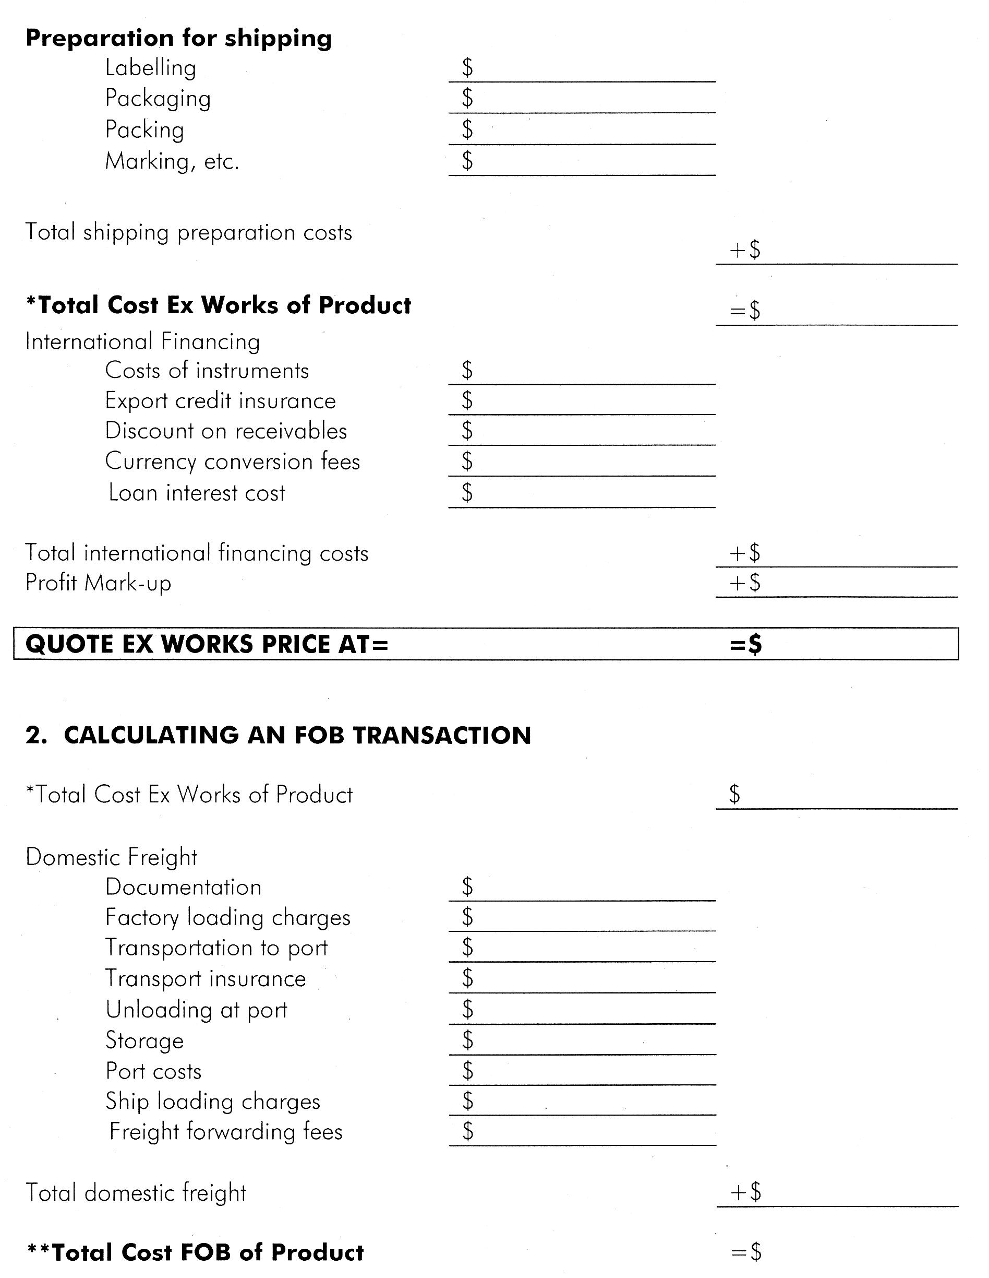
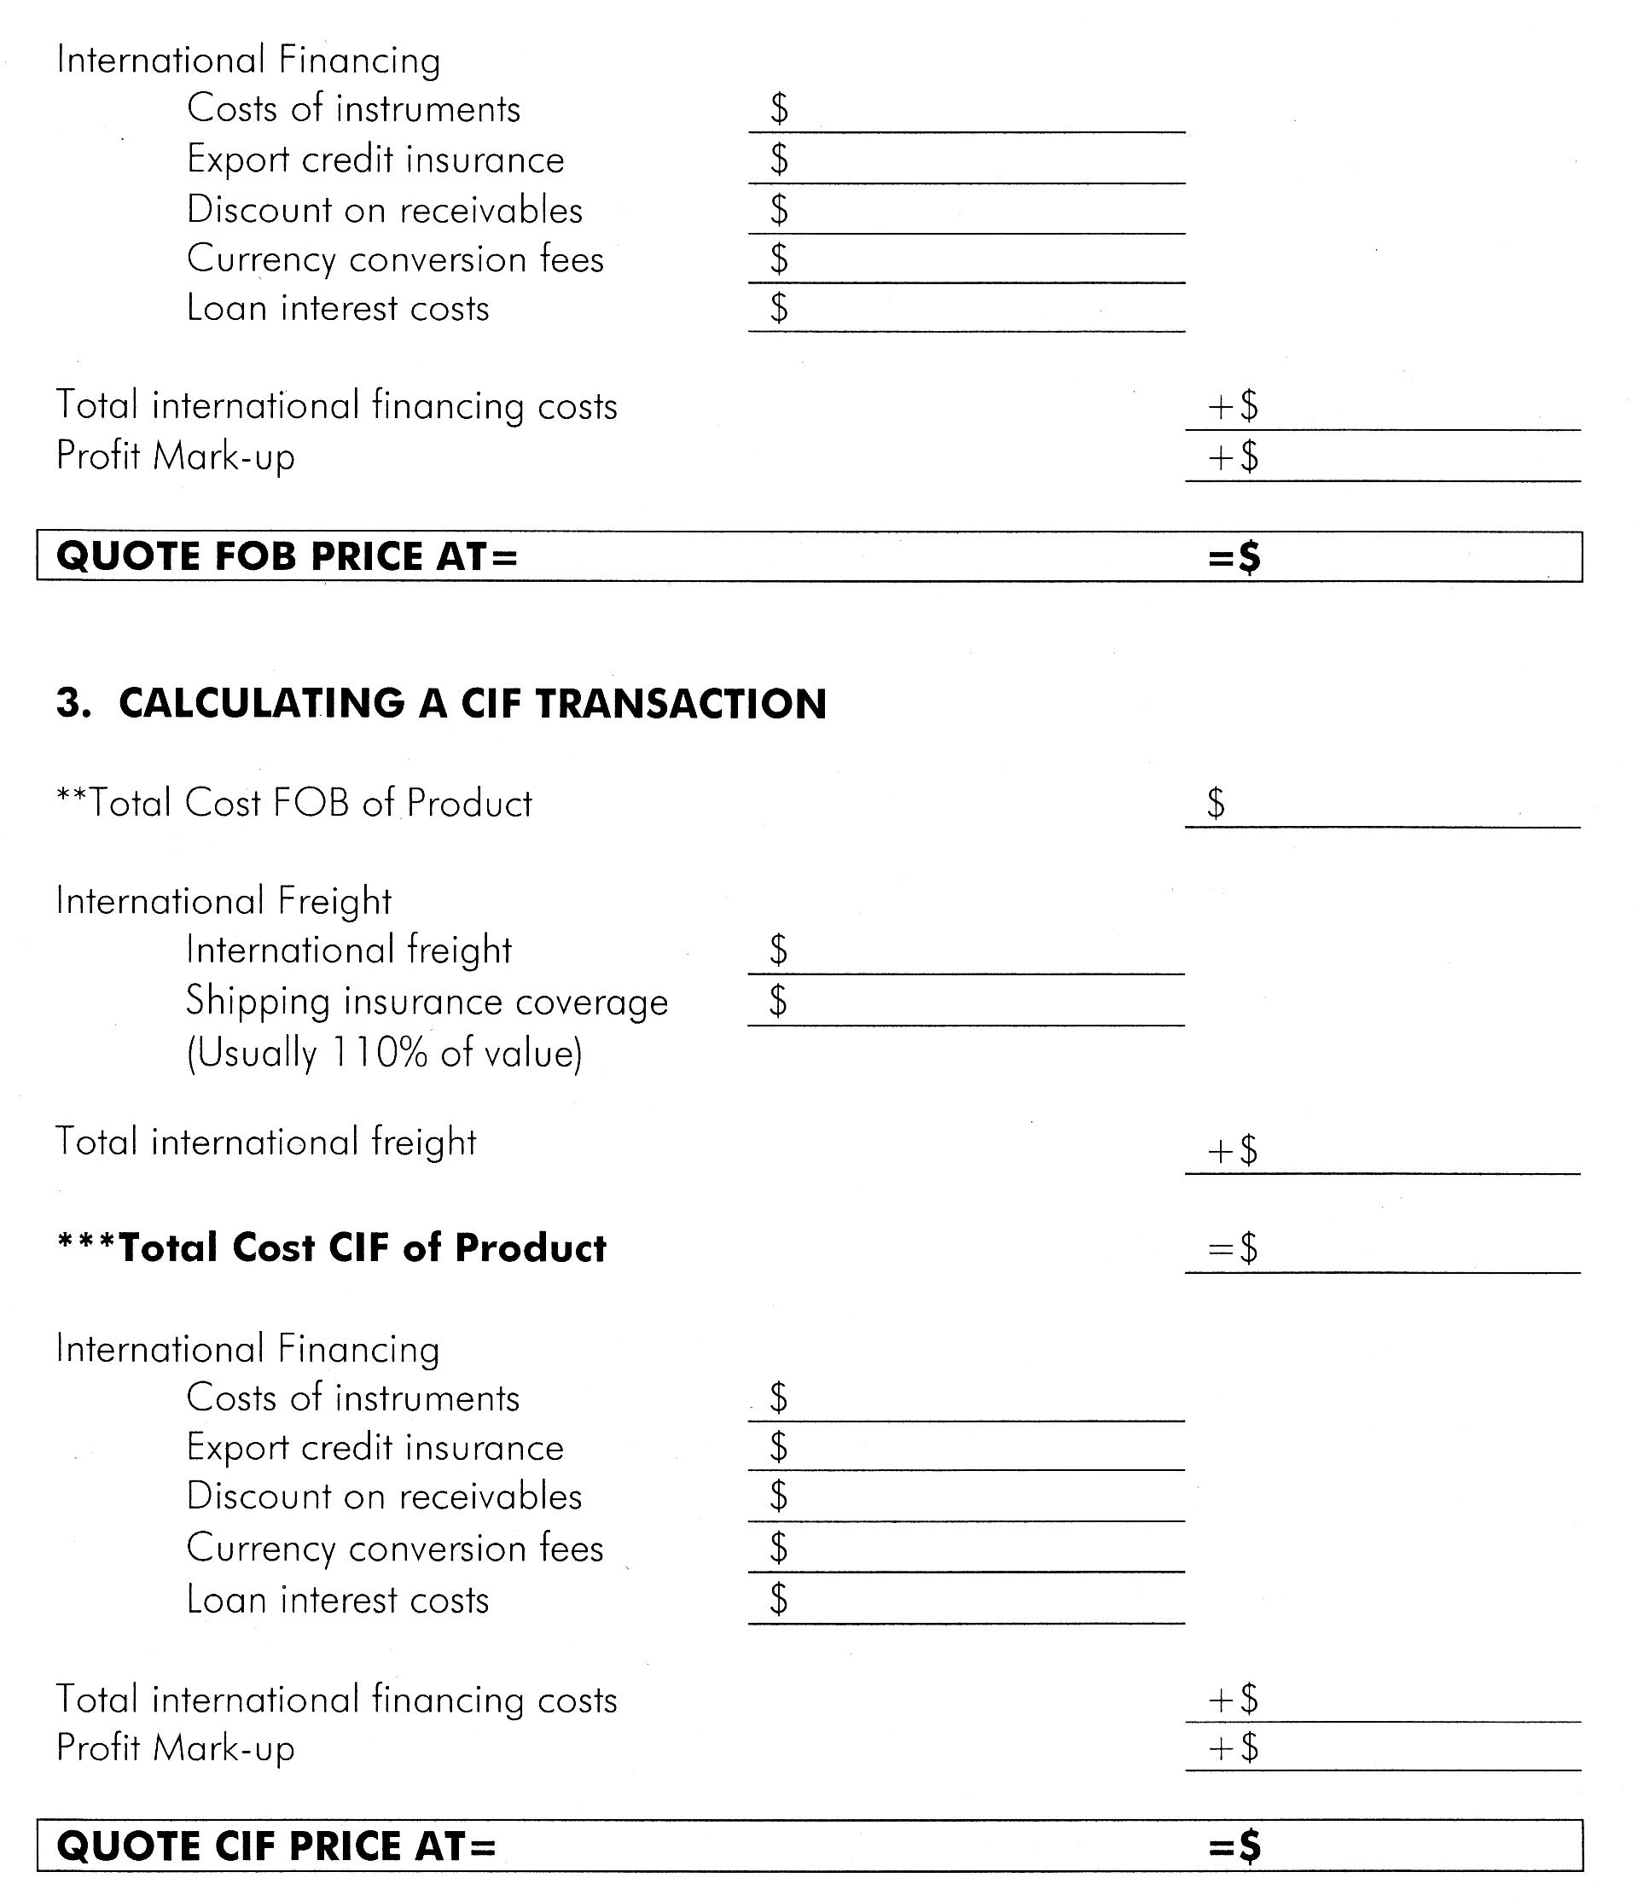
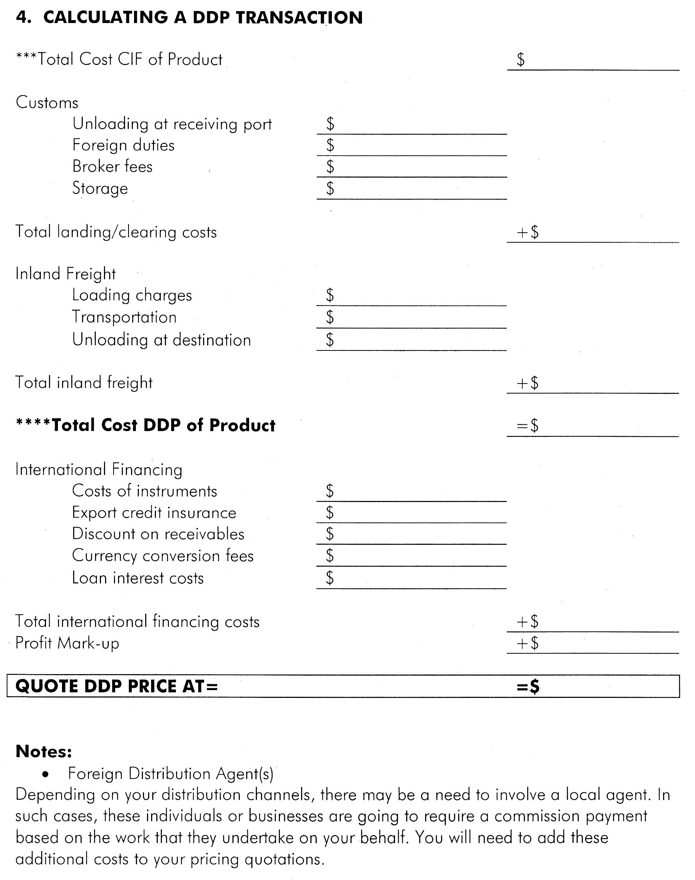
Figure 10 - Sample Export Quotation Worksheet
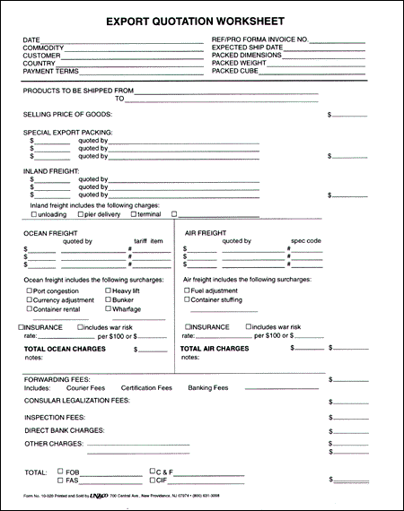
Figure 11 - Sample Pro Forma Invoice
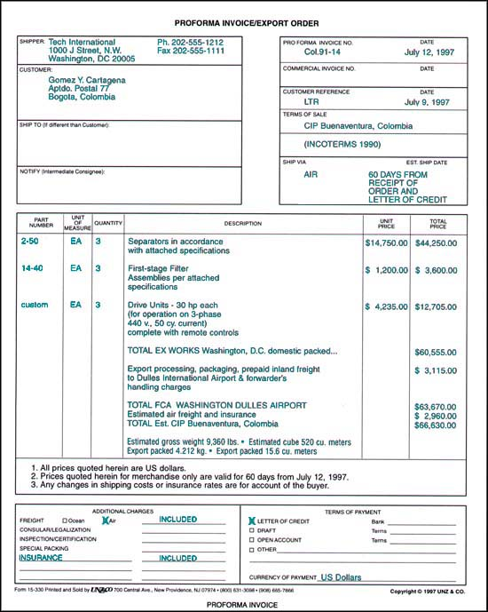
Unz & Co. "Basic Guide to Exporting" © 1998-9
Foreign exchange market
Two basic markets exist for currency.

- the spot currency exchange market and
- the forward currency exchange market.

The Spot Market

SPOT RATES

Like many markets (commodities, stock indexes, T-bonds, currency), there is a) the spot (cash) market, where spot (cash) rates are quoted for immediate delivery (two days to clear for currency); and b) the forward or futures market, where forward rates are quoted for future delivery.

Swiss francs are selling for $.7332/SF, and dollars are selling for SF1.3639/$, in amounts of $1m or more. For smaller amounts, the price will be higher.

Example, an importer needs to buy $10,000 worth of SF, price might be $.75/SF instead of $.7332. $10,000 / ($.75/SF) = SF13,333.33. Or equivalently, $.75/SF = SF1.3333/$, so $10,000 x 1.3333 = SF13,333.33.

General Rule: To convert $10,000 to a foreign currency, DIVIDE by the ex-rate if quoted as $/SF and MULTIPLY by the ex-rate if quoted as SF/$. Point: We want the dollars to cancel.

The ex-rates are quoted as “mid-range rates,” which is the average of the bid (buying rate) – ask (selling rate) spread. For the SF, the bank will pay SF1.3571 to buy dollars and would sell dollars for SF1.3576, and the mid-range quote would be SF1.3574.

Large commercial banks like Citibank stand ready to buy currency at the bid ex-rate and sell currency at the ask ex-rate, and help to “make a market” for foreign exchange.
Bid-Ask Quotes

The bid is the price a dealer will buy a security.
The ask is the price a dealer will sell a security.
A dealer’s profit comes from the spread between the bid and the ask. |  | A customer will buy at the ask and sell at the bid.

A dealer’s spread is calculated as follows:

Q: Assume an investor wants to invest $20,000 in Swiss securities. The exchange rates posted by four U.S. banks are as follows:

Sfr/$ Bank A 1.6357 – 72
Sfr/$ Bank B 1.6116 – 33
Sfr/$ Bank C 1.6261 – 80
Sfr/$ Bank D 1.6531 – 49

At which of these banks should the investor make the currency exchange?

  - Bank A
  - Bank B
  - Bank C
  - Bank D

A: Choice “d” is correct. Exchange rates are generally quoted with the lower price the bank pays (the bid) on the left and the higher price at which they will sell (the ask) on the right. In this example Bank A will buy dollars for 1.6357 Swiss francs but will sell dollars at Sfr1.6372/$. The investor will be selling dollars, so the bank with the highest bid will be the target. In this example, Bank D has the highest bid for dollars at Sfr1.6531/$.

Q: Assume that an investor has just received Sfr 25,000 and wants to obtain dollars for Francs. The exchange rates posted by four U.S. banks are as follows:

Sfr/$ Bank A 1.6357 – 72
Sfr/$ Bank B 1.6116 – 33
Sfr/$ Bank C 1.6261 – 80
Sfr/$ Bank D 1.6531 – 49

With which of the four banks should the investor deal?

  - Bank A
  - Bank B
  - Bank C
  - Bank D

A: Choice “b” is correct. Exchange rates are generally quoted with the lower price the bank pays (the bid) on the left and the higher price at which they will sell (the ask) on the right. In this example, Bank A will buy dollars for 1.6357 Swiss francs but will sell dollars at Sfr1.6372/$. The investor will be buying dollars, so the bank with the lowest ask will be the target. In this example, Bank B has the lowest asking price for dollars at Sfr1.6133/$.

FORWARD RATES

The largest part of the foreign exchange market is for forward currency contracts at the forward rate in the forward market, to avoid currency risk. Forward rates are typically quoted for 1 month, 3 months and 6 months but are available for other maturities.

Example: U.S. importer places an order for Swiss watches for delivery in 3 months, the contract is invoiced for SF100,000, payable in 3 months. Importer could just wait and buy SF in the spot market in 3 months, but would be exposed to currency risk of ___________.

At the current spot rate of $0.7332/SF, SF100,000 would cost $73,320, but what if the SF appreciated and the dollar depreciated, and the future spot rate ended up being $0.75? The watches now cost $75,000, or $1,680 more, a 2.29% increase. If the SF depreciated and the dollar appreciated, to $0.72/SF, then the order would cost only $72,000, a 1.8% decrease in price.

POINTS:

1. Exchange rates change daily, exposing exporters and importers to significant currency risk, when future payments or future revenues are invoiced in a foreign currency.

2. Currency risk can be either: a) positive and beneficial or b) negative and detrimental.

The importer could consider using a forward contract for SF to eliminate currency risk, by locking in at the F₉₀ = $0.7346, and buying the SF forward for 90 days. Now the importer locks in a price to buy SF in 3 months, and locks in a price of $73,460 for the watches, and doesn’t a) have to worry about currency risk and b) doesn’t have to bother with buying SF today and investing for three months in Switzerland (another option). Forward markets are really insurance markets for hedging or eliminating currency risk.

Note: By observing and comparing the spot rates and the forward rates, we can determine whether the dollar or SF is expected to appreciate or depreciate by observing whether the dollar or SF is selling at a forward premium (expected to appreciate), or a forward discount (expected to depreciate). Forward discounts/premiums are expressed as a percentage (%).

Spot Rate: S($/SF) = $0.7332/SF
Forward Rate: F₁₈₀($/SF) = $0.7360/SF

The SF _________ and the USD ____________. The SF is selling at a forward __________ and the USD is selling at a forward ___________ . The percentage change is calculated as:

[(F – S) / S ] x 100

[(.7360 - .7332) / .7332] x 100 = .38%

Therefore, the SF is selling a 6-month forward __________ of .38% and the USD is selling at a 6-month forward ____________ of .38%.

CURRENCY FUTURES MARKET

Futures contracts for currency are similar in principle to forward contracts, except for these differences:

1. Forward contracts are completely flexible in terms of amount ($1m and over) and settlement date, whereas futures contracts are standardized amounts on fixed expiration dates. For example, currency futures contracts are for ¥12.5m (about $115,000), C$100,000, (about $80,000) £62,500 (about $112,500), SF125,000 (about $102,000), for settlement dates in March, June, September and December. A forward contract can be customized, allowing a client to buy/sell SF20m in November on any day, which is not possible with a futures contract.

2. Forward contracts are usually private, customized contracts between a bank and a client, with no secondary market. Standardized futures contacts are traded on the secondary market, e.g., Chicago Mercantile Exchange, Chicago Board of Trade and the NY Board of Trade.

3. Forward contracts are settled in the actual currency, futures contracts are usually settled in cash.

4. Forward contracts are usually used for hedging only, futures contracts are used for hedging currency risk and speculating (pure investment) on currency.

5. Forward contracts are offered as part of commercial, wholesale banking activity for large MNCs with large minimums ($1m), whereas currency futures are part of the larger derivatives market, and offer smaller contracts for smaller firms.

Example of a speculative position in December currency futures for the £ at $1.80/£:

Currency Futures for Hedging

GM has to pay €10m in three months for a delivery of parts from Germany invoiced in euros. Worried? Over the next three months: $______ and € ______ . For example, suppose the spot ex-rate is $1.25/€ and remains constant for 3 months, the parts will cost $12,500,000 ($1.25/€ x €10m). If the euro appreciates by 4% over the next three months, the ex-rate will be ____ and the parts will now cost _________, an increase of _________.

Suppose that 3-month euro futures contracts are priced at $1.2550/€. Euro contracts are for €125,000, so GM would need 80 contracts to cover the €10m. GM would take a _________ position to hedge against the euro __________. Settlement will be in cash, not euros.

