1)
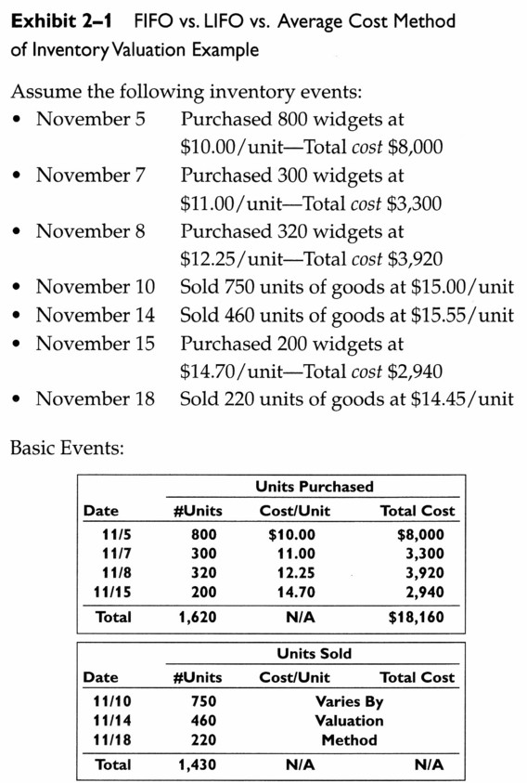
Given gross sales of $21,582, calculate which method will generate the largest gross profit margin.

2)

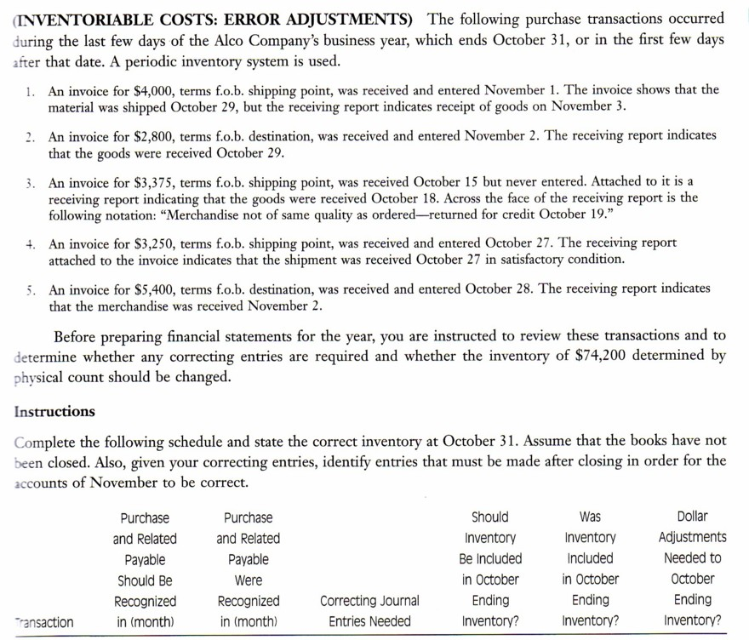
3)
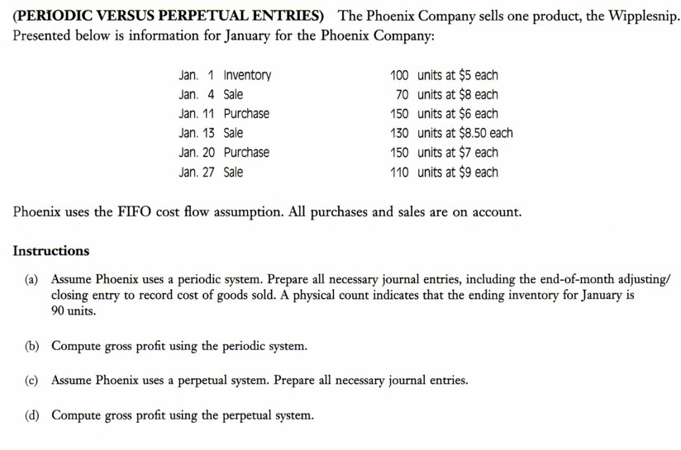
4)
Winston corporation needs to know how frequently to place their orders. They provide the following information:

S = 500 units per month

P = $40 per order

C = $4 per unit

What should be the minimum size order and how often per month should an order be made?

5)
Two companies distribute fast moving consumer goods. Their results for last year were:

Annual accounts | Ace distributors ($ millions) | Deuce associates($millions)
Gross sales | 8 | 26
Fixed assets | 2 | 5
Cost of sales | 6 | 21
Inventory | 4 | 8

You have been offered the job of inventory manager by both companies. Which one would you take and, based on the data provided and using the ratios that you see fit, explain why?

