CANADA'S RESPONSE TO GOLBAL RULES:
Domestic rules on imports and exports

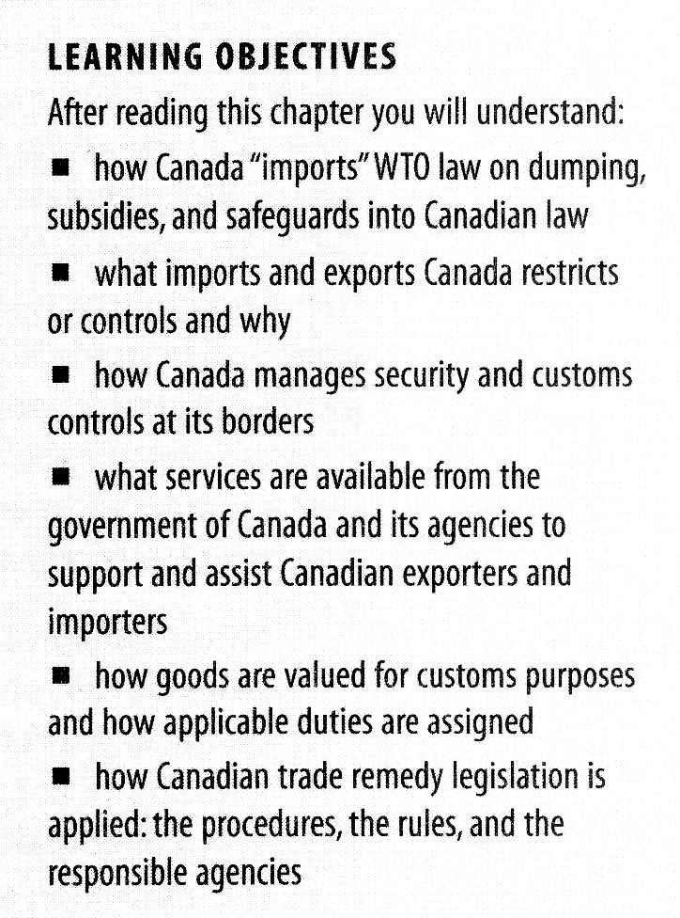
Introduction

Canadian legislation governing imports and exports is influenced by a number of factors that include:
- protection of the health and safety of Canadian residents;
- maintenance of the economic well-being of Canada;
- compliance with the rules established under various international agreements including WTO, NAFTA, and other trade agreements; and
- compliance with the provisions of treaties providing for environment protection.

The customs act: rules for imports an d exports

The Customs Act is Canada's primary legislation relating to imports and exports; it authorizes the Canadian government to control the import and export of goods and to levy duties.

This statute operates in conjunction with two other important acts—the Customs tariff and the Special Import Measures Act (SIMA).

It is the Customs Act that provides for import and export reporting, the calculation of duty, abatements and refunds, and enforcement of the legislation.

Responsibility for border services and security

The Canada Border Services Agency(CBSA) was created in 2003. It is responsible for providing integrated border services that support national security priorities and facilitate the free flow of persons and goods—including animals and plants.

The CBSA is responsible for ensuring that

- all people coming to Canada are admissible under Canadian laws and regulations;
- all commercial shipments comply with Canadian laws and regulations and that no illegal goods enter or leave the country;
- trade statistics are accurate;
- all applicable duties and taxes are paid;
- food safety and plant and animal health are maintained;
- any persons who pose a threat to Canada are detained, and that persons who have been determined inadmissible are removed; and
- measures for the prevention of money laundering are implemented.

US Customs and the CBSA have established a number of programs to facilitate the flow of goods and services across the border:

One of the most important is Free and Secure Trade (FAST). The FAST program is a paperless cargo-release system that uses electronic data transmission, barcode technology, and transponder technology. It is a program opened to importers, carriers, and drivers.
The benefits are:
- reduction in the information requirements for customs clearance,
- elimination of data transmission for each transaction,
- dedicated lanes for FAST clearance,
- reduction of the rate of border examinations, and
- the ability to verify trade compliance away from the border.

Canadian Regulation of Exports

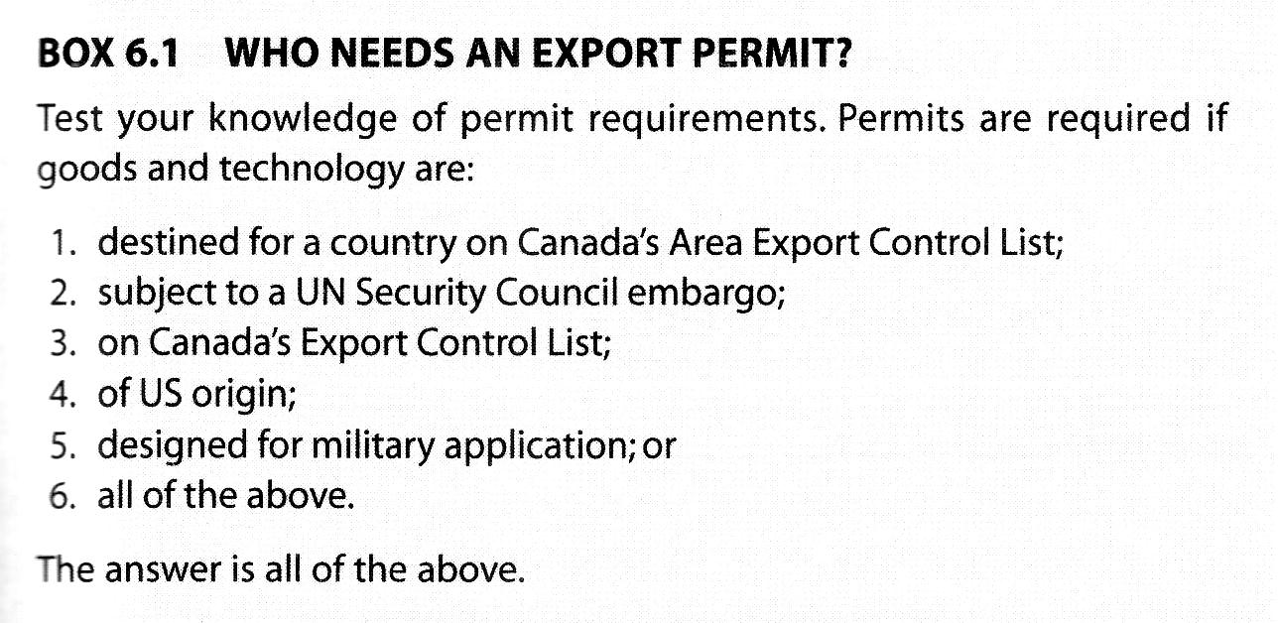
Goods are classified into one of three groups:

- regular goods;
- controlled, prohibited, and regulated goods; and
- in-transit goods (goods shipped through the United States whose final destination is another country).

Quick reference table
Exporting Goods From Canada
Documentation Requirements for Exporters
Type of Goods | United States Destinations (includes Puerto Rico and the U.S. Virgin Islands) | All Other Destinations (includes goods moving through the United States to foreign destinations)
Restricted goods, i.e. controlled, regulated and prohibited goods (regardless of value) | - permit, certificate or licence  - documents required by other government departments (if applicable)  - export declaration is not required | - permit, certificate or licence  - documents required by other government departments (if applicable)  - export declaration
Non-restricted goods | - export declaration is not required | - export declaration (for commercial goods valued at CAN$2,000 or more)

Export controls

There are two lists that are relevant to regulating exports: the Export Control List(ECL) and the Area Control List(ACL).

The Export control List

The ECL is a list of goods that are subject to export controls and that require an export permit prior to exportation.

At present it includes:
- some agricultural products—for example, sugar and peanut butter;
- textiles and clothing;
- military and dual-use goods that may have a strategic purpose;
- nuclear energy materials and technology;
- missile, chemical, or biological goods for which proliferation is a concern;
- softwood lumber, unprocessed logs, and other forest products,
- goods of US origin;
- certain goods with medical value;
- goods subject to a UN Security Council embargo or actions; and
- goods subject to re-export controls by foreign governments.

The Area control List

At present it contains only one name: MYANMAR

Different types of Export permits

- Individual export permit(IEP)
- General export permit(GEP)

The IEP is for specific goods to be exported to a specific destination by a specific exporter.

A GEP does not specify the exporter, but provides a general authorization for the export of specific goods to specific destinations.

An example is General Export Permit no. Ex. 30, which permits the export of a large number of specified goods on the ECL to a specified list of countries, all of which are industrialized democracies.

GEPS may also limit exports—for example, the export of US-originating goods to Cuba, North Korea, Iran, and Libya.

Canadian Regulation of Imports

All carriers are obliged to report the arrival of imported goods at the nearest border point. The goods must be accompanied by a customs invoice or equivalent commercial invoice that describes the transaction and identifies both the vendor and the purchaser.

The Department of National revenue will review the documentation and determine:

- the value for duty of the goods;
- the tariff classification of the goods;
- the origin of the goods; and
- the applicable tariff rate.

Dutiable value of the goods

Using the GATT Valuation code requiring an assessment of actual value, there are six possible method:

Transaction value | This is the price actually paid or payable for the goods—that is, the invoice price.
Transaction value of identical goods | When transaction value method is not suitable, the first alternative is to use the transaction value of identical goods. The sales used as a comparative base must be export sales.
Transaction value of similar goods | Where there are no transactions involving identical goods, the transaction value of similar goods is used.
Deductive value | Obtained by starting with the resale price in Canada and working backward to an export price for the good, relying solely on information available in this country.
Computed value | Takes the costs of producing the goods and allows an amount for profit and general expenses. This method requires the foreign manufacturer to provide information on the costs of production of the goods.
Residual value | When it is not possible to value goods under any of the above methods, the one determined to be most suitable is flexibly applied, but only on the basis of information available in Canada.

Tariff classification

The items are listed with an identifying number and description according to the International Convention of the Harmonized Commodity Description and Coding System (HS)

01-05 Animal & Animal Products
06-15 Vegetable Products
16-24 Foodstuffs
25-27 Mineral Products
28-38 Chemicals & Allied Industries
39-40 Plastics / Rubbers
41-43 Raw Hides, Skins, Leather, & Furs
44-49 Wood & Wood Products
50-63 Textiles
64-67 Footwear / Headgear
68-71 Stone / Glass
72-83 Metals
84-85 Machinery / Electrical
86-89 Transportation
90-97 Miscellaneous
98-99 Service
07 EDIBLE VEGETABLES
0701 potatoes (except sweet potatoes), fresh or chilled
0702 tomatoes, fresh or chilled
0703 onions, shallots, garlic, leeks etc, fr or chilled
0704 cabbages, cauliflower, kale etc, fresh or chilled
0705 lettuce and chicory, fresh or chilled
0706 carrots, turnips & other edible roots, fr or chill
0707 cucumbers and gherkins, fresh or chilled
0708 leguminous vegetables, shelled or not, fr or chill
0709 vegetables nesoi, fresh or chilled
0710 vegetables (raw or cooked by steam etc), frozen
0711 vegetables, temporarily preserved, not now edible
0712 vegetables, dried, whole, cut etc., no added prep
0713 leguminous vegetables, dried shelled
0714 cassava arrowroot etc fresh or dry: sago pith

Rules of origin of goods

An importer is legally obliged to furnish evidence of the country of origin upon entry of the goods into Canada.

See rules of origin in the NAFTA chapter.

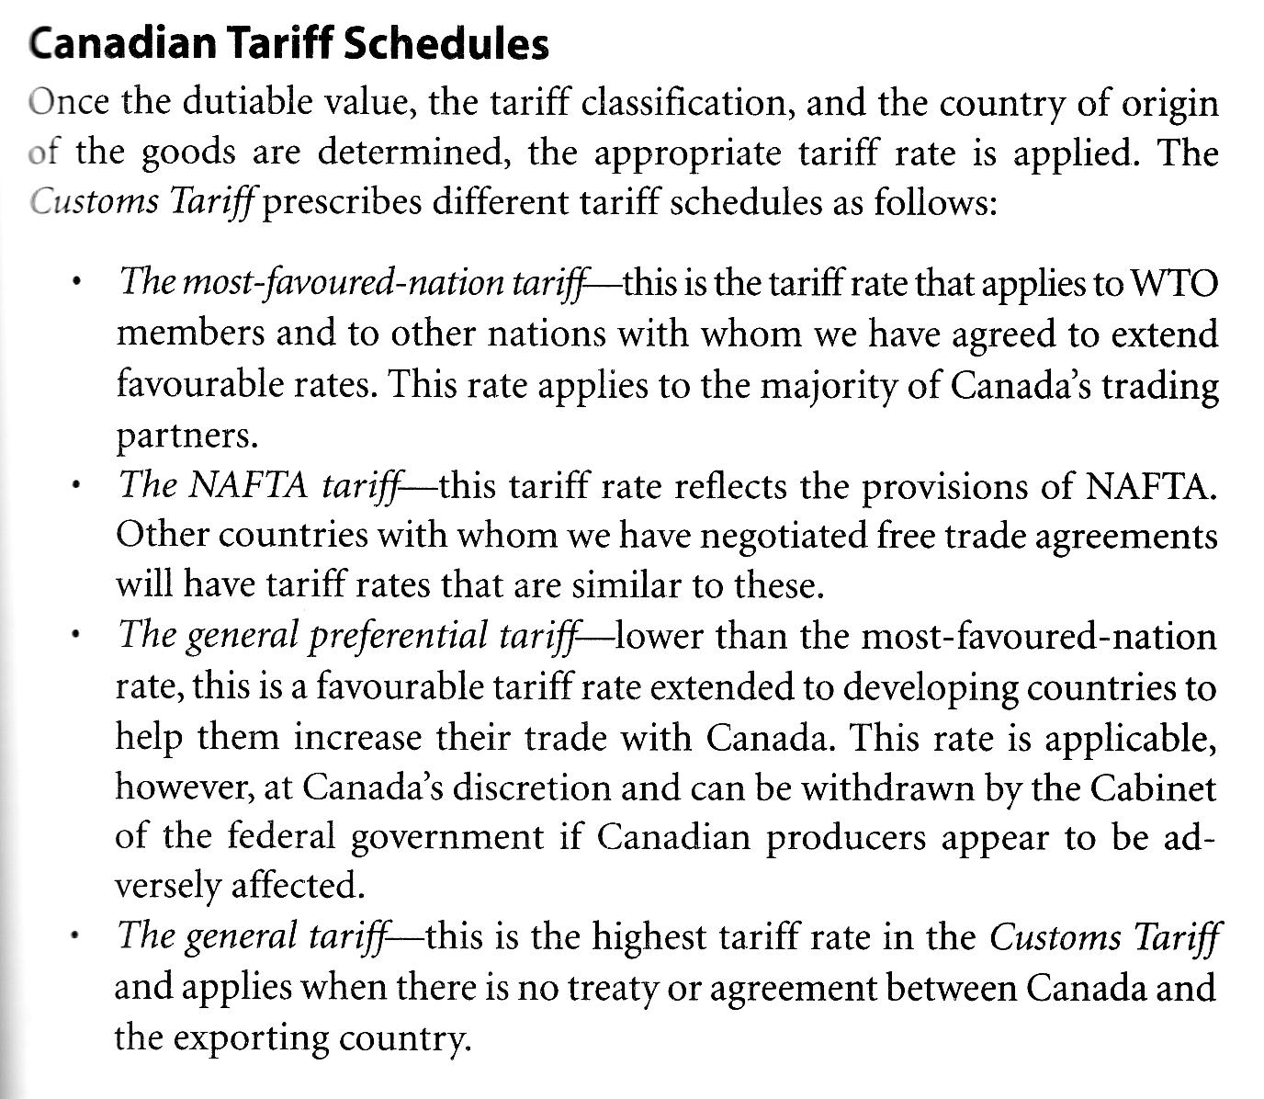
Imports Permits
Import permits are required in a number of areas.
Items where Canada is allowed to limit imports under WTO agreement. | Dairy and poultry products
Food and drug safety: food and Drug Act | Food and Drugs Act (formal title An Act respecting food, drugs, cosmetics and therapeutic devices) is an Act of the Parliament of Canada regarding the production, import, export, transport across provinces and sale of food, drugs, contraceptive devices and cosmetics (including personal cleaning products such as soap and toothpaste). It was first passed in 1920 and most recently revised in 1985. It attempts to ensure that these products are safe, that their ingredients are disclosed and that drugs are effective and are not sold as food or cosmetics. It also states that cures for Schedule A diseases (the most serious, including cancer), cannot be advertised to the general public.
Restricted goods | Prohibited goods  You are not allowed to import prohibited goods such as obscene materials, hate propaganda and child pornography into Canada.  Firearms  The following requirements apply to the importation of firearms and weapons:  you must be at least 18 years of age;  you can import non-restricted and restricted firearms provided all documentation and other requirements are met; and  generally, you may not import prohibited firearms or any type of prohibited weapons or devices, including silencers, replica firearms, switchblades, pepper spray and other weapons.  You are required to declare all weapons and firearms at the CBSA port of entry when you return to Canada. If not, you could face prosecution and the goods may be seized.  Explosives, fireworks and ammunition  Written authorization and permits are required to bring explosives, fireworks and certain types of ammunition into Canada. For more information, contact Natural Resources Canada:  Currency and monetary instruments  If you are importing or exporting monetary instruments equal to or greater than CAN$10,000 (or the equivalent in a foreign currency) to or from Canada, whether in cash or other instruments, you must report this to the CBSA when you arrive or before you leave. For more information, we suggest you read the publication called Crossing the Border with $10,000 or More?, available at http://www.cbsa.gc.ca/ under "Publications and forms."
Clothing and textiles | Only those clothing and textile products eligible for tariff preference levels established under NAFTA or another trade agreement are subject to import permit.
Packaging and labelling.  Consumer packaging and labelling act. | Example of Liquid and Viscous Products with Mandatory Label Information:  A Product Identity Declaration  B Net Quantity Declaration  C Dealer Name and Place of Business
Safety of non-food items | Non-food items may have to meet standards set by the Standards council of Canada or Canadian Standards Association.  See example for toys.

Canadian trade remedy legislation
The two primary remedies available to Canadian firms wishing to protect their industry from unfair practices:

- Anti-dumping duties(AD)
- countervailing duties(CVD)

Dumping: selling an imported good at a price lower than the price at which it is sold in the exporting country.

Anti-dumping duties are duties imposed by an importing country over and above the usual import duties when the goods are being dumped into an importing country.

Countervailing duties: duties imposed by an importing country over and above the usual import duties when the goods have been subsidized by the country in which they are produced.
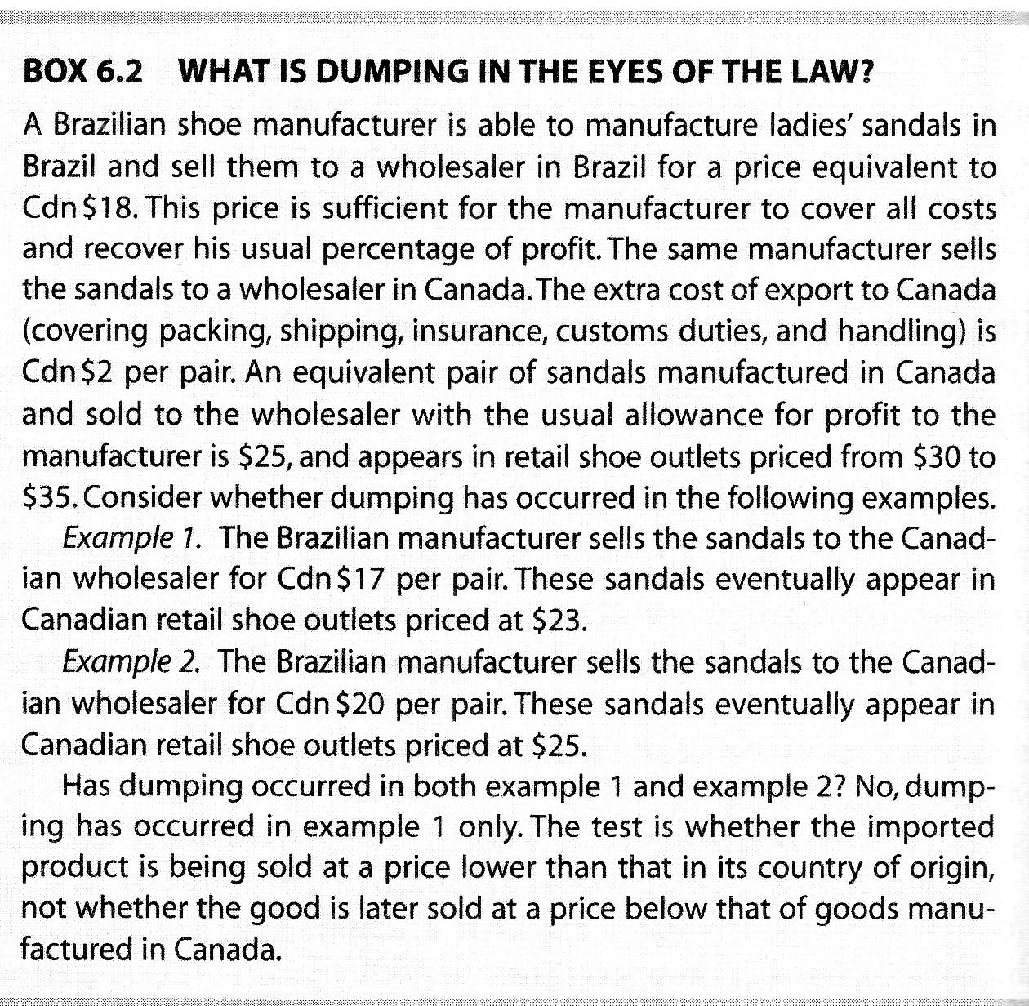
Subsidy and countervailing duty rules in Canada

A subsidy is any financial or commercial benefit given to a producer, manufacturer, grower, distributor, importer, or exporter by any government.

Dumping and subsidy investigations and rulings in Canada

The first issue in a dumping or subsidy case is whether dumping or subsidy has in fact occurred.

The second and necessary requirement is to show that dumped or subsidized imports are causing or threatening to cause injury to the Canadian Industry. Injury is most commonly shown:
- reduced prices
- lost sales
- lost market share
- decreased profits
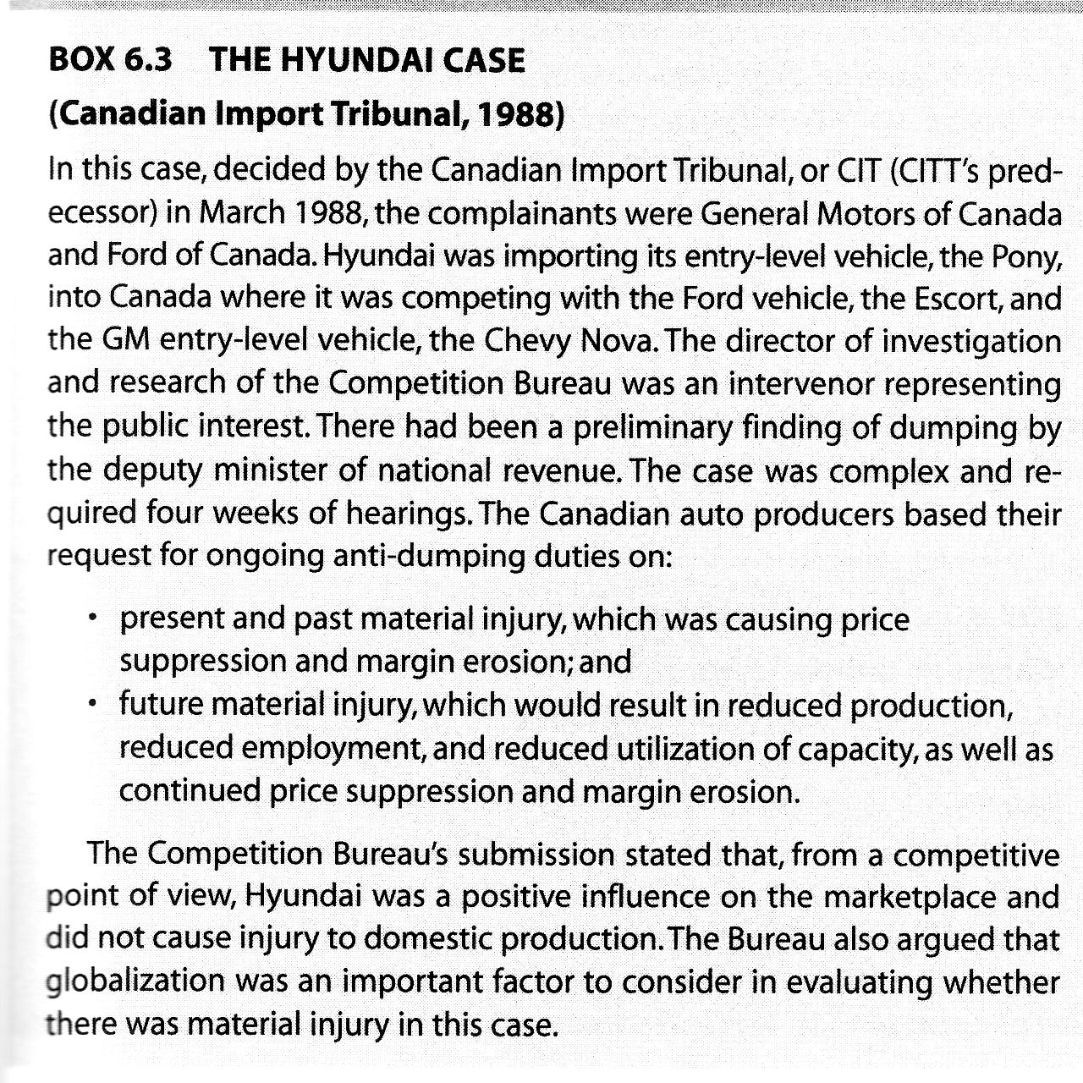

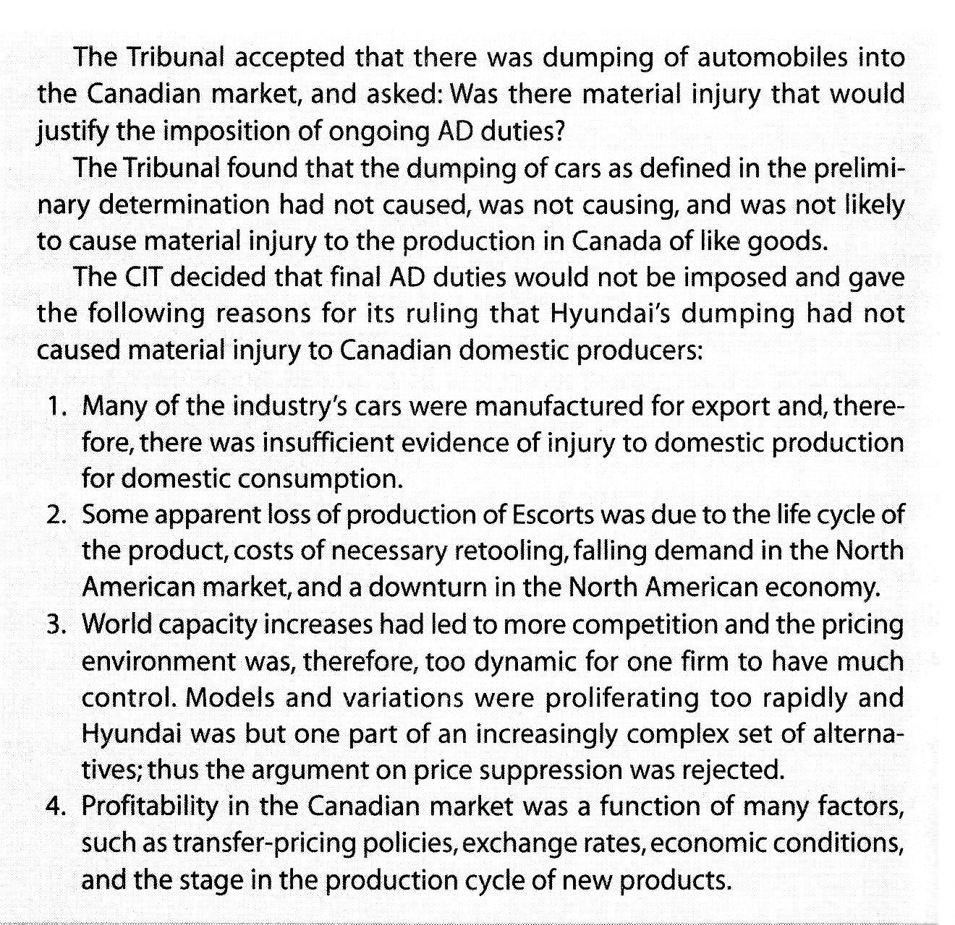
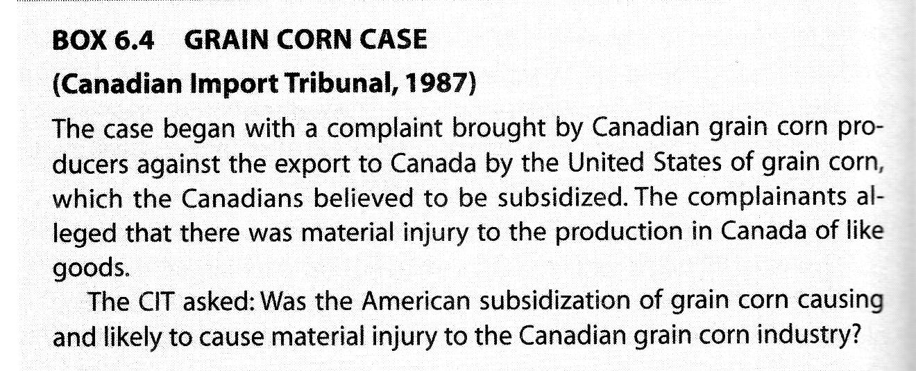
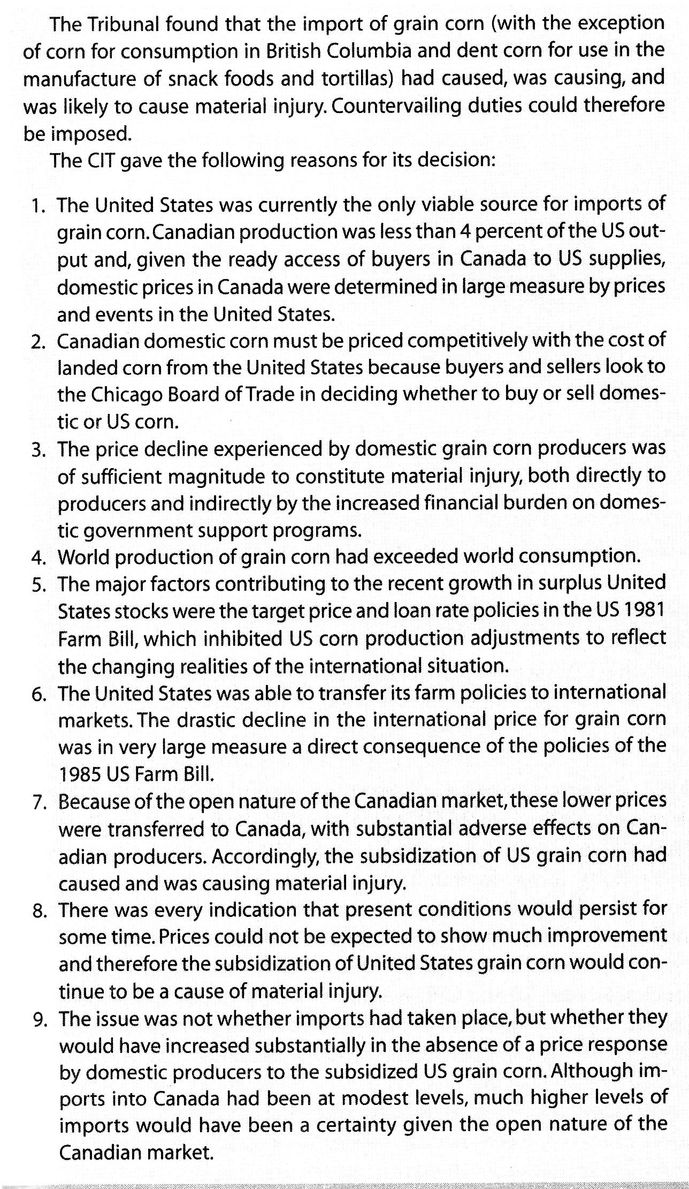
Review questions

What are some of the major reasons that Canada restricts imports and exports?

In what circumstances do you need a permit to export goods from Canada?

What is the difference between export control list and the area control list?

What types of goods are subject to restrictions or limitations when being imported into Canada?

Appendix
NAFTA Rules of Origin
Among other things, NAFTA provides for duty-free trade between Canada, the United States, and Mexico for so-called NAFTA-originating goods. Some changes were made to the underlying rules of origin as of January 1, 2005.

NAFTA originating goods are those deemed to originate in one of the NAFTA countries and are thus eligible for the preferential nil rate of duty when traded between the countries. Simple manufacture or assembly of a good in one of those countries does not confer originating status on the good; reference must be made to the NAFTA rules of origin. The latest changes to those rules affect certain classes of goods, including precious metals, household appliances, speed drive controllers (and their printed assemblies), thermostats, and a number of parts for various types of machinery and equipment. Other goods-specific rule changes cover toys, loudspeakers, tea, spices, carrageenan, and seasonings. (These products represent an estimated US$20 billion in total trilateral trade.)

The changes are generally "liberalizing" in nature, aimed to ensure that more goods qualify as NAFTA goods and thus promote further duty -free trade between NAFTA countries. For example, under the old rules, if a Canadian manufacturer of children's tricycles that imported pedals and accessories from China and merely assembled the tricycles in Canada, the goods were not eligible for NAFTA benefits: the rules required a tariff shift, which flows from actual manufacturing. The new rules add a regional value content (RVC) test that deems the goods to be NAFTA-originating if sufficient Canadian, US, or Mexican value is added. RVC must be at least 50 percent of the tricycle's net cost or 60 percent of the tricycle's selling price. Using the net cost approach, if the non-NAFTA-originating pedals and accessories cost $15 and the tricycle's net cost is $50, the assembled tricycles qualify as NAFTA goods because the RVC is 70 percent.

The changes are expected to affect NAFTA exporters favourably by facilitating the conferring of NAFTA status on goods that are being imported or exported, thus helping to reduce the cost of those goods and improving the competitiveness of businesses that use them in further production processes. The impact on other persons in the relevant industries may be less than favourable. The changes are also a part of a continuing effort on the part of the three countries to liberalize trade, and they come two years after similar liberalizing changes to seven other classes of goods, including alcoholic beverages and petroleum and topped crude oil. However, the NAFTA rules of origin remain quite complex and are often difficult to understand; affected persons should seek professional advice on the rules' application.
Robert G. Kreklewetz and Vern Vipul
Millar Kreklewetz LLP, Toronto

Regional value content

Regional Value Content
As well as a required tariff change, the specific rules of origin may ask that a Regional Value Content (RVC) be met. The RVC, which is always expressed as a percentage, may be figured out by using one of the following two formulas:
RVC = (Transaction Value – Value of Non-Originating Materials) X 100
Transaction Value
OR
RVC = (Net Cost – Value of Non-Originating Materials) X 100
Net Cost
It is the exporters choice to use either the Transaction Value or Net Cost.
The transaction value must be at least 60% of the value.
The net cost must be at least 50% of the value.

NAFTA: Article 401 – The Rules of Origin
For a good to originate it must meet the requirements set out in the Rules of Origin - Article 401 of the NAFTA Agreement
NAFTA grants benefits to a variety of goods from Canada, United States and Mexico. For a good to "originate", it must meet the requirements set out in the Rules of Origin - Article 401 of the Agreement.
Within the context of NAFTA the words origin, originate, or originating are used differently than in the context of determining country of origin.
Article 401 of NAFTA defines originating in four ways:
- Wholly obtained or produced in the NAFTA region.
- Goods produced in the NAFTA region wholly from originating materials. Goods taken from the seabed, the soil or the air in the NAFTA territories.
- Goods meeting the Annex 401 origin rule.
- Unassembled goods, and goods classified with their parts, which do not meet the Annex 401 rule of origin, but contain 60% regional value content using the transaction method, or 50% using the net cost method.
Goods can originate in Canada, Mexico, or the United States, even if they contain non-originating materials, as long as the materials satisfy the rules of origin specified in Annex 401 of the Agreement.

Determining If Your Goods Qualify Under NAFTA Rules of Origin Page 1 of 1 Trillium Customs Brokers Inc. Tel: 905-629-9505 – Fax: 905-629-1865 – www.trilliumcustomsbrokers.com

- Was the good last processed in one of the NAFTA countries?

If YES, go to Step 2, if NO, the goods do not qualify.

2.Do any of the materials or components used in the good originate from outside the NAFTA territories, or otherwise do not qualify as originating under NAFTA in their own right?

If YES, go to Step 3*, if NO, the goods do not qualify.

3.Determine the HS tariff classification number to six digits as required.

4.Using the HS tariff classification number, identify the specific rule(s)** of origin in Annex 401 that applies to the goods.

5.Determine the HS tariff classification of the non-originating materials or components used in producing the goods in a NAFTA country/territory.

6.Does the change from the tariff classification of the non-originating materials to the tariff classification of the good meet the tariff change requirement in the specific rule(s)** as identified in Step 4?

If YES, the tariff classification change requirement is met and, if there are no other requirements to be met in the rule (e.g., the content requirement), the good qualifies. If there are other requirements to be met, go on to them until all are met. If NO, the goods do not qualify, unless the goods fall under certain exemptions***.

7.Does the specific rule also contain regional value content?

If YES, choose whether to use the Transaction Value method or the Net Cost method.

Note: Be sure you can use the Transaction Value method before you select it. In particular, be sure that the price paid for the good will be acceptable under the principles of the customs valuation code. If there is any doubt, you should consult customs officials or use the Net Cost

8. Transaction Value Method:
Determine the actual price your customer paid you for the goods and the value of the non-originating materials used in producing it. Using the Transaction Value method, calculate the Regional Value Content (RVC) percentage. If the RVC percentage is equal to or greater than the minimum percentage set out in the specific rule for Transaction Value calculations (usually 60%), the good qualifies, providing all other conditions in the rule are met. If the percentage is less than the set minimum, you may try using the Net Cost method.
9.Net Cost Method:
Determine the net cost of the goods by deducting the specified ineligible costs from the total cost of the goods. Then determine the value of the non-originating materials and components. Using the Net Cost formula, calculate the RVC percentage. If the RVC percentage is equal to or greater than the minimum set out in the specific rule for Net Cost calculations (usually 50%), the good qualifies, providing all other conditions in the rule are met. If the percentage is less than the set minimum, the good does not qualify.

10. Complete a NAFTA Certificate of Origin if the Goods Qualify.
* If you do not know the origin of any material you must declare it does not originate in a NAFTA country.
** If two rules are applicable, the goods may qualify under either rule. You may find that qualifying under one rule is more convenient than the other, for example, one rule may require only a tariff classification change, whereas the other requires a tariff classification change and a value content calculation.
*** If the value of the non-originating materials that do not meet the tariff change requirement is not more than 7% of the value of the good, the de minimus rule exemption may apply and the good may qualify as originating, providing all other conditions are met.

Taken from the French word abattre and the Latin word battere, both meaning "to beat," abatement in its simplest terms means "to beat something down." When discussed in terms of finances, abatement is the beating down or lessening of debt or taxes.
www.foreign-trade.com/reference/hscode.htm
Trade restrictive quantities system
http://laws.justice.gc.ca/en/F-27/
http://www.bureaudelaconcurrence.gc.ca/eic/site/cb-bc.nsf/eng/01248.html
http://www.hc-sc.gc.ca/cps-spc/pubs/cons/toy_safe-jouet_secur-eng.php

