Output and prices in the long run

Learning objectives

Understand how wages and other factor prices respond to recessionary and inflatkonary gaps, and how this shifts the SRAS curve.

Explain how the economy adjusts following an aggregate demand or aggregate supply shock.

Define the economy’s long-run supply (LRAS) curve

Explain the different causes of short-run and long-run changes in real GDP
Potential output and the output Gap

Potential output is the total output that can be produced when all productive resources—labour and capital equipment—are being used at their normal rates of utilization.

When a nation’s actual GDP diverges from its potential GDP, the difference is called the output gap (or GDP gap).

Here, we view variations in the output gap as determined solely by variations in actual DGP around a constant level of potential GDP.
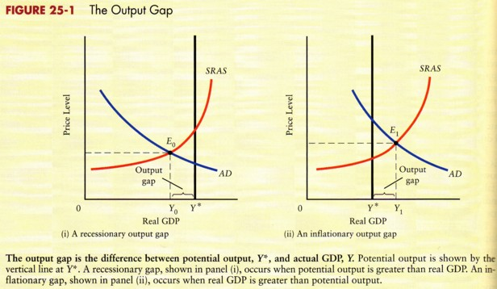

Factor prices and output gap
When real GDP is above potential output, demand for factors will also be high. When real GDP is below potential output, demand for factors will be low.

With an inflationary output gap, firms are producing beyond their normal capacity output, there is an unusually large demand for all factor inputs, including labour. Labour shortages will emerge in some industries and among many groups of workers. Firms will try to bid workers away from other firms in order to maintain the high levels of output and sales made possible by the boom conditions.

With a recesionary gap, firms are producing below their normal-capacity output. Firms will have below-normal sales and not only will resist upward pressures on wages but will seek reductions in wages.

Demand and supply shocks
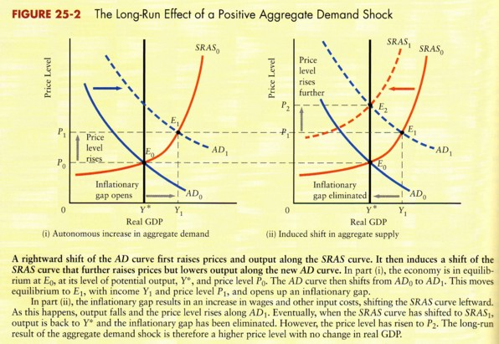
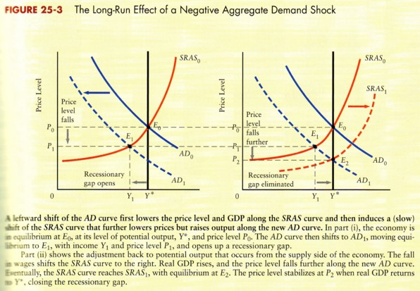
Flexible wages  When wages fall quickly in response to the recessionary gap, the SRAS curve would shift to the right as the lower wages lead to reduced costs.  If wages were to fall rapidly whenever there was unemployment, the resulting shift in the SRAS curve would quickly restore full employment. | Sticky wages  It is sometimes said that wages are ssticky n the downward direction. It’s not that they never fall it is that they fall more slowly.  The recessionary gap remains open longer.

Aggregate supply shocks

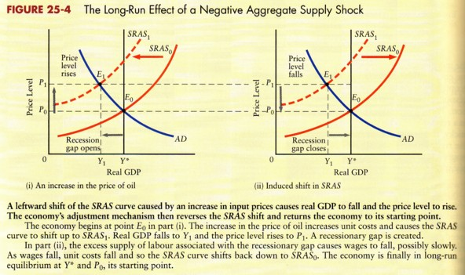
Economic shocks and business cycles

Both aggregate demand and aggregate supply are subject to continual random shocks.

The economy’s adjustment mechanism can convert these shocks into cyclical fluctuations in real GDP.

The long-run aggregate supply curve
This curve relates the price level to real GDP after wage rates and all other input costs have been fully adjusted to eliminate any unemployment or overall labour shortages.

Once all the adjustments have occurred, any excess demand or excess supply of labour will have been eliminated. In other words, full employment will prevail, and output will be at its potential level, Y*.

The economy’s long-run aggregate supply (LRAS) curve is vertical at the level of potential output, Y*.

In the long run, total output is determined solely by conditions of aggregate supply, and the role of aggregate demand is only to determine the price level.

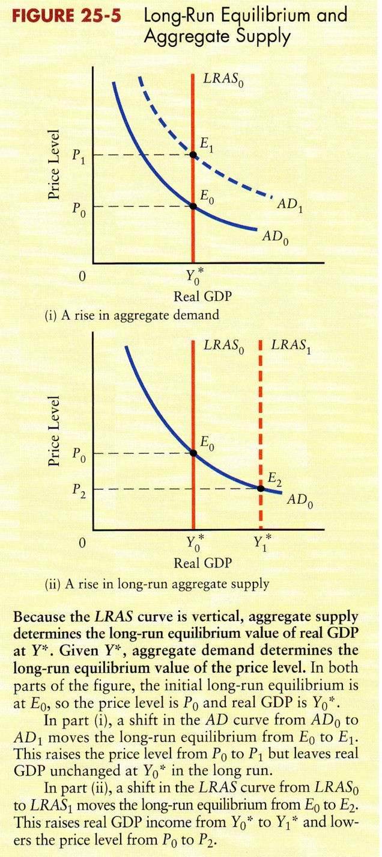
national income in the short and long run

Output is afected by changes in demand in the short run, whereas changes in supply are the crucial facotr determining output in the long run.

Important disticntion between the short run and the long run.

- In the short run, the economy is in equilibrium a the level of real GDP and prices where the SRAS curve intersects the AD curve.
- In the long run, the economy is in equilibrium at potential output, the position of the vertical LRAS curve. The price level is determined where the AD curve intersects the LRAS curve. In thelong run, only changes to the level of Y* can change the level of real GDP

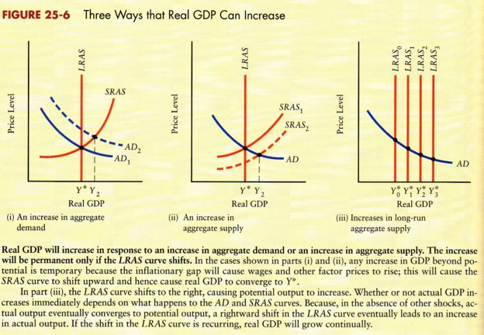
Fiscal policy and the business cycle

The basic theory of fiscal stabilization
A recessionary gap.
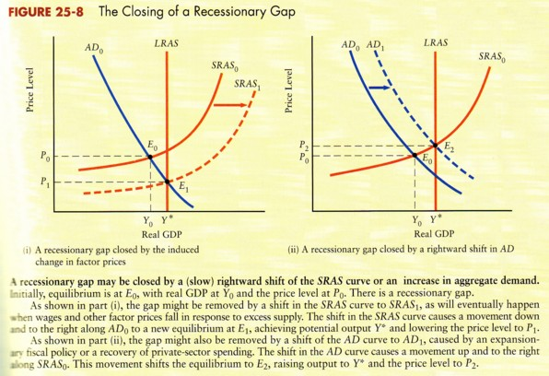

There are two ways that the gap can be closed.
First, the recessionary gap may eventually drive wages and other factor prices down enough to shift the SRAS curve to the right.
Second, the AD curve could shift to the right, restoring the economy to potential output.

An inflationary gap
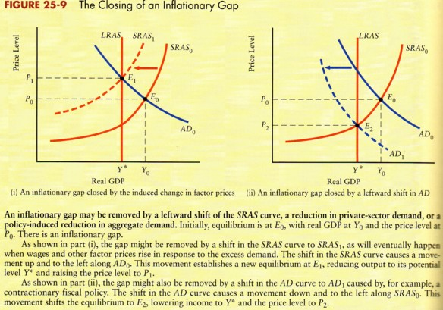

When the economy’s adjustment mechanism is slow to oeprate, or produces undesirable side effects as rising prices, there is a potential stabilization role for fiscal policy.

The paradox of thrift
The theory of national income detemination predicts that an increase in national saving will shift the AD curve to the left and hence reduce the equilibrium level of real GDP in the short run. The contrary case, a decrease in saving and increase in expenditure, shifts the AD curve to the right and hence increases real GGP in the short run.
The policy implication of this prediction is that a major and persistent recession can be battled by encouraging governments, firms, and households to spend more, not to save more.
The paradox of thrift concentrates on shift in agregate demand that have been caused by changes in saving (and hence spending) behaviour. That is why it applies only in the short run, when the AD curve plays an important role in the determination of real GDP.

In the long run, the paradox does not apply. In the long run aggregate demand is not the determinant of real GDP, only the position of LRAS curve determines long-run GDP. In the long run, the more people and governments save, the larger the supplyof funds available for investment. An the more that people invest, the greater is the growth of potential output, shifting the LRAS curve to the right.
Limitations of discretionary fiscal policy.

Lags
To change fiscal policy requires making changes in taxes and government expenditures.
The delay between theintial recognition of a gap and the enactment of legislation to change fiscal policy is called a decision lag.
Once policy changes are agreed on, there is still an execution lag.
Because of these lags, it is quite possible that by the time a given policy decision has any impact on the economy, circumstances willhave changed such that the policy is no longer appropriate.

Temporary versus permanent policy changes.
Tax measures that are known to be temporary are generally less effective that measures that expected to be permanent.

The role of discretionary fiscal policy
All these difficulties suggest that attempts to use discretionary fiscal policy to fine tune the economy are fraught with difficulties.
Many economists still argue that when a recessionary gap is large enough and persists for long enough fiscal policy should be used.

